User Manual
Platform for the Design and Analysis of Microstrip Structures

Overview of GielisMeta-CST
GielisMeta-CST is a MATLAB-based tool for designing, generating, and analyzing microstrip electromagnetic structures based on Gielis geometries. Within a single environment, users can define the geometric parameters, generate the electromagnetic model, configure the simulation, and analyze the results in CST Studio Suite.
The graphical user interface provides controls for the geometry, material properties, and simulation settings. Automated model construction in CST Studio Suite reduces design time and avoids rebuilding each configuration manually. The application supports three operating modes: absorber, transmitter, and sensor mode.

Reference validation environment
This configuration corresponds to the environment used to validate the examples included in this manual. It should not be interpreted as a minimum hardware requirement. Simulation time and memory usage may vary depending on the geometry, frequency range, mesh settings, and CST solver configuration.
- Operating system: 64-bit Windows 11 Pro.
- MATLAB version: R2026a.
- CST Studio Suite version: 2025.
- Processor: Intel Core i5-14600 at 2.70 GHz.
- RAM: 64 GB.
- Storage capacity: 2.75 TB.

Repository contents
The repository provided for review contains the following items:
- GielisMetaCST.mlapp: MATLAB App Designer application.
- CST_MicrowaveStudio.m: MATLAB–CST automation interface.
- macros/: CST macro files required during model construction.
- docs/GielisMeta-CST_User_Manual.pdf: software user manual.

Software repository and citation

The source code, CST automation interface, helper macros, documentation, release history, and machine-readable citation metadata are maintained at: https://github.com/sebasvlld-creator/GielisMeta_CST

Recommended software citation: Montoya-Villada, S., Sierra-Gutierrez, V., & Reyes-Vera, E. (2026). GielisMeta-CST: A MATLAB-Based Engineering Software Tool for Automated Design and Simulation of Gielis-Inspired Microstrip Electromagnetic Structures (Version 1.0.0) [Computer software]. GitHub. https://github.com/sebasvlld-creator/GielisMeta_CST

Instructions
The following sections describe how to set up and use GielisMeta-CST to design, generate, and simulate microstrip electromagnetic structures based on Gielis geometries.
Step 1. Set up the working environment
Install MATLAB R2026a, the version used to develop the application. Download the latest GielisMeta-CST release from https://github.com/sebasvlld-creator/GielisMeta_CST and extract it. Keep GielisMetaCST.mlapp, CST_MicrowaveStudio.m, and the macros folder in the same directory. Finally, open GielisMetaCST.mlapp in MATLAB and run the application.

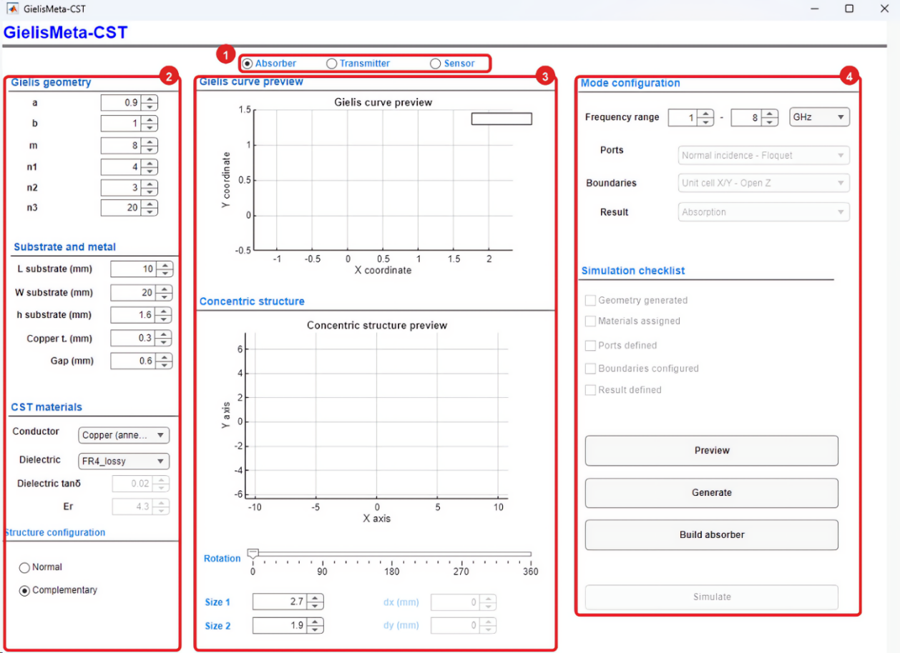
Figure 1. Initial GielisMeta-CST interface.
- Operating mode selection. Select Absorber, Transmitter, or Sensor. The selected mode determines the available electromagnetic configuration options.
- Geometry and materials. Use this area to enter the Gielis-curve parameters, substrate and metal dimensions, material properties, and structure type.
- Preview areas. Use these plots to verify the Gielis curve and the concentric structure before building the model in CST Studio Suite.
- Configuration and execution. This area contains the frequency range, the Simulation checklist, and the Preview, Generate, Build absorber, and Simulate buttons. The workflow is as follows: preview the curve, generate the concentric structure in MATLAB, adjust its size and rotation, build the model in CST Studio Suite, and run the simulation.

Absorber mode
Objective
Create and simulate an electromagnetic absorber based on a Gielis curve. In this mode, the application automatically configures normal incidence, periodic boundary conditions, and the absorption calculation.
Note: Figure 2 shows the configuration used in this example. The values correspond to a Gielis-geometry absorber and may be modified to suit the objectives of the study.
Step 1. Select Absorber mode
1. Select Absorber at the top of the interface.
2. Verify that the application has assigned the following configuration:
- Ports: Normal incidence - Floquet.
- Boundaries: Unit cell X/Y - Open Z.
- Result: Absorption.
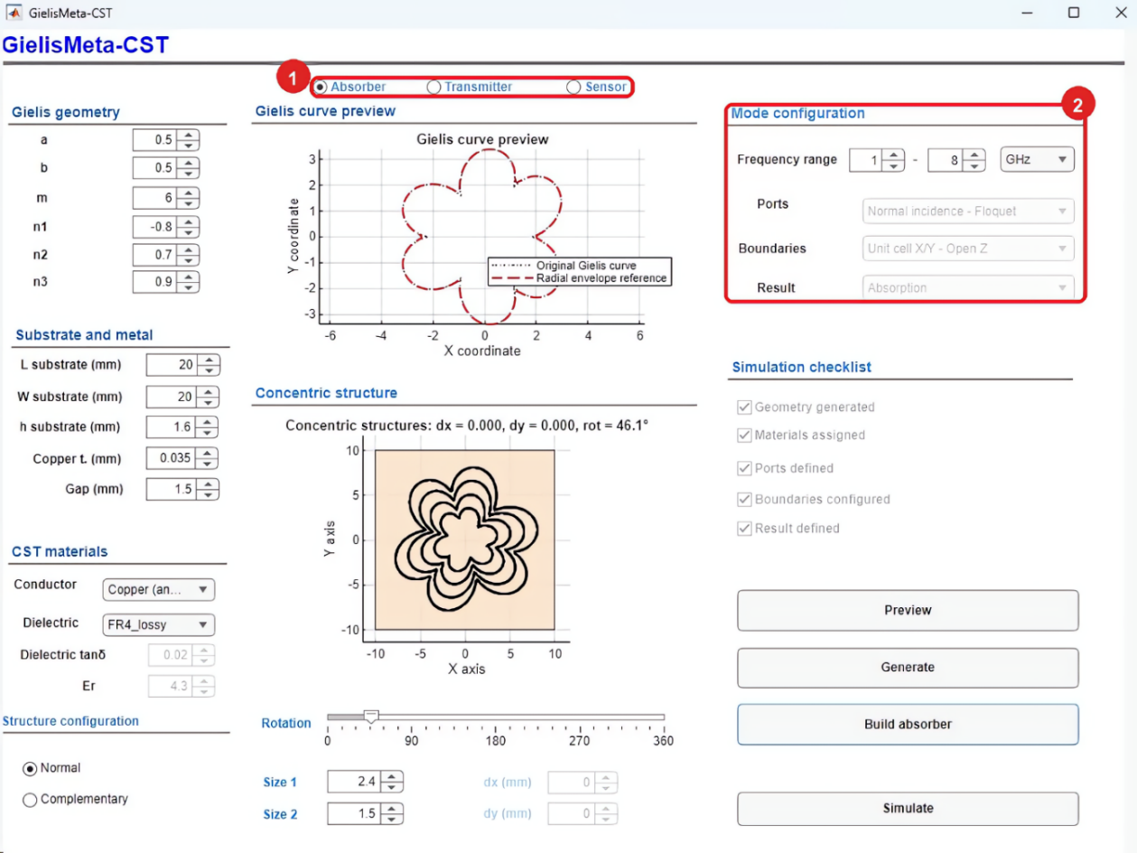
Figure 2. Absorber-mode selection and automatically assigned configuration.
Step 2. Define the Gielis geometry
1. In the Gielis geometry panel, enter the values of a, b, m, n1, n2, and n3.
- The parameters a and b control the proportions of the curve.
- The parameter m sets the number of symmetries or lobes.
- The parameters n1, n2, and n3 control the lobe contour.
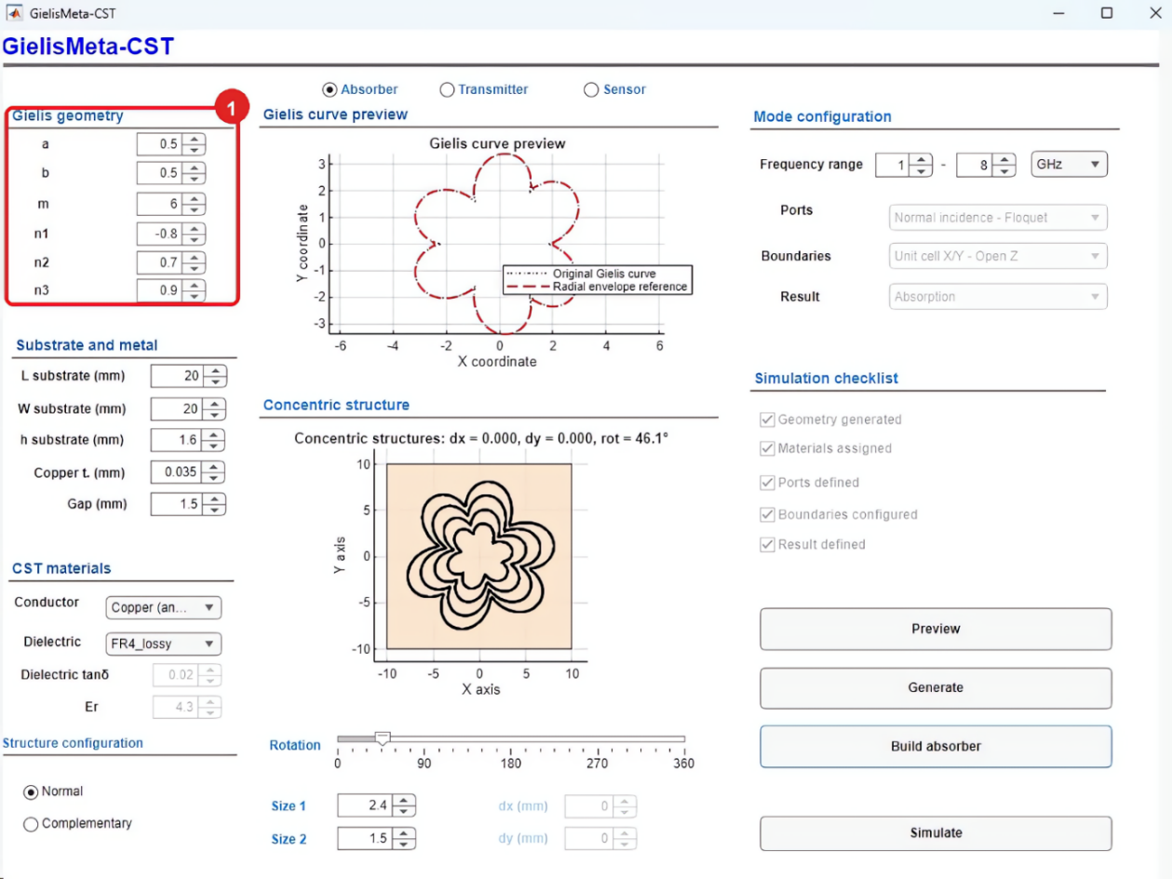
Figure 3. Entry of the Gielis geometry parameters.
Step 3. Preview the Gielis curve
1. Click Preview after defining the geometric parameters.
2. Verify that the curve displayed in the preview panel has the intended shape.
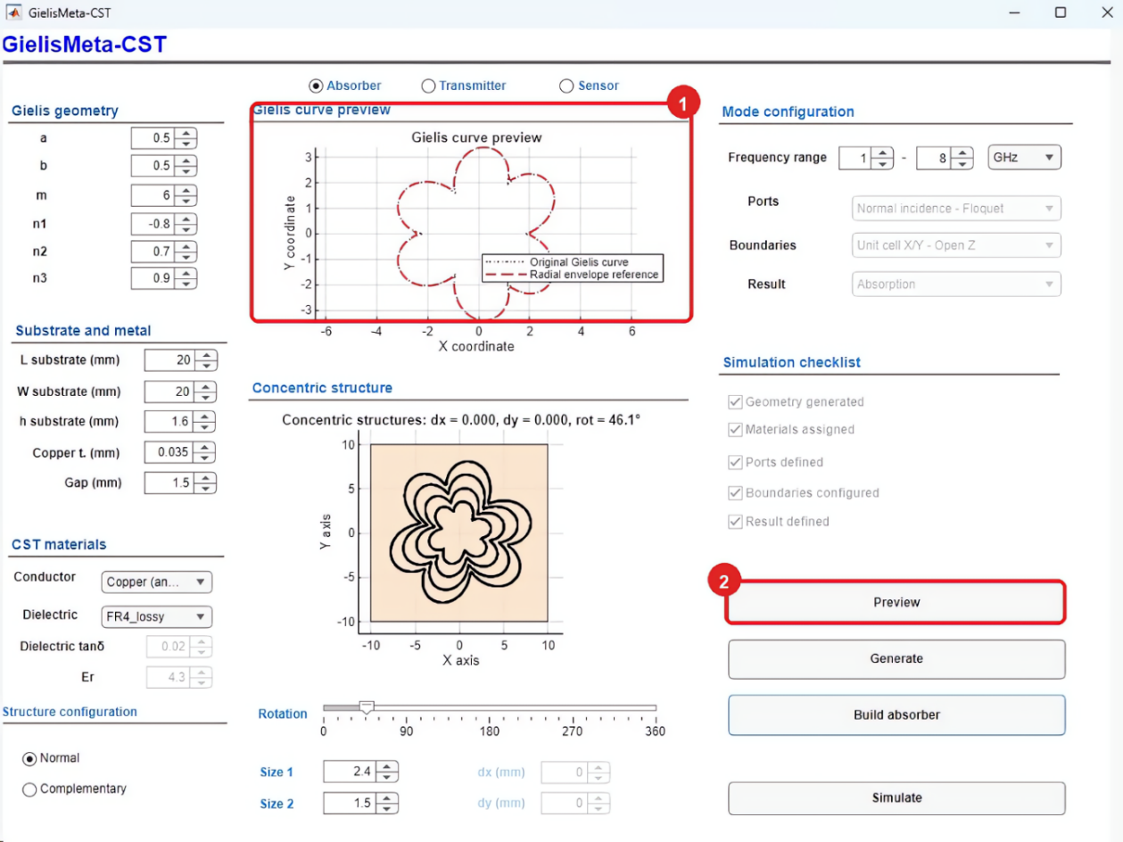
Figure 4. Gielis curve preview.
Step 4. Configure the substrate and materials
1. Under Substrate and metal, enter the substrate length, width, and thickness, together with the copper thickness and gap value.
2. Under CST materials, select the conductor and dielectric material.
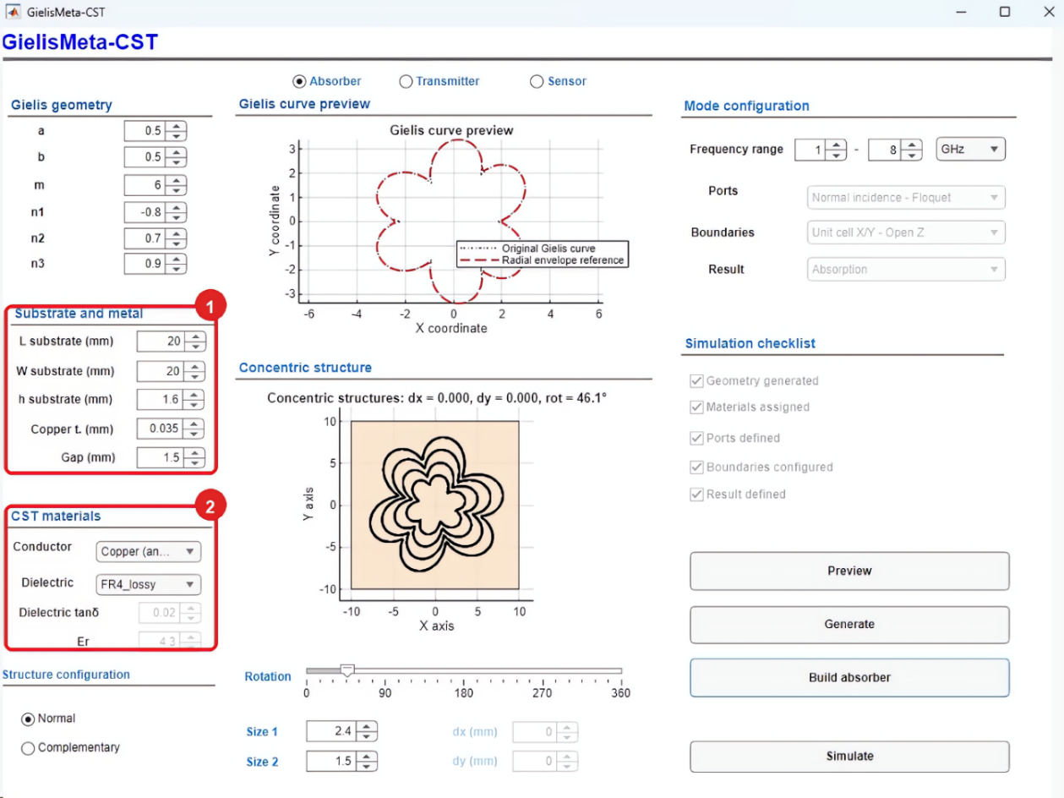
Figure 5. Substrate and copper dimensions and conductor and dielectric selection.
Step 5. Select the structure type and generate the geometry
1. Under Structure configuration, select Normal to create conductive rings or Complementary to create Gielis-shaped slots in a continuous copper layer.
2. Click Generate to create the concentric structure in MATLAB. When the confirmation dialog appears, click OK.
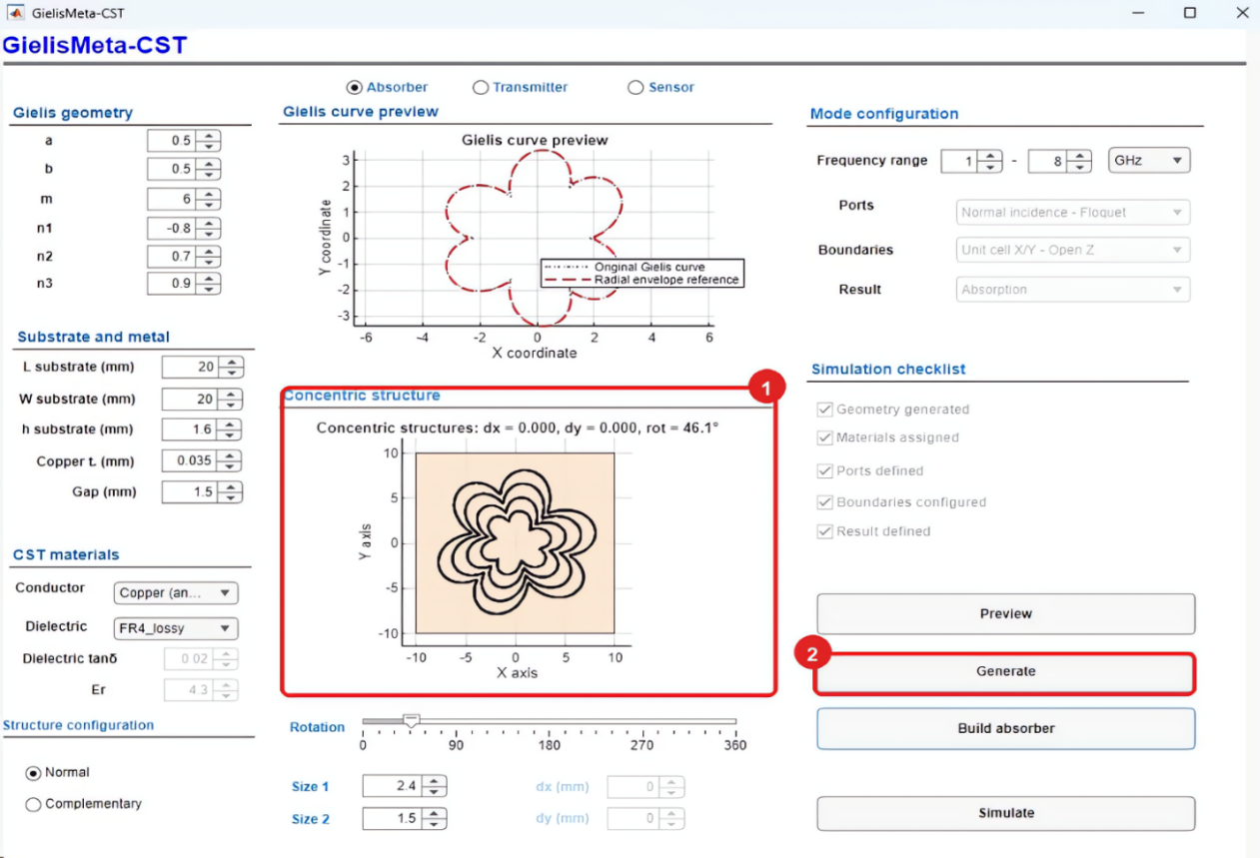
Figure 6. Generation of the concentric structure.
Step 6. Adjust the size and rotation
1. After generating the structure, confirm the selected type and set Size 1, Size 2, and Rotation as required by the design.
2. In the Concentric structure panel, verify that the size and orientation are correct before building the model in CST Studio Suite.
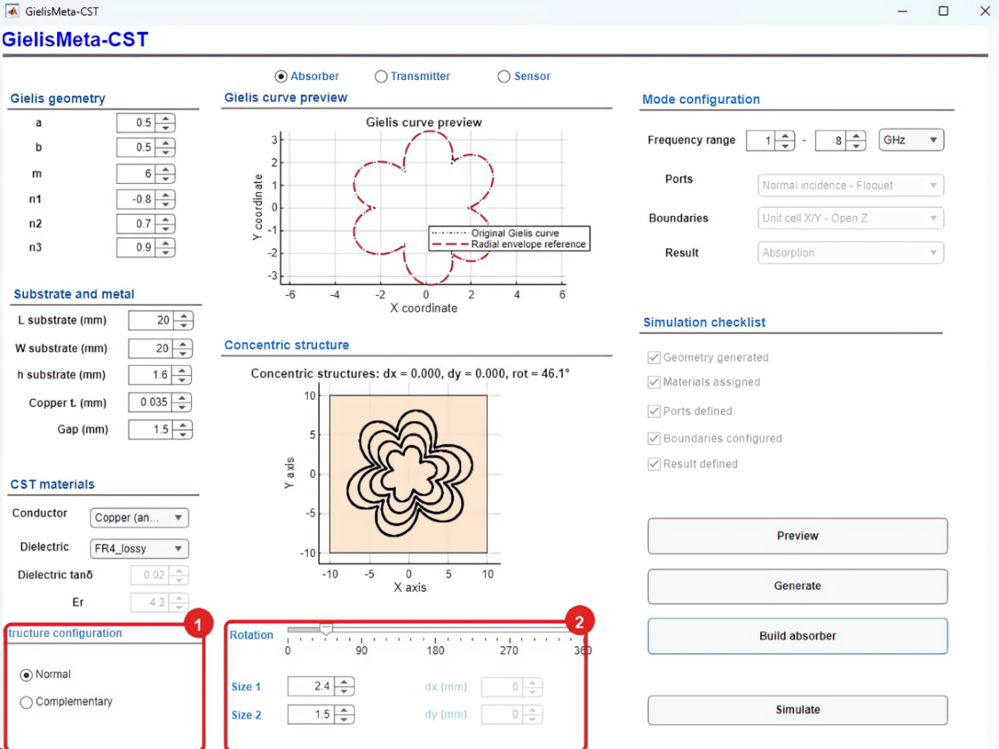
Figure 7. Absorber size and rotation settings.
Step 7. Set the frequency range
1. Under Mode configuration, enter the lower and upper frequencies of the analysis range.
In Absorber mode, the application automatically assigns the ports, boundary conditions, and result type.
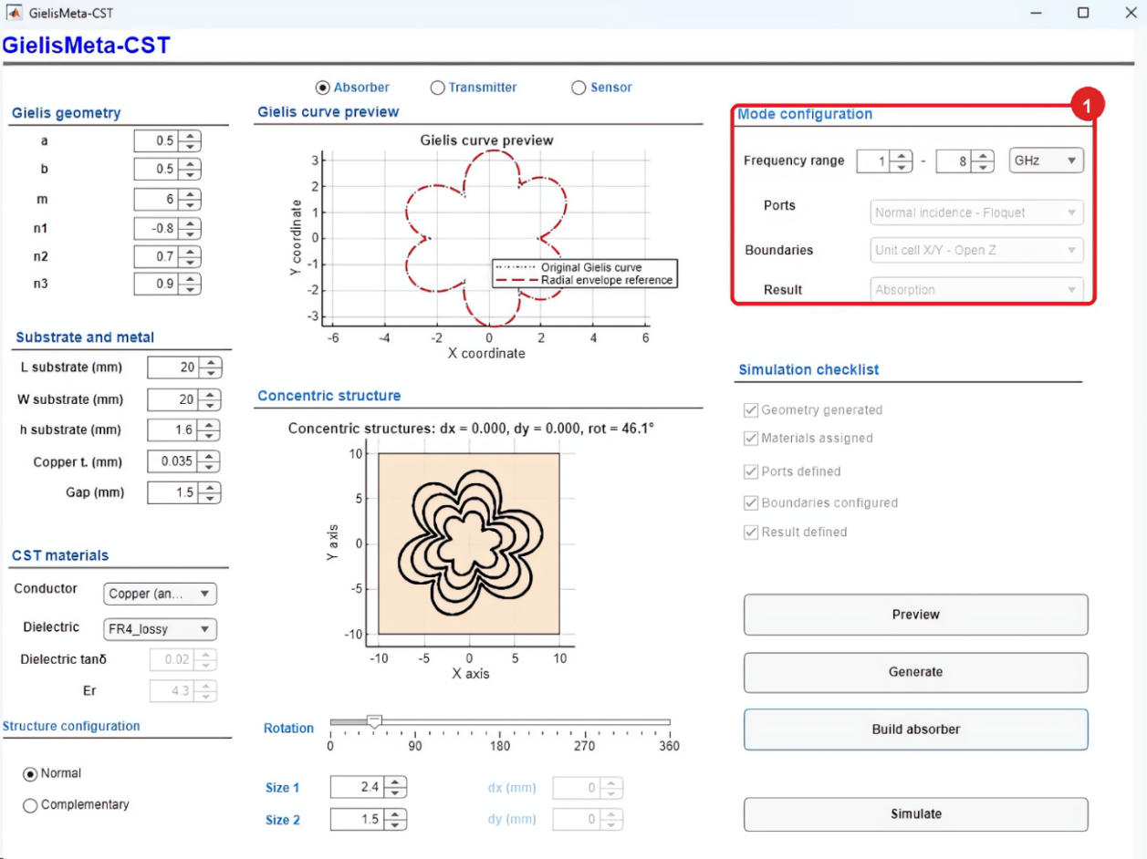
Figure 8. Absorber frequency-range configuration.
Step 8. Build the model in CST Studio Suite
1. Click Build absorber to create the electromagnetic model in CST Studio Suite. When the confirmation dialog appears, click OK.
2. After the model has been built, verify that all five boxes in the Simulation checklist are selected.
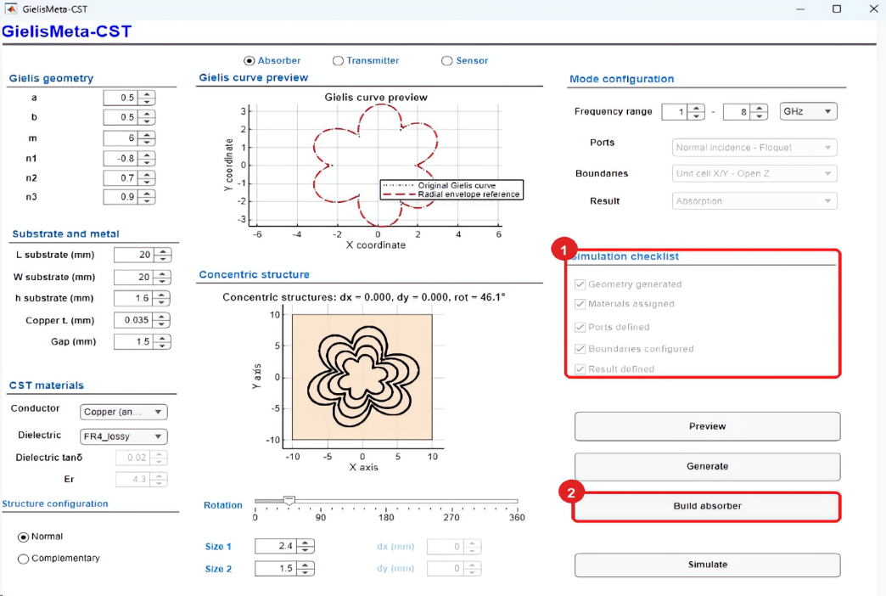
Figure 9. Build absorber command and completed Simulation checklist.
The CST Studio Suite model should retain the concentric Gielis rings on the substrate, as shown in Figure 10.
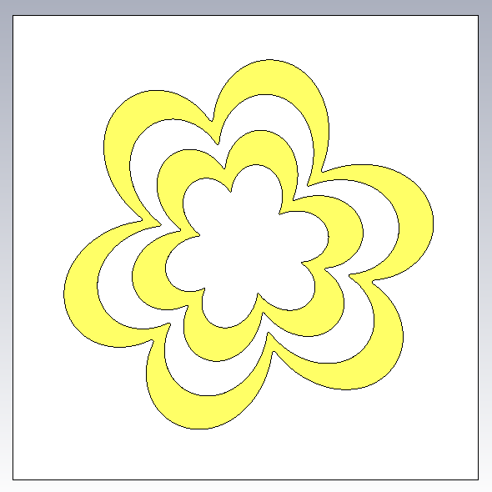
Figure 10. CST Studio Suite view of the generated absorber model.
Step 9. Run the simulation
1. Verify that all boxes in the Simulation checklist are selected.
2. Click Simulate to run the analysis using the specified parameters.
The application instructs CST Studio Suite to start the solver for the model built in the previous step. Wait for the solver to finish before changing any values or starting another run.
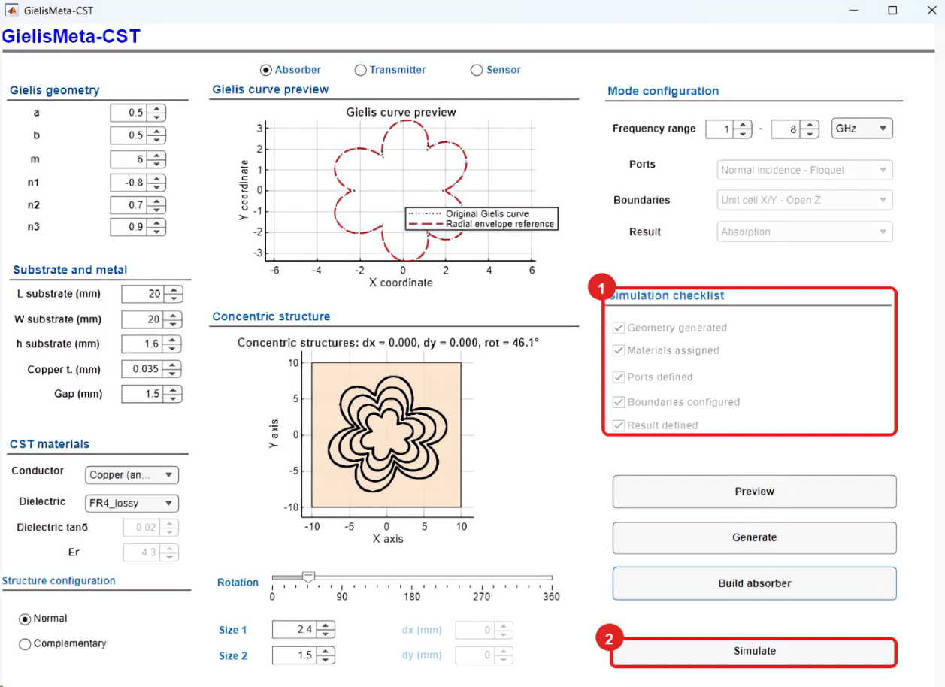
Figure 11. Running the absorber simulation.

Step 10. Inspect the absorption results
After the solver finishes, the application opens a window containing the results plot.
1. Verify the absorber response over the selected frequency range.
2. Use the legend to identify the absorption and reflection curves. For this ground-backed absorber, transmission is assumed to be zero (T = 0).
3. In this example, the strongest absorption maximum occurs near 2.435 GHz, with an absorptance close to 97.9%. A second absorption maximum appears near 3.849 GHz.
4. The second absorption maximum occurs near 6.0 GHz.
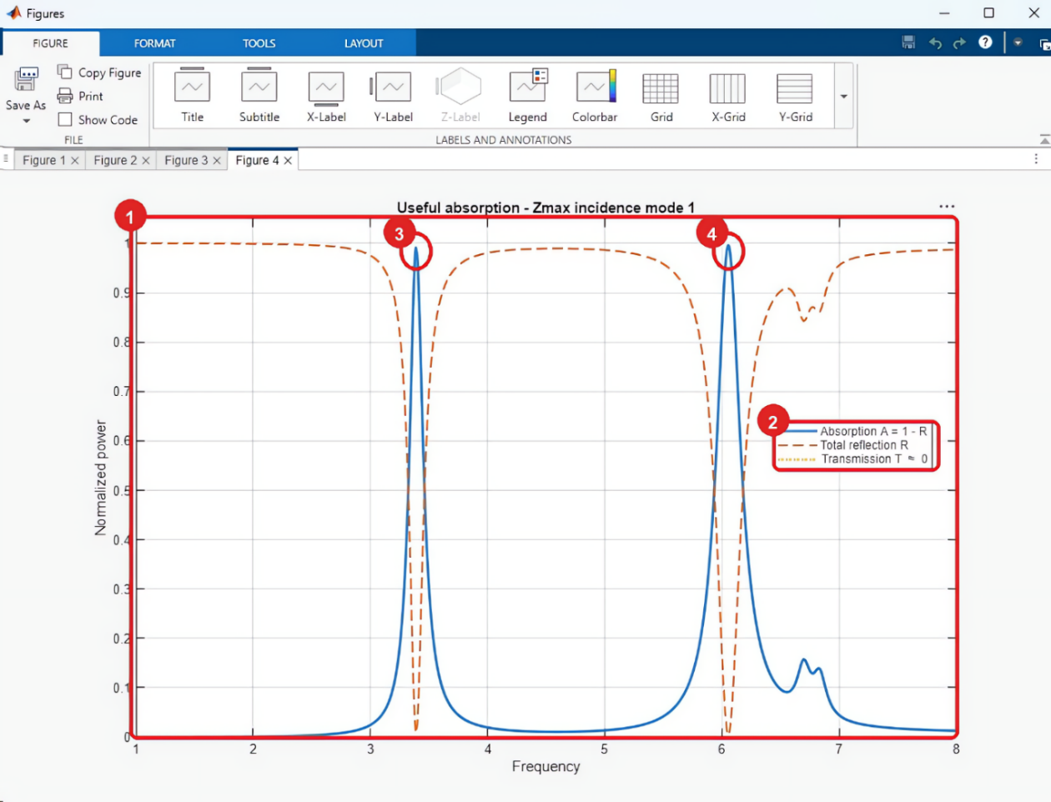
Figure 12. Absorption response for the example: 1. absorption curve; 2. legend; 3. maximum near 3.4 GHz; 4. maximum near 6.0 GHz.

Transmitter mode
Objective
Create and simulate a transmissive structure based on a Gielis curve.
The general workflow is the same as for Absorber mode: define and preview the curve, select the structure type, click Generate, adjust the size and rotation, set the frequency range, build the model in CST Studio Suite, and run the simulation. Only the options and controls specific to Transmitter mode are described below.
Note: Figure 13 shows the configuration used in this example. The values correspond to a Gielis-geometry transmissive structure and may be modified to suit the objectives of the study.
Step 1. Configure and run Transmitter mode
1. Select Transmitter at the top of the interface.
2. Verify that Mode configuration displays the transmission-analysis settings. Then complete the geometry, material, preview, generation, sizing, rotation, and frequency-range operations described in Steps 2-7 of Absorber mode.
3. After the structure has been generated and adjusted, click Build transmitter to build the model in CST Studio Suite.
4. Click Simulate to run the transmission analysis.
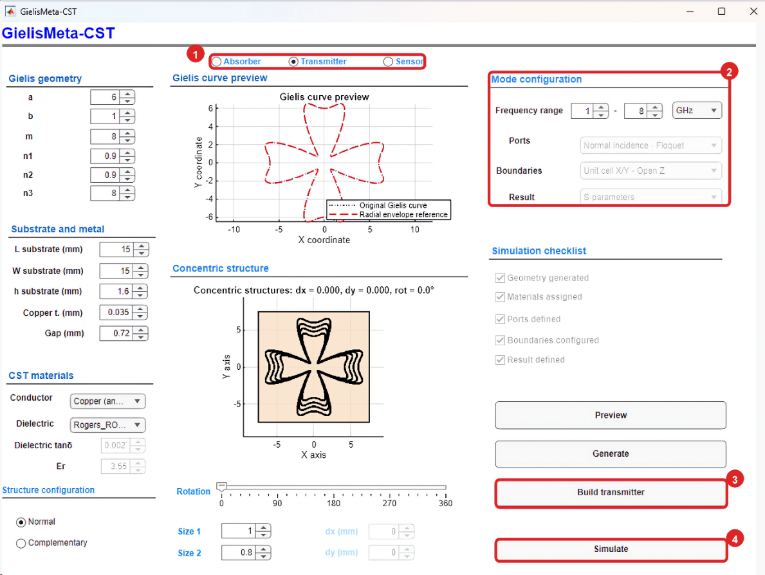
Figure 13. Transmitter-mode configuration: 1. Transmitter selection; 2. automatically assigned analysis settings; 3. model construction using Build transmitter; 4. simulation started using Simulate.
The CST Studio Suite model retains the concentric resonators on the substrate, as shown in Figure 14.
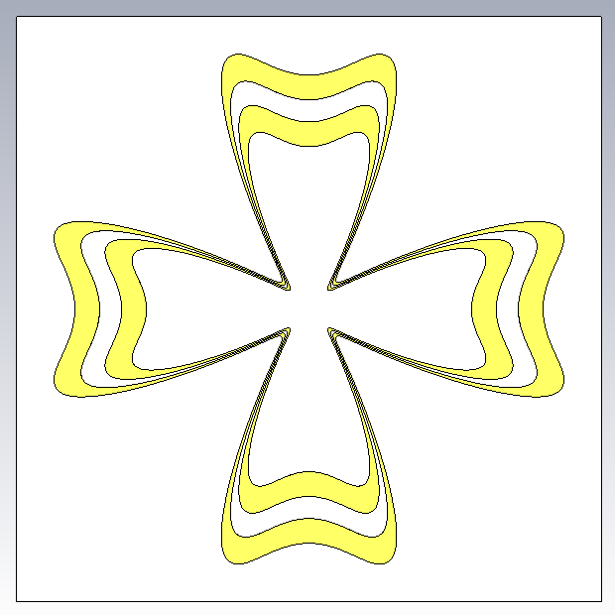
Figure 14. CST Studio Suite view of the generated transmitter model.
Step 2. Inspect the transmission results
1. Examine the magnitude of the transmission coefficient |S21| in dB.
Response minima identify frequencies at which transmission is attenuated.
2. In this example, the first minimum occurs near 3.4 GHz and corresponds to a secondary resonance.
3. The main minimum occurs near 4.9 GHz, with an approximate magnitude of −34 dB.
Values near 0 dB indicate high transmission. More-negative values indicate greater attenuation of the transmitted signal.
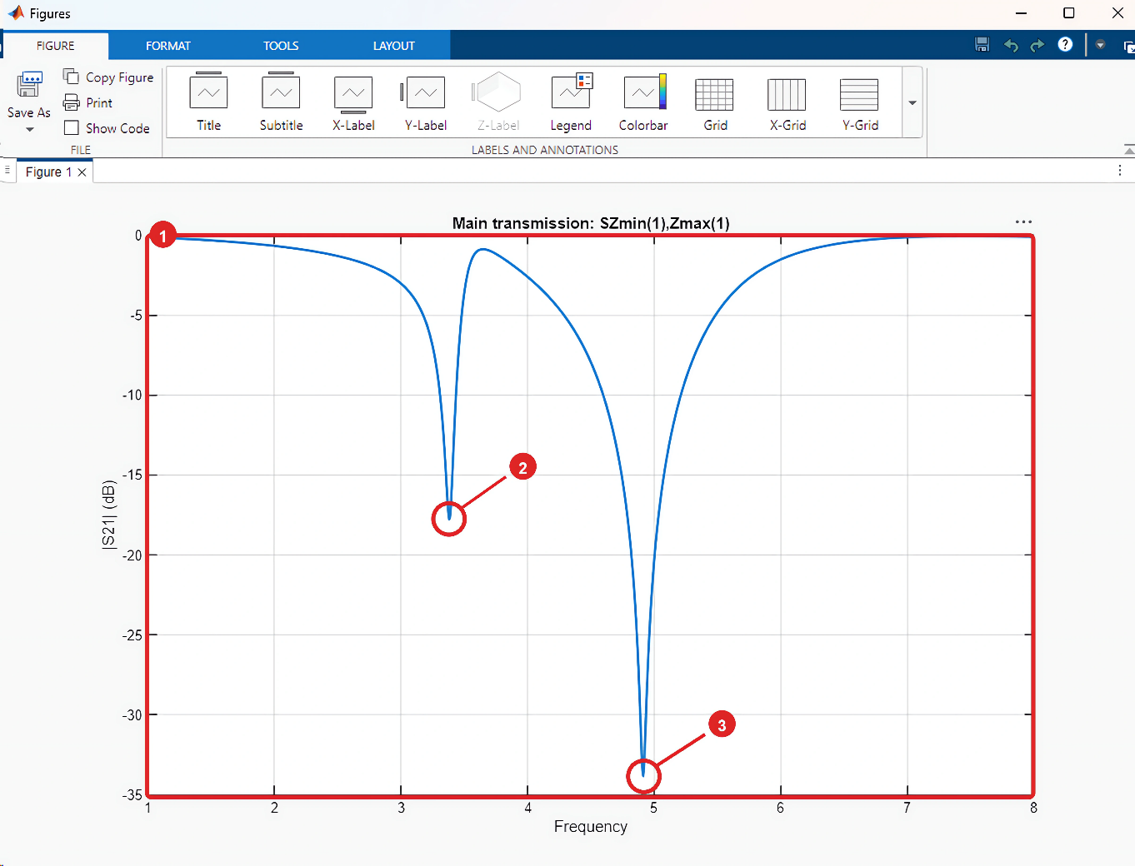
Figure 15. Transmission response for the example: 1. |S21| in dB; 2. secondary resonance near 3.4 GHz; 3. main minimum near 4.9 GHz.
Step 3. Configure the field monitors
After the initial simulation, CST Studio Suite opens the Field monitors dialog. Use this dialog to select the field quantity to be evaluated over the structure.
For this example, select Electric field. This option creates a monitor for displaying the electric-field distribution at the identified resonance frequency.
Alternatively, select one of the following options:
- Do not generate fields: continue without creating any field monitors.
- Electric and magnetic field: create both electric- and magnetic-field monitors.
CST Studio Suite proposes a frequency of interest. Retain the default value or enter another value, and then click OK. If the Results May Get Incompatible With Model dialog appears, click OK again.
Step 4. Display the electric field
After the simulation finishes, expand 2D/3D Results in the CST Studio Suite navigation tree and open E-Field.
Select the generated electric-field result to open the visualization.
On the top ribbon, change Arrows to Contour. The resulting map shows the regions of higher and lower electric-field magnitude at the selected frequency.
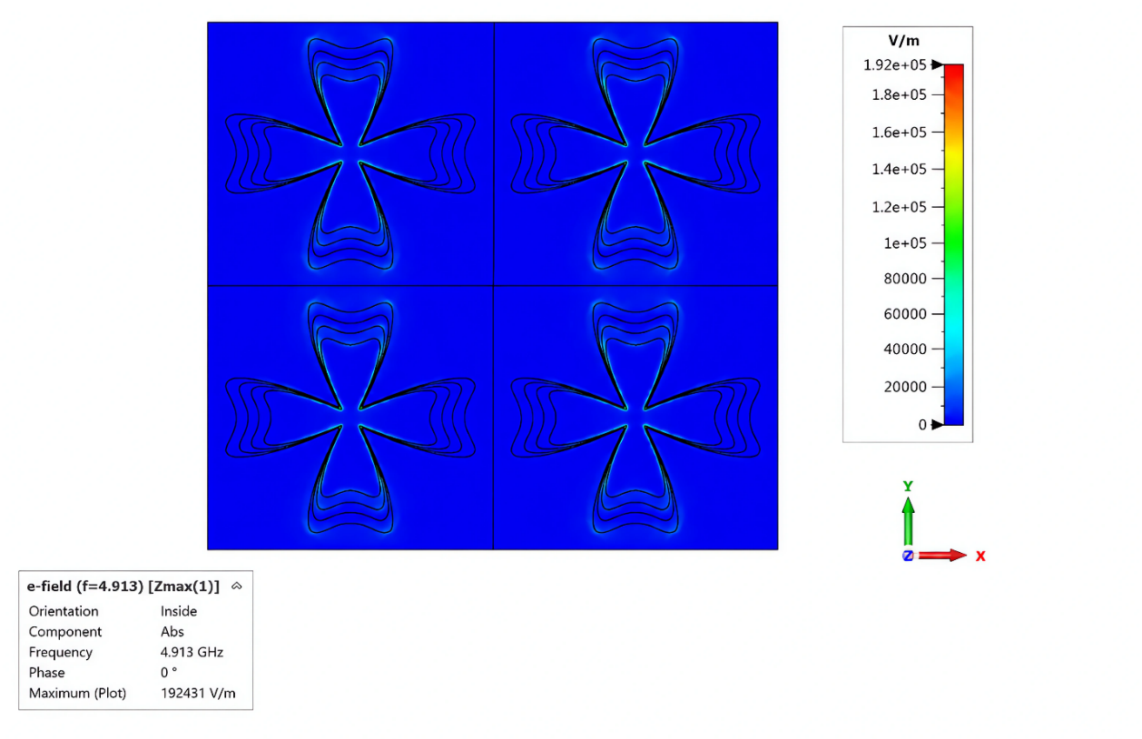
Figure 16. Electric-field distribution of the transmitter structure at 4.913 GHz.

Sensor mode
Objective
Create and simulate a Gielis-curve-based sensing structure and evaluate its electromagnetic response.
Sensor mode follows the same common workflow: Preview, Generate, size and rotation adjustment, Build sensor, and Simulate. Only the options specific to this mode are described below.
Note: Figure 17 shows the configuration used in this example. The geometry, dimensions, and frequency values may be modified to suit the objectives of the study.
Step 1. Configure and run Sensor mode
1. Select Sensor at the top of the interface.
2. Verify that the application has assigned the following configuration:
- Ports: 2 waveguide ports.
- Boundaries: Open all boundaries.
- Result: S-parameters.
Set the frequency range of interest; this example uses 1 to 8 GHz.
Under Structure configuration, Complementary is selected and locked by default; this option cannot be changed in Sensor mode.
3. Complete the geometry, substrate, material, preview, generation, sizing, rotation, and frequency-range operations described in Steps 2-7 of Absorber mode. Then click Build sensor to build the model in CST Studio Suite.
4. When the Simulation checklist is complete, click Simulate to run the sensor analysis.
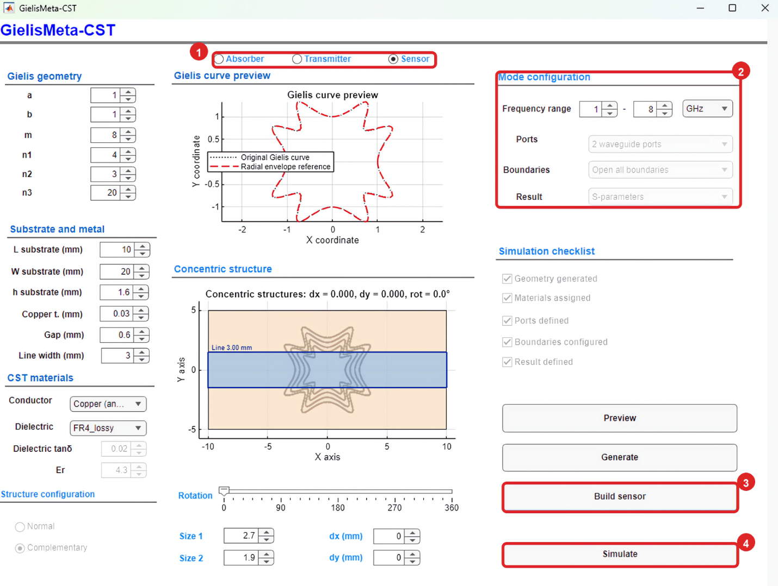
Figure 17. Sensor-mode configuration and execution: 1. Sensor selection; 2. automatically assigned analysis settings; 3. Build sensor button; 4. Simulate button.
In CST Studio Suite, the sensor model appears as concentric Gielis-shaped slots in the conductive layer, as shown in Figure 18.
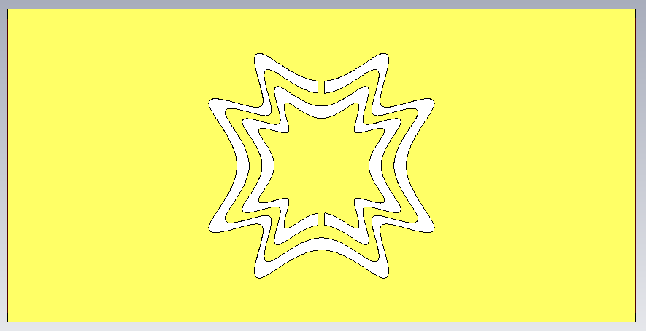
Figure 18. CST Studio Suite view of the generated complementary sensor model.
Step 2. Inspect the sensor response
1. After the simulation finishes, examine the magnitude of the transmission coefficient |S21| in dB over the analyzed frequency range.
2. In this example, the main resonance occurs near 3.4 GHz, with an approximate magnitude of −19 dB.

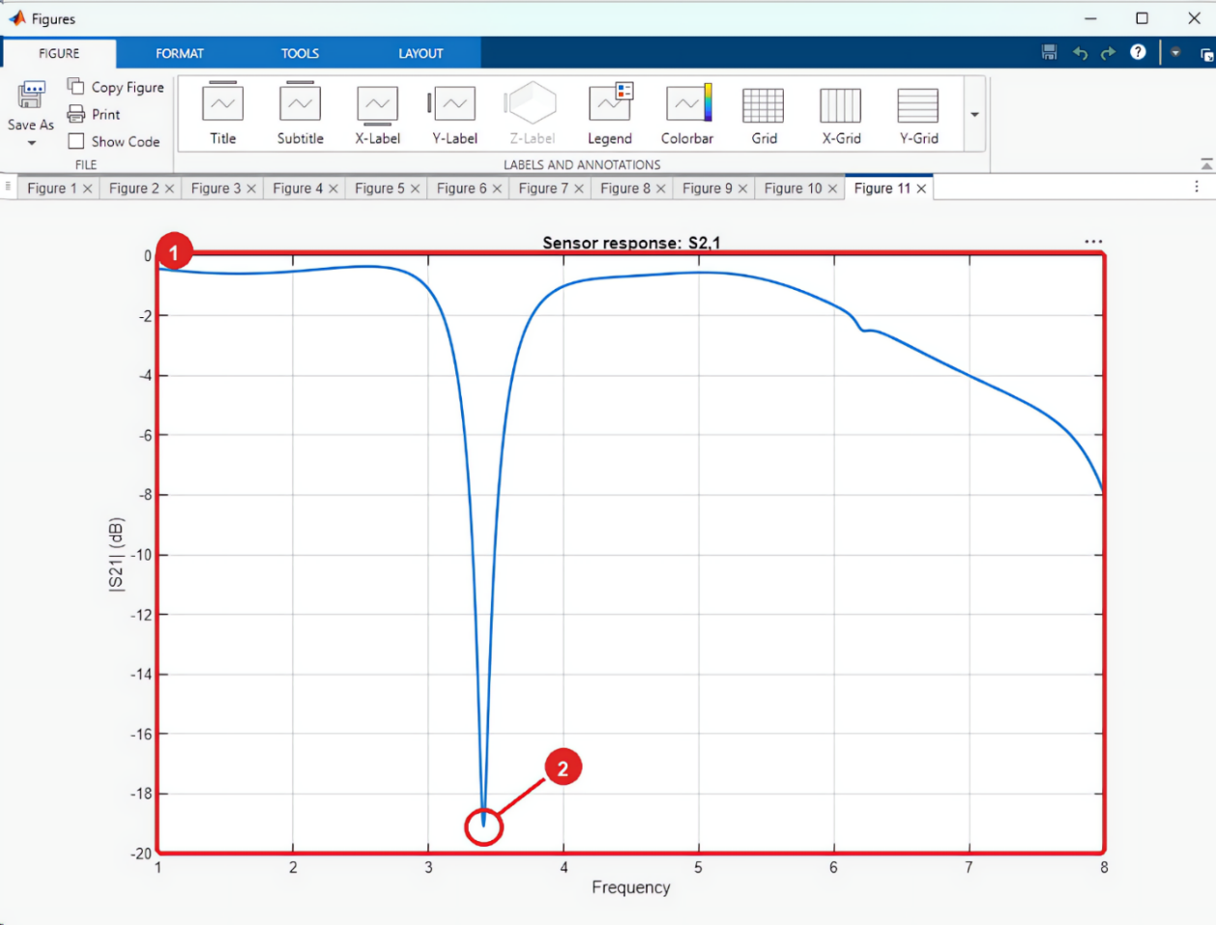
Figure 19. Sensor response for the example: 1. |S21| curve; 2. main resonance near 3.4 GHz with a magnitude of approximately −19 dB.
Step 3. Configure the field monitor and display the electric field
Follow Steps 3 and 4 of Transmitter mode to configure and display the electric-field monitor for Sensor mode.
Figure 20 shows the resulting electric-field distribution at the selected frequency.
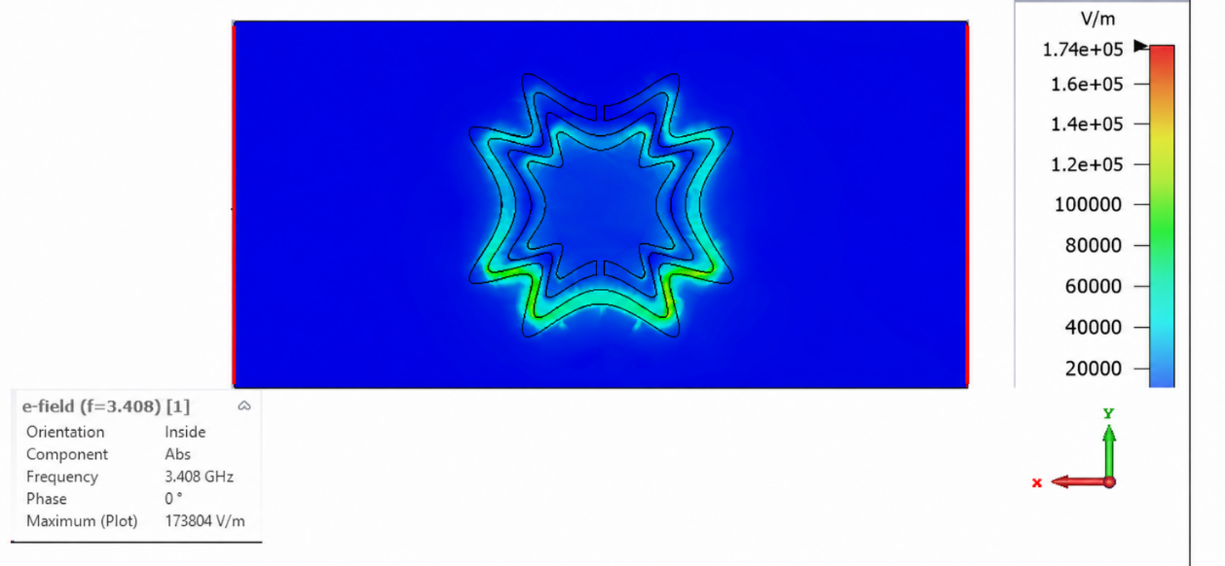
Figure 20. Electric-field distribution of the sensor structure at 3.408 GHz. Lighter colors indicate higher field magnitude; the scale on the right is given in V/m.

