Title Goes Here

Myfirstname Mylastname1,✉, and Yourfirstname Yourlastname2

30 November, 2021

Text of abstract

1 University of One Place  
2 University of Another Place

✉ Correspondence: [Myfirstname Mylastname <[fl@oneplace.edu](mailto:fl@oneplace.edu)>](mailto:fl@oneplace.edu)

Keywords: keyword 1; keyword 2; keyword 3

Highlights: These are the highlights.

# 1 Introduction

This is a replication of figure 2A from1

# 2 Background

# 3 Methods

# 4 Results

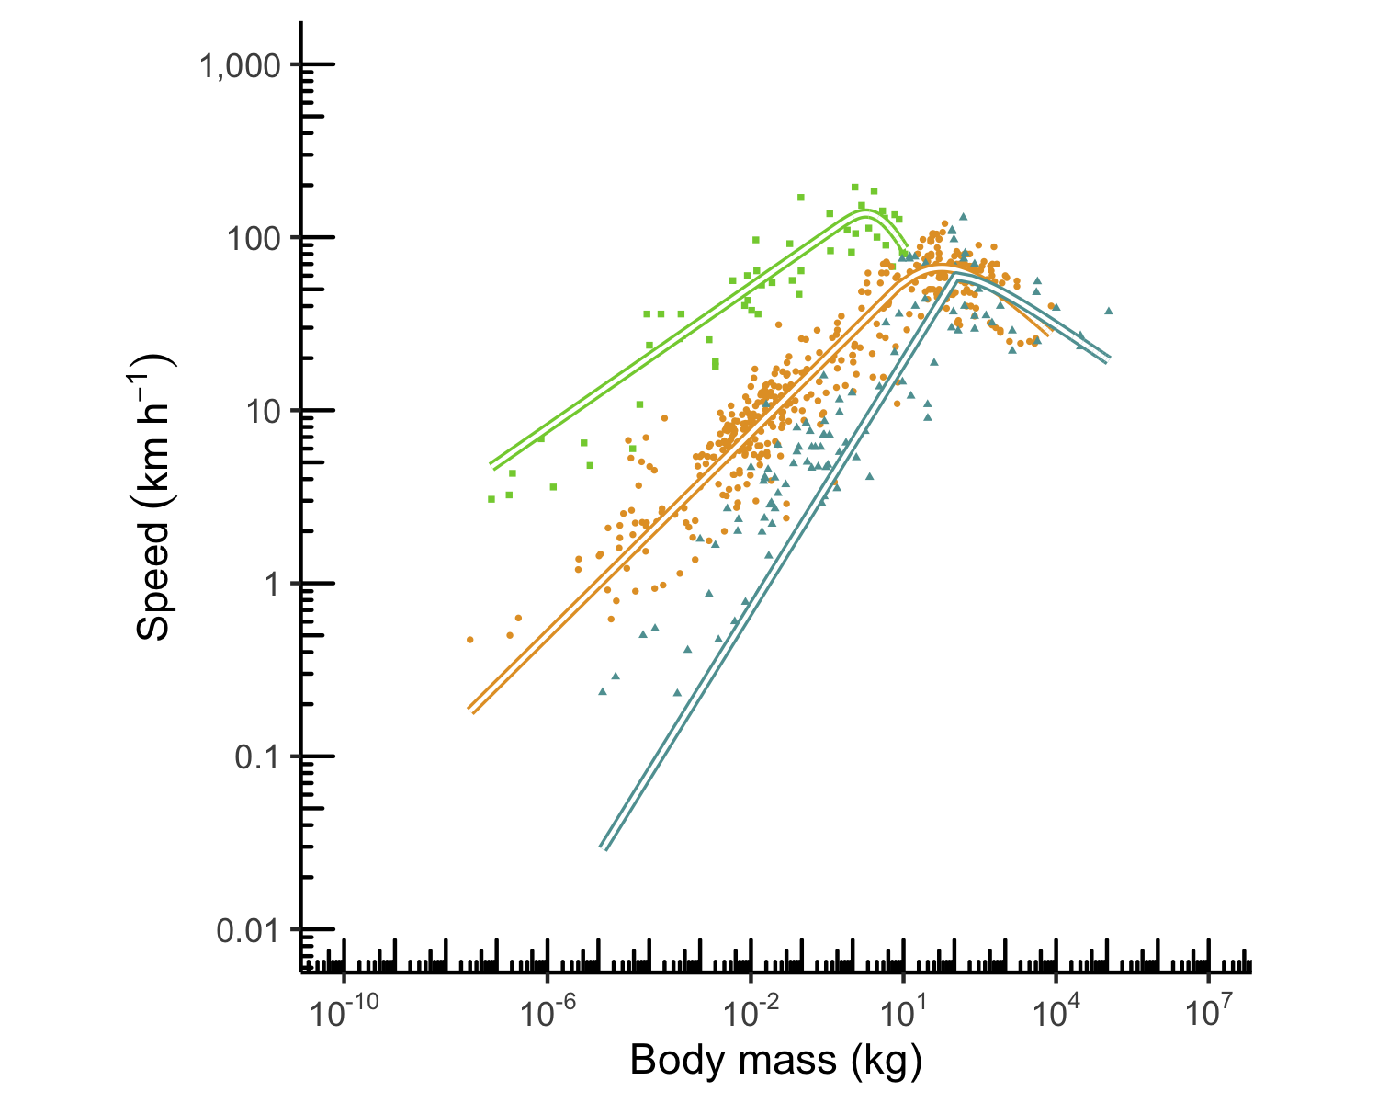

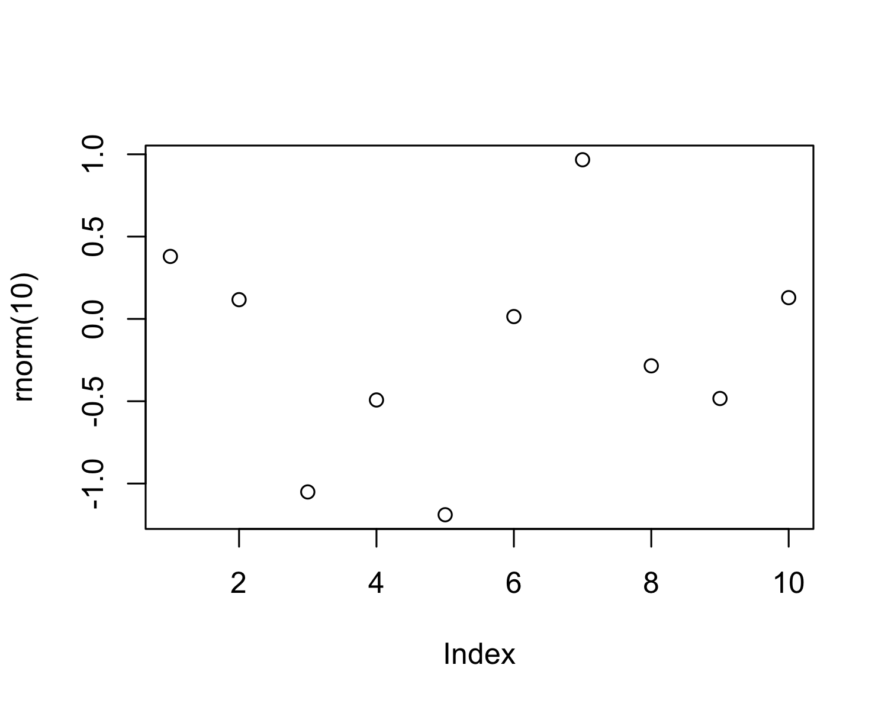

Figure 4.1: A plot of random numbers

Figure 4.1 shows how we can have a caption and cross-reference for a plot

Here is an example of inline code 3.14 in the middle of a sentence.

# 5 Discussion

# 6 Conclusion

# 7 Acknowledgements

# 8 References

1. Hirt, M. R., Jetz, W., Rall, B. C. & Brose, U. A general scaling law reveals why the largest animals are not the fastest. *Nature Ecology & Evolution* **1**, 1116–1122 (2017).

### 8.0.1 Colophon

This report was generated on 2021-11-30 11:38:11 using the following computational environment and dependencies:

#> ─ Session info ───────────────────────────────────────────────────────────────  
#> setting value   
#> version R version 4.0.4 (2021-02-15)  
#> os macOS Big Sur 10.16   
#> system x86_64, darwin17.0   
#> ui X11   
#> language (EN)   
#> collate en_US.UTF-8   
#> ctype en_US.UTF-8   
#> tz America/Los_Angeles   
#> date 2021-11-30   
#>   
#> ─ Packages ───────────────────────────────────────────────────────────────────  
#> package * version date lib source   
#> assertthat 0.2.1 2019-03-21 [1] CRAN (R 4.0.2)  
#> bookdown 0.24 2021-09-02 [1] CRAN (R 4.0.2)  
#> cachem 1.0.4 2021-02-13 [1] CRAN (R 4.0.2)  
#> callr 3.7.0 2021-04-20 [1] CRAN (R 4.0.2)  
#> cli 3.0.1 2021-07-17 [1] CRAN (R 4.0.2)  
#> colorspace 2.0-0 2020-11-11 [1] CRAN (R 4.0.2)  
#> crayon 1.4.1 2021-02-08 [1] CRAN (R 4.0.2)  
#> DBI 1.1.1 2021-01-15 [1] CRAN (R 4.0.2)  
#> desc 1.4.0 2021-09-28 [1] CRAN (R 4.0.2)  
#> devtools 2.4.2 2021-06-07 [1] CRAN (R 4.0.2)  
#> digest 0.6.27 2020-10-24 [1] CRAN (R 4.0.2)  
#> dplyr * 1.0.7 2021-06-18 [1] CRAN (R 4.0.2)  
#> ellipsis 0.3.2 2021-04-29 [1] CRAN (R 4.0.2)  
#> evaluate 0.14 2019-05-28 [1] CRAN (R 4.0.1)  
#> fansi 0.4.2 2021-01-15 [1] CRAN (R 4.0.2)  
#> farver 2.1.0 2021-02-28 [1] CRAN (R 4.0.2)  
#> fastmap 1.1.0 2021-01-25 [1] CRAN (R 4.0.2)  
#> fs 1.5.0 2020-07-31 [1] CRAN (R 4.0.2)  
#> generics 0.1.0 2020-10-31 [1] CRAN (R 4.0.2)  
#> ggplot2 * 3.3.3 2020-12-30 [1] CRAN (R 4.0.2)  
#> glue 1.4.2 2020-08-27 [1] CRAN (R 4.0.2)  
#> gtable 0.3.0 2019-03-25 [1] CRAN (R 4.0.2)  
#> highr 0.8 2019-03-20 [1] CRAN (R 4.0.2)  
#> htmltools 0.5.1.1 2021-01-22 [1] CRAN (R 4.0.2)  
#> knitr 1.31 2021-01-27 [1] CRAN (R 4.0.2)  
#> lifecycle 1.0.0 2021-02-15 [1] CRAN (R 4.0.2)  
#> magrittr 2.0.1 2020-11-17 [1] CRAN (R 4.0.2)  
#> maxspeed * 0.0.0.9000 2021-11-30 [1] local   
#> memoise 2.0.0 2021-01-26 [1] CRAN (R 4.0.2)  
#> munsell 0.5.0 2018-06-12 [1] CRAN (R 4.0.2)  
#> pillar 1.6.1 2021-05-16 [1] CRAN (R 4.0.2)  
#> pkgbuild 1.2.0 2020-12-15 [1] CRAN (R 4.0.2)  
#> pkgconfig 2.0.3 2019-09-22 [1] CRAN (R 4.0.2)  
#> pkgload 1.2.1 2021-04-06 [1] CRAN (R 4.0.2)  
#> prettyunits 1.1.1 2020-01-24 [1] CRAN (R 4.0.2)  
#> processx 3.5.2 2021-04-30 [1] CRAN (R 4.0.2)  
#> ps 1.5.0 2020-12-05 [1] CRAN (R 4.0.2)  
#> purrr 0.3.4 2020-04-17 [1] CRAN (R 4.0.2)  
#> R6 2.5.0 2020-10-28 [1] CRAN (R 4.0.2)  
#> remotes 2.4.0 2021-06-02 [1] CRAN (R 4.0.2)  
#> rlang 0.4.10 2020-12-30 [1] CRAN (R 4.0.2)  
#> rmarkdown 2.11 2021-09-14 [1] CRAN (R 4.0.2)  
#> rprojroot 2.0.2 2020-11-15 [1] CRAN (R 4.0.2)  
#> rstudioapi 0.13 2020-11-12 [1] CRAN (R 4.0.2)  
#> scales 1.1.1 2020-05-11 [1] CRAN (R 4.0.2)  
#> sessioninfo 1.1.1 2018-11-05 [1] CRAN (R 4.0.2)  
#> stringi 1.5.3 2020-09-09 [1] CRAN (R 4.0.2)  
#> stringr 1.4.0 2019-02-10 [1] CRAN (R 4.0.2)  
#> testthat 3.0.2 2021-02-14 [1] CRAN (R 4.0.2)  
#> tibble 3.1.0 2021-02-25 [1] CRAN (R 4.0.4)  
#> tidyselect 1.1.0 2020-05-11 [1] CRAN (R 4.0.2)  
#> usethis 2.1.3 2021-10-27 [1] CRAN (R 4.0.2)  
#> utf8 1.2.1 2021-03-12 [1] CRAN (R 4.0.2)  
#> vctrs 0.3.8 2021-04-29 [1] CRAN (R 4.0.2)  
#> withr 2.4.1 2021-01-26 [1] CRAN (R 4.0.2)  
#> xfun 0.28 2021-11-04 [1] CRAN (R 4.0.2)  
#> yaml 2.2.1 2020-02-01 [1] CRAN (R 4.0.2)  
#>   
#> [1] /Library/Frameworks/R.framework/Versions/4.0/Resources/library

The current Git commit details are:

#> Local: master /Users/seba/Dropbox/Stanford/Classes/Just Enough Software Engineering/maxspeed  
#> Remote: master @ origin (https://github.com/sebatoroarana/maxspeed.git)  
#> Head: [134583a] 2021-11-30: Create a figure