**Continuity equation:**

|  |  |
| --- | --- |
| $$\frac{∂H}{∂t}$$ | $$=-\frac{1}{W_{s}}\left(\frac{∂\overline{F}}{∂x}\right)+b_{a}$$ |
|  | $$=-\frac{1}{W_{s}}\left(\frac{∂\left(-D\frac{∂h}{∂x}\right)}{∂x}\right)+b_{a}$$ |
|  | $$=-\frac{1}{W_{b}+µH}\left[\frac{∂}{∂x}\left(\left[{(W}_{0}+\frac{1}{2}µH) *{\left(ρ_{i}gH\right)}^{3}*\left(f_{d}H^{2}+f_{s}\right)*{\left(\frac{∂h}{∂x}\right)}^{2}\right]*\frac{∂h}{∂x}\right)\right]+b_{a}$$ |
|  |  |

$H$ ice thickness (m), $t$ time (y), $W_{s}$ surface width (m), $x$ distance along flow line (m), $\overline{F}$ ice volume flux (m^3 y^-1), $b_{a}$ local annual surface mass balance (m i.e. y^-1), $D$ diffusivity (m^3 y^-1), $h$ surface elevation (m), $W_{b}$ width of the bed (m), $µ$ factor for the slope of the valley walls, $ρ_{i}$ ice density (kg m^-3), $f_{d}$ flow factor for internal deformation (Pa^-3 y^-1), $f_{s}$ flow factor for basal sliding (Pa^-3 m^2 y^-1).

The surface width $W_{s}$ is then:

$$W_{s}=W_{b}+μH$$

The parameterization of the valley geometry, as will be used in the model, is illustrated below through a lateral profile in the middle section of the glacier:

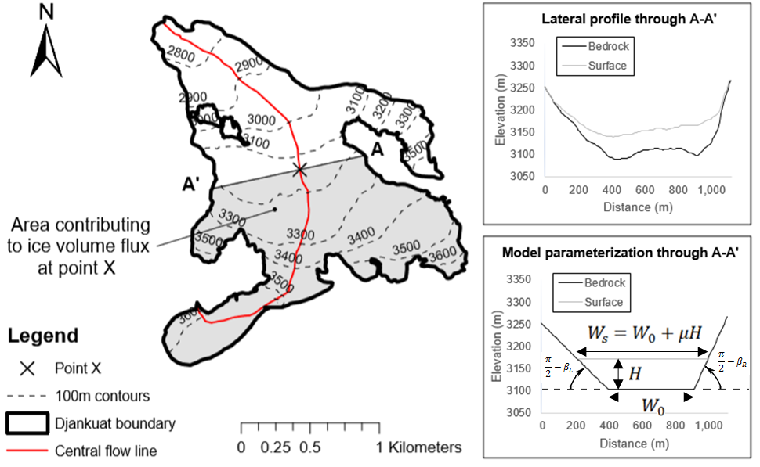

**Vertically averaged horizontal velocity:**

$$\overline{u}={\overline{u}}_{d}+u_{s}={\left({-ρ}_{i}gH\frac{∂h}{∂x}\right)}^{3}*\left(f_{d}H+\frac{f_{s}}{H}\right)$$

**Surface velocity:**

$$u_{sfc}= \frac{5*{\overline{u}}_{d}}{4}+u_{s}$$