**EF Core Relationships in ASP .NET Core 3.1**

By Shahed C on February 3, 2020

[5 Replies](https://wakeupandcode.com/ef-core-relationships-in-asp-net-core-3-1/#comments)



This is the fifth of a new [series of posts](https://wakeupandcode.com/aspnetcore/#aspnetcore2020) on ASP .NET Core 3.1 for 2020. In this series, we’ll cover 26 topics over a span of 26 weeks from January through June 2020, titled **ASP .NET Core A-Z!** To differentiate from the [2019 series](https://wakeupandcode.com/aspnetcore/#aspnetcore2019), the 2020 series will mostly focus on a growing single codebase ([NetLearner!](https://wakeupandcode.com/netlearner-on-asp-net-core-3-1/)) instead of new unrelated code snippets week.

Previous post:

* [Deploying ASP .NET Core 3.1 to Azure App Service](https://wakeupandcode.com/deploying-asp-net-core-3-1-to-azure-app-service/)

**NetLearner on GitHub**:

* Repository: <https://github.com/shahedc/NetLearnerApp>
* v0.5-alpha release: <https://github.com/shahedc/NetLearnerApp/releases/tag/v0.5-alpha>

**In this Article:**

* E is for EF Core Relationships
* Classes and Relationships
* One to One
* One to Many
* Many to Many
* References

**E is for EF Core Relationships**

In my [2018 series](https://wakeupandcode.com/aspnetcore/#aspnetcore2018), we covered [EF Core Migrations](https://wakeupandcode.com/ef-core-migrations-in-asp-net-core/) to explain how to add, remove and apply Entity Framework Core Migrations in an ASP .NET Core web application project. In this article, we’ll continue to look at the newer 2020 [NetLearner](https://wakeupandcode.com/netlearner-on-asp-net-core-3-1/) project, to identify entities represented by C# model classes and the relationships between them.

* NetLearner on GitHub: <https://github.com/shahedc/NetLearnerApp>

**NOTE:** Please note that NetLearner is a work in progress as of this writing, so its code is subject to change. The UI web apps still needs work (and will be updated at a later date) but the current version has the following models with the relationships shown below:

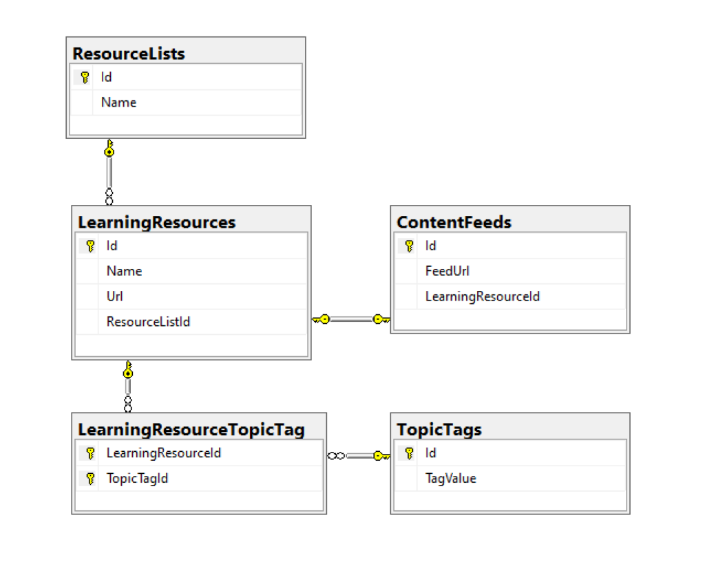 NetLearner database diagram

**Classes and Relationships**

The heart of the application is the [LearningResource](https://github.com/shahedc/NetLearnerApp/blob/main/src/NetLearner.SharedLib/Models/LearningResource.cs) class. This represents any online learning resource, such as a blog post, single video, podcast episode, ebook, etc that can be accessed with a unique URL.

public class LearningResource  
{  
 public int Id { get; set; }  
  
 [DisplayName("Resource")]  
 public string Name { get; set; }  
  
  
 [DisplayName("URL")]  
 [DataType(DataType.Url)]  
 public string Url { get; set; }  
  
 public int ResourceListId { get; set; }  
 [DisplayName("In List")]  
 public ResourceList ResourceList { get; set; }  
  
 public ContentFeed ContentFeed { get; set; }  
  
 public List<LearningResourceTopicTag> LearningResourceTopicTags { get; set; }  
}

The **ContentFeed** class represents the RSS Feed (or channel information) for an online resource, a URL that can be used to retrieve more information about the online resource, if available.

public class ContentFeed  
{  
 public int Id { get; set; }  
  
 [DisplayName("Feed URL")]  
 public string FeedUrl { get; set; }  
  
 public int LearningResourceId { get; set; }  
 public LearningResource LearningResource { get; set; }  
}

The [ResourceList](https://github.com/shahedc/NetLearnerApp/blob/main/src/NetLearner.SharedLib/Models/ResourceList.cs) class represents a logical container for learning resources in the system. It is literally a list of items, where the items are your learning resources.

public class ResourceList  
{  
 public int Id { get; set; }  
  
 public string Name { get; set; }  
  
 public List<LearningResource> LearningResources { get; set; }  
}

The TopicTag class represents a single “tag” value that can be used to categorize online resources. Possibly values could be “.NET Core”, “ASP.NET Core” and so on.

public class TopicTag  
{  
 public int Id { get; set; }  
  
 [DisplayName("Tag")]  
 public string TagValue { get; set; }  
  
 public List<LearningResourceTopicTag> LearningResourceTopicTags { get; set; }  
}

At this point, you may have noticed both the **LearningResource** and **TopicTag** classes contain a List<T> property of **LearningResourceTopicTag**. If you browse the database diagram, you will notice that this table appears as a connection between the two aforementioned tables, to establish a many-to-many relationship. (more on this later)

The following diagram shows an example of how the a **LearningResource** (e.g. link to a doc/video) is a part of a **ResourceList**, while each **LearningResource** also has a link back to its root site, channel or RSS feed (via **ContentFeed**).

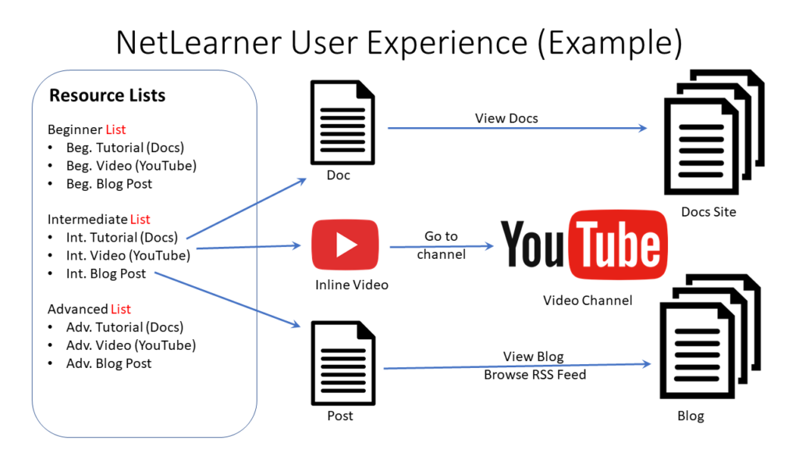

**One to One**

Having looked through the above entities and relationships, we can see that each **LearningResource** has a **ContentFeed**. This is an example of a 1-to-1 relationship. For example:

* Learning Resource = Wake Up and Code! blog site
* Content Feed = RSS Feed for blog site

In the two classes, we see the following code:

public class LearningResource{ public int Id { get; set; } [DisplayName("Resource")] public string Name { get; set; } [DisplayName("URL")] [DataType(DataType.Url)] public string Url { get; set; } public int ResourceListId { get; set; } [DisplayName("In List")] public ResourceList ResourceList { get; set; } public ContentFeed ContentFeed { get; set; } public List<LearningResourceTopicTag> LearningResourceTopicTags { get; set; }} public class ContentFeed{ public int Id { get; set; } [DisplayName("Feed URL")] public string FeedUrl { get; set; } public int LearningResourceId { get; set; } public LearningResource LearningResource { get; set; }}

Each Learning Resource has a corresponding Content Feed, so the **LearningResource** class has a property for **ContentFeed**. That’s pretty simple. But in the  **ContentFeed** class, you don’t necessarily need a property pointing back to the  **LearningResource** . In fact, all you need is a  **LearningResourceId**  property. EF Core will ensure that **LearningResource**.**Id** points to **ContentFeed**.**LearningResourceId** in the database. But to help with object-property navigation in your code, it is useful to include an actual **LearningResource** object in the **ContentFeed** class to point back to **LearningResource**.

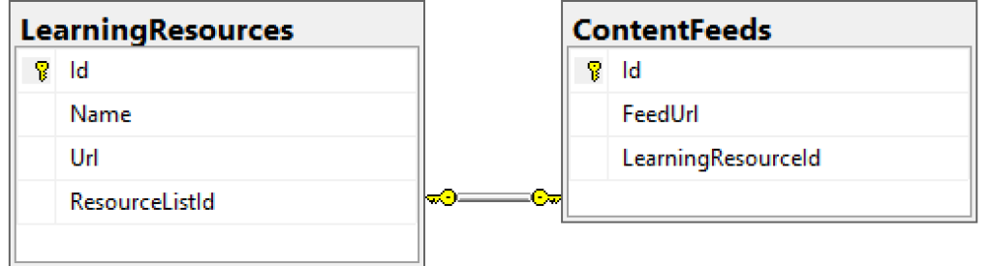One to One Relationship

Another way of looking at the One-to-One relationship is to view the constraints of each database entity in the visuals below. Note that both tables have an Id field that is a Primary Key (inferred by EF Core) while the **ContentFeeds** table also has a Foreign Key for the **LearningResourceId** field used for the constraint in the relationship.

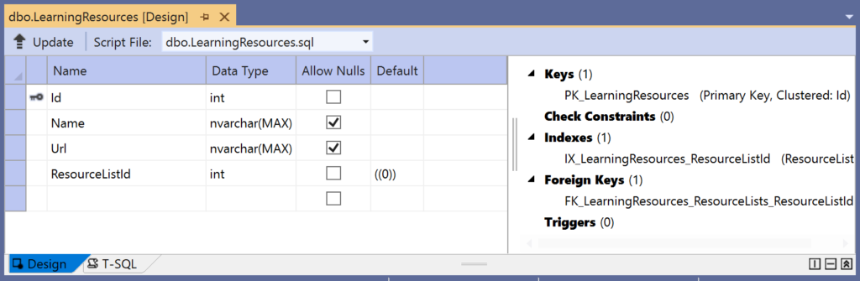LearningResources table 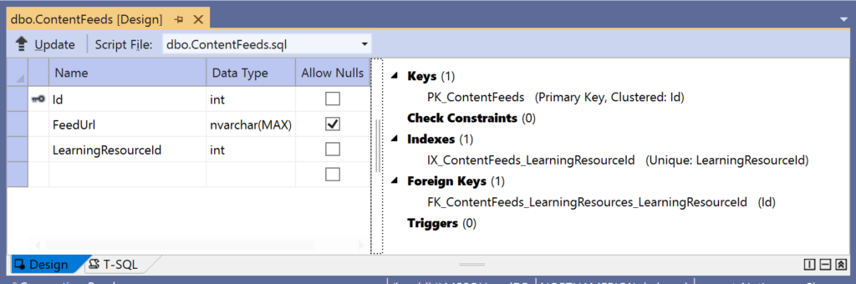ContentFeeds table 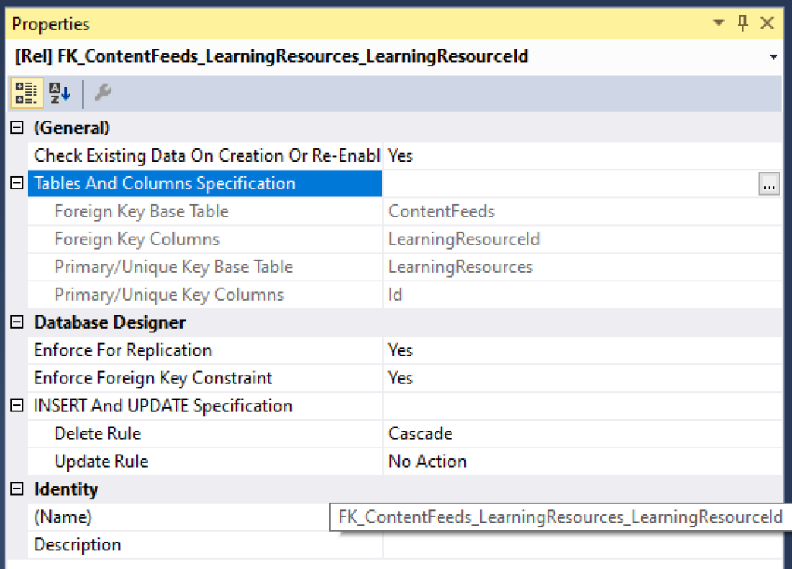One to One Relationship

**One to Many**

Next, let’s take a look at the One-to-Many relationship for each **ResourceList** that has zero or more **LearningResource**s. For example:

* Resource List = ASP .NET Core Blogs (parent container)
* Learning Resource = ASP .NET Core A-Z Blog Series (single URL)

In the two classes, we see the following code:

public class ResourceList{ public int Id { get; set; } public string Name { get; set; } public List<LearningResource> LearningResources { get; set; }} public class LearningResource{ public int Id { get; set; } [DisplayName("Resource")] public string Name { get; set; } [DisplayName("URL")] [DataType(DataType.Url)] public string Url { get; set; } public int ResourceListId { get; set; } [DisplayName("In List")] public ResourceList ResourceList { get; set; } public ContentFeed ContentFeed { get; set; } public List<LearningResourceTopicTag> LearningResourceTopicTags { get; set; }}

Each Resource List has zero or more Learning Resources, so the **ResourceList** class has a List<T> property for **LearningResources**. This is even simpler than the previously described 1-to-1 relationship. In the **LearningResource** class, you don’t necessarily need a property pointing back to the **ResourceList**. But once again, to help with object-property navigation in your code, it is useful to include an actual **ResourceList**  object in the **LearningResource** class to point back to **ResourceList**.

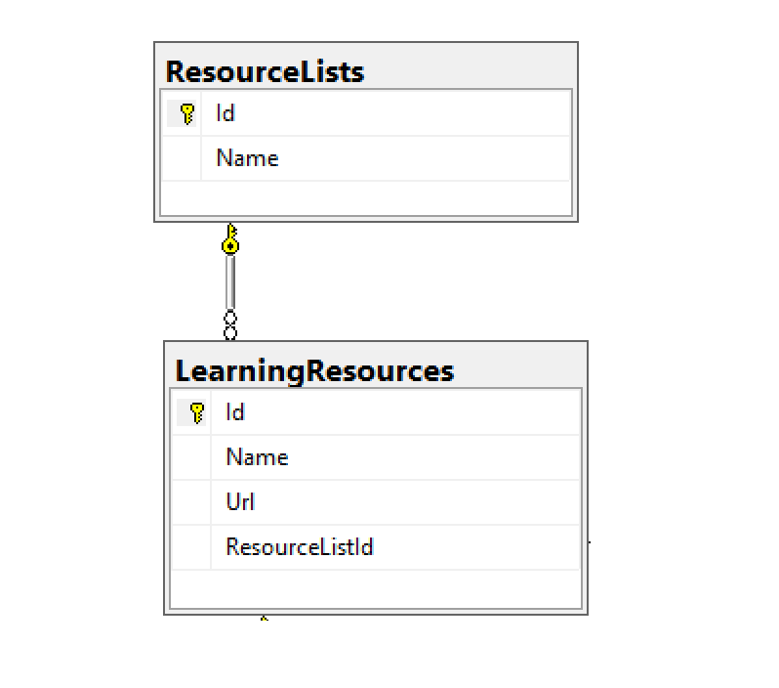One to Many Relationship

Another way of looking at the *One-to-Many* relationship is to view the constraints of each database entity in the visuals below. Note that both tables have an Id field that is a Primary Key (once again, inferred by EF Core) while the **ResourceLists**table also has a Foreign Key for the  **ResourceListsId** field used for the constraint in the relationship.

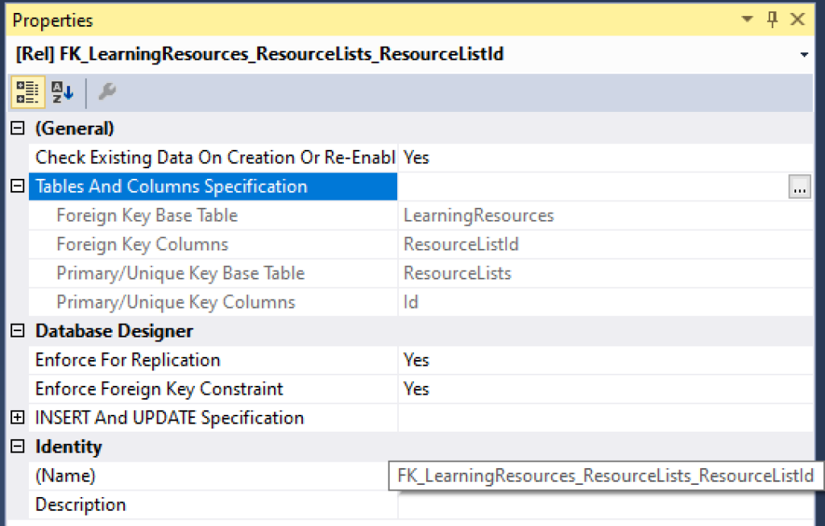One to Many Constraint

**Many to Many**

Finally, let’s also take a look at a Many-to-Many relationship, for each **TopicTag**and **LearningResource,**either of which can have many of the other. For example:

* Topic Tag = “ASP .NET Core” (tag as a text description)
* Learning Resource = Specific blog post on site (single URL)

This relationship is a little more complicated than all of the above, as we will need a “join table” to connect the two tables in question. Not only that, we will have to describe the entity in the C# code with connections to both tables we would like to connect with this relationship.

In the two classes we would like to connect, we see the following code:

public class TopicTag  
{  
 public int Id { get; set; }  
  
 [DisplayName("Tag")]  
 public string TagValue { get; set; }  
  
 public List<LearningResourceTopicTag> LearningResourceTopicTags { get; set; }  
} public class LearningResource{ public int Id { get; set; } [DisplayName("Resource")] public string Name { get; set; } [DisplayName("URL")] [DataType(DataType.Url)] public string Url { get; set; } public int ResourceListId { get; set; } [DisplayName("In List")] public ResourceList ResourceList { get; set; } public ContentFeed ContentFeed { get; set; } public List<LearningResourceTopicTag> LearningResourceTopicTags { get; set; }}

Next, we have the [LearningResourceTopicTag](https://github.com/shahedc/NetLearnerApp/blob/main/src/NetLearner.SharedLib/Models/LearningResourceTopicTag.cs) class as a “join entity” to connect the above:

public class LearningResourceTopicTag  
{  
 public int LearningResourceId { get; set; }  
 public LearningResource LearningResource { get; set; }  
  
 public int TopicTagId { get; set; }  
 public TopicTag TopicTag { get; set; }  
  
}

This special class has the following properties:

* **LearningResourceId**: integer value, pointing back to LearningResource.Id
* **LearningResource**: optional “navigation” property, reference back to connected LearningResource entity
* **TopicTagId**: integer value, pointing back to TopicTag.Id
* **TopicTag**:  optional “navigation” property, reference back to connected **TopicTag** entity

To learn more about navigation properties, check out the official docs at:

* Relationships – EF Core: <https://docs.microsoft.com/en-us/ef/core/modeling/relationships>

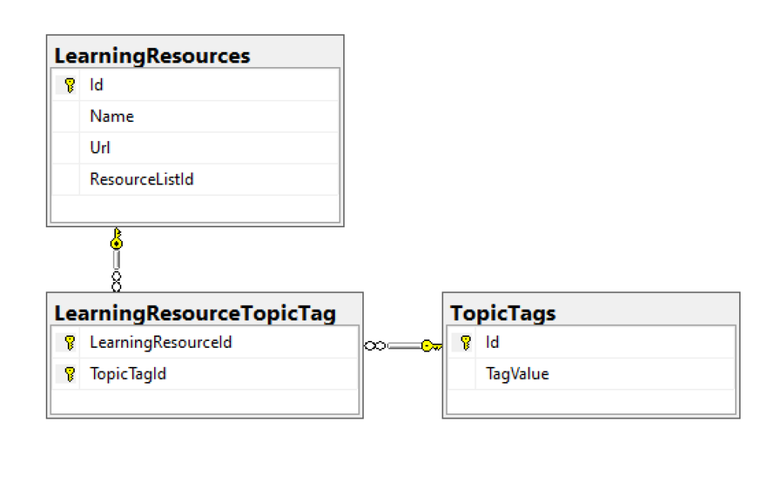Many to Many Relationship

Another way of looking at the Many*-to-Many* relationship is to view the constraints of each database entity in the visuals below. Note that the two connected tables both have an Id field that is a Primary Key (yes, inferred by EF Core!) while the **LearningResourceTopicTag**table has a *Composite Key* for the **TopicTagId** *and* **LearningResourceId**fields used for the constraints in the relationship.

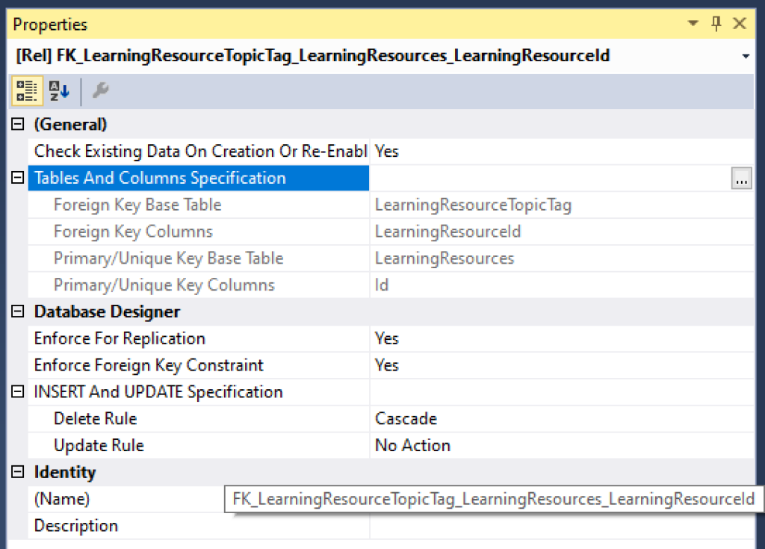Constraints for LearningResources 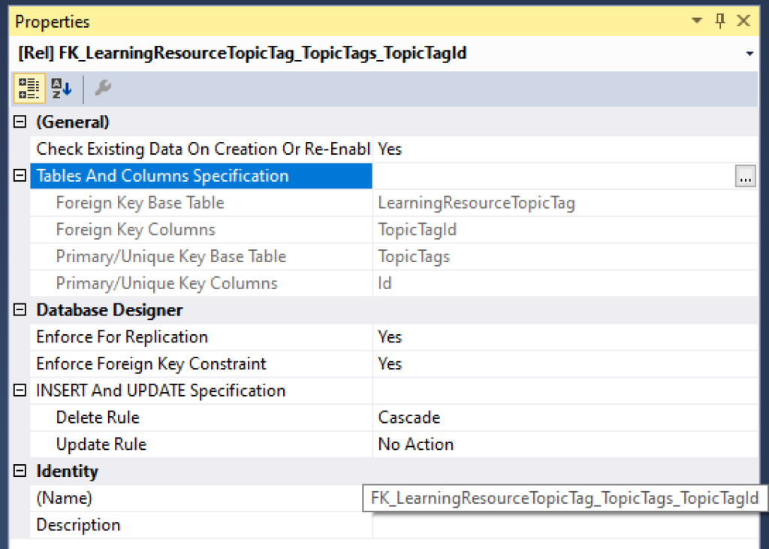 Constraints for TopicTags

The composite key is described in the **LibDbContext** class inside the **OnModelCreating**() method:

public class LibDbContext : IdentityDbContext  
{  
 ...  
 protected override void OnModelCreating(ModelBuilder modelBuilder)  
 {  
 ...  
 modelBuilder.Entity<LearningResourceTopicTag>()  
 .HasKey(lrtt => new { lrtt.LearningResourceId, lrtt.TopicTagId });  
 }  
}

Here, the [HasKey() method](https://docs.microsoft.com/en-us/ef/core/modeling/keys#fluent-api) informs EF Core that the entity **LearningResourceTopicTag** has a composite key defined by both **LearningResourceId** and **TopicTagId**.

**References**

For more information, check out the list of references below.

* Relationships – EF Core: <https://docs.microsoft.com/en-us/ef/core/modeling/relationships>
* Keys – EF Core: <https://docs.microsoft.com/en-us/ef/core/modeling/keys>
* Introduction to Relationships: <https://www.learnentityframeworkcore.com/relationships>
* Julie Lerman on Pluralsight: <https://app.pluralsight.com/profile/author/julie-lerman>
* 3.1 Getting Started:  <https://www.pluralsight.com/courses/getting-started-entity-framework-core>
* (For reference) 2.0 Mappings:  <https://www.pluralsight.com/courses/e-f-core-2-beyond-the-basics-mappings>

For detailed tutorials that include both Razor Pages and MVC, check out the official tutorials below:

* New database – EF Core: <https://docs.microsoft.com/en-us/ef/core/get-started/aspnetcore/new-db?tabs=visual-studio>
* Existing Database – EF Core: <https://docs.microsoft.com/en-us/ef/core/get-started/aspnetcore/existing-db>
* ASP.NET Core MVC with EF Core: <https://docs.microsoft.com/en-us/aspnet/core/data/ef-mvc>
* ASP.NET Core Razor Pages with EF Core: <https://docs.microsoft.com/en-us/aspnet/core/data/ef-rp>