Short-term impacts of island restoration on seabirds in Gwaii Haanas (Feb. 07 update)

## Spatial and temporal coverage

Task 2a) Describe seabird and songbird data coverage in space and time with appropriate plots 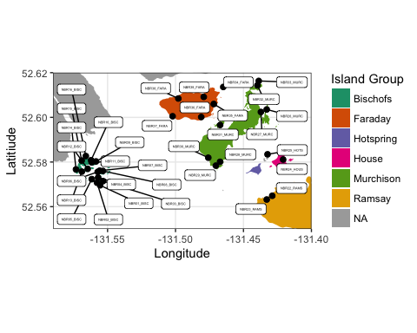

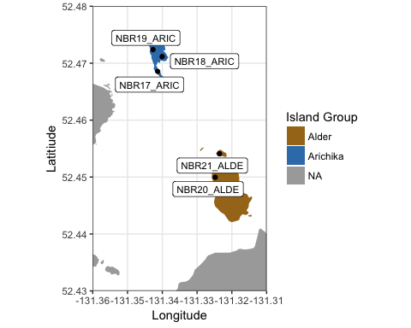

Figure 2: Location of ARUs and island groups within southern part of study area.

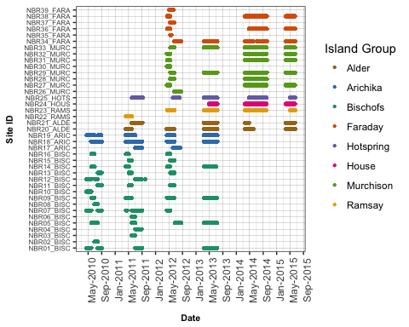

Figure 3: Temporal coverage by ARUs at sites, 2010-2015. Color indicates island. Note that Bischofs, Arichika, Faraday and Murchison were impact islands.

# Vocalization rates

Task 2c) Describe the annual and nightly variation in seabird vocalization (proportion of recordings with presence, and proportion of recordings with presence of multiple individuals), by species (appropriate figures such as box plots).

## Methods

Acoustic Recording Units (ARUs) were located at sites to target breeding habitat of certain species. Some sites had no or very few detections of certain species. For visulaization of nightly and seasonal vocalization rates for each species, we excluded from analyses any sites deemed to have a low amount of vocalization activity, which was defined as less than 50 detections. This approach was taken rather than relying on a priori understanding of habitat. For Ancient Murrelets, Cassin's Auklets, Fork-Tailed Storm-Petrels, and Leach's Storm-Petrels: 9, 11, 11 and 7 sites had 50 or more detections, respectively. For visualization of nightly vocalization rates, we calculated: (1) proportion of recordings with detection of at least one individual in each 10-minute recording period; and (2) proportion of recordings with detection of at least two individuals in each recording period. Proportions were calculated separately for each site. For visualization of seasonal vocalization rates, we calculated: (1) proportion of recordings with detection of one or more individuals in each week-long period; and (2) proportion of recordings with detection of two or more individuals in each week-long period. Proportions were calculated separately for each site. Separate plots were provided for all years combined, and for each year individually to assess whether seasonal vocalization rates shifted between years.

## Results

### Nightly Vocalization Rates

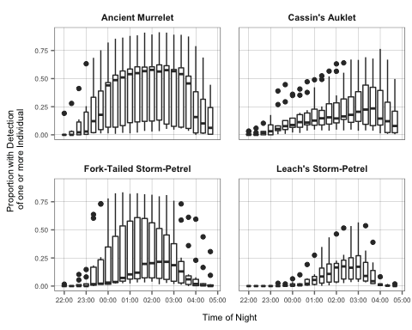

Figure 4: Nightly vocalization rates by species. Each boxplot summarizes proportion of recordings with detection of one or more individuals.

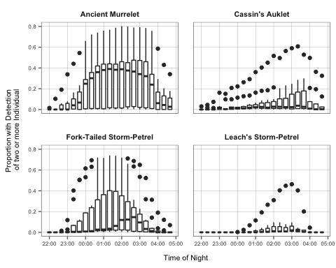

Figure 5: Nightly vocalization rates by species. Each boxplot summarizes proportion of recordings with detection of two or more individuals.

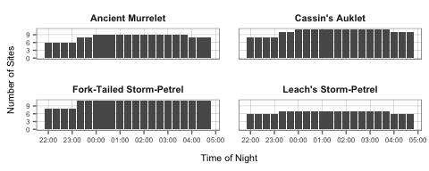

Figure 6: Number of sites in each 10-minute recording period.

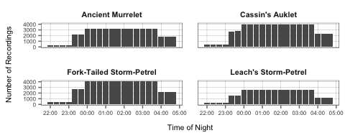

Figure 7: Number of recordings in each 10-minute recording period.

### Annual vocalization rates, all years combined

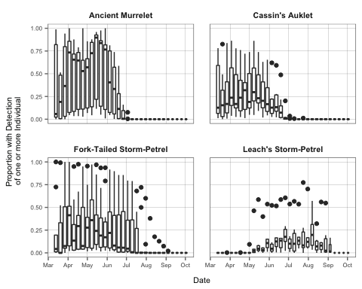

Figure 8: Annual vocalization rates by species, all years combined. Each boxplot summarizes proportion of recordings with detection of one or more individuals at each site.

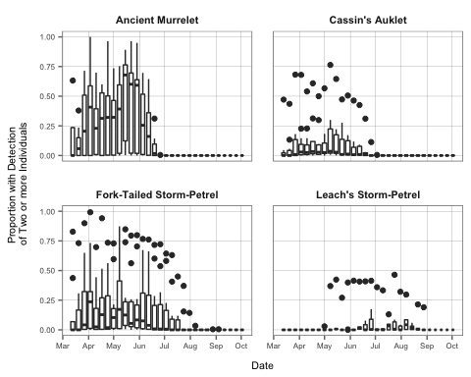

Figure 9: Annual vocalization rates by species, all years combined. Each boxplot summarizes proportion of recordings with detection of two or more individuals at each site.

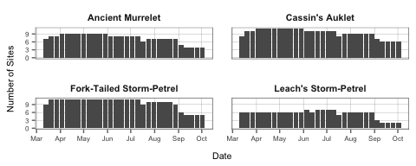

Figure 10: Number of sites in each week.

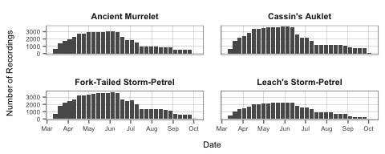

Figure 11: Number of recordings in each week.

### Annual vocalization rates by year

#### Ancient Murrelet

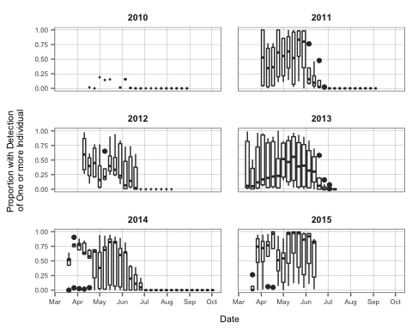

Figure 12: Annual vocalization rates of Ancient Murrelet, 2010-2015. Boxplots summarize proportion of recordings with detection of one or more individuals.

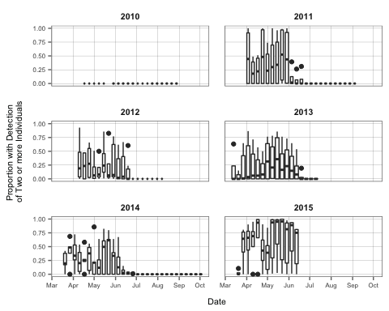

Figure 13: Annual vocalization rates of Ancient Murrelet, 2010-2015. Boxplots summarize proportion of recordings with detection of two or more individuals.

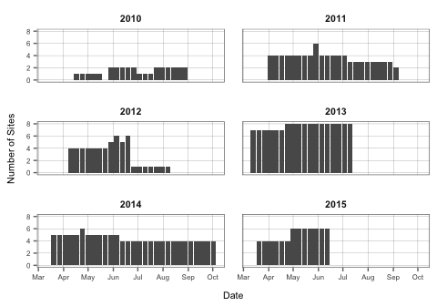

Figure 14: Ancient Murrelet annual vocalization rates. Number of sites in each week.

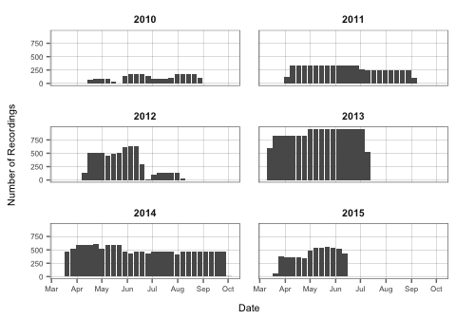 # #### Cassin's Auklet 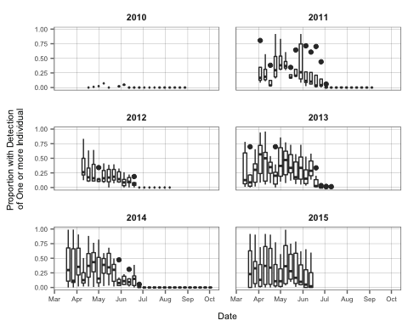

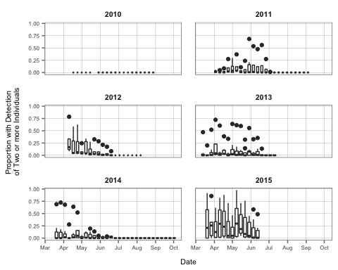

Figure 17: Annual vocalization rates of Cassin's Auklet, 2010-2015. Boxplots summarize proportion of recordings with detection of two or more individuals.

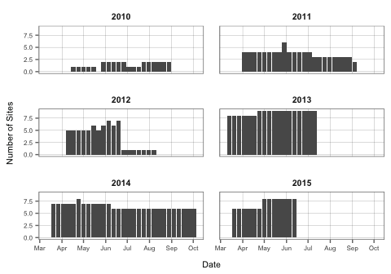

Figure 18: Cassin's Auklet annual vocalization rates. Number of sites in each week.

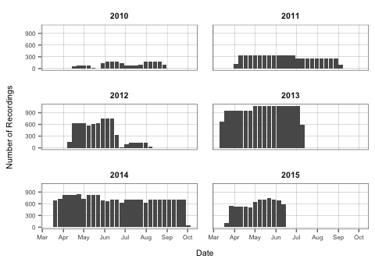

Figure 19: Cassin's Auklet annual vocalization rates.Number of recordings in each week.

#### Fork-Tailed Storm-Petrel

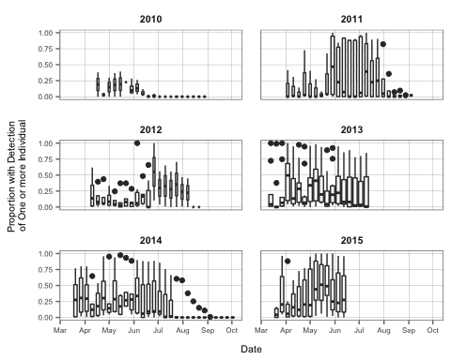

Figure 20: Annual vocalization rates of Fork-Tailed Storm-Petrel, 2010-2015. Boxplots summarize proportion of recordings with detection of one or more individuals.

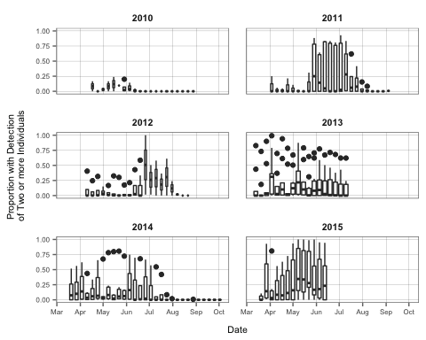

Figure 21: Annual vocalization rates of Fork-Tailed Storm-Petrel, 2010-2015. Boxplots summarize proportion of recordings with detection of two or more individuals.

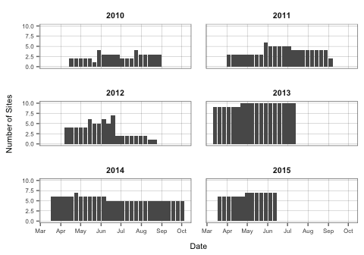

Figure 22: Annual vocalization rates of Fork-tailed Storm-Petrel. Number of sites in each week.

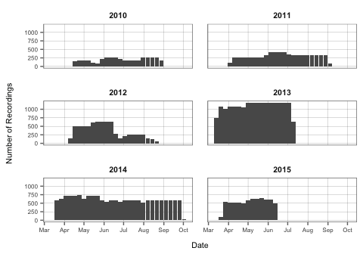

Figure 23: Annual vocalization rates of Fork-tailed Storm-Petrel. Number of recordings in each week.

#### Leach's Storm-Petrel

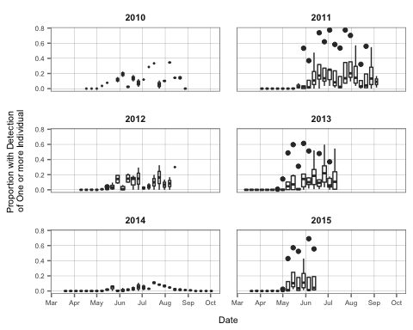

Figure 24: Annual vocalization rates of Leach's Storm-Petrel, 2010-2015. Boxplots summarize proportion of recordings with detection of one or more individuals.

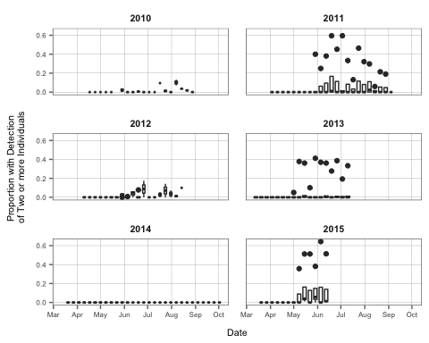

Figure 25: Annual vocalization rates of Leach's Storm-Petrel, 2010-2015. Boxplots summarize proportion of recordings with detection of two or more individuals.

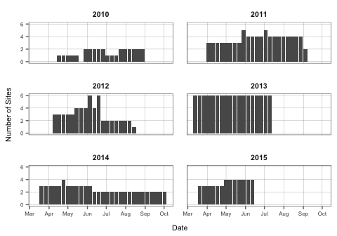

Figure 26: Annual vocalization rates of Leach's Storm-Petrel. Number of sites in each week.

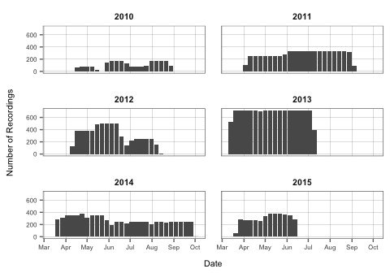

Figure 27: Annual vocalization rates of Leach's Storm-Petrel. Number of recordings in each week.