An update to the global critical habitat screening layer: data processing

1 Important Marine Mammal Sites (IMMAs)
- Number of records: 159
- Area: 14,150,666 km²
- Original CRS: WGS 84
- Data type: Polygon

1.1 IMMAs under criterion A
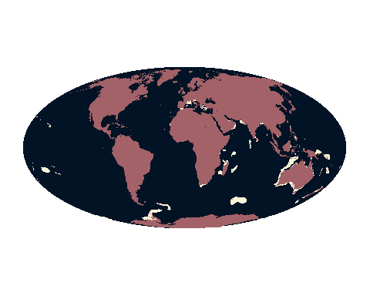
- Number of records: 130
- Area: 8,327,285 km²
- Critical habitat type: Potential
- IFC PS6 criteria triggered: C1 (Critically Endangered and Endangered Species)

How the data are filtered
- Sites designated under IMMA Criterion A (Species or Population Vulnerability)

2 Ramsar sites
- Records without “Proposed” or “Not Reported” as Status.
- Records labelled as “Ramsar Site, Wetland of International Importance”, with Designation Type “International”.
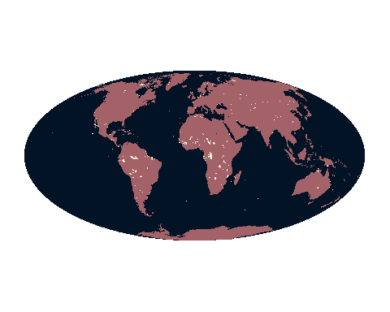

2.1 Ramsar sites under criterion II

How the data are filtered
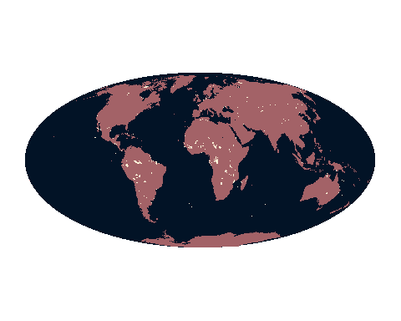

2.2 Cold seeps
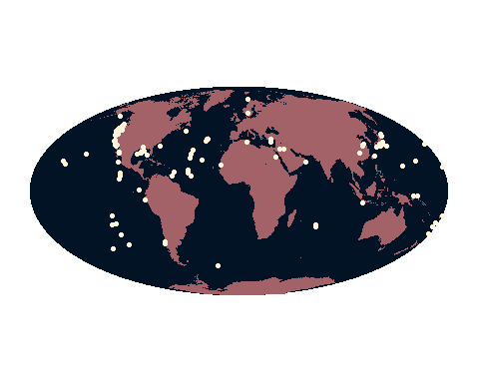

3 Tropical moist forest
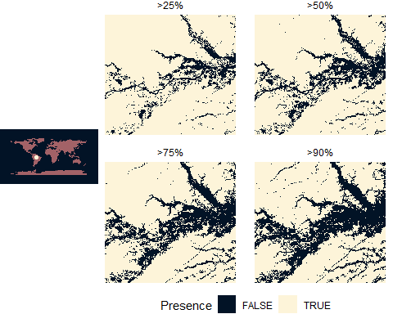
Sensitivity analysis of % presence cutoff values.
