Individual Project – VR Applications in Ophthalmology



An Educational Virtual Reality Approach to Raising Awareness of Digital Eye Strain (Computer Vision Syndrome)

30077548@students.southwales.ac.uk
Sebastian Ha
30077548

Table of Contents
List of Acronyms 4
Abstract 5
Introduction 6
Project Aim 7
Objectives 7
Project Planning and Timeline 8
Risk Assessment 9
Ethical Considerations 9
Literature Review 10
Motivation 10
Existing Solutions/Techniques 10
Eyesi 10
OntoPhaco 10
ISVC 11
Opportunities for innovation 11
Related Domains 11
VR in medical education 11
VR in Health Awareness 12
Technical/Implementation Issues 12
Appendices 13
Ethics Checklist 13
Project Timeline Gantt Chart 16
Methodology 18
Prototype Implementation 18
Usability and Flow 18
Environment Design and Scene Setup 18
Objective System Implementation 18
Player Objective Feedback 18
Objective Based Interaction Objects 18
Post Processing Effects for Simulating Symptoms 18
Player Look Direction and Attention Detection 18
Asset Licenses and Sources 19
Modern Office Table 19
Free Studio Starter Pack 19
General Desktop Bundle 19
General Gaming Headset 20
General Gaming Chair 20
Light Switch 20
Materials for General PC setup 21
Monitor background image 22
Button Hover Sfx by Fachii 23
Button click Sfx by AndrewEathan 23
Light Switch On Sfx 24
Light Switch Off Sfx 24
References 25

List of Acronyms
Acronym | Meaning
DES | Digital Eye Strain
VR | Virtual Reality
CVS | Computer Vision Syndrome
AR | Augmented Reality

Abstract
Digital eye strain (DES) is an increasingly common issue caused from prolonged use of digital screens. Sheppard and Wolffsohn, (2018) discuss how the 2016 digital eye strain report found that approximately 65% of participants experienced symptoms of DES. Also known as Computer Vision Syndrome (CVS), symptoms include dry, red or tired eyes, double or blurred vision, headaches, general discomfort in the eyes, sensitivity to light, difficulty focusing on tasks and pain in areas such as the neck, shoulders, or back. Within the literature both terms are used, however for this report, the term DES will be used to avoid confusion.
This project aims to raise awareness of DES to promote healthier screen use habits by using Virtual Reality (VR) to develop an educational experience. The experience simulates the effects of eye strain to the user, with an interactive game to engage the user into learning techniques to prevent the effects of DES from happening while being tested on the knowledge they have gained. By mixing immersive learning and medical education the experience will raise awareness on the importance of eye health and encourage the use of healthy screen habits to prevent the risks associated with excessive screen time.

Introduction
As technology continues to advance, many everyday tasks and jobs now require screen use for several hours a day, if not more. Constant use has seen a rise in DES. Porcar et al., (2016) overviews how long periods of exposure can cause ocular and extraocular discomfort, visual complaints, eye strain or tired eyes, headaches and musculoskeletal problems. Groups most affected by DES are office workers, students, gamers and others that are exposed to screens for long periods of time.
Research conducted by Cantó-Sancho et al., (2023) where 238 office workers carried out a questionnaire on symptoms of DES they experienced during long periods of screen exposure. Results showed that screen use over 6 hours a day in the workplace significantly increased the chances of DES, with women being affected more compared to men. The findings highlight how prolonged screen use in a workplace is a growing concern for ocular health.
Although advice exists on how to reduce the possibilities of DES occurring, effective awareness that results in preventative measures remains low. Chandrasekhara et al., (2013) carried out research on college students to gather information on screen time, use of glasses, and preventative measures they took to reduce the symptoms. The results found that although 87% of university students were aware that prolonged use has negative effects on ocular health, almost 90% still experienced one or more symptoms of CVS. This highlights how awareness that is impactful enough to cause changes for the better against symptoms of DES isn’t substantial enough, particularly the impacts it has on ocular health. This suggests the need for better engagement and education on the topic especially so younger users can incorporate those healthy habits before they develop long term health issues.
This project explores the use of VR as an educational interactive tool to raise awareness and increase the adoption of healthy habits, as opposed to other traditional methods. Doing this ensures that users will remember the healthier habits more easily due to how engaging and memorable the material being taught becomes, as shown by Sharma et al., (2024) who discuss the general benefits of applying VR to education. Similarly, Santilli et al., (2025) compared both VR and traditional learning environments by evaluating the findings and outcomes of 71 existing studies exploring this topic. The review found that over half of the studies were conducted with undergraduate students, with close to half concerning education in Health. The outcomes found that 63% of the VR alternatives were immersive, interactive and had a positive influence on the students learning experience.
To tackle the growing issue of DES while raising awareness by educating users on the effects, preventative measures and healthy habits, this project aims to develop an educational VR experience that is immersive and memorable.

Project Aim
This project aims to raise awareness of DES by incorporating VR to immerse and engage users with educational material relating to ocular health.

Objectives
- Carry out research into preventative methods for DES, understand the problem at hand and identify educational content appropriate for the VR experience.

- Review existing medical VR applications to identify effective interaction and design strategies for the development process.

- Design and develop the VR experience to simulate the effects of DES and include an interactive quiz to teach preventative techniques.

- Conduct user testing to discover issues with the experience to improve upon.

- Apply modifications to improve the experience based on the feedback provided from the user testing results.

- Evaluate the effectiveness of the VR experience in improving the awareness of users and their understanding of DES through user feedback and testing.

Project Planning and Timeline
To understand the feasibility of the project being undertaken, a Gantt chart was produced to map out the project’s timeline and divide the workload between four phases. Each phase focuses on a key element of the project, ensuring that tasks are clearly set within each phase and all work is completed within allocated time for this project.
Milestone 1 - Project Planning, Research and Literature Review
During phase 1, initial planning, drafting and research are undertaken. While carrying out the research, the project needs to be evaluated to determine its feasibility across multiple factors. Examples include available time, resources to carry out the work for this project, accessibility to resources for target audience and if the project doesn’t breach ethical guidelines. During this phase ethical considerations, aims and objectives, project timelines and background research are mapped out acting as a base for the subsequent phases to flourish.
Milestone 2 - Implementation Process
Development is fully undertaken in phase two, with most of the effort being put into the practical implementation of the project. Most of the project time is put into this phase compared to other phases as the last two phases are dependent on the development carried out. For evaluation and improvements to be carried out there needs to be an experience for users to test.
Testing, Evaluation and Improvements
This phase is a supportive phase for milestone three, it requires an even amount of time to phases one and four. Multiple testing periods need to be carried out, retrieving feedback, taking a note of improvements and applying those improvements to the experience. Improvements vary from increasing engagement, simplifying demonstrations if not received well and fixing broken features. The goal of this phase is to fix bugs, contradictions or areas that aren’t performing well before the release, so users have the best possible experience.
Milestone 3 - Poster, Presentation and Final Thesis Submission
The final phase is arguably the most important, it concludes the project by making sure that accumulation of work and effort put into this project is shown. Analysis of the work carried out as well as improvements during the project timeline is crucial to evaluate how far this project has come and whether it has met the aims and objectives first set at the beginning.

Risk Assessment
Risks could include mild discomfort, motion sickness or fatigue during VR use, due to symptoms of Digital Eye Strain being simulated. These symptoms are only visual representations and do not cause any direct harm. Users will be advised to stop immediately if they experience any discomfort or motion sickness. The project has been identified as Low Risk and the risks were defined as below.
- Possible mild discomfort, motion sickness or physical fatigue from VR equipment use
- Risk of eye strain, blurred vision or light sensitivity from simulation of DES symptoms
- Accessibility limitations for users with existing visual impairment or users wearing glasses
- Users may be unfamiliar with using VR equipment
- Data protection and privacy of testers

Ethical Considerations
Target groups will not include children or vulnerable groups such as users with visual impairments, disabilities, unable to consent, diagnosed with mental illnesses or older age groups that may be more sensitive to VR experiences.
The experience will not involve any drugs, substances or invasive procedures. It is a purely virtual, educational simulation to raise awareness of DES. Testing groups will mainly consist of undergraduate students and lecturers within the university where this project is being carried out.
The experience is designed to be low risk and voluntary, meaning withdrawal or refusal is accepted if users are uncomfortable for any reason. The aim is for sessions to be under 10 minutes to mitigate risk of mild discomfort, motion sickness. The experience also aims to have multiple real-world uses such as for consultations between a patient and doctor regarding the patient’s eye health. No personal data is collected and feedback received remains anonymous, feedback will only be used to reflect on the quality of the experience and be used for improvements. The ethical considerations are outlined as below.
- Keeping sessions roughly 10 minutes reduces risk of discomfort, motion sickness or physical fatigue
- Provide prompts in the experience of what symptoms may include and to stop the experience immediately if feeling unwell.
- Exclude participants with known visual impairments or vertigo to mitigate risk of injury, users with glasses will be warned of the symptoms and will continue only if they are comfortable
- Clear on screen prompts to guide and support users that aren’t familiar with VR equipment
- Keep feedback anonymous, and only accept feedback that helps improve usability of the experience

Literature Review

Motivation
The motivation for this project stems from how dependent workers, students and other groups of users are to digital screens whether it is in a professional, academic or casual setting. As technology continues to advance so will the need for long exposure times to these screens. However, the number of users that are still unaware of the symptoms and long-term effects of DES is still significantly high. This project presents an opportunity to raise awareness through an engaging learning method by using VR. By applying VR, it allows users to experience and interact with the material through an immersive experience that encourages healthier screen habits through active learning.

Existing Solutions/Techniques

Eyesi
Muñoz et al., (2022) discussed Eyesi, an advanced augmented reality simulator for indirect binocular ophthalmoscopy training. It has an extensive database of clinically relevant pathologies, significantly expanding the range of diagnostic and surgical training in ophthalmology and optometry. The simulator provides a model of patient’s head with a cataract, which can be operated in a frontal or lateral position with a stereoscopic microscope view offering realistic depth of field. In addition to this, there is an online training portal (vrmnet) allowing comparison between trainees, progress tracking and data storage for trainers. Experienced and novice surgeons demonstrated clear improvements in time taken and the accuracy of task completion after repeated use, indicating a rapid familiarisation and training effect. By having an immersive and realistic environment without risk to patients, it becomes suitable for training in hospitals and universities. Although there are limitations due to acquisition costs, however the time savings produced and greater security in training shows potential for a shift towards modern medical education. While Eyesi is effective for medical training for medical professionals, similar applications are not used for public education about medical topics.

OntoPhaco
Youcef et al., (2021) examined OntoPhaco, an ontology-based VR training framework for ophthalmology that supports cataract surgery training through expert input and existing field knowledge. It builds on how VR can enhance skill acquisition and learning. Although, its success depends on how closely it replicates the real-world conditions it is educating. Ontology provides a shared understanding of a training domain, standardising the terminology and actions within. Combining both areas means ontology facilitates the implementation process during development by bridging the gap between developers and domain experts. Since OntoPhaco’s systematic verification and validation processes include theoretical evaluation and expert feedback, each change, minor or major is verified and validated. OntoPhaco demonstrates VR’s effectiveness paired with ontology for medical training. This project applies similar immersive and educational knowledge for DES to raise awareness, spreading the benefits of VR use in education beyond professional training.

ISVC
Vieira et al., (2019) describes a multi-platform web-based solution called ISVC for the detection and prevention of DES. It detects and warns users when eye fatigue occurs, suggesting corrective behaviours to prevent further health complications. The goal of the system is to provide quality data that users and health professionals can analyse to raise awareness of accumulated strain to promote healthier screen habits. By operating on a client-server model, there is a reduction in dependency on user devices, it is also accessible on devices that have cameras. The fatigue detection only requires one click making it a user-friendly option that is accessible to a wide range of people. The system detects eye fatigue in real-time to alert users of which habits are more likely to cause DES so they can correct those behaviours. However, the system relies on informing users after fatigue has occurred instead of engagement in understanding the symptoms with more of a focus on detection and not education. The system is a public facing instead of training medical professionals, instead of VR it’s a digital platform. Its aim is awareness and prevention which overlaps with this project’s goals. However, this project will do this using VR implementation and aim to engage users by educating them on the symptoms instead of being a real-time detection system.

Opportunities for innovation
While Eyesi focuses on hands on surgical practices, OntoPhaco focuses on the way knowledge is represented and conceptual understanding. Both show how VR supports ophthalmology training from both skill and knowledge-based perspectives.
On the other hand, ISVC shows a non-VR approach for raising awareness of eye strain through computer vision and automated feedback. However, this method lacks the immersive engagement that promotes long-term behavioural change.
This project bridges the gap between professional training and public education by simulating the symptoms of DES in an interactive VR environment. Allowing users to directly experience the effects, raises awareness and encourages healthier screen habits to deter the likelihood of users developing symptoms in an uncontrolled environment.

Related Domains

VR in medical education
Wasswa and Ware, (2025) states that VR improves knowledge acquisition, motivation and engagement when used to supplement traditional teaching methods. It increases student satisfaction and confidence in their learning, making it an ideal usable tool in medical education. However, high costs, technical barriers, difficulty in content creation, and issues with data privacy and security make implementation challenging. Examples such as Mediverse by Goggleminds give access to simulation training to healthcare providers and medical schools. ClassVR by Systems improves student engagement to help teachers with educating students on learning material. PrismsVR helps students grasp core concepts in algebra and geometry, by using recognised teaching methods and immersive, interactive virtual environments. This shows how VR enhances interaction and engagement in learning across fields, it is applicable to raising awareness of health issues such as DES, by utilising the engaging techniques to increase knowledge acquisition users will be able to use the healthy screen habits taught from the experience.

VR in Health Awareness
Orji et al., (2022) examines how VR and AR offer immersive environments that are valuable tools in fields such as education, health, wellness and gaming. Their goal was to uncover the success and effectiveness of VR and AR technology in promoting safety and security, identifying the strategies employed and the limitations within. After screening four popular databases for relevant papers using a set of eligibility criteria, the results showed that twenty-six papers had successful outcomes, whereas five had a partially successful outcome. These results consisted of 57% of the studies being aimed at improving safety knowledge, with the second most popular being risk alert at 14%, 7% were aimed at various outcomes, with the lowest being 4% for safety awareness. This paper encounters the same problems this project addresses, where there is an alarmingly low rate of VR use for raising awareness on topics such as the one this project focuses on. By adjusting those aims to raising awareness of a topic such as DES, instead of improving general knowledge, this project will be able to contribute to increasing general awareness of healthier habits related to screen use.

Technical/Implementation Issues
Most existing systems focus on professional training rather than raising awareness on topics. However, converting medical concepts into accessible, interactive VR experiences presents many technical challenges, especially when balancing how realistic the experience is to the content it is trying to teach and the comfort of users. This project relates to these challenges, such as hardware limitations of VR devices that could run the experience, headsets may vary in performance and lower end models could cause more nausea or eye strain than the intended simulated symptoms. This means that the project will need to focus on balancing the realism of the symptoms being simulated with the compatibility of devices that could be used.
Too much realism could trigger actual symptoms of DES. Limits would need to be put in place to what can be shown but enough where users will remember why they need to incorporate the healthy screen use habits that are being taught to them. If this is not focused on the experience could turn harmful rather than preventative. Accuracy of educational material will also need to be reviewed through an expert consultation to ensure that there is no representation of the material being taught in the experience. Otherwise, it could send the wrong message than the one intended. It is crucial that these challenges are addressed so the final experience is effective and comfortable enough to raise the awareness of DES.
When developing the VR experience, Unreal Engine 5.3.2 will be used due to its stability and support for VR platforms. Its capabilities for realism make it especially suited for simulating the effects of DES as this version includes Lumen for real time illumination and Nanite for rendering complex visual environments. This engine version offers compatibility with VR headsets and scalability allowing the project to be ported to other VR devices such as the meta quest 2 or the HTC VIVE etc while keeping performance the highest it can. The primary device that will be used is the meta quest 3, this choice is due to its large commercial availability and likelihood of being chosen for educational use.

Appendices

Ethics Checklist
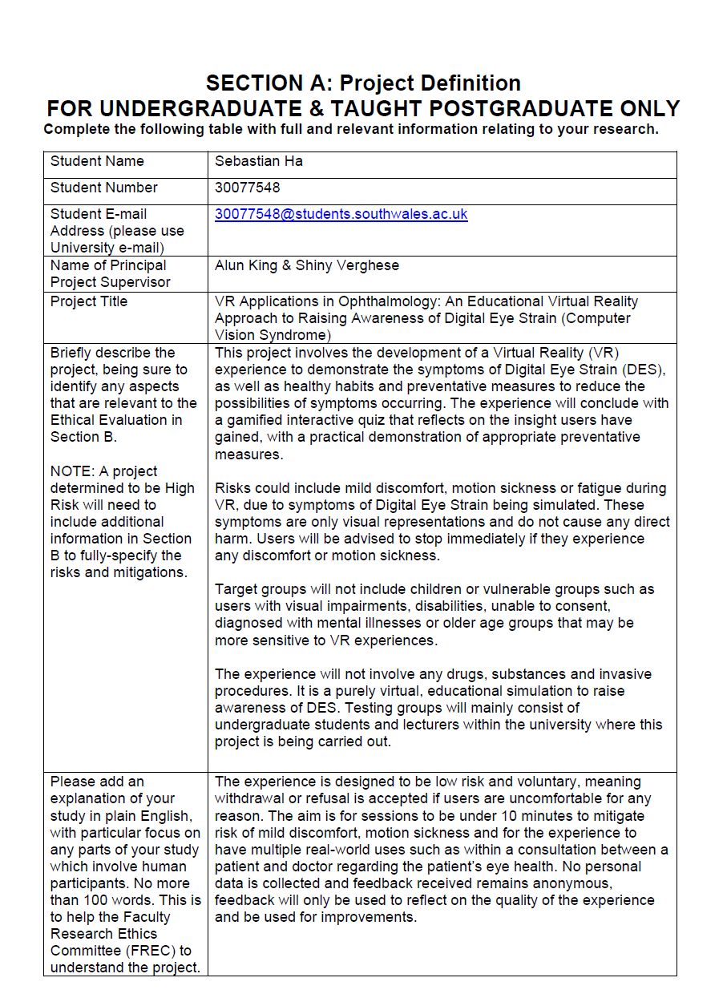
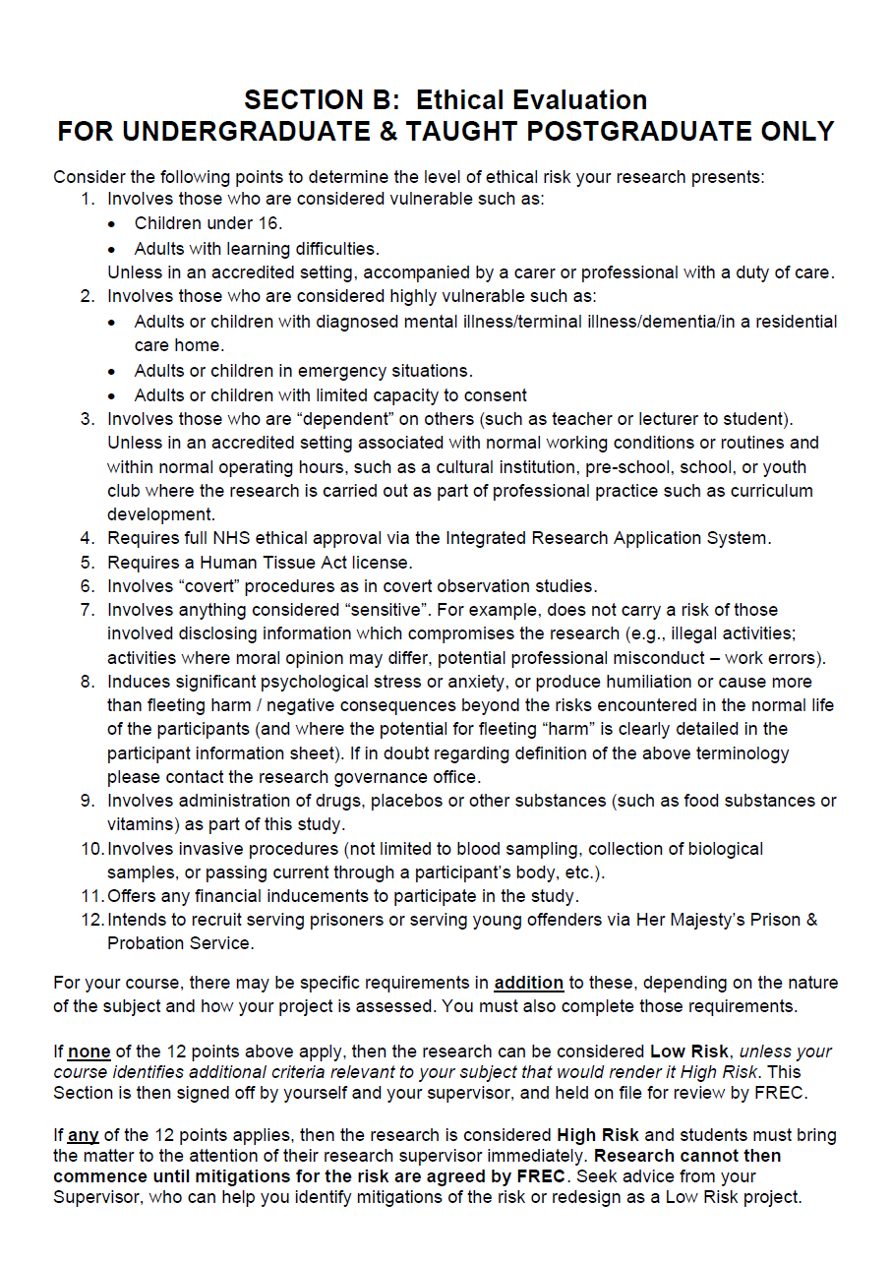

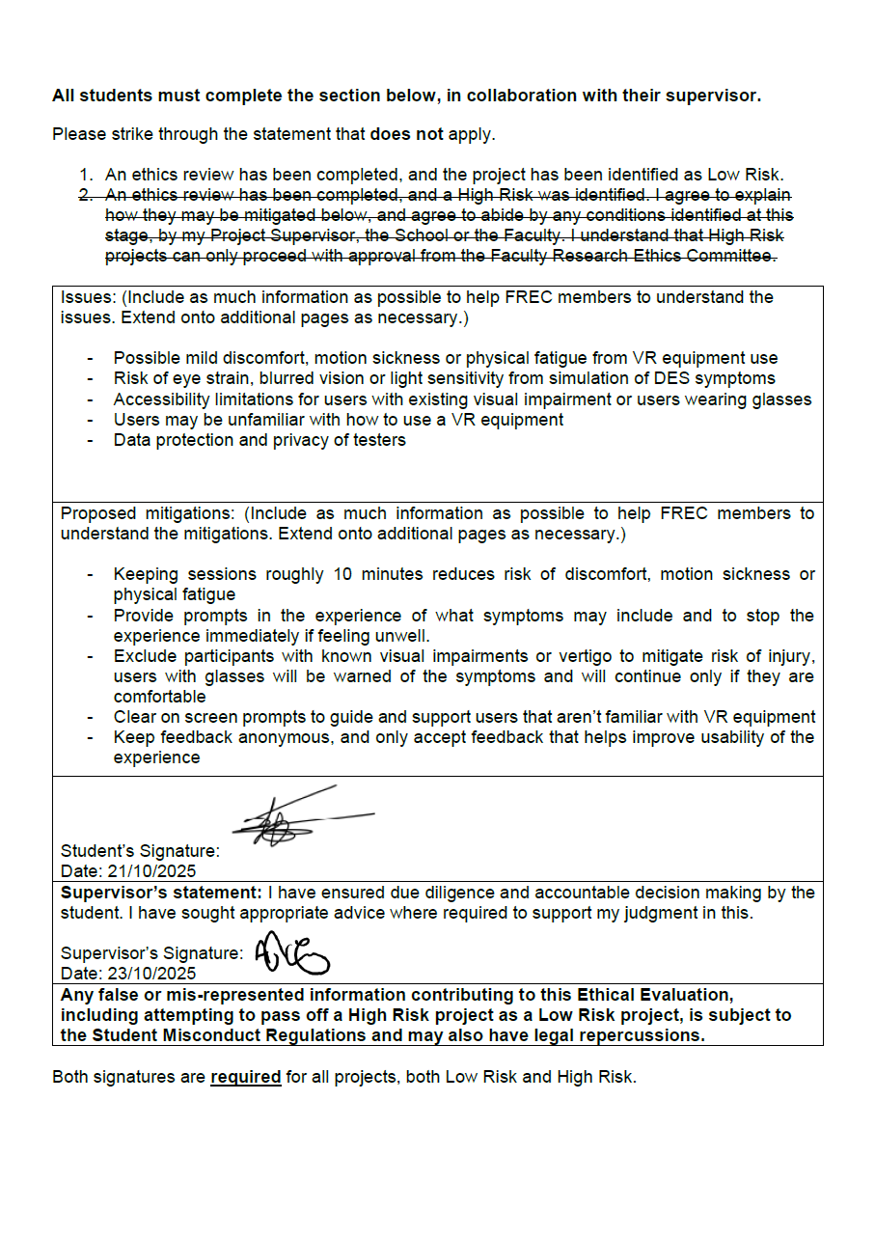

Project Timeline Gantt Chart
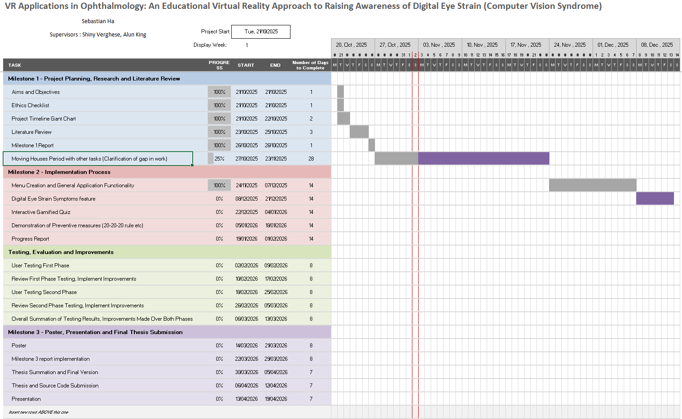

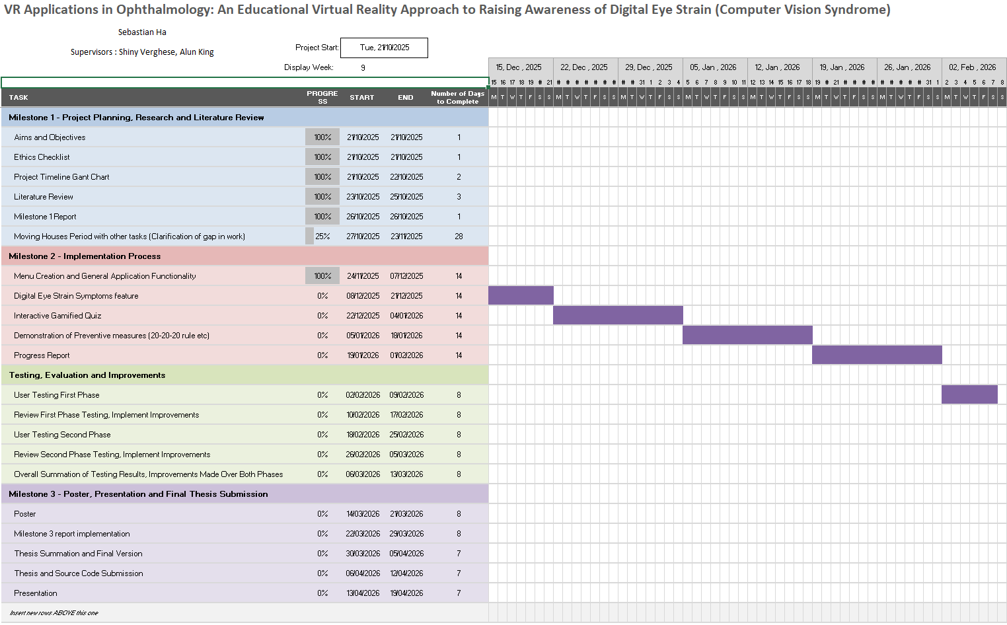

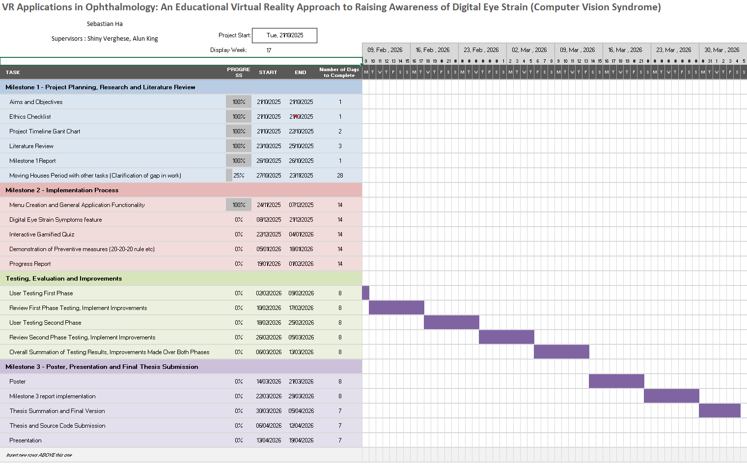

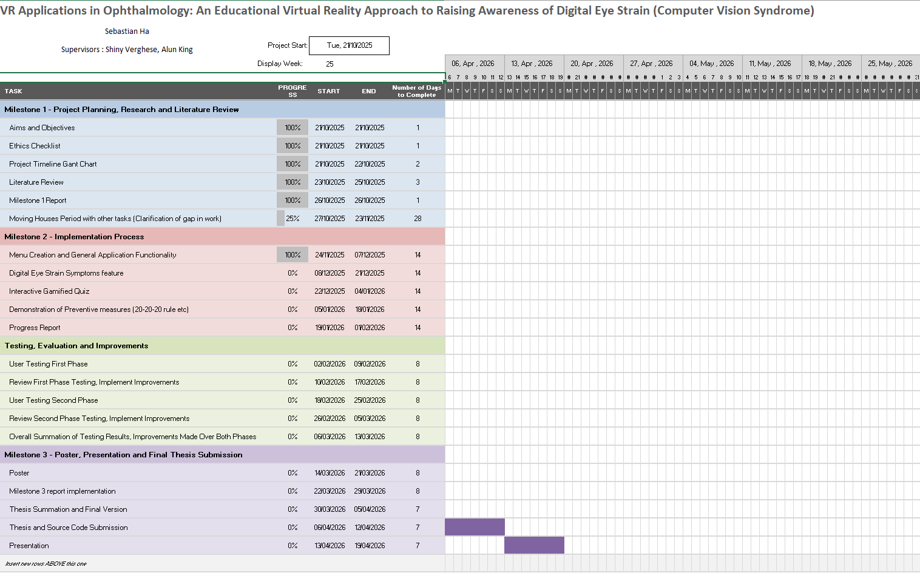

Methodology

Prototype Implementation

Usability and Flow

Environment Design and Scene Setup

Objective System Implementation

Player Objective Feedback

Objective Based Interactive Objects

Post Processing Effects for Simulating Symptoms

Player Look Direction and Attention Detection

Results

Critical Evaluation

Conclusions and Future Work

Asset Licenses and Sources

Modern Office Table
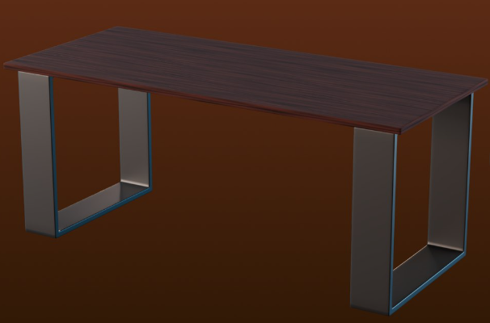
Source: https://www.turbosquid.com/3d-models/modern-office-table-2385755
License: https://blog.turbosquid.com/turbosquid-3d-model-license/

Free Studio Starter Pack
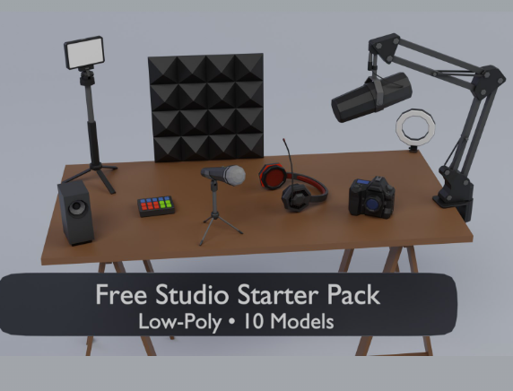
Source: https://www.turbosquid.com/3d-models/free-studio-starter-pack-2507769
License: https://blog.turbosquid.com/turbosquid-3d-model-license/

General Desktop Bundle
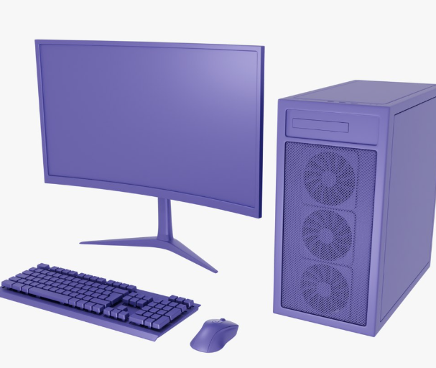
Source: https://www.turbosquid.com/3d-models/general-desktop-bundle-2487712
License: https://blog.turbosquid.com/turbosquid-3d-model-license/

General Gaming Headset
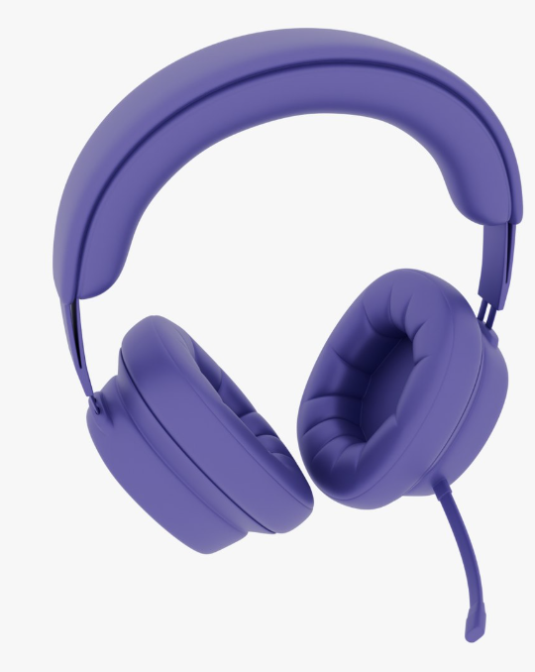
Source: https://www.turbosquid.com/3d-models/general-gaming-headset-2482838
License: https://blog.turbosquid.com/turbosquid-3d-model-license/

General Gaming Chair
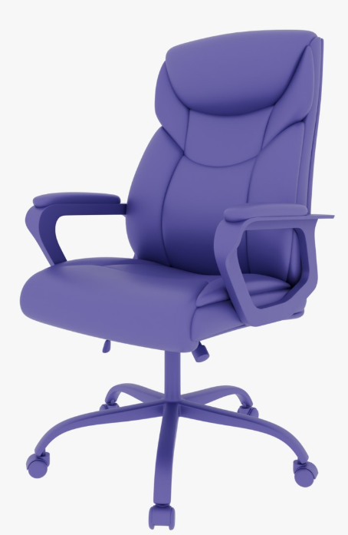
Source: https://www.turbosquid.com/3d-models/general-gaming-chair-2479359
License: https://blog.turbosquid.com/turbosquid-3d-model-license/

Light Switch
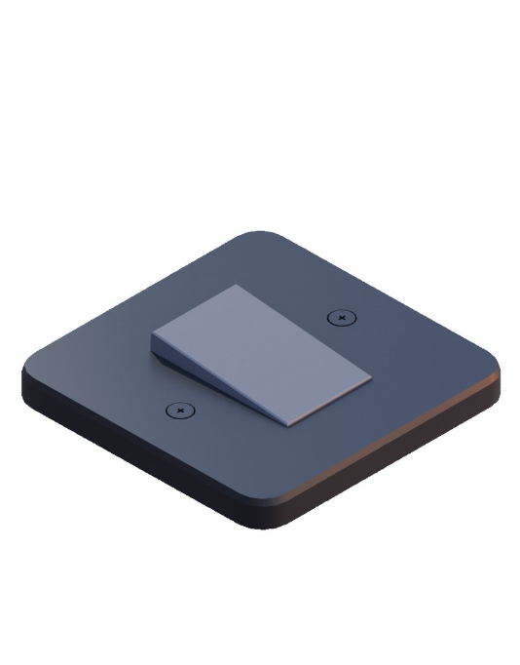
Source: https://www.turbosquid.com/3d-models/low-poly-light-switch-2266534
License: https://blog.turbosquid.com/turbosquid-3d-model-license/

Materials for General PC setup
Source: https://freepbr.com/product/download-all-pbr-textures-now/
License: https://freepbr.com/about-free-pbr/

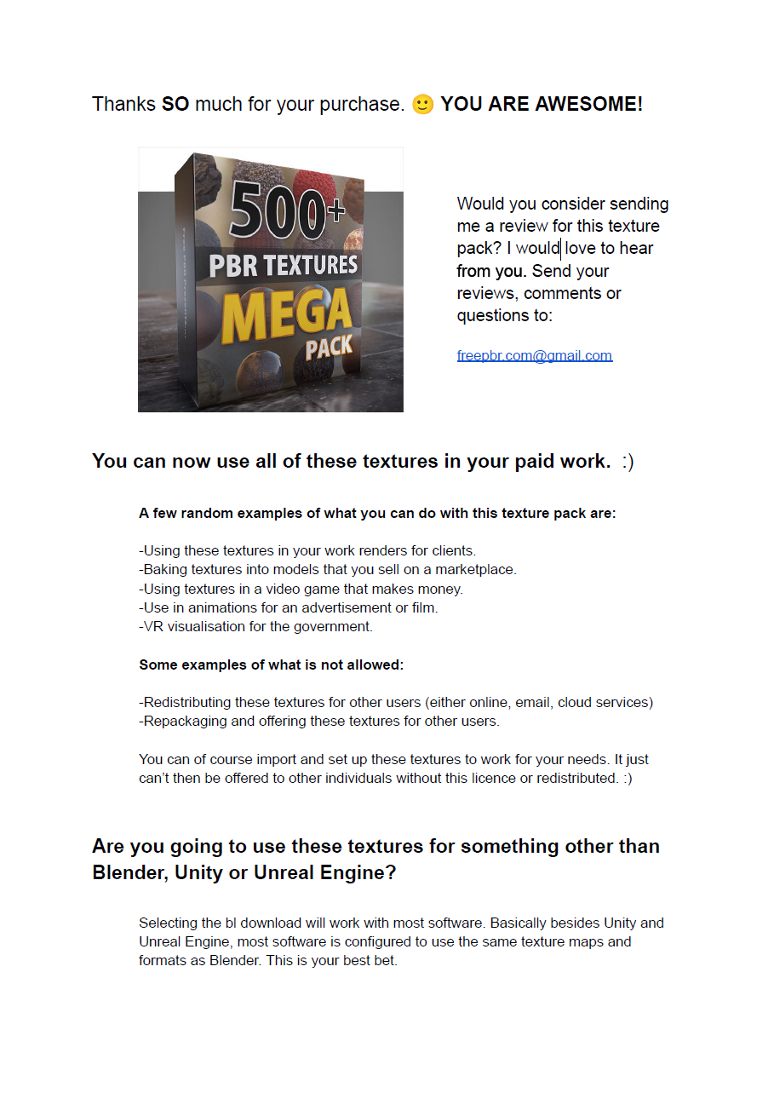

Monitor background image
Created by Paul Earle
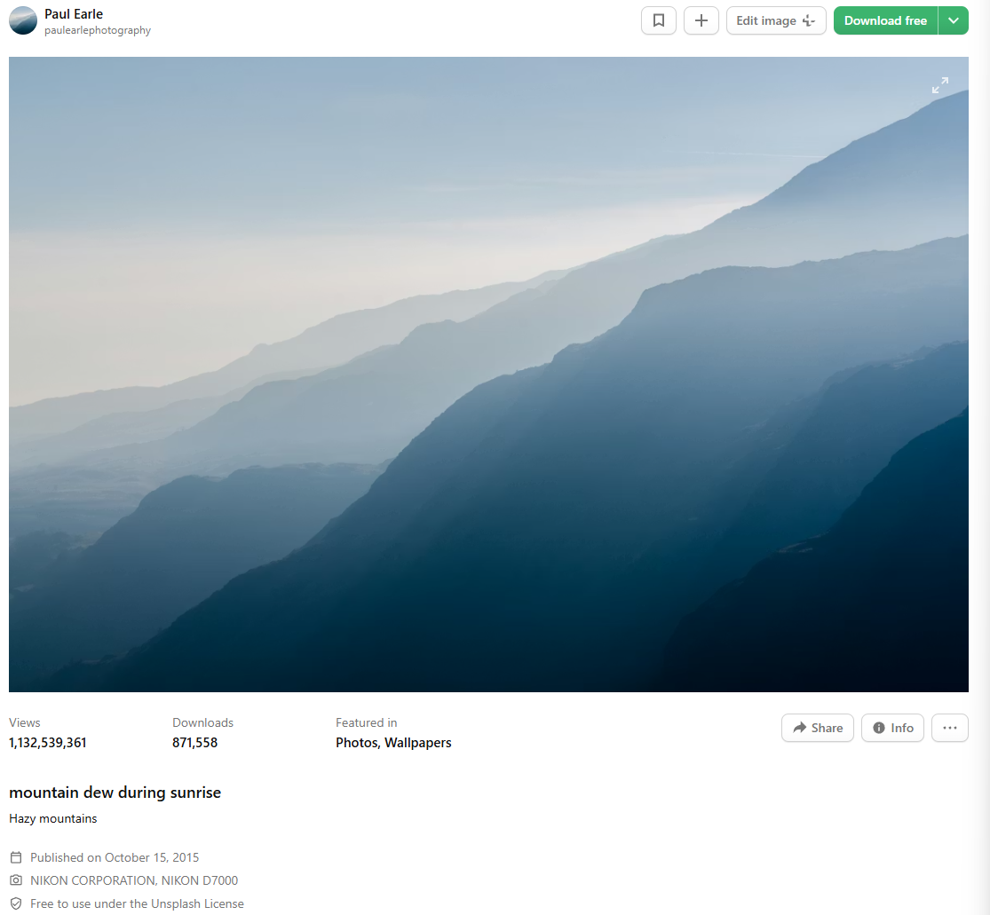
Source: https://unsplash.com/photos/mountain-dew-during-sunrise-xJ2tjuUHD9M
License: https://unsplash.com/license

Button Hover Sfx by Fachii
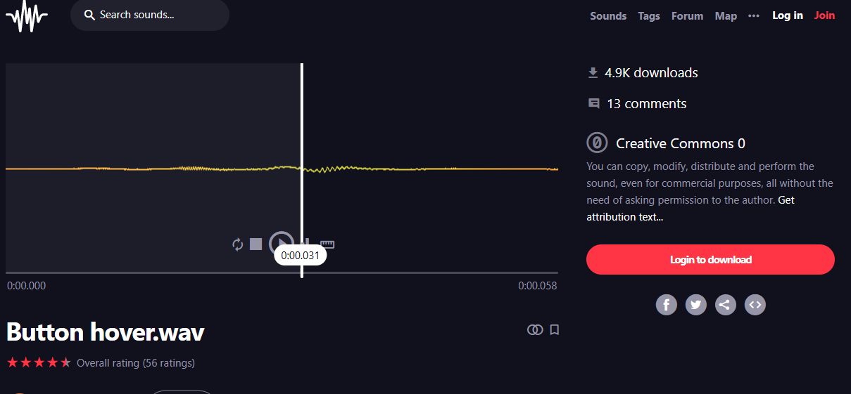
Source: https://freesound.org/people/Fachii/sounds/338229/
License: https://creativecommons.org/publicdomain/zero/1.0/

Button click Sfx by AndrewEathan 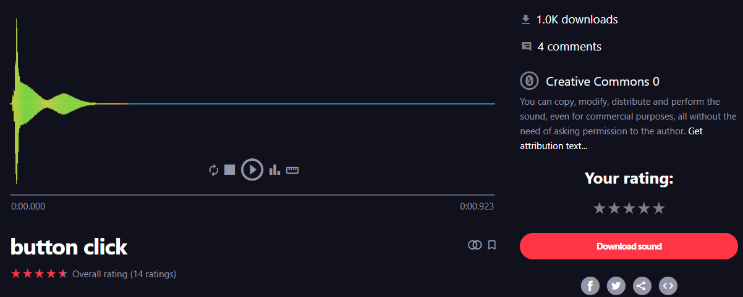Source: https://freesound.org/people/AndrewEathan/sounds/538727/
License: http://creativecommons.org/publicdomain/zero/1.0/

Light Switch On Sfx
Source: https://freesound.org/people/tbrook/sounds/348224/
License: http://creativecommons.org/publicdomain/zero/1.0/
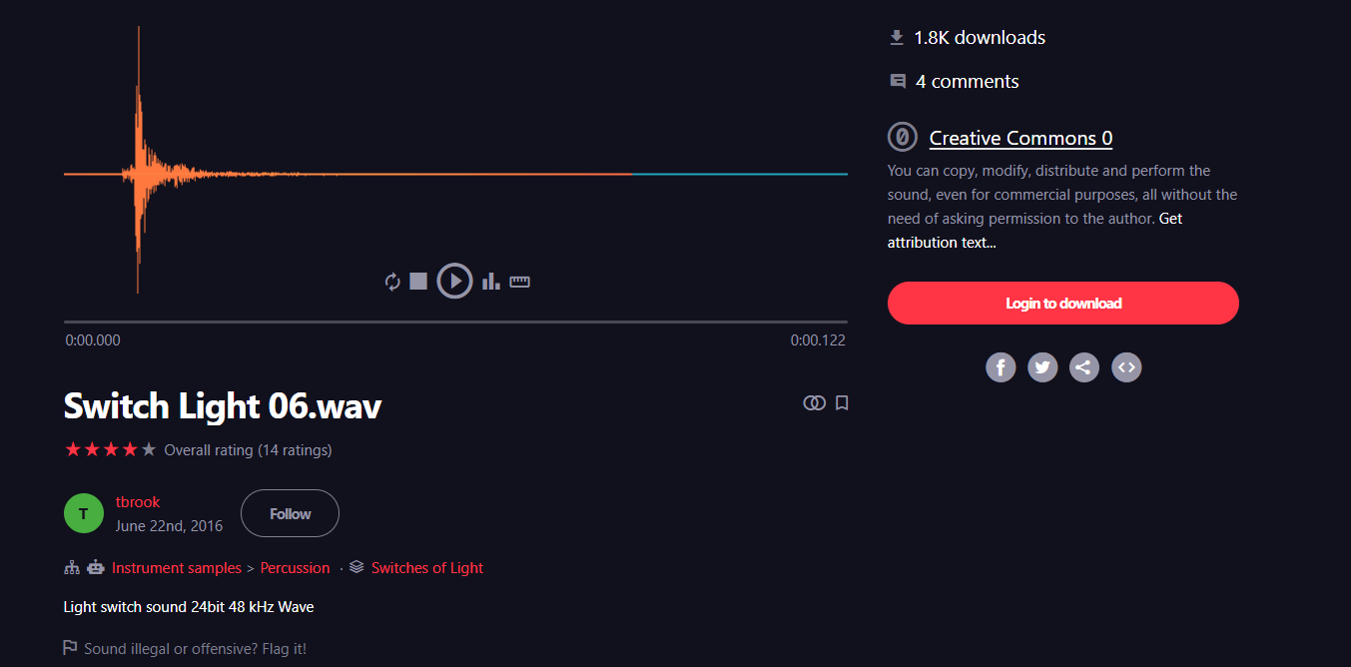

Light Switch Off Sfx
Source: https://freesound.org/people/Philip_Berger/sounds/788642/
License: http://creativecommons.org/publicdomain/zero/1.0/
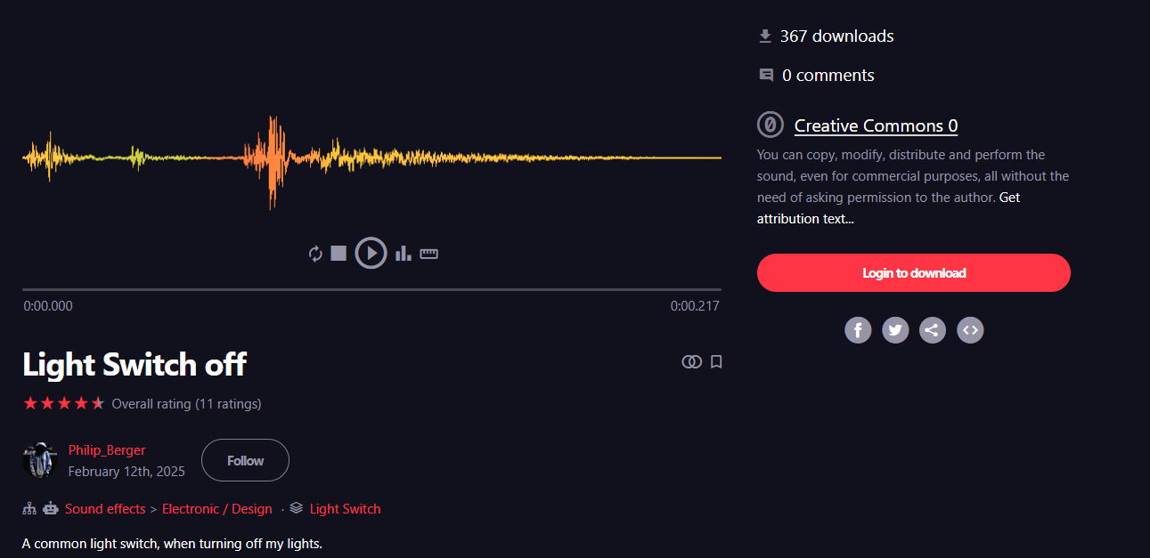

References
Cantó-Sancho, N., Porru, S., Casati, S., Ronda, E., Seguí-Crespo, M. and Carta, A. (2023) ‘Prevalence and risk factors of computer vision syndrome—assessed in office workers by a validated questionnaire’. PeerJ 11, p. e14937. Available at: https://www.researchgate.net/publication/369002899_Prevalence_and_risk_factors_of_computer_vision_syndrome-assessed_in_office_workers_by_a_validated_questionnaire (Accessed: 20 October 2025).
Chandrasekhara, R.S., Low, C., Lim, Y., Low, L., Mardina, F. and Nursaleha, M. (2013) ‘Computer vision syndrome: a study of knowledge and practices in university students’. Nepalese Journal of Ophthalmology 5, pp. 161–168. Available at: https://www.nepjol.info/index.php/NEPJOPH/article/view/8707.
Muñoz, E.G., Fabregat, R., Bacca-Acosta, J., Duque-Méndez, N. and Avila-Garzon, C. (2022) ‘Augmented Reality, Virtual Reality, and Game Technologies in Ophthalmology Training’. Information 13(5), p. 222. doi: https://doi.org/10.3390/info13050222.
Orji, J., Hernandez, A., Selema, B. and Orji, R. (2022) ‘Virtual and augmented reality applications for promoting safety and security: A systematic review’., pp. 1–7. doi: https://doi.org/10.1109/SEGAH54908.2022.9978597.
Porcar, E., Pons, A. and Lorente, A. (2016) ‘Visual and ocular effects from the use of flat-panel displays’. International journal of ophthalmology 9(6), pp. 881–5. Available at: https://pmc.ncbi.nlm.nih.gov/articles/PMC4916147/ (Accessed: 20 October 2025).
Santilli, T., Ceccacci, S., Mengoni, M. and Catia Giaconi (2025) ‘Virtual vs. traditional learning in higher education: A systematic review of comparative studies’. Computers & Education 227(0360-1315), p. 105214. Available at: https://www.sciencedirect.com/science/article/pii/S0360131524002288.
Sharma, M., Kumar, P. and Singh, D.K. (2024) ‘The Role of Virtual Reality in Education: A Comprehensive Review of Research and Application’. Available at: https://ieeexplore.ieee.org/document/10406461/authors#authors (Accessed: 21 October 2025).
Sheppard, A.L. and Wolffsohn, J.S. (2018) ‘Digital eye strain: prevalence, measurement and amelioration’. BMJ Open Ophthalmology 3(1), p. e000146. Available at: https://bmjophth.bmj.com/content/3/1/e000146.
Vieira, F., Oliveira, E. and Rodrigues, N. (2019) ‘iSVC – digital platform for detection and prevention of computer vision syndrome’., pp. 1–7. doi: https://doi.org/10.1109/SeGAH.2019.8882438.
Wasswa, W. and Ware, J.A. (2025) ‘A Systematic Literature Review on Virtual Reality Applications in Medical Education’. Annals of Emerging Technologies in Computing 9(3), pp. 50–68. doi: https://doi.org/10.33166/aetic.2025.03.004.
Youcef, B., Ahmad, M.N. and Mustapha, M. (2021) ‘OntoPhaco: An ontology for virtual reality training in ophthalmology Domain—A case study of cataract surgery’. IEEE Access 9, pp. 152347–152378. doi: https://doi.org/10.1109/ACCESS.2021.3126697.

