Notes
Vignette Intensity - 3.5
Bloom - 5.0

IMPORTANT
Blur function crashes ue5 need a safer way to call the function
Most likely need to change the value of blur within the material if not then maybe the material in blend instead of blend weight of the post processing

Website links for features within the experience
Smooth transitioning of post processing effects:
https://forums.unrealengine.com/t/smooth-transition-of-a-post-process-effect/461159
Specifically this:
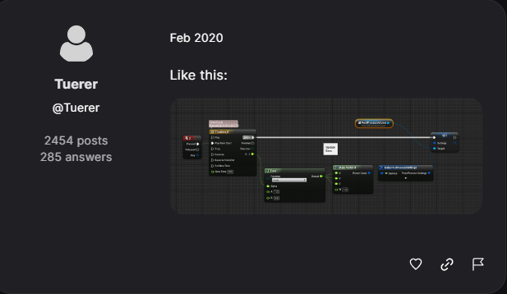

Radial blur post processing material:
https://www.youtube.com/watch?v=KLOGaHgo2GY
Using a post process material instance:
https://forums.unrealengine.com/t/access-blend-weight-in-custom-post-processing-material/284076/5
Specifically this:
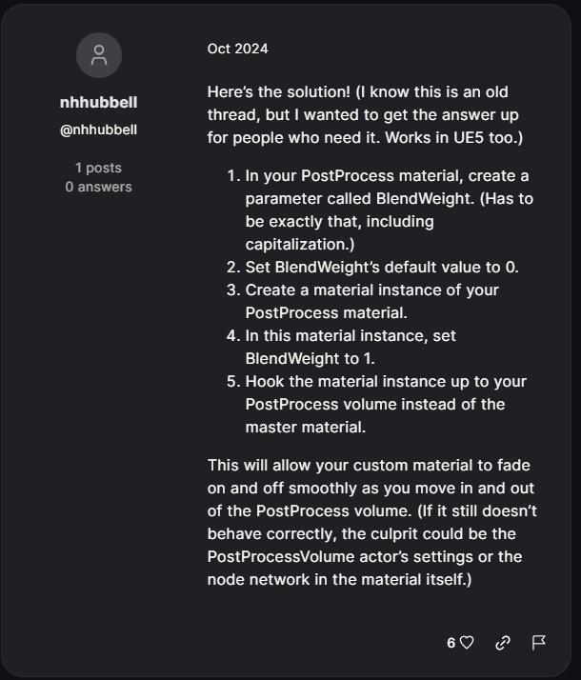
Learning about event dispatchers:
https://www.youtube.com/watch?v=r20VEPH_e0o
https://dev.epicgames.com/documentation/en-us/unreal-engine/event-dispatchers-in-unreal-engine
Learning how to apply a widget as a texture onto the monitor screen:
https://www.youtube.com/watch?v=37UmUAdIHss

Objectives, conditions and satisfaction results
1 -> Stare at screen for 8 seconds continuously
(Screen will track how long the player is staring at it for, general idea is that the monitor will look out for a trace channel coming from the camera object of the vr pawn and use those hits to track the duration the player is staring at the screen)
Result -> Trigger vignette post processing effect
2 -> Look away from screen at target on desk for 10 seconds
(There will be a red target or something in the background enabled so that it can be tracked how long the player is looking at the object for)
Result -> Revert vignette post processing effect
3-> Turn off lights within room, increase the brightness of the monitor screen, stare at monitor screen for 6 seconds
(Increasing the brightness of the monitor and decreasing brightness in the room will trigger the light sensitivity)
Result -> Trigger the bloom post processing effect
4-> Turn on room lights
(Balancing out difference in lights)
Result -> Revert bloom post processing effect
5-> Look around desk area and screen, do not look at further distances
(Need to show difference between eye fatigue and focus strain)
Result -> Trigger blur post processing effect
6 -> Look away from screen at target at a longer distance to relieve symptoms
(Specifically looking away will help to relieve focus strain)
Result -> Revert blur post processing effect

