H8-64 Rev 2.1

The H8-64 Rev 2 memory card for the Heathkit H8 computer is a newly designed, highly configurable 64K RAM card. Any memory chip that is pin compatible with the Alliance AS6C 32pin memory will work, including 128K, 256K and 512K SRAMs. Recommended memory chips to use with this card are the Alliance AS6C1008 (128K), AS6C2008 (256K) or AS6C4008 (512K) in the 32pin DIP package. Although the chips are capable of more than 64K of RAM, only 64K will be used on the H8 computer unless additional paging circuitry is added to the prototyping area. In addition, as the card comes it only works on systems with the HA-8-8 Extended Configuration card or a HA-8-6 Z80 CPU card.
If you are building the card yourself, pin headers should be soldered in positions OE#, CE#, WE#, A17, A16 and CE2/A17. Jumpers should be added to these headers for proper operation. See below for component layout.
If a 512K x 8 chip is to be used, a jumper should be added horizontally to the CE2/A17 OFF (512K) header. This disables the A17 address line for the 512K chip but on the 128K/256K chips this pin is the CE2 (chip enable) control. In this case, this pin needs to tied high so set the jumper in the vertical position.

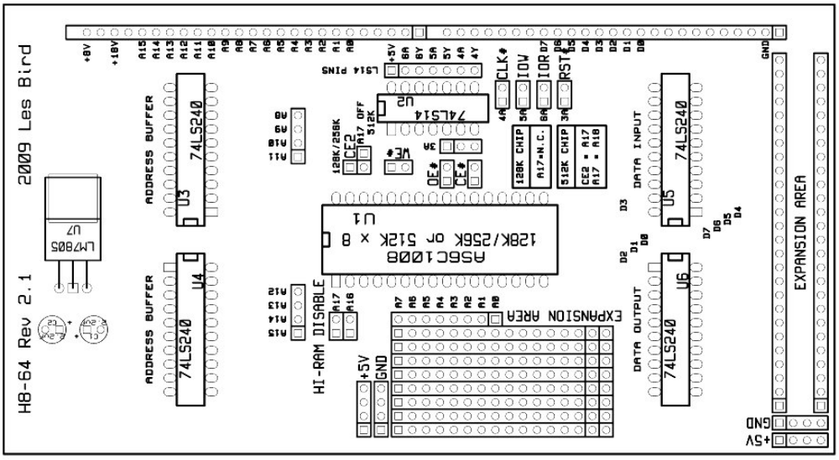
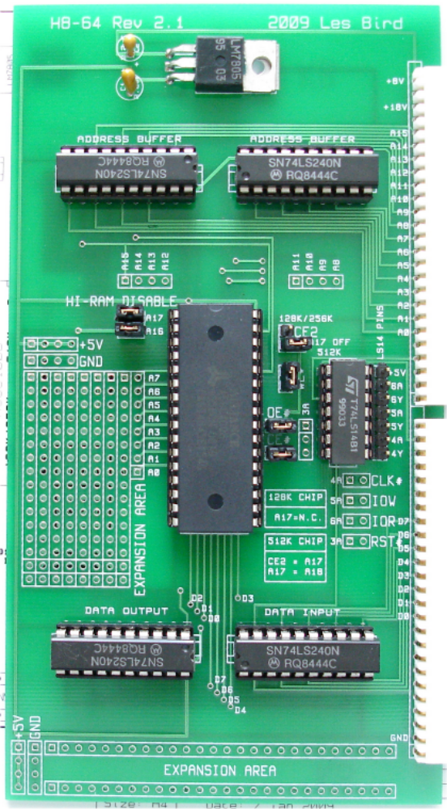
Jumpers shown configured for 512K x 8 SRAM. To configure the board for 128K or 256K chips swap the position of the jumper for CE2/A17 OFF.

