H8-Z80-64
The H8-Z80-64 is a replacement CPU card for the H8 computer using the Z80 processor. This document explains how to configure the card for your system. The card was manually routed using KiCad and not auto-routed from a schematic. I used the 8080 CPU card schematic and the HA-8-6 Z80 CPU card schematic as reference.
CURRENT STATE OF THE BOARD
The H8-Z80-64 is functional as a replacement for the 8080 CPU board. It offers a clockable Z80 CPU and circuitry necessary to support it on the Heathkit H8 system.
CLOCKING
If you are using the recommended 16.384mhz clocking chip (ECS-300CX-16.384 Mouser part# 520-DCO1638-X) the board can be configured using the onboard jumpers to operate at 1, 2, 4, 8 or 16mhz. For 16mhz operation, just move the “DIVIDER” jumper to the right side which will bypass the divider output. I have not been able to clock higher than 4mhz in testing as my Z80 chip can only go as high as 6mhz. So anything above 4mhz is untested. Also note that at higher than 2mhz there may be software and hardware incompatibilities.
ONBOARD RAM
The onboard RAM initially was not working with this board. However, I’ve recently tracked down the problem and with a small modification it can be made to work. See notes on the last page to learn how to enable the onboard RAM. A single jumper wire is all that is needed.
OPERATING SYSTEMS
I’ve booted HDOS and CP/M with this CPU board and ran several apps without any problems. In addition I’ve run the built-in memory test with a 64K card installed and there were no problems encountered.
REQUIREMENTS
The H8-Z80-64 card has been tested in an H8 computer with the ORG0 configuration (HA8-8 or my H8-8-8 Extended Configuration card) and 64K of RAM. Although you can configure the card for non-ORG0 systems, I don’t know if it will work correctly. A manual reset (RST/0) after power-up may be necessary for the card to work correctly.
BOARD JUMPER SETTINGS
The card has several jumpers on it that may not be clear so I will try to explain what they do. Refer to the diagram on the next page.
Normal configuration of the jumpers are as follows:
X1-X2, Z1-Z2, U5-2+5V, F1-F2, E1-E2, C1-C2, IE ENABLE¹, MEMR, MEMW
DESCRIPTION
X1-X2 enables the ROM disable on the H8 bus. Z1-Z2 ties pin 1 on the ROM decoder chip (U5) high. This pin is not needed to decode the ROM enable when part #444-70 or a 4K x 8 (2732) ROM is used. U5-2+5V ties pin 2 on the ROM decoder chip (U5) high. This pin is not needed to decode the ROM enable signal. F1-F2 connects the /BUSREQ signal to pin 27 (/HOLD) of the H8 bus. The left pin of this jumper (F2) leads directly to U1 (Z80) pin 25 and is pulled high via the 1K resistor pack. E1-E2 connects the /BUSACK signal to pin 25 (HOLD) of the H8 bus. The bottom pin of this jumper (E2) leads to the inverted output of U8 pin 16. Pin 4 of U8 is connected directly to pin 23 of U1 and is pulled high via the 1K resistor pack. C1-C2 connects pin 11 of U11 (Interrupt Encoder) to pin 9 of the H8 bus. Also this same pin is connected to P201 pin 4. This connection was part of the original 8080 CPU board. IE ENABLE¹ connects the output of the interrupt enable circuitry to P201 pin 3. This turns the front panel ION light on when interrupts are enabled on the CPU. The circuitry decodes instructions on the data bus of the Z80 and determines if interrupts are enabled or disabled by looking for the EI and DI instructions. The Z80 does not have a INTE pin like the 8080 does so this circuitry is necessary. If you set the jumper to IE DISABLE by flipping the jumper 90 degrees the ION light will always be on and single stepping from the front panel monitor will not work. Jumpers MEMR and MEMW connect the corresponding signals to the H8 bus, pins 28 and 23 respectively. Normally you want these jumpered but with onboard RAM it may not be necessary.

¹ Note that the PCB has IE ENABLE labeled as IE DISABLE by mistake.

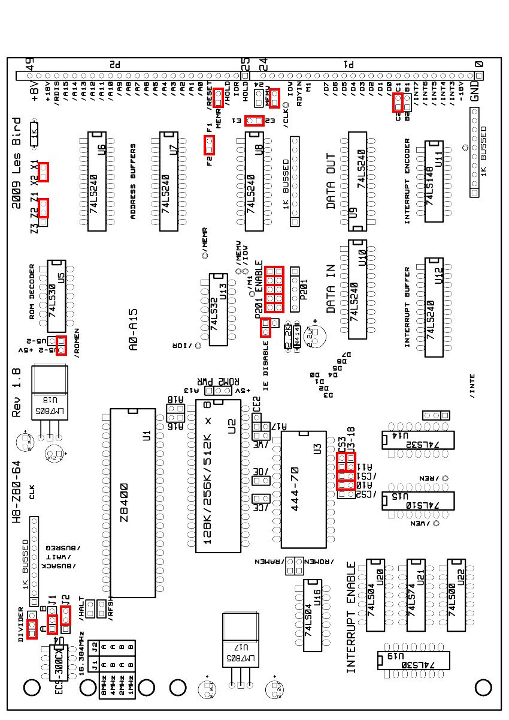

H8-Z80-64
ROM JUMPER SETTINGS
For the ROM configuration set the following jumpers (see diagram on previous page):
For part #444-70: A10, /CS1, A11-U3-18, CS3
For a 2732: A10, /CS1, /CS2, A11
For a 2716: A10, /CS1, /CS2, CS3 (theoritical)
DESCRIPTION
Jumper A10 connects pin 19 (A10) of the ROM (U3) to the same A10 address line of the Z80. This pin is not needed for ROMs that are 1K x 8 but those ROMs are not supported as they usually require +/-12V and +/-5V. The H8-Z80-64 only supplies +5V. Jumper /CS1 is used to enable the ROM. The ROM enable signal comes from U5 (ROM decoder) pin 8. The ROM decoder takes address lines /A11 through /A14, combines that with MEMR and X1-X2 and determines if the ROM should be enabled. These should all be high for the ROM to be enabled. Jumper A11 can be configured in one of two ways. It can be configured to connect pin 21 of U3 to address line A11 or it can be configured to tie pin 21 of U3 high and connect A11 to pin 18 of U3. Depending on which ROM is used these jumpers will need to be changed. However, if using part #444-70 you want pin 21 of U3 to be tied high (CS3) and A11 connected to pin 18 of U3. Looking at the pinouts of a 2732 pin 21 is shown as A11 however the pinouts for part #444-70 show pin 21 as CS3 and pin 18 as CS2 but the schematic for the HA-8-6 shows pin 18 connected to A11. It’s confusing, yes, so I tried to accommodate all of the possible combinations. Testing has shown that with part #444-70 the correct configuration is to tie pin 21 of U3 high (CS3) and connect A11 to pin 18 of U3 (U3-18). For your information, I burned a copy of part #444-70 to a HN462732G (2732 compatible ROM) and had to jumper /CS2 and A11 instead of U3-18 and CS3.

H8-Z80-64
ONBOARD RAM MODIFICATION
The initial design allowed for RAM to be installed on the board itself. However, in order to get the onboard RAM to function correctly with the V1.8 board a modification needs to be made to disable the DATA-IN buffer when the Z80 is requesting data from memory. Without this modification, the DATA-IN buffer will trash the data lines and the onboard RAM will not work. This modification will enable the DATA-IN buffer only when an I/O read operation is performed.
- Lift pin 1 of U15 (74LS10) so that it does not contact the socket.
- Connect a wire from the lifted pin to the ‘via’ right above U14 (74LS32) as shown below:
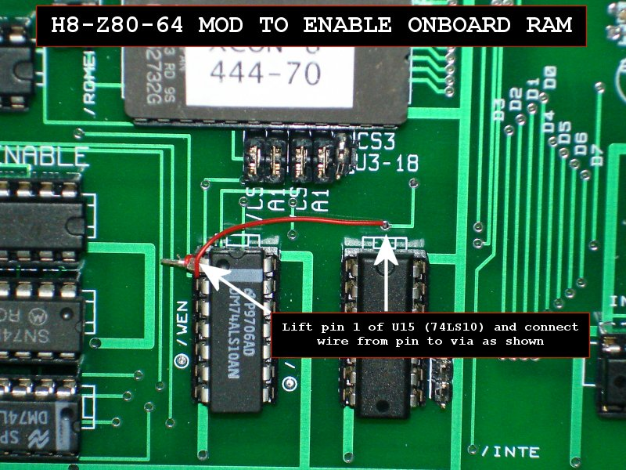
End of modifications.

H8-Z80-64
ONBOARD RAM CONFIGURATION
There are several jumpers for configuring the onboard RAM. The RAM chip can be any 32pin SRAM that is pin compatible with the Alliance AS6C1008. Although the AS6C1008 is a 128K chip, only 64K will be used. To configure the RAM using the jumpers, see below:
/CE, /OE, /WE should be jumpered for all chips.
A16, CE2 should be jumpered if a 128K (AS6C1008) chip is used.
A16, A18, CE2 should be jumpered if a 256K (AS6C2008) chip is used.
A16, A17, A18 should be jumpered if a 512K (AS6C4008) chip is used.

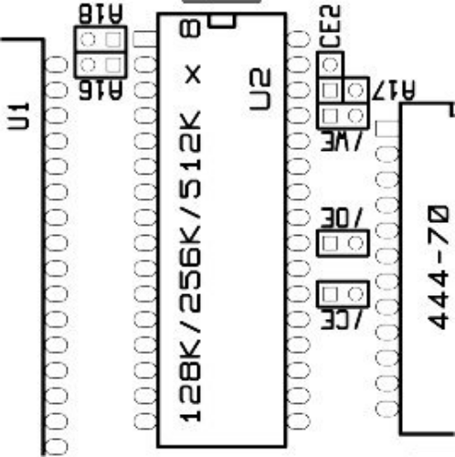

When using onboard RAM be sure to uninstall any memory cards in your H8 as they are no longer needed.
Finally, if you have any questions please e-mail me at lesbird@bellsouth.net or post a message on the SEBHC forum (http://groups.google.com/group/sebhc).
Les Bird
More information on additonal add-on cards for the Heathkit H8 can be found at http://www.lesbird.com/SEBHC

H8-Z80-64
PARTS LIST

74LS240 x 6
74LS30 x 2
74LS32 x 2
74LS148 x 1
74LS10 x 1
74LS04 x 2
74LS74 x 1
74LS00 x 1
Z8400 x 1
XCON8 ROM 444-70 x 1
ECS-300CX-16.384 x 1
1K 10pin BUSSED Resistor Pack x 3
1K 1/4W Resistor x 1
2.2K 1/4W Resistor x 1
2.2uf Tantalum Capacitor x 5
1N4149 Diode x 1 (included)
LM7805 Regulator x 2
MOLEX part # 22-16-2251 connectors x 2
(http://estore.heilind.com/) search for “22-16-2251”

