Question 1 :

Fichier FreeFem :

real h = 1; // umetre
real L = 5; // umetre
real R = h/4; // rayon R

real disqueX = L/4; // x centre disque
real disqueY = h/2; // y centre disque

// Outter borders
border gammabot(t=0,1) {x=t*L; y=0;}
border gammaRight(t=0,1) {x=L; y=t*h;}
border gammatop(t=0,1) {x=L*(1-t); y=h;}
border gammaLeft(t=0,1) {x=0; y=h*(1-t);}

// Circle
border disque(t=0,2*pi) {x=disqueX+R*cos(t);y=disqueY+R*sin(t);}

int npum = 6;// node per um
int nh = L * npum; // Nodes for top and bottom
int nv = h * npum; // Nodes for left and right
int nd = R*3*pi*npum; //Nodes for disque

cout<< "nd:" << nd << endl;

mesh Th = buildmesh(gammabot(nh)+gammaRight(nv)+gammatop(nh)+gammaLeft(nv)+disque(-nd));

plot(Th, ps="maillage.eps");

Capture du maillage :

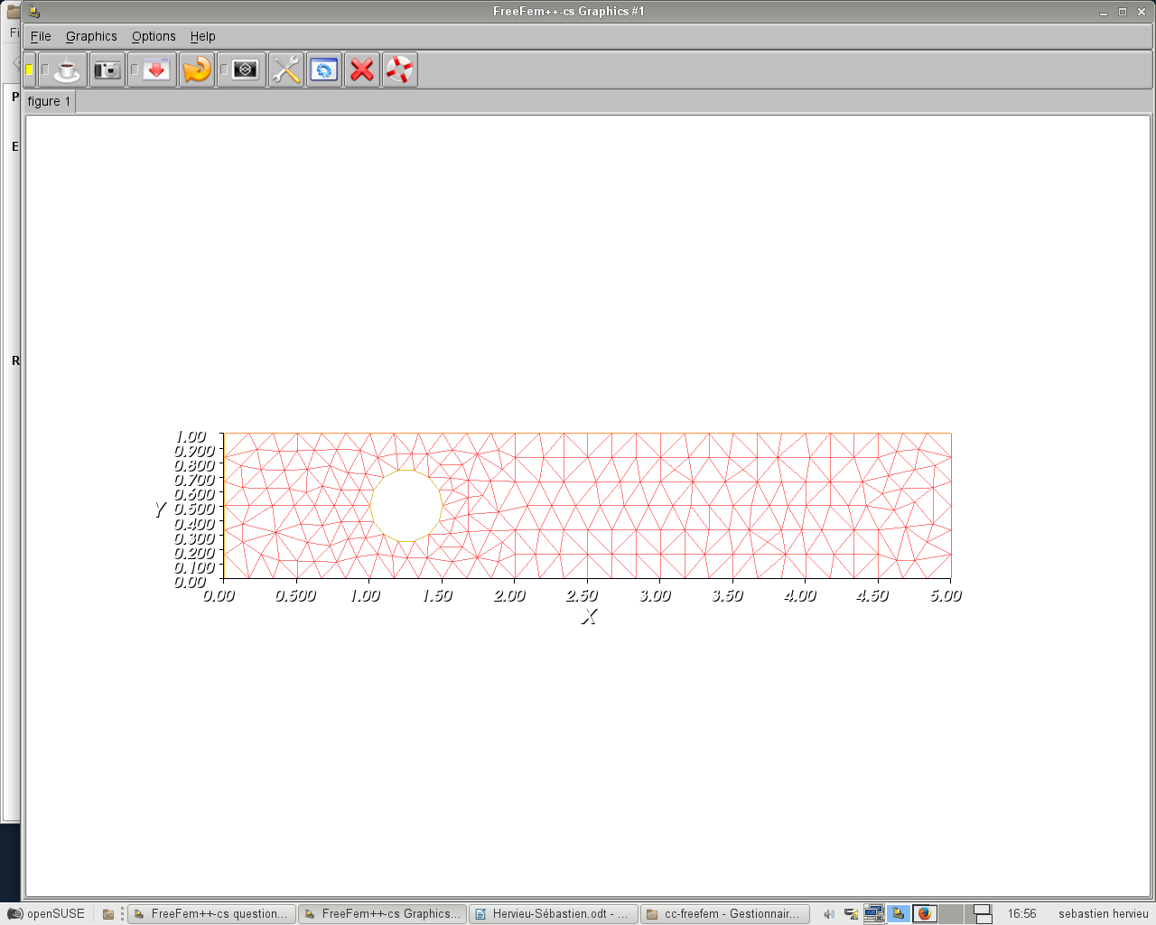

Exercice 2 :

real h = 1; // umetre
real L = 5; // umetre
real R = h/4; // rayon R

real disqueX = L/4; // x centre disque
real disqueY = h/2; // y centre disque

// Outter borders
border gammabot(t=0,1) {x=t*L; y=0; label=1;}
border gammaRight(t=0,1) {x=L; y=t*h; label=2;}
border gammatop(t=0,1) {x=L*(1-t); y=h; label=3;}
border gammaLeft(t=0,1) {x=0; y=h*(1-t); label=4;}

// Circle
border disque(t=0,2*pi) {x=disqueX+R*cos(t);y=disqueY+R*sin(t);}

int npum = 6;// node per um
int nh = L * npum; // Nodes for top and bottom
int nv = h * npum; // Nodes for left and right
int nd = R*3*pi*npum; //Nodes for disque

cout<< "nd:" << nd << endl;

mesh Th = buildmesh(gammabot(nh)+gammaRight(nv)+gammatop(nh)+gammaLeft(nv)+disque(-nd));

plot(Th, ps="maillage.eps");

// Définition du calcul approché
fespace Vh(Th,P2);
Vh<complex> u,v;

real k = 4.18879;
int m = 0;
real gammam = sqrt(k*k-(m*pi/h)^2);
func gm=1i*gammam*cos(m*pi*y/h); // x1 is y

problem harmo(u,v)= int2d(Th)([dx(u),dy(u)]'*[dx(v),dy(v)]) – int2d(Th)(k^2*u*v) - int1d(Th,4)(gm*v) + int1d(Th,2)(1i*k*u*v);

harmo; // on resoud le problème

plot(u);

Capture d’écran MODULE DE LA SOLUTION :

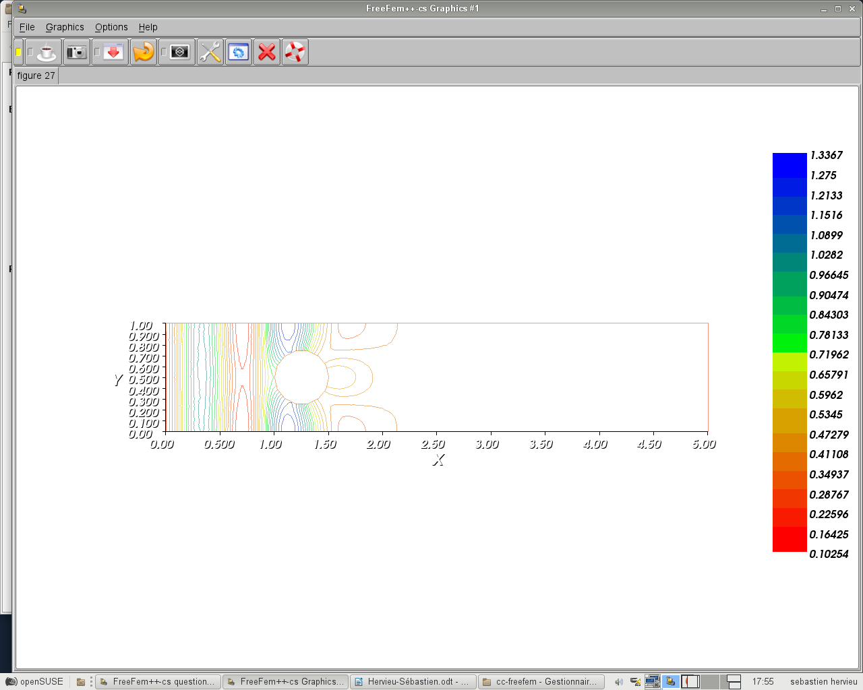

Capture PARTIE REELLE DE LA SOLUTION :

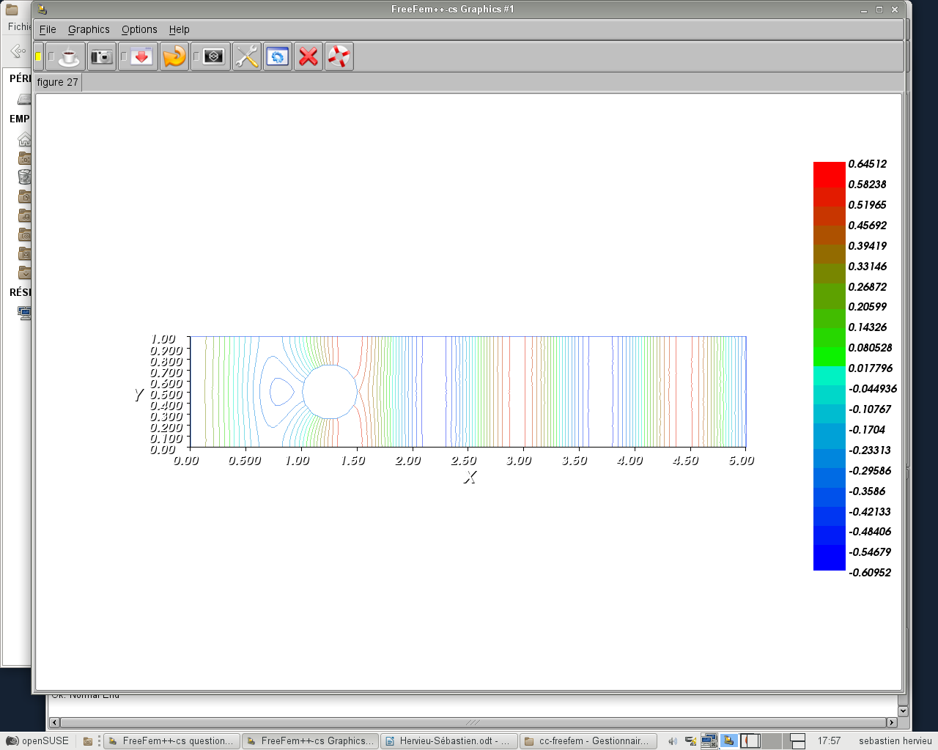

Exercice 3 :

real h = 1; // umetre
real L = 5; // umetre
real R = h/4; // rayon R

real disqueX = L/4; // x centre disque
real disqueY = h/2; // y centre disque

// Outter borders
border gammabot(t=0,1) {x=t*L; y=0; label=1;}
border gammaRight(t=0,1) {x=L; y=t*h; label=2;}
border gammatop(t=0,1) {x=L*(1-t); y=h; label=3;}
border gammaLeft(t=0,1) {x=0; y=h*(1-t); label=4;}

// Circle
//border disque(t=0,2*pi) {x=disqueX+R*cos(t);y=disqueY+R*sin(t);}
int npum = 6;// node per um
int nh = L * npum; // Nodes for top and bottom
int nv = h * npum; // Nodes for left and right
int nd = R*3*pi*npum; //Nodes for disque

cout<< "nd:" << nd << endl;

mesh Th = buildmesh(gammabot(nh)+gammaRight(nv)+gammatop(nh)+gammaLeft(nv));

plot(Th, ps="maillage.eps");

// Définition du calcul approché
fespace Vh(Th,P2);
Vh<complex> u,v;

real k = 4.18879;
int m = 0;
real gammam = sqrt(k*k-(m*pi/h)^2);
func gm=1i*gammam*cos(m*pi*y/h); // x1 is y

func uex=cos(m*pi*y/h)*exp(1i*gammam*x);

problem harmo(u,v)= int2d(Th)([dx(u),dy(u)]'*[dx(v),dy(v)]) - int2d(Th)(k^2*u*v)
- int1d(Th,4)(gm*v) + int1d(Th,2)(1i*k*u*v);
//- int1d(Th,4)(gm*v)
//+1i*k*int1d(Th,gammaRight)(u*v);

harmo; // on resoud le problème

plot(u);

real errL2 = int2d(Th)(abs(u - uex)^2);
real uexL2 = int2d(Th)(abs(uex^2));
real errL2rel = sqrt(errL2/uexL2);
cout << "errL2: " << errL2 << endl;
cout << "uexL2: " << uexL2 << endl;
cout << "errL2 Relative: " << errL2rel << endl;

