Agent-based MATSim Simulation
As the simulation MATSim [reference book] is used. It is an agent-based activity-centered framework for traffic simulation. The way it works is as follows: Each agent can either be present at an activity or a leg, which describes a movement from one position in the traffic network to another.
For activities the simulation does a per-second-based evaluation of a priority queue, in which the agents are ordered according to their activity end time. This queue-based approach is common in agent-based simulations and results in large improvements in computational time compared to a per-second and per-agent evaluation of the whole scenario. [reference for queue simulations?] A similar approach is taken for simulating cars in the network, which makes it possible to simulate a whole scenario within reasonable time.
Agents in this simulation have initial plans, of what they want to do during a day. This means they know when they will end their first acitivity, which usually is “home”, which transport mode they will choose, e.g. “car”, “walk” or “public transport”, how long they will stay at their second activity (usually “work”) and so on. Furthermore there are constraints on how long certain activities should last, when an agent wants to arrive at latest and when the agent wants to end an activity.
How good these constraints are met and how much time agents need to spend in traffic is all combined in a daily utility score. An agent always keeps a number of plans with different utility scores and for the next iteration step another plan is chosen, or the current one is modified. By running through a number of iterations for all the agents, finally the plans arrive at a quasi-equilibirum, which will be called the “relaxed state”.
According to start locations, availability of transport modes, social measures like income and car ownership and congestion on the network, agents will make their choices on traffic modes and departure times.
The simulation of complex behaviours for autonomous taxi services cannot be resembled completely by the functional structure of the framework. For instance, if an agent is in a certain activity (like a waiting taxi), one needs to circumvent the efficient queue simulation structure of the framework. In the following one established contribution is examined and compared to a new framework, which has been developed as part of this thesis.

DVRP Extension
The DVRP extension is divided into to integral parts. While the actual DVRP provides classes structures for the easy implementation of arbitrary taxi-like services, the DynAgent contribution provides a way of simulating agents dynamically, i.e. separated from the constrained queue simulation.
The approach that is used in DVRP is polling: If there are 100 dynamic agents, each agent is checked one per simulation step if it wants to change the end time of its current activity or leg. According to that, the DynAgent engine may decide to let the agent progress to the next activity. Furthermore, it allows the agent to execute arbitrary code in every simulation step, which makes the approach very flexible and imposes almost no constraints one what can be simulated with the agent.
The downside is, that the polling leads to higher computation times, the more agents are present. So if n_a is the number of agents, the algorithm will need to do at least 2*n_a function calls per agent and simulation step. For a daily simulation of 10000 seconds, which is repeated 100 times and with 500 agents, this leads to 10^9 function calls. If each takes around 1ms, the computational cost, even if the agents do nothing useful in particular, is already around 20 minutes.
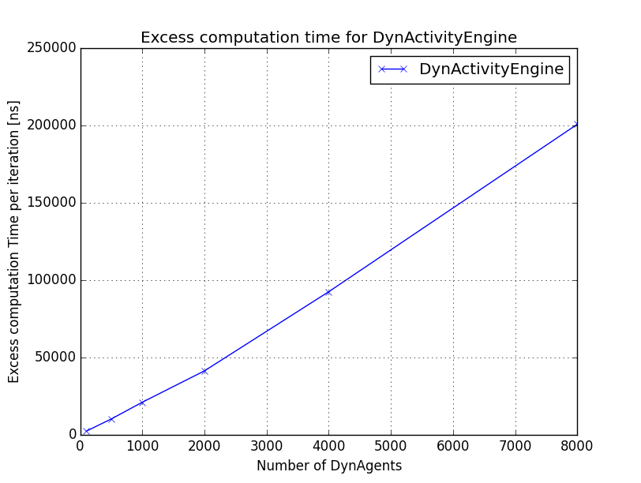
Figure 1

Figure 1 shows how just inserting dynamic agents without any logic into the simulation leads to a linear increase in computational time.
Since for this thesis scenarios should be evaluated, where are large number of autonomous vehicles are available, the idea was to find a more efficient way of simulating them. This lead to the development of the AgentLock framework, which is described in the following.

AgentLock Framework
The AgentLock framework is a small extension for MATSim, which allows for the dynamic simulation of agents, which is – contrary to the polling approach of DVRP – event-based. This means that agents are just “woken up” when they actually want or need to perform an action.
The implementation uses a priority queue, where “wake up” events for the agents can be registered. However, those requests can be invalidated if the agent inserts another event into the queue, which is either earlier or later in time. Then, while processing the queue in every time step, the engine behind the AgentLock framework just drops all wakeup-calls that have been invalidated before.
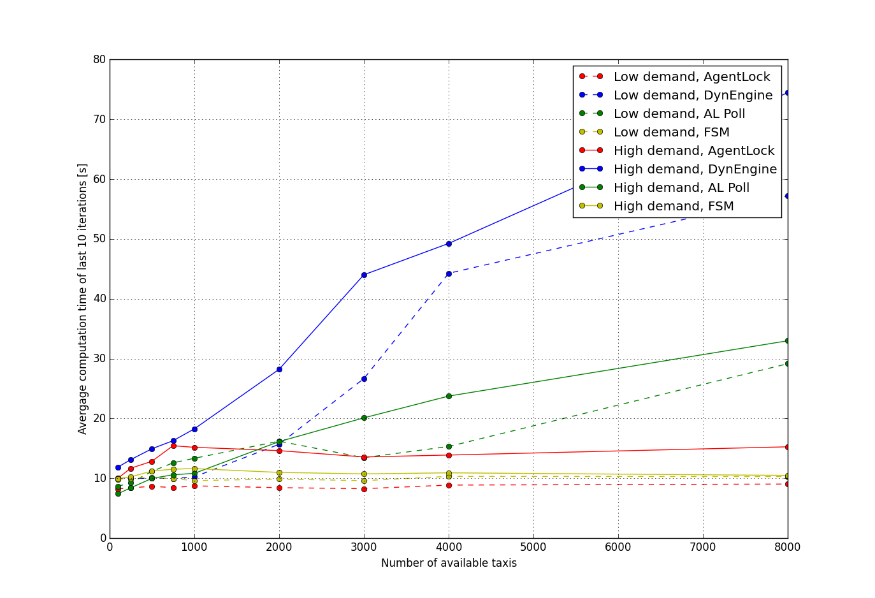
Figure 2

Figure 2 shows the progression of the different simulation approaches, tested using the same basic AV implementation. (Figure 3 shows that the implementations lead to similar simulation results in terms of mode choice). As expected from previous results, the implementation using the DVRP framework (blue) scaled roughly linear with the number of available taxis, while the first priority-queue-based implementation, which was using the within-day-rescheduling facilities of MATSim (red) lead to almost no dependency of the computation time on the number of available taxis. That is because in this scenario with 8000 possible passengers, requests only appeared from time to time and taxi agents did not have to be evaluated one per time-step.
As a comparison, the implementation with the within-day replanning has been replaced by a drop-in implementation using a polling approach like in the DVRP framework, so each agents has been checked on a per-timestep basis. Again, this lead to a linear dependency (green), which shows that, also when neglecting all the helper functions of DVRP, a polling approach just imposes a structural problem in computation time.
Finally, a resusable, flexible event-based system for dynamic agents, AgentLock, has been developed as described above (yellow). It clearly leads to a great improvement over a polling approach in most of the cases. However, one can see that the polling-based green algorithm crosses the yellow one at some point. So for small numbers of agent, it actually would be more efficient.
Both approaches can be formalized as follows. The complexity of the polling approach with n_a agents can per simulation step be described as
C_polling = n_a
On the other hand, the queue approach can be described as:
C_queue = f * (log (n_a) + n_a)
So in every simulation step a “poll” operation on the priority queue costs log(n_a) and a remove n_a, but only a fraction f of the possible number of action are performed on the queue. So it is clear that if every agent in every iteration would change its mind an modify the queue, the computational time for the polling approach would be shorter.
The parameter f can be described as
f = number_of_av_services * number_of_reschedules_per_service / number_of_timesteps
Since the number of timesteps per day is fixed and an upper bound for the number of reschedules in a av service can be given, one can find a number of AV services on a day, which would determine the border where the polling or the queueing approach gets more efficient.
This can also be observed in figure 2. Comparing the red queueing approach and the green polling approach ,there is a point where both graphs cross. As expected from theory, for small numbers of agents, where the system goes into saturation, i.e. using all the vehicles quite frequently, the polling offers a better efficiency, because the frequent queue operations cost too much time. On the other hand, if the number of agents increases, many AVs are not used, therefore in the queue simulaiton they aren't even touched, whereas in the polling approach they are checked in every step, which leads to high computational costs.
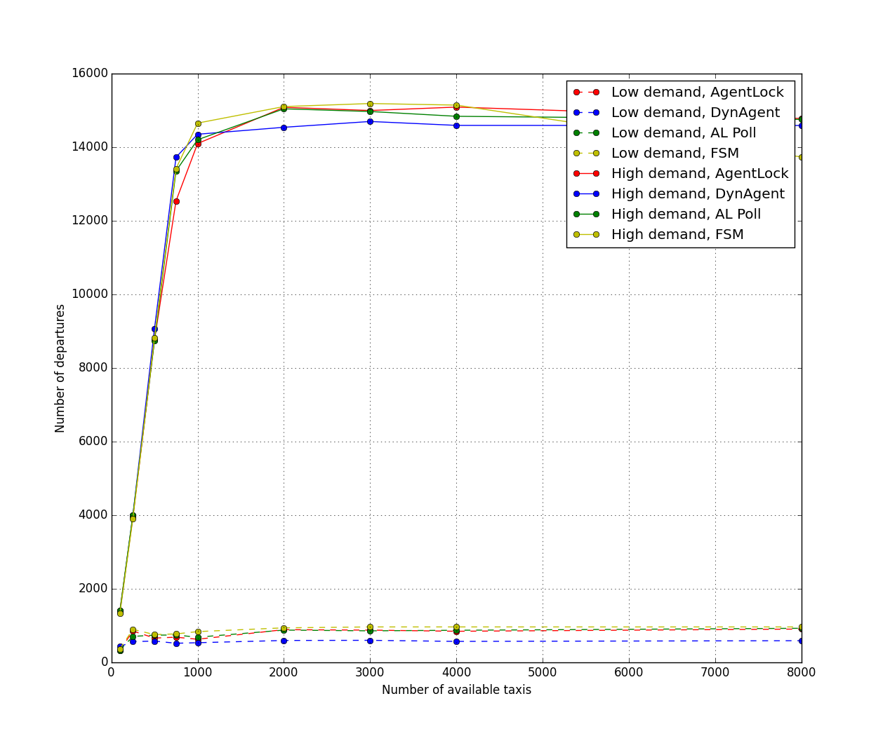
Figure 3

IMPORTANT
In the paper they don't need mode choice, so it is sufficient to simulate ONCE, while here I need to do this N times, for the corridor, this is already 100 times more. So if they state in the paper that they can solve 250000 agents in 3h, this would mean 300h for the mode choice!

