Plan
- Working Simulation Framework
  - Decision / statement of parameters that are involved
  - Definition of underlying assumptions
  - Implementation decisions
- Scenario simulation
  - Define which are the interesting outcomes
  - How are the dependent variables dependent on the parameter choice?
  - What are realistic ranges for the parameters, which produce realistic results?
- Iteration, Refinement, etc.

“Iteration 1”

Model
- Roughly inspired by Boesch model, maybe reasonable comparison is possible
- Initial distribution model:
  - There is a parametric number N_{AV} of available Avs
  - For each iteration there are initially N_{init} plans with AV as the first mode
  - AVs are placed initially at the start positions of random AV agents until all of them are “served” or the maximum number of AVs is reached. If there are more AVs than initial legs, distribute the remaining AVs
  - Assumption: Cars are “ready to use” in the morning
- Allocation model
  - Calculate the expected arrival time at the pickup location of the request for each AV
  - Choose the optimal one (with the shortest waiting time for the passenger)
  - If there are several optimal ones, choose the one which has the shortest schedule, i.e. do some kind of basic load balancing
  - Assumption: People call AVs on demand, there is no pre-ordering, in that case more sophisticated scheduling algorithms could be used… actually this is quite a big advantage of AVs that might decrease waiting times significantly, especially at peak times which have great impact on the scoring… so maybe this should be taken into account!
- Scoring
  - Constant utility (interpretation as fixed costs / initial price, maybe also as “hesitation”)
  - Utility of travel (time-based), interpretation as “comfortness” of AVs, also “suspicion” about the technology
  - Utility of costs (distance-based, distance * monetaryCostFactor) interpreted as the actual travel costs for the AV user

Observations / Problems / Ideas
- Long computation time due to excessive optimization for the allocation
  - Several heuristic approaches possible and reasonable (see further down the document)
- The “normalized” case with car parameters as utility systematically prefers the mode choice of cars, also for the saturated case with 8000 AVs. Does this make sense?
  - Theoretically if everyone can have his own AV, the AV is there in the morning, waits at work and brings the agent back home later (equal score as car, should be 50/50 distribution)
  - Distribution of scores should be examined, what happens for slightly smaller / bigger scoring?
  - Maybe a TO / FROM – Link problem?
  - Fixed, scoring problem first/last link
- Many utility parameters: Is this necessary for the initial tests?
  - Maybe compare all cases in terms of the actual scores of the legs
  - Reduction to average score values and number of vehicles (avg score dependent on network structure, but since distance and travel time distributions are known, might be a good approach to infer some statistical dependencies!)

What is interesting?
- Shares of cars, av and pt (e.g. are there ways to keep pt constant, while drawing agents away from cars?)
- travel time distribution → does average travel time decrease?
- total distance driven → how much does overall distance increase (emissions, etc.)
- passenger origins, cross-scenarios
- overall number of cars
- Parameters (Which are reasonable? Which are realistic? Can be explained?)
  - Pareto-front like analysis e.g. “if the overall number of cars should be 90% from baseline, which are the parameters values that define this threshold?)
- Time until served
- distribution idle / in use
- revenue per car

Results

Leg modes vs. number of AV legs
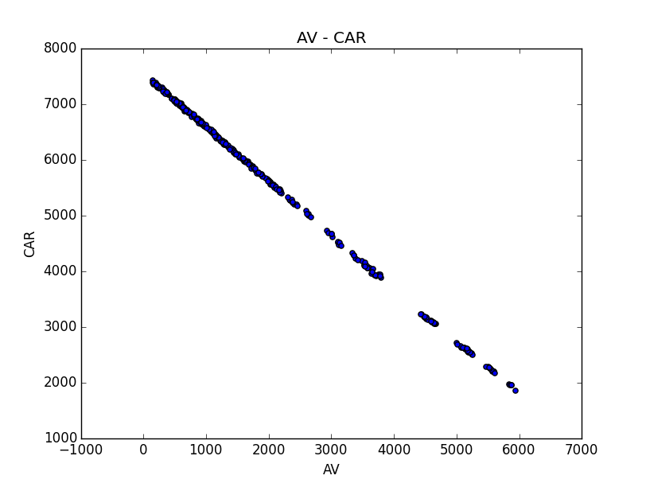 | 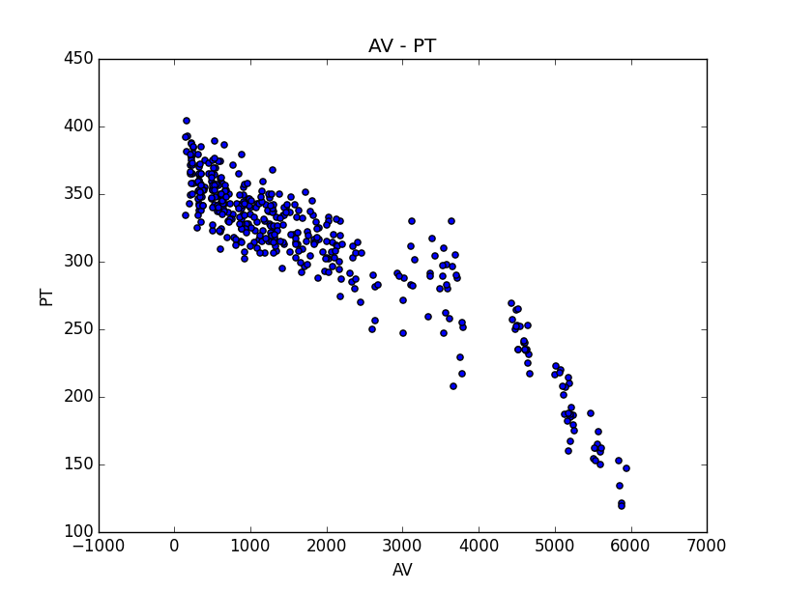
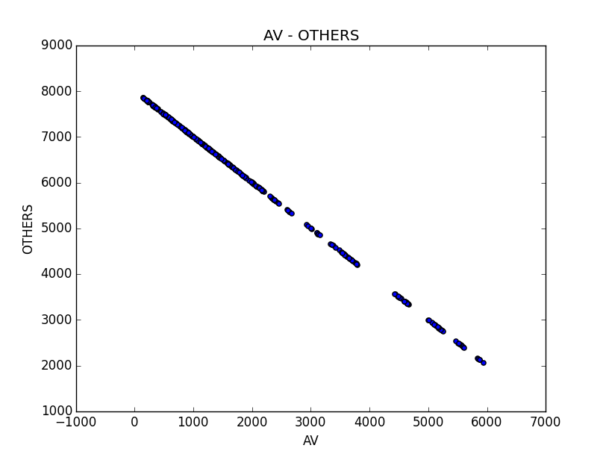

Distribution of AV legs dependent on parameters

Histograms over the number of start legs (full) | Cars + Avs < 7200
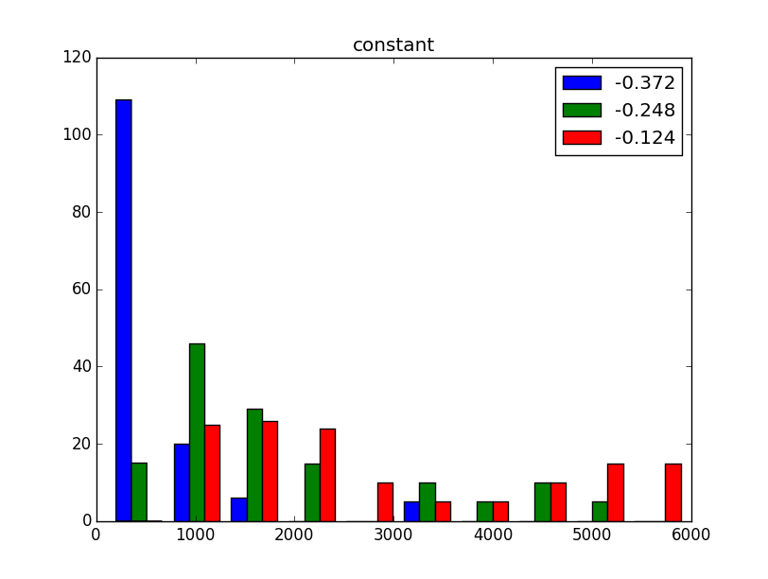 | 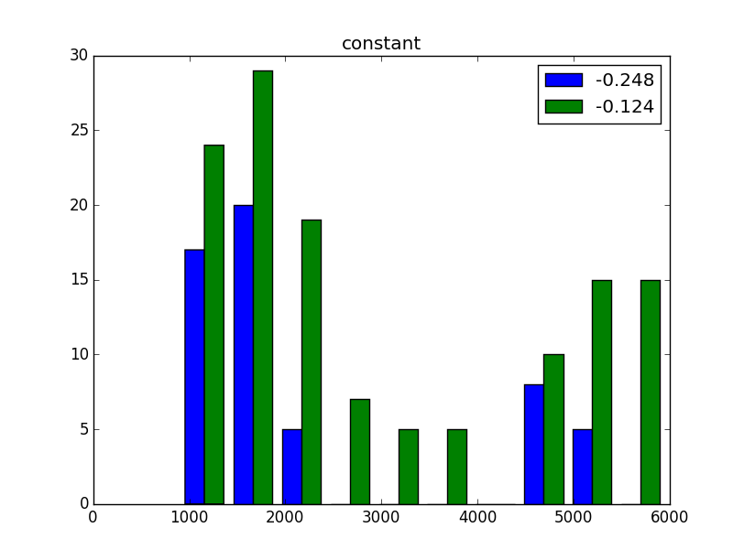
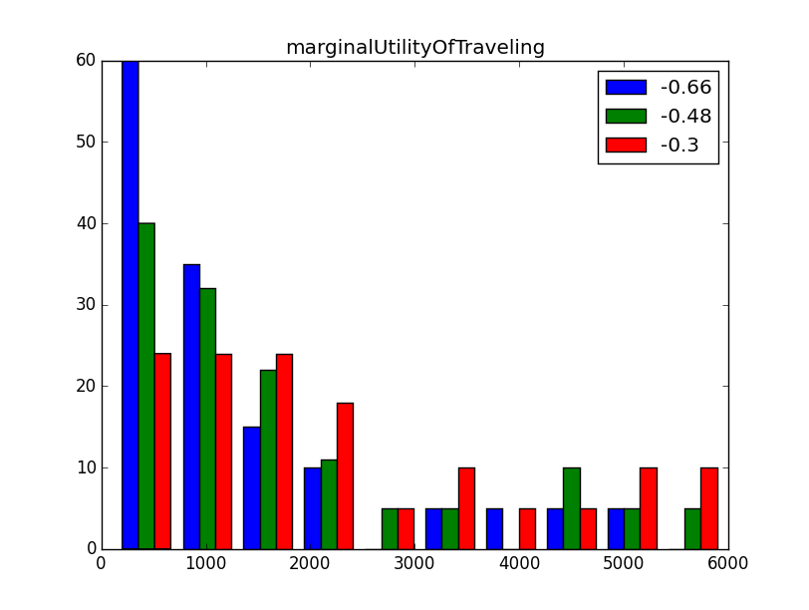 | 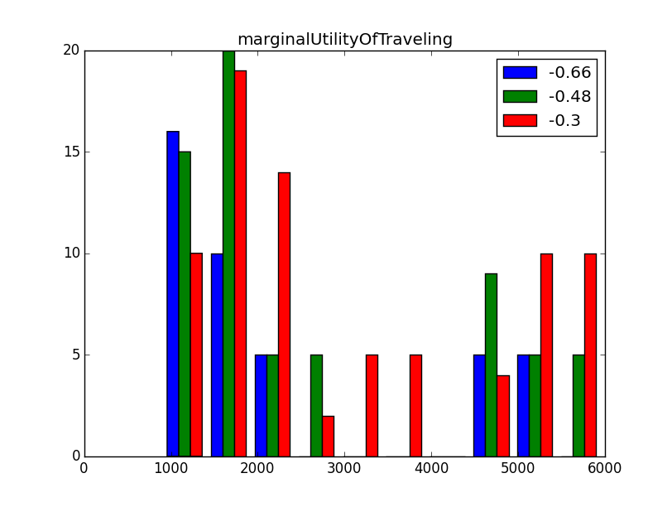
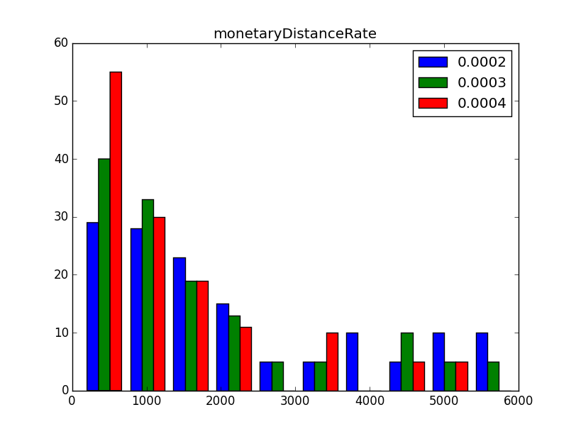 | 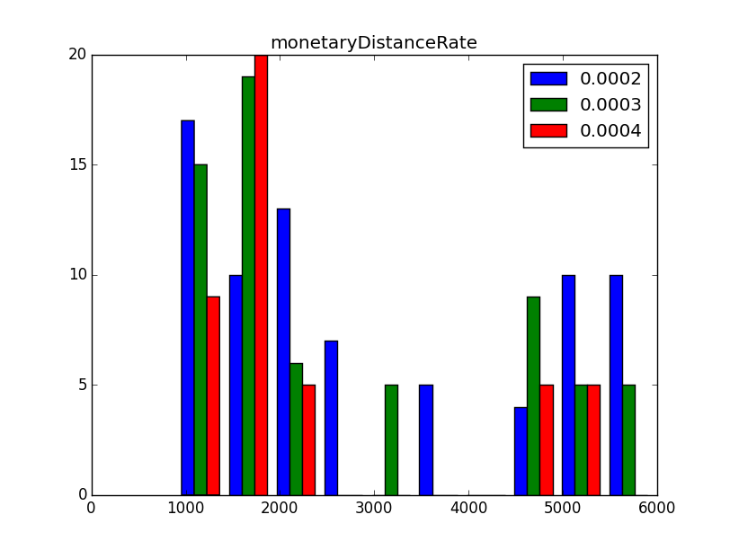
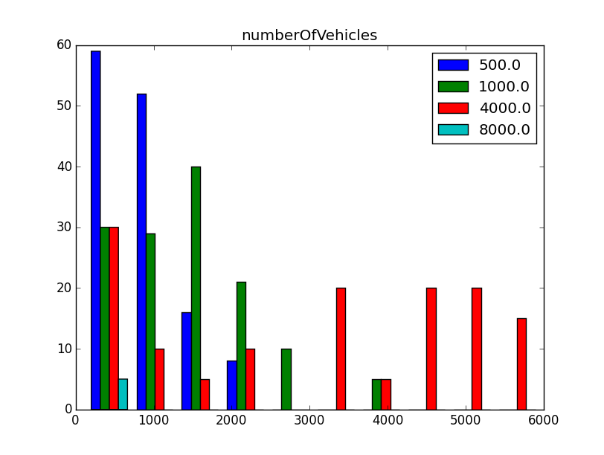 | 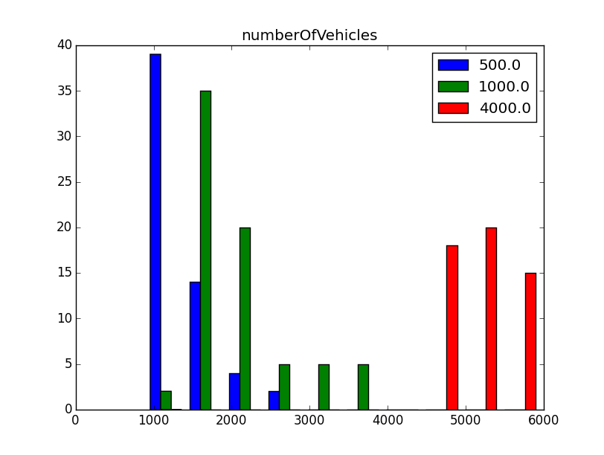

Total number of vehicles compared to baseline / full saturation
(AVs + Cars) / 7500 (~ baseline)
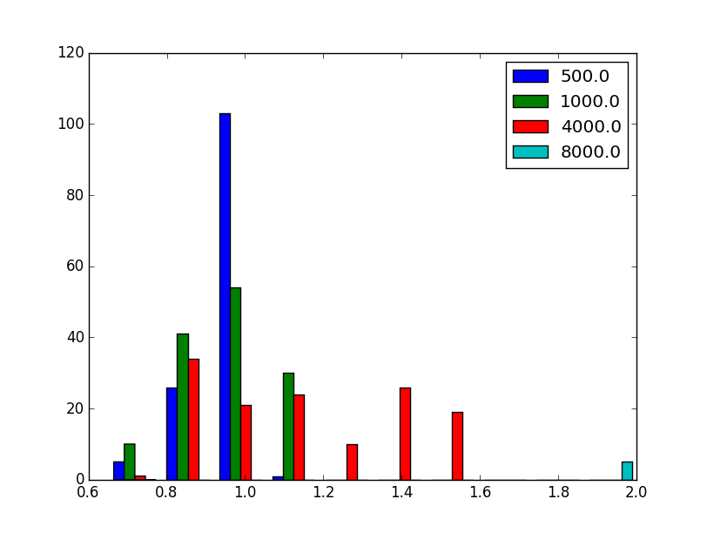 | 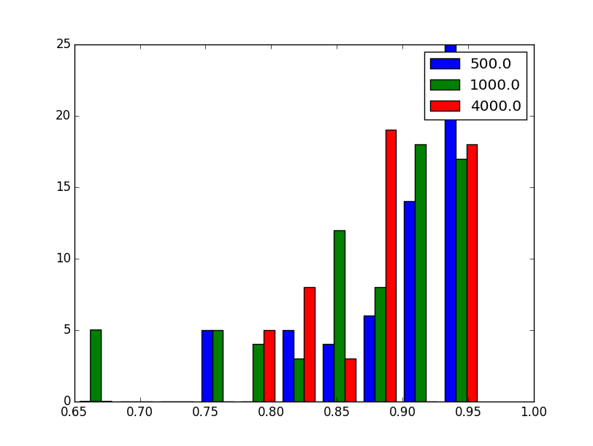

Right Now
- Fix last problems with simple model
- Use simpler optimization algorithm (e.g. just L2 norm / Quadtree?)
- Check that score distributions make sense!
- Do analysis again, main purpose to finish up the tools for analysis
- Afterwards adjust simulation to the model of the Boesch study
- Fix waiting time!

Upcoming

Operator Model
- Different fees for the users could be imposed:
  - per Distance
  - per Ride (booking) / per Subscription (using the car somewhere during the day)
- Costs for the operator
  - per Distance
  - per Car
- Costs can be defined similarly to “car” mode, fees have to be chosen accordingly
- Problem: Different pricing will lead to different agent choices… one can find an equilibrium using a feedback loop / large scale optimization

(Theoretic) comparison with established taxi schemes
- Taxi market is highly subsidised, no classic supply/demand structure
- Compare to AVs: Easier to calculate (no cursing needed etc)

Data-based reasoning for the parameter vallues
- Preference studies along the lines of “How likely would you be to enter an autonomous vehicle?” exist

Comparison with previous demand analysis
- Countless studies that come to quite different results depending on how the simulation is done

Relax initial distribution
- Modify in early iterations, later on keep it fixed
- Maybe not necessary at all
- put them where they ended / put them where the start legs are / put them where the people are

Taxi allocation
- A lot of ideas: Iteratively find congestion on the network, e.g. plan trips according to that and therefore save time compared to cars (btw, has this been done with cars somwhere already? Would make sense to give “more knowledge” to a certain share of drivers)

Willingness to pay vs. utility
- As mentioned roughly before, utility could be generalized to the score: How is the dependency of the score (or single utilities) to the pricing scheme?

Faster Allocation
- Small improvement: Cache distances, reuse them, maybe parallelize optimization for the sake of optimality (need to check if and how this is possible with the Dijkstra implementation), also the problem of time-dependent road maps!
- Otherwise simple queue allocation exists (but is quite dumb, probably not nearly the same performance, but might be interesting to examine how much the difference actually is)
- Possible heuristic:
  - Find free cars at the start node → if there is one, take it!
  - Find cars that are currently going to the start node (this is cached already) → if they arrive within a certain time limit, assign it! (Actually this has quite a good resemblance in the Boesch paper!)
  - If no car has been found yet, find optimal car as before
- Another possibility: Instead of finding the nearest car in terms of network, use a simple L2 or even L1 norm, maybe even find travel distance – travel time distribution for the network and use an approximate measure?
- Generally: It might be worth to look into and compare different allocation strategies and maybe even find some scaling evidence in terms of computational complexity? Though not sure if this is beyong the scope of the thesis…

Intelligent distribution
- AVs could be distributed not only based on the start nodes of the agents, but also according to a “heat map” where agents are likely to start a trip during the day (or in general, also in the beginning if one does not assume “prebooked trips”

Statistical Utility Ideas
- Scores depend on distance and time distribution of trips
- Mode choice is based on softmax function
- Maybe possible: Infer what utility parameters are needed to arrive at a 70% share of AVs

Notes

AV Boesch
- Based on generated car trips from a MATSim demand simulation, a certain fraction of trips is chosen to be AV-based and simulated afterwards
- Initial Distribution
  - Sample random agents from the demand
  - Put an AV at their start location (in that study the AV supply is always <= demand)
- Request / Arrival
  - Request is made 5min before preceding activity ends
  - People expect AV to arrive 5min after request
  - “Served in time” if AV arrives within this time
  - “Served late” if AV arrives within 10min after request
  - Otherwise request is dropped and marked “unserved”
- Allocation
  - Determine closest AV to to request location (L2)
  - Determine if expected travel-time to req location is within the 10min buffer time
  - If no AV is found, try again next simulation step (1 second interval)
  - If one is found, it is assigned, no subsequent testing for better alternatives is done
- “Movement” to the request is based on a beeline distance times an average speed
- “Movement” of the passenger is simulated using the trip from the demand simulation

- Should be able to implement that in general, it is easy to let people “wait” and try this very easy heuristic in every time step. PT does similar thing if boarding is denied.
- But how are not served requests handled? If those agents use AVs anyways, the cars will not be available for the other agents, thus changing the supply. There is the ABORT state… maybe use it here? How is it handled in the scoring?

Quadtree
- Can be used to at least get a small selection of candidates and then compute actual distances
- If the “close set” is empty, other ideas…

DynActivityEngine
- Do not loop every iteration
- Create list of “interrupts” when PassengerActivity is done…
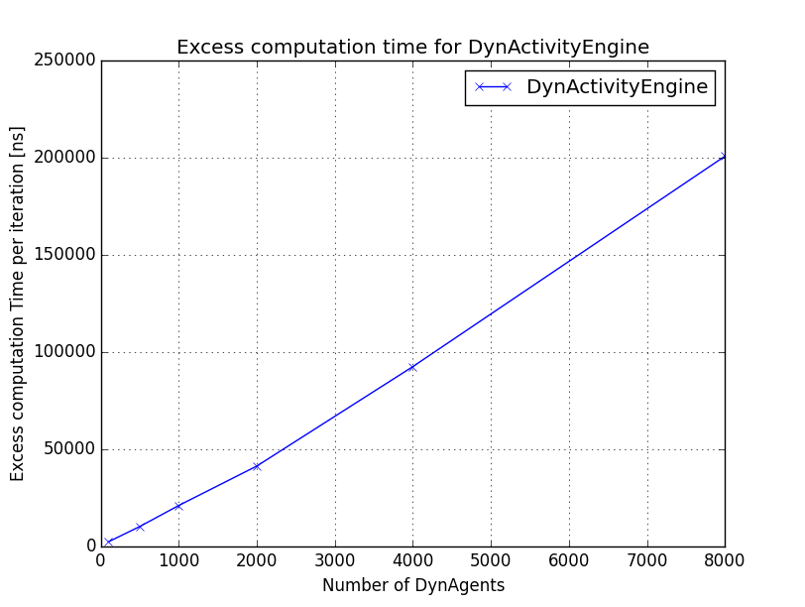
- Agents have only been ideling, i.e. not doing anything but checking whether a job is assigned

Objections Boesch Model
- Difficulty of dropped trips: In Boesch model, those requests are just deleted, so there is less cascading demand for AVs
- [1] Random assignment: Scoring problem! Really badly scored AV trips are collected if no suitable vehicle could be found, those trips clutter the repertorie of the agents and are really unlikely to be selected and refined, thus they just drag the overall score down
  - Check: Is this really the explanation for the scoring behavior?
- Thus: Load balancing model is better (even simple nearest neighbor), but especially an unadaptive distribution strategy might be beneficial, i.e. not randomly choosing who has a car to start, but distributing cars according to population density. This way the population can adapt towards a Nash equilibirum. Otherwise, a trip that was very promising in the beginning might get a really bad score in a subsequent iteration, just because there was no car available!

Random Distribution
- See above [1], if one has a fixed start distribution, this behaviour cannot be observed anymore.
- Downside: This puts a constraint on the spatial choice distribution. i.e. the “choice” of AV depends quite on availability. It would be nice to see the usage correlate to income level etc.
- Still, might it be better to createa a custom Replanning Module and kick out the bad plans? After all in that case, people should realize that AVs are not available for them
- planSelectorForRemoval = SelectExpBetaForRemoval seems to solve the problem!
- It was a problem with the waiting time scoring! Actually everything works as expected!
- Nevertheless, thoughts about “throwing out” the plans for variable distribution might still be true, i.e. plans would relax to “as few AV plans as possible”, because AV plans after turning of innovation would degrade due to inavailability of vehicles, OR it would stabilize at a level that is definitely

Bifurcation effects
- Should be possible to observe bifurcations with MATSim
- Bring system to an equilibirum state, then e.g. vary pricing slightly, find equilibirum again and so on, then plot how the equilibirum depends on the pricing. This can be done from a low-demand situation, slowly increasing the price and also with a high-demand scenario, slowly decreasing the price. Theoretically it could be possible to observe a hysteresis curve.

Parking
- Where do cars park when they are done?
- Are there MATSim extensions that can be easily used for that?

Last Mile
- Implement replanning strategy that works for the last mile problem

Parallel Processing
- Mchal: Is DynActivityEngine thread-safe?
- DynAgent finishes leg, but modifies a normal agent, which is in a Netsim currently → What happens?

Artem's Modules
- Should they be included? Probably some modifications needed for MATSim master.

First Meeting
ciari teleportation study scenario definition

how is waiting scored (done)

experiments
---------------------

cost: low 0.4 / km - high 1 / km
250 / 1000 , 150 / 1000, 50 / 1000

compare computational time of different fleet sizes

Simulation Framework

MATSim Framework
- How does it work
- Queue simulation
- Replanning, Evolutionary Algorithm
- Problem: Dynamic acitivties are contrary to queue based concept

Scoring
- Marginal utility, Charypar-Nagel utility function

DVRP Extension
- Approach
- Problem: Polling
- Taxi problem easier to handle

Within-day replanning
- Approach
- Improvement
- Show difference, computational complexity considerations

Basic Model of an Autonomous Taxi Service

Previous Work and Models
- Boesch
- Macjiewski, Bischoff
- Parameter estimation

Initial distribution
- Dynamic distribution: Scoring problem
- Static distribution: No results on spatial distribution of requests!

Allocation strategy
- Problem: No dynamic replanning, every leg needs to be served
- Structural problem, probably depends on spatial structure and much more
- Caution: Some “islands” might not be served if nearest-neighbor searches are used
  - Scoring problem, see above

Parameter Definition

Scenario Definition

Simulation Results

Operator Model
...

