🛠️ Lab: "The Broken Hostname"
Network Debugging – Individual Home Activity
🇬🇧 English Version

Background
Your company's internal wiki is supposed to be accessible at wiki.local. A colleague says it's down. Your job is to investigate and fix it.

Setup (takes 2 minutes)
Add this WRONG entry to your hosts file:

• Windows:
C:\Windows\System32\drivers\etc\hosts
• Mac/Linux:
/etc/hosts

Add this line at the bottom:
1.2.3.4 wiki.local

Your Tasks

Task 1 — Confirm the problem
Run:
ping wiki.local
❓ What IP does it resolve to? Is it reachable? What is the error?

Task 2 — Check DNS resolution
Run:
nslookup wiki.local
❓ Where is the answer coming from — your DNS server or a local override?

Task 3 — Trace the path
Run:
tracert wiki.local (Windows)
traceroute wiki.local (Mac/Linux)
❓ How many hops before it times out? Where does it die?

Task 4 — Fix the problem
Edit the hosts file again and point wiki.local to your own machine:
127.0.0.1 wiki.local
Re-run ping wiki.local and nslookup wiki.local.
❓ What changed? Is it reachable now? Why?

Task 5 — Reflect
Answer in 2–3 sentences:
- What was the root cause of the outage?
- In a real company, what tool or system could have caused this misconfiguration automatically?
- How would you prevent it?

What to Submit
- Screenshots of each command output
- Written answers to the ❓ questions

Solutions

Task 1: It resolves to IP 1.2.3.4, which is not reachable due to “Request timed out”.
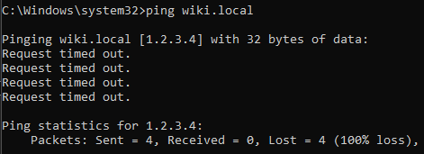

Task 2: The answer comes from my DNS server.
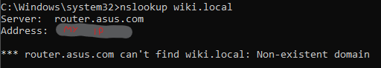

Task 3: It dies after 5 hops without leaving the ISP’s internal network.
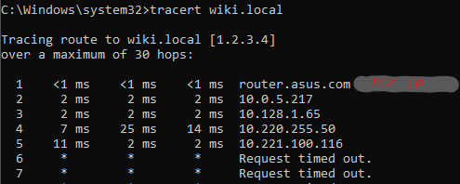

Task 4: Ping works now because 127.0.0.1 is the loopback address. Nslookup still fails because it queries the DNS server, no matter what’s on my “hosts” file.
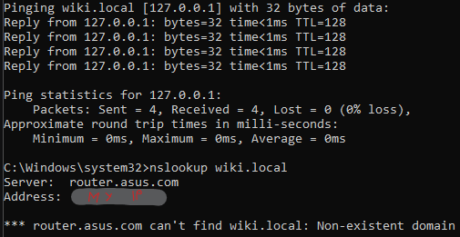

Task 5:

Task 5:
- The root cause was a wrong address in the hosts file. Therefore, the OS ignored the actual DNS server and routed traffic to a non-existent IP.
- Relying on “hosts” files is not good practice. This could’ve been caused by automation scripts like Ansible or SCCM.
- Stop trusting local files for corporate routing. Revoke local administrator privileges to block manual edits.

