Spectra & Filter Efficiency Calculation

Inhaltsverzeichnis
1 The main program - Spectra 2
1.1 Spectral Data Files 3
2 Main Functions 3
2.1 File 3
2.2 Dyes 3
2.3 Filter 4
2.4 Light Source 4
2.5 Miscellaneous Spectra 4
2.6 Fura Excitation 5
2.7 Laser Lines 5
2.8 Raman Lines 5
2.9 Filter Efficiency 5
2.9.1 Scaling Options 6

The main program - Spectra
In order to use the software one must install Python and some additional modules. The easiest way is probably to install and complete Python distribution called PythonXY. It can be found here:
http://www.pythonxy.com/
Actually required modules are:
- Python 2.6
- numpy
- scipy
- wxPython
- matplotlib

Once everything is installed the program can be started just by double-clicking the python script called spectra.py and you should see this:
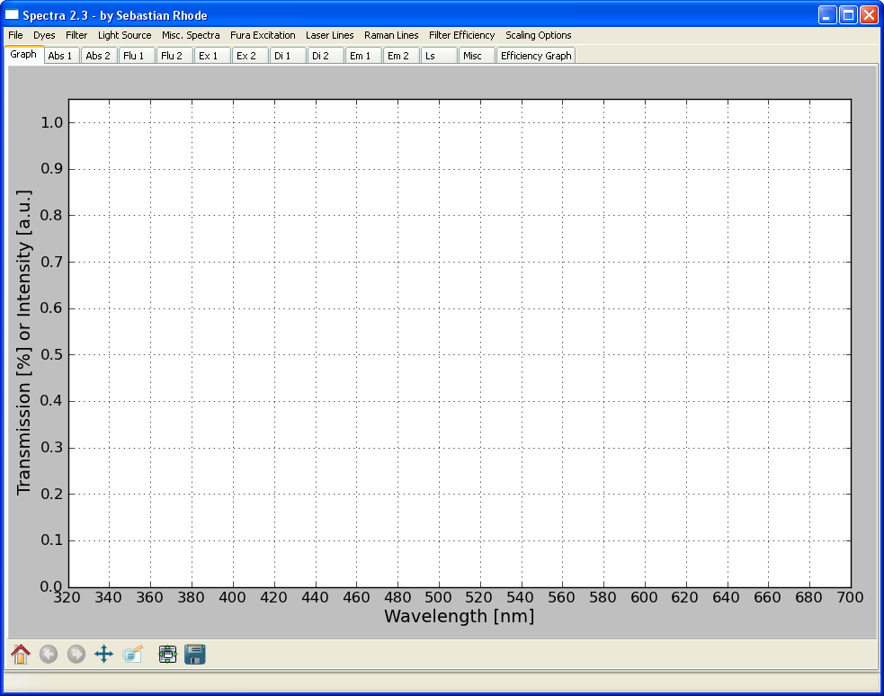

Spectral Data Files
All used spectral data files must have the following specs:
- 1st column → wavelength [nm]
- 2nd column → transmission / intensity
- decimal separator = . (point, not comma)

All those files are actually text files. The file extensions were adapted:
- *.abs → dye absorption
- *.flu → dye emission
- *.ex → excitation filter
- *.di → dichroic mirror
- *.em → emission filter
- *.ls → light source
- *.txt → any spectral file

Main Functions

The main purpose of spectra is to easily display spectral data of dyes and filters to enable the user to select the appropriate “dye/filter/light source” combination.

File
- Save Graph As or Save Efficiency Graph As → opens save dialog
- Set Working Directory → allows to set a directory (where the dyes & filter are)
- Quit → ends the program

Dyes
- Load Dye Absorption / Emission → displays *.abs or *.flu spectral data file
- Delete Dye Absorption / Emission → deletes absorption or emission data
- works for 2 sets of dyes

Filter
- Load Excitation / Dichroic Mirror / Emission Filter → displays *.ex or *.di or *.em spectral data file
- Delete Excitation / Dichroic Mirror / Emission Filter → deletes the data
- works for 2 sets of filters
- allows simulation of 1 bandpass filter

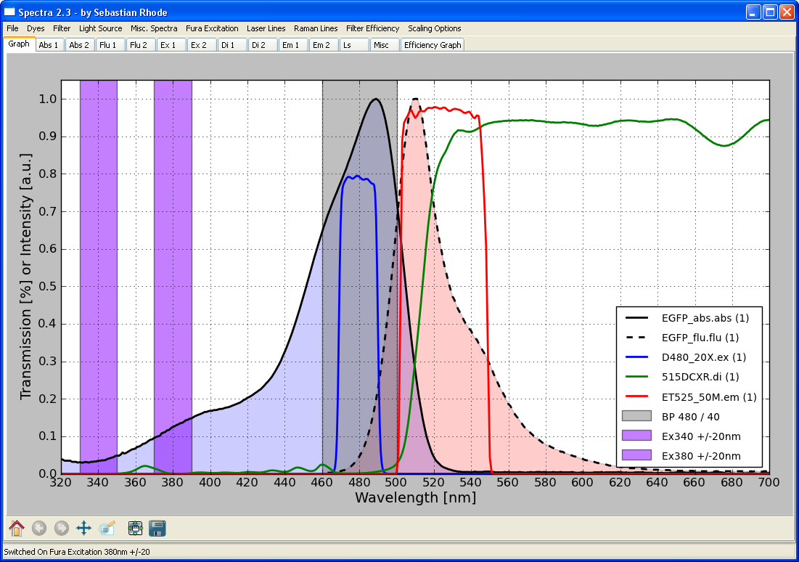

Light Source
- Load Light Source → displays *.ls spectral data file
- Delete Light Source → deletes light source from graph page

Miscellaneous Spectra
- Load Miscellaneous Spectra → displays *.txt spectral data file
- Delete Light Source → deletes miscellaneous spectral data from graph page

Fura Excitation
- displays Fura 340/380 excitation bar to check for filter compatibility

Laser Lines
- displays various laser lines with the corresponding color
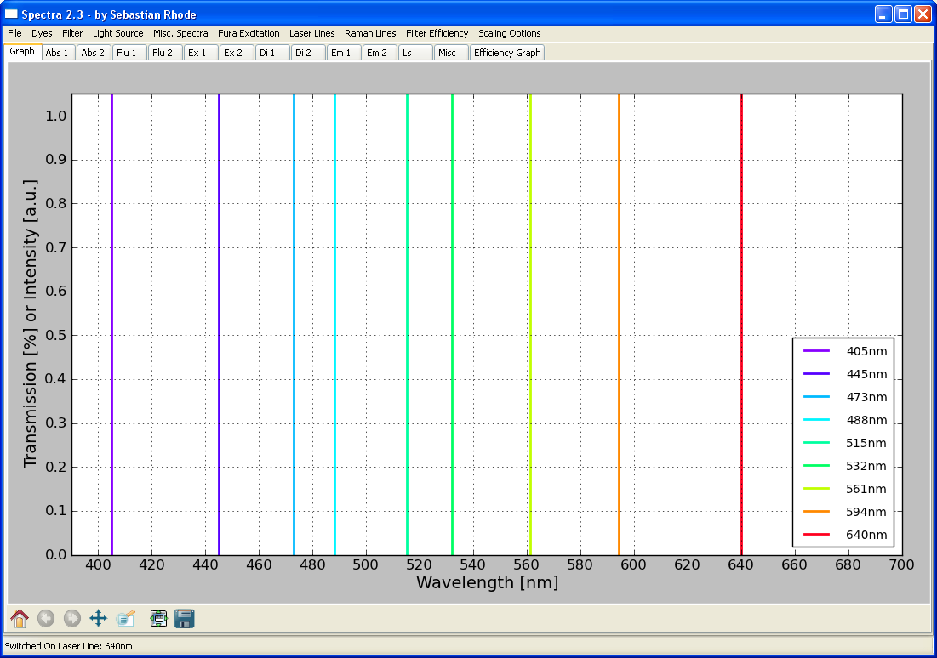

Raman Lines
- displays possible Raman laser lines for glas and water

Filter Efficiency
- allows an „rough“ estimation of the detection efficiency
- a seperate dialog windows allows choosing the required spectral data
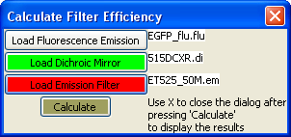
- to see the calculated curves the Efficieny Graph must be in focus
  - fluorescence emission spectra is filtered by dichroic and emission filter
  - the areas under the curves are compared
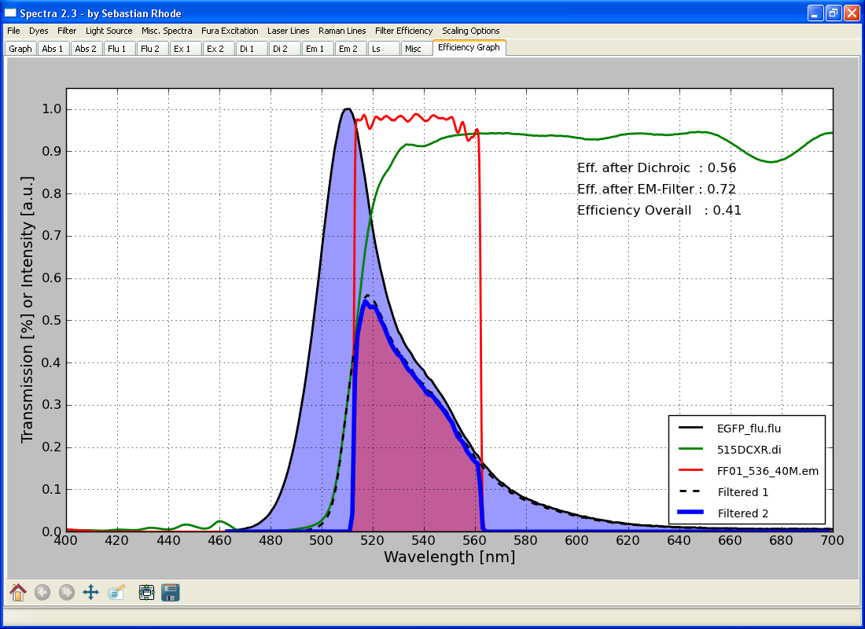

Scaling Options
- Allows adjusting the left and right border of the Graph and Efficiency Graph

