**[served](https://ixox.fr/forum/index.php?action=profile;u=43897" \o "View the profile of served)**

* Team Member
* **
* Posts: 68
  + [View Profile](https://ixox.fr/forum/index.php?action=profile;u=43897)

* + [Van Daal Electronics](http://vandaal-electronics.com/)

https://ixox.fr/forum/Themes/default/images/post/thumbup.gif

[**PreenFM Eurorack module**](https://ixox.fr/forum/index.php?topic=69505.msg73206#msg73206)

« **on:** January 04, 2019, 03:14:39 PM »

Hello,  
  
I am starting this thread to give more information about the PreenFM Eurorack implementation.  
  
We have now finished the case design.  
  
Beta panel looked like this but had some mounting issues etc. So we had to make a change.  
  
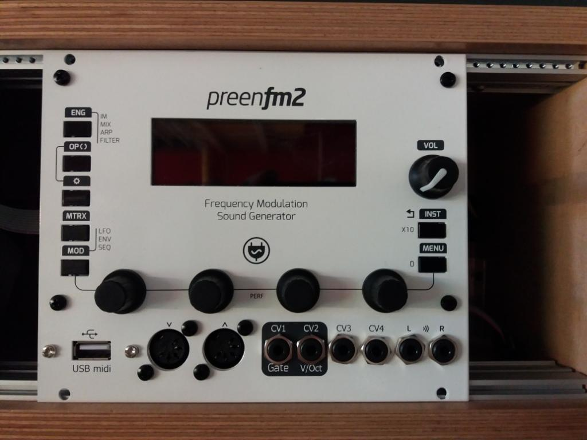  
  
Current and the latest revision.  
  
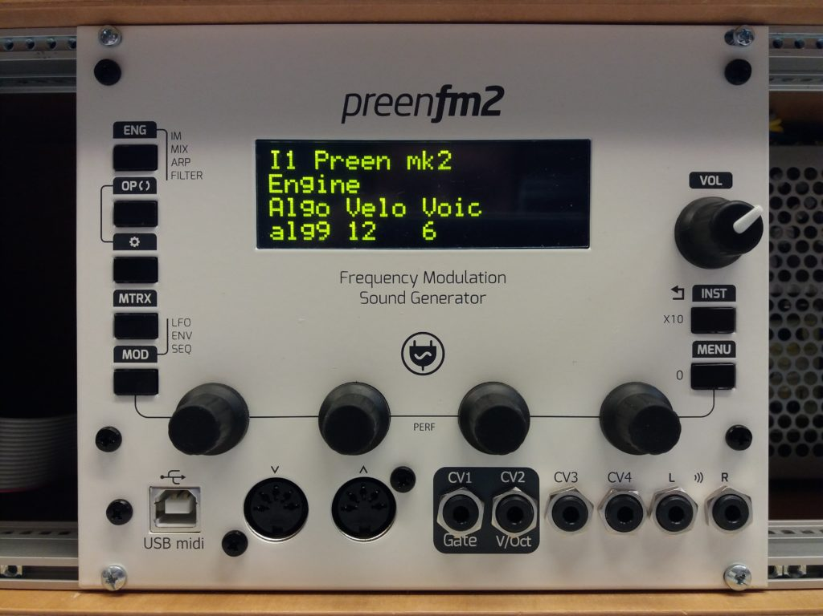  
  
  
Unit has total of 5 different PCBs. So its a bit complex build but it can be DIY kitted and assembled with good instructions.  
  
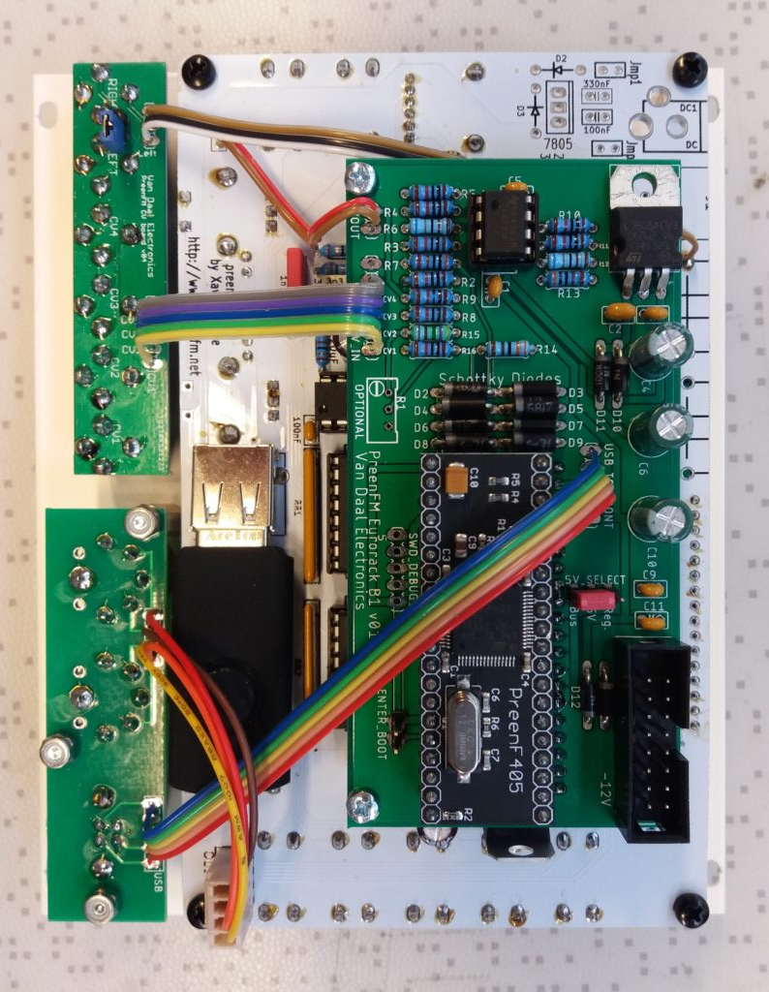  
  
  
  
CV1 is routed to GATE and it triggers a note.   
Gate input is limited to 3V pulse. So it is only capable to trigger something like Gate but also it can be mapped to the matrix.  
  
CV2 is routed to V/Oct input. It is designed to get 0V to 10V input. 1V is one octave. PreenFM is using only 8 octaves on that input.  
CV3 and CV4 are similar -5V to +5V.   
  
All the inputs are buffered and voltage protected. meaning that they can take anything coming from Eurorack system.  
  
CV1-4 inputs can be mapped to matrix parameters.  
Options:  
  
None;  
Gate;  
IM1; IM2; IM3; IM4; IM*  
Mix1; Pan1; Mix2; Pan2; Mix3; Pan3; Mix4; Pan4; Mix*; Pan*;  
o1Fq; o2Fq; o3Fq; o4Fq; o5Fq; o6Fq; o*Fq; o*Fh  
Att1; Att2; Att3; Att4; Att5; Att6; AttC; AttM;  
DecC; DecM; RelC; RelM  
mx01; mx02; mx03; mx04  
l1Fq; l2Fq; l3Fq;  
e2si; s1ga; s2ga;  
Fltr  
  
PSU section.  
Takes a normal Eurorack +/-12V power and +5V. There is an onboard 5V regulator if your eurorack system doesnt have a 5V rail.  
You can choose to use that regulator by connecting a jumper to "Reg." position. Or to "Bus" if you have a 5V bus.  
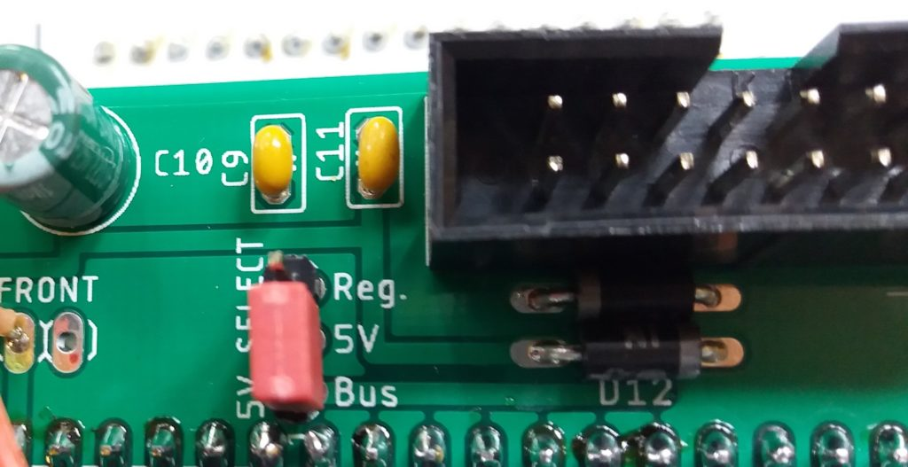  
  
On the Audio outputs there is an option to use a stereo cable by having a jumper installed to RIGHT-LEFT link pins.  
Then Stereo output is LEFT channel out.  
  
USB power has 5V supply cut to escape various powering issues.  
  
31HP in width.  
Total 400mA current draw, using +5V; +12V; -12V; bus.  
  
V/Octave calibration process:  
Menu > Tools > Set > to adjust v/oct (first 3 encoders change the parameter, last 4th encoder changes the value)  
You need to adjust CV A(33) (midi note 33) and adjust CV A(81) (midi note 81).  
This will scale the V/Oct with out the need to adjust each octave one by one.  
Example values are: CV A(33) 256 and CV A(81) 735. Each unit has its own values and depend on your voltage generator settings.  
  
I will post some videos in the near future how it performs.  
  
We will start to produce the modules assembled this month.  
They will become available here: <http://vandaal-electronics.com/product/preenfm-eurorack-module/>  
  
  
Any feedback is welcome and will help with the developement!

« *Last Edit: March 07, 2019, 01:17:04 PM by Xavier* »

https://ixox.fr/forum/Themes/default/images/ip.gif Logged

[http://vandaal-electronics.com](http://vandaal-electronics.com/)

[**benjaminr**](https://ixox.fr/forum/index.php?action=profile;u=80733)

* Team member
* *
* Posts: 13
  + [View Profile](https://ixox.fr/forum/index.php?action=profile;u=80733)

https://ixox.fr/forum/Themes/default/images/post/xx.gif

[**Re: PreenFM Eurorack module**](https://ixox.fr/forum/index.php?topic=69505.msg73207#msg73207)

« **Reply #1 on:** January 04, 2019, 03:22:57 PM »

Very excited about this! Built mine in a panel with the CV inputs, but they're not hooked up to anything yet. I need to learn more about voltage scaling first lol. I will definitely watch the videos and read any docs you have when there available! Keep up the good work!

https://ixox.fr/forum/Themes/default/images/ip.gif Logged

[**served**](https://ixox.fr/forum/index.php?action=profile;u=43897)

* Team Member
* **
* Posts: 68
  + [View Profile](https://ixox.fr/forum/index.php?action=profile;u=43897)

* + [Van Daal Electronics](http://vandaal-electronics.com/)

https://ixox.fr/forum/Themes/default/images/post/xx.gif

[**Re: PreenFM Eurorack module**](https://ixox.fr/forum/index.php?topic=69505.msg73209#msg73209)

« **Reply #2 on:** January 04, 2019, 03:45:03 PM »

Tested the PreenFm with Doepfer A-105 filter and it plays really well.   
So Preen audio output should be enough for most of the Eurorack modules.

https://ixox.fr/forum/Themes/default/images/ip.gif Logged

[http://vandaal-electronics.com](http://vandaal-electronics.com/)

[**served**](https://ixox.fr/forum/index.php?action=profile;u=43897)

* Team Member
* **
* Posts: 68
  + [View Profile](https://ixox.fr/forum/index.php?action=profile;u=43897)

* + [Van Daal Electronics](http://vandaal-electronics.com/)

https://ixox.fr/forum/Themes/default/images/post/xx.gif

[**Re: PreenFM Eurorack module**](https://ixox.fr/forum/index.php?topic=69505.msg73223#msg73223)

« **Reply #3 on:** January 09, 2019, 07:14:53 AM »

On request by Matthis I have made a post into ModularGrid database.  
PreenFM Module can be found at [www.modulargrid.net/e/other-unknown-preenfm](http://www.modulargrid.net/e/other-unknown-preenfm)  
  
This is just a demo-post to test how it acts. I will fill in the correct information in near future!  
  
Measured Current Draw on each rail.  
  
-12VDC 10mA  
+12VDC 20mA  
+5VDC 250mA

« *Last Edit: January 09, 2019, 12:18:00 PM by served* »

https://ixox.fr/forum/Themes/default/images/ip.gif Logged

[http://vandaal-electronics.com](http://vandaal-electronics.com/)

[**served**](https://ixox.fr/forum/index.php?action=profile;u=43897)

* Team Member
* **
* Posts: 68
  + [View Profile](https://ixox.fr/forum/index.php?action=profile;u=43897)

* + [Van Daal Electronics](http://vandaal-electronics.com/)

https://ixox.fr/forum/Themes/default/images/post/xx.gif

[**Re: PreenFM Eurorack module**](https://ixox.fr/forum/index.php?topic=69505.msg73224#msg73224)

« **Reply #4 on:** January 09, 2019, 02:09:00 PM »

First video uploaded.  
  
<https://youtu.be/Lq88y8aF-hE>

https://ixox.fr/forum/Themes/default/images/ip.gif Logged

[http://vandaal-electronics.com](http://vandaal-electronics.com/)

[**benjaminr**](https://ixox.fr/forum/index.php?action=profile;u=80733)

* Team member
* *
* Posts: 13
  + [View Profile](https://ixox.fr/forum/index.php?action=profile;u=80733)

https://ixox.fr/forum/Themes/default/images/post/xx.gif

[**Re: PreenFM Eurorack module**](https://ixox.fr/forum/index.php?topic=69505.msg73225#msg73225)

« **Reply #5 on:** January 09, 2019, 11:49:02 PM »

Yesssss. :D:D:D

https://ixox.fr/forum/Themes/default/images/ip.gif Logged

[**Fizmo**](https://ixox.fr/forum/index.php?action=profile;u=49371)

* Team member
* *
* Posts: 1
  + [View Profile](https://ixox.fr/forum/index.php?action=profile;u=49371)

https://ixox.fr/forum/Themes/default/images/post/xx.gif

[**Re: PreenFM Eurorack module**](https://ixox.fr/forum/index.php?topic=69505.msg73228#msg73228)

« **Reply #6 on:** January 11, 2019, 06:11:03 PM »

[**Quote from: served on January 09, 2019, 02:09:00 PM**](https://ixox.fr/forum/index.php?topic=69505.msg73224#msg73224)

First video uploaded.  
  
<https://youtu.be/Lq88y8aF-hE>

Cool!!! :D When will it be available for order?

https://ixox.fr/forum/Themes/default/images/ip.gif Logged

[**served**](https://ixox.fr/forum/index.php?action=profile;u=43897)

* Team Member
* **
* Posts: 68
  + [View Profile](https://ixox.fr/forum/index.php?action=profile;u=43897)

* + [Van Daal Electronics](http://vandaal-electronics.com/)

https://ixox.fr/forum/Themes/default/images/post/xx.gif

[**Re: PreenFM Eurorack module**](https://ixox.fr/forum/index.php?topic=69505.msg73232#msg73232)

« **Reply #7 on:** January 13, 2019, 05:40:35 PM »

[**Quote from: Fizmo on January 11, 2019, 06:11:03 PM**](https://ixox.fr/forum/index.php?topic=69505.msg73228#msg73228)

[**Quote from: served on January 09, 2019, 02:09:00 PM**](https://ixox.fr/forum/index.php?topic=69505.msg73224#msg73224)

First video uploaded.  
  
<https://youtu.be/Lq88y8aF-hE>

Cool!!! :D When will it be available for order?

Few weeks to go! I will post when they are in stock.

https://ixox.fr/forum/Themes/default/images/ip.gif Logged

[http://vandaal-electronics.com](http://vandaal-electronics.com/)

[**served**](https://ixox.fr/forum/index.php?action=profile;u=43897)

* Team Member
* **
* Posts: 68
  + [View Profile](https://ixox.fr/forum/index.php?action=profile;u=43897)

* + [Van Daal Electronics](http://vandaal-electronics.com/)

https://ixox.fr/forum/Themes/default/images/post/xx.gif

[**Re: PreenFM Eurorack module**](https://ixox.fr/forum/index.php?topic=69505.msg73234#msg73234)

« **Reply #8 on:** January 17, 2019, 09:03:30 AM »

Time schedule:  
  
1) Stock of Assembled Eurorack modules: End of January/Beginning of February  
2) Eurorack DIY Full kit and assembly instructions: Around April.  
3) DIY kit to build your PreenFM into Eurorack version: Later around April.  
4) Semimodular tabletop PreenFM: Around summer period.   
  
Lets hope it all goes faster actually. But thouse times are reachable.

https://ixox.fr/forum/Themes/default/images/ip.gif Logged

[http://vandaal-electronics.com](http://vandaal-electronics.com/)

[**served**](https://ixox.fr/forum/index.php?action=profile;u=43897)

* Team Member
* **
* Posts: 68
  + [View Profile](https://ixox.fr/forum/index.php?action=profile;u=43897)

* + [Van Daal Electronics](http://vandaal-electronics.com/)

https://ixox.fr/forum/Themes/default/images/post/xx.gif

[**Re: PreenFM Eurorack module**](https://ixox.fr/forum/index.php?topic=69505.msg73241#msg73241)

« **Reply #9 on:** January 31, 2019, 11:05:09 AM »

Started a besic video tutorial series for PreenFM  
No audio. Just a task in the topic and deomstration.  
As it turns out some people dont know how to load patches and do other stuff.  
<https://www.youtube.com/watch?v=jc-VuiMIuLI&list=PL238wWrYx5q7TxD_buGOsudcFCfYaRdaE>

https://ixox.fr/forum/Themes/default/images/ip.gif Logged

[http://vandaal-electronics.com](http://vandaal-electronics.com/)

[**served**](https://ixox.fr/forum/index.php?action=profile;u=43897)

* Team Member
* **
* Posts: 68
  + [View Profile](https://ixox.fr/forum/index.php?action=profile;u=43897)

* + [Van Daal Electronics](http://vandaal-electronics.com/)

https://ixox.fr/forum/Themes/default/images/post/xx.gif

[**Re: PreenFM Eurorack module**](https://ixox.fr/forum/index.php?topic=69505.msg73249#msg73249)

« **Reply #10 on:** February 04, 2019, 07:16:46 PM »

The Third version will introduce fully functional CV1 CV2 CV3 CV4 with +/-5V CV input.  
Switchable CV1 CV2 to 0-10V CV signals.  
  
Digitally Adjustable gate level. Firmware update made by Xavier.

« *Last Edit: February 05, 2019, 09:13:40 AM by served* »

https://ixox.fr/forum/Themes/default/images/ip.gif Logged

[http://vandaal-electronics.com](http://vandaal-electronics.com/)

[**prephylve1**](https://ixox.fr/forum/index.php?action=profile;u=63235)

* Team member
* *
* Posts: 16
  + [View Profile](https://ixox.fr/forum/index.php?action=profile;u=63235)

https://ixox.fr/forum/Themes/default/images/post/xx.gif

[**Re: PreenFM Eurorack module**](https://ixox.fr/forum/index.php?topic=69505.msg73251#msg73251)

« **Reply #11 on:** February 05, 2019, 06:09:09 PM »

Will there be an adapter kit for those of us with an already built PFM2? I would love to add this functionality to my PFM2. Is it possible for it to work unracked? Thanks for all of this work btw. Its amazing!

https://ixox.fr/forum/Themes/default/images/ip.gif Logged

[**served**](https://ixox.fr/forum/index.php?action=profile;u=43897)

* Team Member
* **
* Posts: 68
  + [View Profile](https://ixox.fr/forum/index.php?action=profile;u=43897)

* + [Van Daal Electronics](http://vandaal-electronics.com/)

https://ixox.fr/forum/Themes/default/images/post/xx.gif

[**Re: PreenFM Eurorack module**](https://ixox.fr/forum/index.php?topic=69505.msg73255#msg73255)

« **Reply #12 on:** February 07, 2019, 07:14:40 AM »

We are working on this. Its still unclear how it will exatly look like. But electronically such solution has been tested and it works with no issues.  
Case design and how to mount it is the next part now.

« *Last Edit: February 07, 2019, 07:29:31 PM by served* »

https://ixox.fr/forum/Themes/default/images/ip.gif Logged

[http://vandaal-electronics.com](http://vandaal-electronics.com/)

[**prephylve1**](https://ixox.fr/forum/index.php?action=profile;u=63235)

* Team member
* *
* Posts: 16
  + [View Profile](https://ixox.fr/forum/index.php?action=profile;u=63235)

https://ixox.fr/forum/Themes/default/images/post/xx.gif

[**Re: PreenFM Eurorack module**](https://ixox.fr/forum/index.php?topic=69505.msg73256#msg73256)

« **Reply #13 on:** February 10, 2019, 01:50:39 AM »

Amazing! I can’t wait!! I’ll definitely be grabbing a kit when its ready :) thank you

https://ixox.fr/forum/Themes/default/images/ip.gif Logged

[**served**](https://ixox.fr/forum/index.php?action=profile;u=43897)

* Team Member
* **
* Posts: 68
  + [View Profile](https://ixox.fr/forum/index.php?action=profile;u=43897)

* + [Van Daal Electronics](http://vandaal-electronics.com/)

https://ixox.fr/forum/Themes/default/images/post/xx.gif

[**Re: PreenFM Eurorack module**](https://ixox.fr/forum/index.php?topic=69505.msg73276#msg73276)

« **Reply #14 on:** February 22, 2019, 02:08:10 PM »

We have finished building the Pre-production patch of Eurorack modules.  
All the units come with Blue OLED screen.  
Also a Black front panel has been introduced and will be an option.  
  
A conflict with fat Eurorack aluminium rails has been discovered.  
It involves only some racks that have thicker aluminium rails.  
Doepfer and Gie-Tec type rails are fitting nicely.  
We will work on to make the unit fit. It introduces some adjustments on the PCB sizes.  
It only affects customers with odd rack rails.

[**served**](https://ixox.fr/forum/index.php?action=profile;u=43897)

* Team Member
* **
* Posts: 68
  + [View Profile](https://ixox.fr/forum/index.php?action=profile;u=43897)

* + [Van Daal Electronics](http://vandaal-electronics.com/)

https://ixox.fr/forum/Themes/default/images/post/xx.gif

[**Re: PreenFM Eurorack module**](https://ixox.fr/forum/index.php?topic=69505.msg73286#msg73286)

« **Reply #15 on:** March 06, 2019, 09:54:34 AM »

A guide for the jumper arrangement and Power connector.  
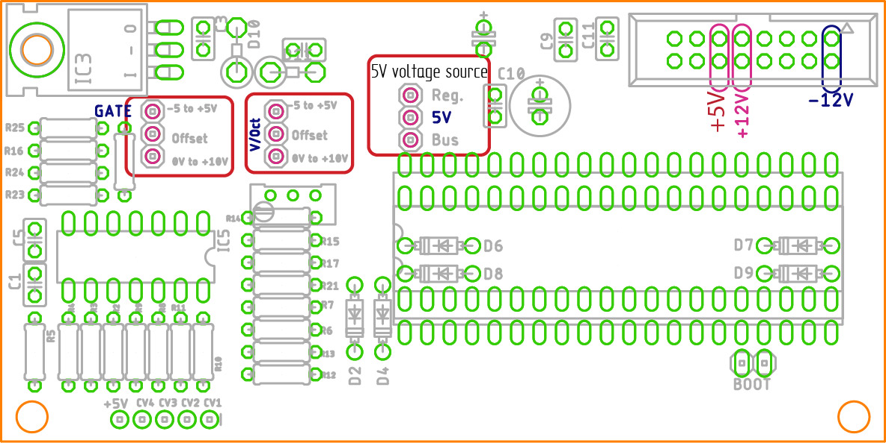

https://ixox.fr/forum/Themes/default/images/ip.gif Logged

[http://vandaal-electronics.com](http://vandaal-electronics.com/)

[**served**](https://ixox.fr/forum/index.php?action=profile;u=43897)

* Team Member
* **
* Posts: 68
  + [View Profile](https://ixox.fr/forum/index.php?action=profile;u=43897)

* + [Van Daal Electronics](http://vandaal-electronics.com/)

https://ixox.fr/forum/Themes/default/images/post/xx.gif

[**Re: PreenFM Eurorack module**](https://ixox.fr/forum/index.php?topic=69505.msg73287#msg73287)

« **Reply #16 on:** March 07, 2019, 12:48:46 PM »

We have realeased a DIY kit to build your existing PreenFM into Eurorack module.  
Its a full kit. You will have all the parts you need to do it.  
Due to differences in some version some extra steps and parts might be needed to complete the mod.  
  
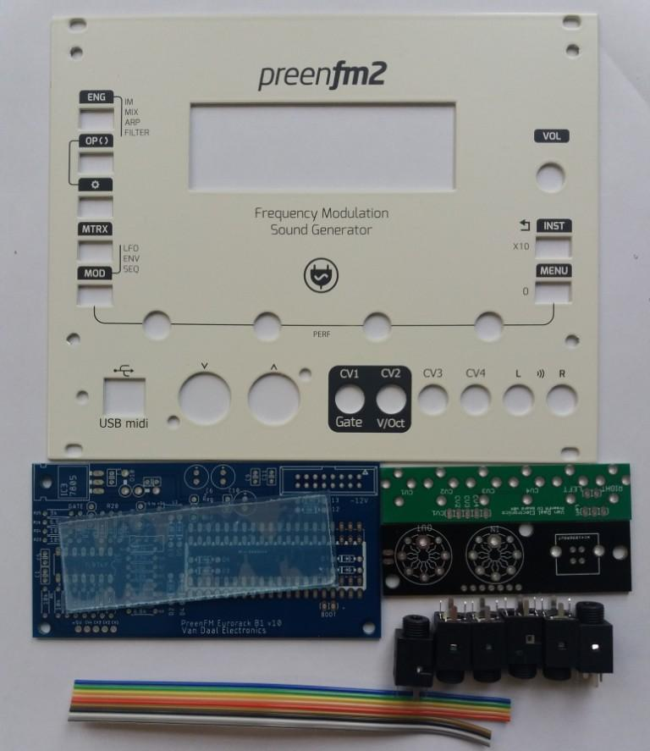

« *Last Edit: March 07, 2019, 01:00:55 PM by served* »

https://ixox.fr/forum/Themes/default/images/ip.gif Logged

[http://vandaal-electronics.com](http://vandaal-electronics.com/)

[**Xavier**](https://ixox.fr/forum/index.php?action=profile;u=2)

* Administrator
* Hero Member
* *
* Posts: 1362
  + [View Profile](https://ixox.fr/forum/index.php?action=profile;u=2)

https://ixox.fr/forum/Themes/default/images/post/xx.gif

[**Re: PreenFM Eurorack module**](https://ixox.fr/forum/index.php?topic=69505.msg73288#msg73288)

« **Reply #17 on:** March 07, 2019, 01:19:21 PM »

[**Quote from: served on March 07, 2019, 12:48:46 PM**](https://ixox.fr/forum/index.php?topic=69505.msg73287#msg73287)

We have realeased a DIY kit to build your existing PreenFM into Eurorack module.  
Its a full kit. You will have all the parts you need to do it.

This is awesome news !!!  8)  
Thanks Ardi for your work on that, I'll announce that tonight on facebook after i update github with the schema and the official CV firmware.

https://ixox.fr/forum/Themes/default/images/ip.gif Logged

[**Thonihz**](https://ixox.fr/forum/index.php?action=profile;u=67683)

* Team member
* *
* Posts: 2
  + [View Profile](https://ixox.fr/forum/index.php?action=profile;u=67683)

https://ixox.fr/forum/Themes/default/images/post/xx.gif

[**Re: PreenFM Eurorack module**](https://ixox.fr/forum/index.php?topic=69505.msg73302#msg73302)

« **Reply #18 on:** March 21, 2019, 07:27:29 PM »

Hello  
  
I received a preenfm2 eurorack retrofit diy kit  
  
Do you have a diagram of the electronic board?  
  
For example, i do not know the position of the diodes  
  
Thank you  
  
Best regards

https://ixox.fr/forum/Themes/default/images/ip.gif Logged

[**Thonihz**](https://ixox.fr/forum/index.php?action=profile;u=67683)

* Team member
* *
* Posts: 2
  + [View Profile](https://ixox.fr/forum/index.php?action=profile;u=67683)

https://ixox.fr/forum/Themes/default/images/post/xx.gif

[**Re: PreenFM Eurorack module**](https://ixox.fr/forum/index.php?topic=69505.msg73303#msg73303)

« **Reply #19 on:** March 22, 2019, 10:51:02 AM »

Pictures from Van Daal web  
Thanks to Ardi Mäesalu  
Excellent!!  
  
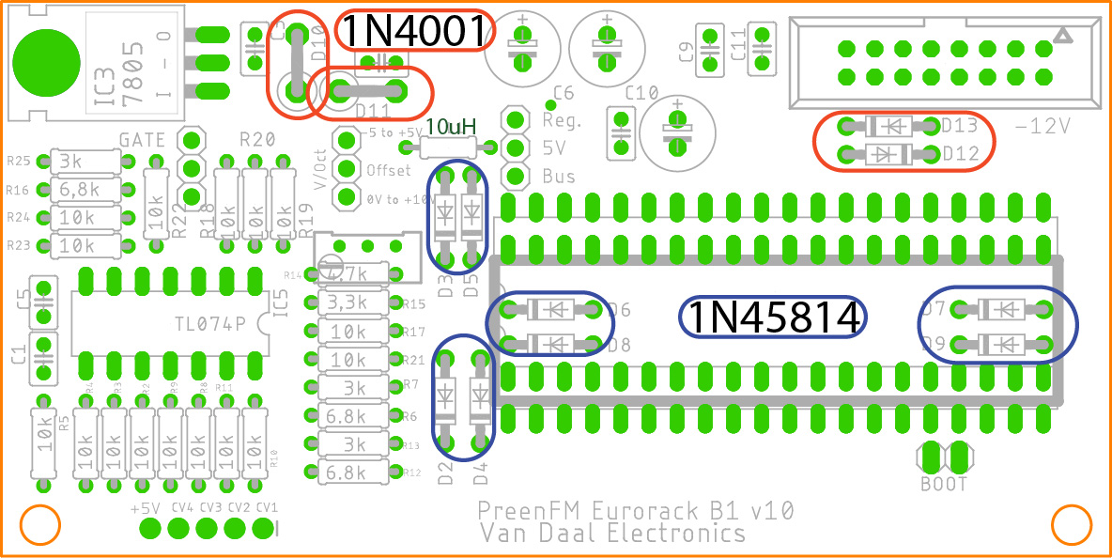  
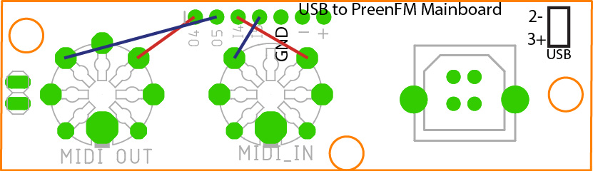  
  
D10-D13 are 1N4XXXX  
The rest 8 are Schotkey.  
 So 4 diodes in the PSU section or Upper section of the board are 1N4XXX.  
  
L1 can be replaced with wire. It might need an inductor if you have very noisy 5V supply in your eurorack.  
But its not mandatory.  
  
USB + and - should be wired to the PReenFM main board. There is a connector labeled USB 2- 3+.

https://ixox.fr/forum/Themes/default/images/ip.gif Logged

[**served**](https://ixox.fr/forum/index.php?action=profile;u=43897)

* Team Member
* **
* Posts: 68
  + [View Profile](https://ixox.fr/forum/index.php?action=profile;u=43897)

* + [Van Daal Electronics](http://vandaal-electronics.com/)

https://ixox.fr/forum/Themes/default/images/post/xx.gif

[**Re: PreenFM Eurorack module**](https://ixox.fr/forum/index.php?topic=69505.msg73304#msg73304)

« **Reply #20 on:** March 23, 2019, 08:54:18 PM »

Also. Dont forget to do the V/OCt callibration procedure.

https://ixox.fr/forum/Themes/default/images/ip.gif Logged

[http://vandaal-electronics.com](http://vandaal-electronics.com/)

[**tangram**](https://ixox.fr/forum/index.php?action=profile;u=74036)

* Team member
* *
* Posts: 3
  + [View Profile](https://ixox.fr/forum/index.php?action=profile;u=74036)

https://ixox.fr/forum/Themes/default/images/post/xx.gif

[**Re: PreenFM Eurorack module**](https://ixox.fr/forum/index.php?topic=69505.msg73308#msg73308)

« **Reply #21 on:** April 02, 2019, 08:14:56 PM »

Hello,  
I have now also bought the conversion kit and am still very disappointed.  
I have the following questions:  
Which software version is needed and where can I get it?   
Is there a reasonable construction manual for the modification?  
What about the IC3 7805? Do I have to solder it in?  
Where is the circuit diagram?  
  
I'm really in doubt whether I'm going to do the modification.  
The information is nevertheless very daring.  
Has a user of the Preem already done the modification?  
  
Greetings Klaus

https://ixox.fr/forum/Themes/default/images/ip.gif Logged

[**served**](https://ixox.fr/forum/index.php?action=profile;u=43897)

* Team Member
* **
* Posts: 68
  + [View Profile](https://ixox.fr/forum/index.php?action=profile;u=43897)

* + [Van Daal Electronics](http://vandaal-electronics.com/)

https://ixox.fr/forum/Themes/default/images/post/xx.gif

[**Re: PreenFM Eurorack module**](https://ixox.fr/forum/index.php?topic=69505.msg73309#msg73309)

« **Reply #22 on:** April 03, 2019, 07:22:27 AM »

What is your disapointment about?  
  
You need to poulate the boards and wire it together and your are ready to go.  
I will answer all your questions by email.  
  
Firmware is available on PreenFM Github.  
<https://github.com/Ixox/preenfm2/releases>  
Get this file: pfm2_Eurorack_2.09a.zip  
  
  
The modification has been done by many users.

« *Last Edit: April 03, 2019, 07:34:30 AM by served* »

https://ixox.fr/forum/Themes/default/images/ip.gif Logged

[http://vandaal-electronics.com](http://vandaal-electronics.com/)

[**served**](https://ixox.fr/forum/index.php?action=profile;u=43897)

* Team Member
* **
* Posts: 68
  + [View Profile](https://ixox.fr/forum/index.php?action=profile;u=43897)

* + [Van Daal Electronics](http://vandaal-electronics.com/)

https://ixox.fr/forum/Themes/default/images/post/xx.gif

[**Re: PreenFM Eurorack module**](https://ixox.fr/forum/index.php?topic=69505.msg73310#msg73310)

« **Reply #23 on:** April 03, 2019, 11:00:24 AM »

Another step on the way.  
A dedicated PCB for Semimodular/Eurorack design.  
The depth of this module is 3cm. Which makes it Skiff ready.  
A special Skiff is in developement. That will allow to use USB to power the system.  
  
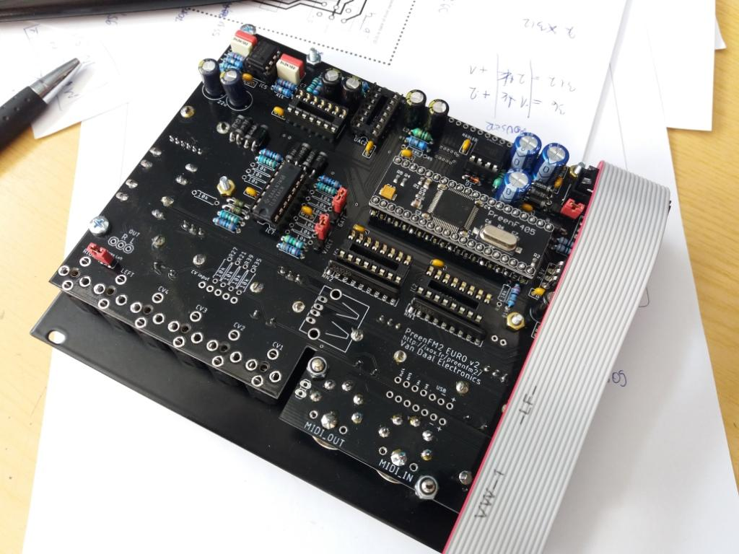

https://ixox.fr/forum/Themes/default/images/ip.gif Logged

[http://vandaal-electronics.com](http://vandaal-electronics.com/)

[**tangram**](https://ixox.fr/forum/index.php?action=profile;u=74036)

* Team member
* *
* Posts: 3
  + [View Profile](https://ixox.fr/forum/index.php?action=profile;u=74036)

https://ixox.fr/forum/Themes/default/images/post/xx.gif

[**Re: PreenFM Eurorack module**](https://ixox.fr/forum/index.php?topic=69505.msg73311#msg73311)

« **Reply #24 on:** April 03, 2019, 12:04:18 PM »

[**Quote from: served on April 03, 2019, 07:22:27 AM**](https://ixox.fr/forum/index.php?topic=69505.msg73309#msg73309)

What is your disapointment about?  
  
You need to poulate the boards and wire it together and your are ready to go.  
I will answer all your questions by email.  
  
Firmware is available on PreenFM Github.  
<https://github.com/Ixox/preenfm2/releases>  
Get this file: pfm2_Eurorack_2.09a.zip  
  
  
The modification has been done by many users.

ok, thanks for your information. I will try to do it.  
Klaus

https://ixox.fr/forum/Themes/default/images/ip.gif Logged

[**tangram**](https://ixox.fr/forum/index.php?action=profile;u=74036)

* Team member
* *
* Posts: 3
  + [View Profile](https://ixox.fr/forum/index.php?action=profile;u=74036)

https://ixox.fr/forum/Themes/default/images/post/xx.gif

[**Re: PreenFM Eurorack module**](https://ixox.fr/forum/index.php?topic=69505.msg73322#msg73322)

« **Reply #25 on:** **Today** at 12:43:13 AM »

[**Quote from: served on April 03, 2019, 07:22:27 AM**](https://ixox.fr/forum/index.php?topic=69505.msg73309#msg73309)

What is your disapointment about?  
  
You need to poulate the boards and wire it together and your are ready to go.  
I will answer all your questions by email.  
  
Firmware is available on PreenFM Github.  
<https://github.com/Ixox/preenfm2/releases>  
Get this file: pfm2_Eurorack_2.09a.zip  
  
  
The modification has been done by many users.

Ok,  
have build it.   
The firmware version P2_209AO.BIN cannot be used with the rebuild,  
the modification is not implemented.  
Version P2_209A.BIN has this implementation. So you can't use the overclocked version.  
Otherwise the rebuild worked and it would be nice if the version P2_209AO.BIN is supplemented with the CV.  
Hope that I'm right.  
  
Greetings  
Klaus