**x0x-heart User Manual**

Please read this document carefully before building up your synth. The x0x-heart does not come with any pots or control interface, so you will have to add parts to create a working synthesizer. It is possible to damage the x0x-heart if improper voltages are applied, so be sure to verify everything is in order before powering up your circuit. **NOTE: power-supply voltage is 5VDC MAX!!**

**1. Overview:**

Below is a picture of the x0x-heart board:

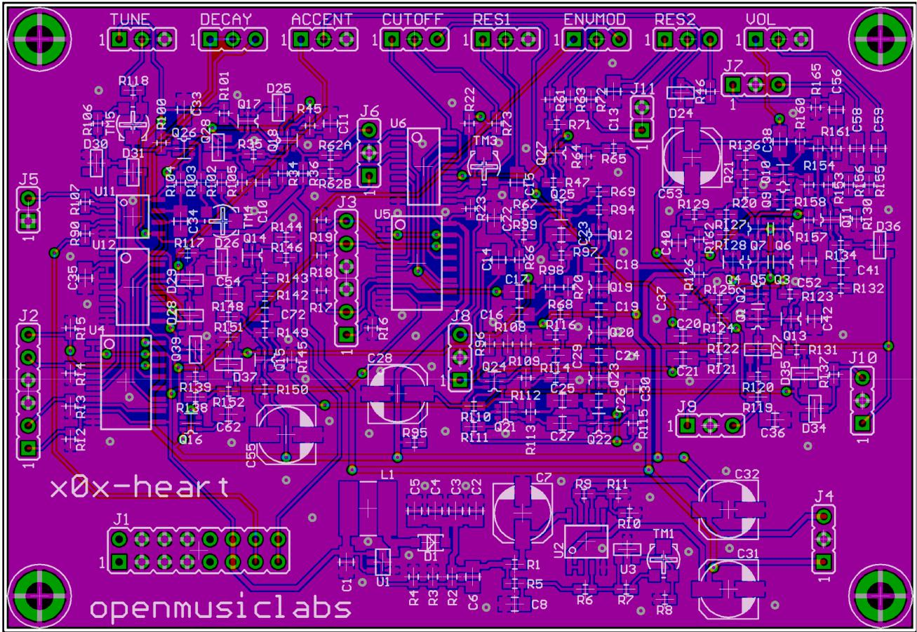

There are 8 headers for potentiometers, and 11 headers for control inputs and outputs. There are also 4 on-board potentiometers for tuning the power-supply, VCO, and VCF. The rest of this document will explain how to tune the x0x-heart, what all of the headers connect to, and how to interface with them. For all headers, pin1 has a square pad, and is labeled with a 1.

**2. Tuning**

The x0x-heart has 4 SMT trim pots, which require a small phillips screwdriver to adjust. TM1 adjusts the 5.333V supply, TM5 and TM4 adjust the VCO CV response, and TM3 adjusts the VCF cutoff frequency. These trim pots are meant to be turned a few times to get the setting right, and then left alone. They can only handle a few rotations, so do not use them as control inputs. These tuning procedures are best done after you have wired everything up, so that the operating currents are in their normal ranges. You should also let the x0x-heart warm up a bit before performing any calibration.

**The 5.333V adjust** was used on the original 303 to set the DAC controlvoltage for the VCO CV generator. Although this is not required on the x0x-heart, as CVs are not generated internally, the 5.333V supply determines how the x0x-heart sounds, so you are welcome to tune this to taste. To set it, turn TM1 while monitoring the output voltage on pin1 of J4 (5.333V is standard).

The x0x-heart uses a switching power-supply and resistive filter to replicate the 303 power-supply. And, just like the original, it sometimes droops under heavy load. Setting TM1 to 5.333V should cause only occasional drooping; going higher than that increases how often this happens, and going lower can eliminate it. The drooping only occurs on the 12V line, and usually only on accented notes. Adding extra circuitry which runs off the 12V line also increases the probability of this happening.

If the droop is not desired, solder a resistor in parallel with R4 and R3. A value between 47k and 100k should do the trick. The lower the resistor value, the less likely it will be to droop. Do not use a value below 12k, as this could hurt the regulator.

**The VCO CV adjust** is best done by first adjusting the CV width, andthen adjusting the offset. This is usually set to 1V/octave, but can be set to any other value within the limits of the device. Set the TUNE knob to mid-position, and alternate between a 1V and 2V CV at the CV input (J1 - pin13,14), and monitor the audio output with an oscilloscope or guitar tuner. Adjust TM5 until the 1V and 2V signals produce tones that are exactly 1 octave apart. Next, adjust the CV offset by turning TM4 until a 2V signal produces a note 2 octaves below middle C (65.4Hz). Your x0x-heart should now be in tune.

**The VCF cutoff adjust** is a matter of taste. It modifies the exactrange that the envelope modulation sweeps through. The 303 manual suggests setting it as follows: Set the CUTOFF knob to center, the waveform to saw, RES1 and RES2 knobs full clockwise, and the ENVMOD, DECAY, and ACCENT knobs full counterclockwise. Apply a 2V CV to the VCO (65.4Hz) and monitor the VCF output (J8 - pin1) on an oscilloscope. The ripples on the saw wave should be spaced at 2ms. If you don't have an oscilloscope, listen for a 500Hz tone on top of the 65.4Hz tone.

**3. Potentiometers:**

The potentiometers all have the 'top' of the pot at pin1, the wiper at pin2, and the 'bottom' at pin3. The 'top' is the side of the pot which is full clockwise. To find out which pins on your pot go where, turn the pot full clockwise, and measure the resistance between the wiper and the 2 other pins. One pin will measure the full resistance of the pot, and the other will measure 0ohms. The side which is 0ohms goes to pin1.

The following table lists the resistance values of the pots:

|  |  |
| --- | --- |
| TUNE | 50kB |
| DECAY | 1MA |
| ACCENT | 50kB |
| CUTOFF | 50kA |
| RES1 | 50kB |
| ENVMOD | 50kA |
| RES2 | 50kB |
| VOL | 50kA |

The only odd thing about the pots, is that the resonance pot is a dual pot. But, the 2 independent parts of the resonance pot are broken out to 2 different headers: RES1 and RES2. RES1 is the feedback pot in the filter, and controls the actual resonance. RES2 controls the amount the accent affects the cut-off frequency. If you are wiring these as 2 separate pots, you may choose to wire RES2 backwards, as turning RES2 more clockwise would normally decrease the affect the accent has on the cut-off frequency.

**4. J1 - Eurorack header:**

All of the pins are doubled up on the Eurorack header (i.e. pin1 and pin2 shorted, pin3 and pin4 shorted).

The following table lists the connections on Eurorack header:

|  |  |
| --- | --- |
| pin1,2 | no connection |
| pin3,4 | ground |
| pin5,6 | ground |
| pin7,8 | ground |
| pin9,10 | no connection |
| pin11,12 | Power in, **5VDC MAX!!** |
| pin13,14 | VCO CV in |
| pin15,16 | GATE in |

**The Power in** connection goes straight to a switching power-supply.This input can work as low as 3.3VDC, and as high as 5VDC. The lower limit is actually set by the level shifter chips, which are not guaranteed to work below 3.3V (although will probably work at 3V). If you want to operate at lower voltages, you can cut some traces and power the level shifters from another bus. The voltage regulator can work down to 1.8VDC, but is not very reliable below 2.7VDC because the inductor and capacitors are optimized for 5VDC.

The high limit is set by the destructive voltage on the switching regulator (actually 6V, but best not to tempt fate). The switching regulator IC can be easily destroyed by over voltage, so be certain that there is no more than 5VDC on pin11 or pin12 of J1! Measure with a multimeter before connecting for the first time.

If you do not have a 5VDC supply, you can easily create one with a 7805 regulator. This will also act as input over-voltage protection. There is no input protection on the circuit as there wasn't a good way of doing this cheaply while keeping the input current consumption down. If you are running the x0x-heart off of a battery, you may want to put a high current diode in parallel or series with the input, to protect against reversed battery connections.

The x0x-heart consumes around 50mA from a 5V supply. This value goes up as the voltage goes down, so a 3V supply will require 85mA.

**The VCO CV in** connection goes through a 220k resistor to theslide/buffer circuitry. This can handle inputs from 0V to 12V, and is fairly tolerant of over/under-voltage conditions. The input can be tuned within a certain range, but is optimized for 1V/octave. CV inputs above 5V might start getting out of tune, as the original 303 was not designed for CVs above this range. The x0x-heart will normally not produce any sound unless there is a CV applied (the CV drifts out of range).

**The Gate in** connects to the base of transistor through a 22kresistor. It can accept 0V to 12V in, and is tolerant of over/under-voltage conditions. A 5V signal is preferred, as this is used in the original 303, and other voltages might affect the timing slightly (although probably not noticeably). A high level voltage turns on the gate, and 0V turns off the gate.

**5. J2 - Digital control input 1:**

This header controls the slide, accent, and decay circuitry. All of these pins are inputs, and are 12V tolerant. They are normally pulled low, so if there is no input connection, all of the controls will be off. The inputs go directly to the CD40109 level shifters, which use the **Power in** voltage as their logic level. Using a logic level lower than the **Power in** voltage is not guaranteed to work. You can use voltages higher than **Power in**, but the input pins will draw more current. You should only send digital signals to these pins, as slow transition times will cause the device to draw significantly more power, and might cause the x0x-heart to temporarily stop functioning.

|  |  |
| --- | --- |
| pin1 | slide input control in |
| pin2 | slide output control in |
| pin3 | ground |
| pin4 | ground |
| pin5 | decay control in |
| pin6 | accent control in |

**The Slide input control in** connects the slide capacitor to the inputCV, and enables slid notes. A logic level high signal engages the slide, and 0V disengages the slide.

**The Slide output control in** connects the slide capacitor to theoutput of the CV buffer. This transfers the current CV level to the slide capacitor, so that new notes slide from the old value to the new one. A logic level high signal connects the capacitor, and 0V disengages the capacitor.

To replicate original 303 behaviour, these 2 slide signals must always be opposite of one another. So when one is high, the other must be a 0V, and vice-versa. The reason why this was not hard-wired this way, is that unique slide effects can be made by having independent control of the 2 slide lines. It is not advisable to turn both slide control inputs on at the same time. This will cause the CV buffer to become unstable and no longer respond to the input CV. The device probably won't be harmed under that condition, but it's not guaranteed.

One effect worth trying, is to only using the **Slide input control**, and pulse width modulate (PWM) the signal. This will engage the slide capacitor for a smaller percentage of the time, effectively increasing its value, and increasing the slide time. This slide time is then determined by the PWM value.

**The Decay control in** shorts out the DECAY pot, and reduces the decaytime to its minimum value. A high level engages the short, and a 0V signal gives control back to the pot. Using a PWM signal on this control line will allow for digitally controlled decay times, as long as the DECAY pot is set to its longest value. In the 303, the decay control and accent control are tied together, so whenever accents are turned on, the decay time is also set to its minimum.

**The Accent control in** sends a replica of the VCF envelope to both theVCF and VCA, to give extra punch to accented notes. This goes through the ACCENT pot to set the accent amount. Again, using a PWM signal here will allow for digital control of the accent level.

**6. J3 - Digital control input 2:**

This header controls the waveform select, cutoff frequency, and envelope mod parameters. The same voltage conditions apply to this header as to J2, so review that section as necessary.

|  |  |
| --- | --- |
| pin1 | square wave control in |
| pin2 | saw wave control in |
| pin3 | ground |
| pin4 | ground |
| pin5 | cutoff control in |
| pin6 | envmod control in |

**The Square wave control in** determines whether the square wave is sentto the VCF/VCA circuitry. A high level logic signal enables the square wave, and a 0V signal disables the square wave.

**The Saw wave control in** determines whether the saw wave is sent tothe VCF/VCA circuitry. A high level logic signal enables the saw wave, and a 0V signal disables the saw wave.

Both of the wave control signals can be PWM'd to change their amplitude. This could be used as another form of VCA control. They can also be modulated at slower rates to effectively LFO the VCO output, which is a pretty good effect. They can also be mixed together by turning both wave controls on at once, although since the square and saw are out of phase, this has the effect of eliminating the fundamental, and accentuating the higher harmonics.

**The cutoff control in** is a digital control line for setting the cut-off frequency. A high level signal sets the cut-off to its maximum value, and a 0V signal returns control to the CUTOFF pot. With the control signal engaged, the CUTOFF pot still has a small effect, and can be used to boost levels above what is attainable in a normal 303. PWM signals can be used to set the cut-off level anywhere between maximum, and whatever the CUTOFF pot is set to. As a result, this signal works best when the CUTOFF pot is set to minimum.

**The Envmod control in** is a digital signal line for setting theenvelope modulation amount. A high level signal sets the modulation to its maximum level, and a 0V signal sets it to whatever the ENVMOD pot is set to. With the control signal engaged, the ENVMOD pot will still have a small effect, and can be used to boost levels above what is attainable in a normal 303. PWM signals can be used to set the modulation level anywhere between maximum and whatever the ENVMOD pot is set to. As a result, this signal works best when the ENVMOD pot is set to minimum.

**7. J4 - Power out:**

This header supplies the 5.333V and 12V from the x0x-heart power-supply for use in external circuits. Be careful about how much current you draw from these lines, as excess current will cause the x0x-heart to drift out of tune, or not function. The 303 was designed with a very weak power-supply, which is one of the keys to its unique sound. Altering how much current is drawn will alter the sound. A few milliamps is acceptable, but more than that might cause audible problems. These outputs are mostly for reference use. Be careful to not connect them to other voltage supplies, as that could damage the circuit.

|  |  |
| --- | --- |
| pin1 | 5.333V out |
| pin2 | ground |
| pin3 | 12V out |

**8. J5 - VCO CV out**

This header supplies the buffered VCO CV signal. It is post the slide circuitry, so the CV will be slid if enabled. The output is diode protected to ground and the 12V rail, but be careful to not connect the CV out to other voltage sources, as that could damage the circuit.

|  |  |
| --- | --- |
| pin1 | ground |
| pin2 | VCO CV out |

**9. J6 - Waveform out**

This header supplies the saw and square wave for external use. These signals are **DC coupled!** This means that the average voltage on these

lines is over 5VDC, and damage can occur to other synths or to the x0x-heart if improperly connected. The reason why they are not AC coupled, is twofold: 1. it is uncertain what value of coupling capacitor would be appropriate for your application, and 2. you may not want it AC coupled for your application. But, for almost all applications you probably will want to AC couple the signal. This simply involves placing a capacitor from the output pin to your external circuit.

The voltage levels coming off the waveform out header are also not line level. They are approximately 5Vpp, which can damage some audio equipment. So, if you intend to send the signal to a mixing board or computer input, you will need to both AC couple, and attenuate the signal. A voltage divider of 100k/22k should do a good job of reducing the signal to line level. For modular synth usage, you might need to amplify the signal.

Be careful to not draw too much current from these pins, as it will effect the sound of the waveforms. only drive input impedances of 47k or greater (100k is preferred). You can probably go a little lower, but avoid it if possible.

|  |  |
| --- | --- |
| pin1 | saw out |
| pin2 | ground |
| pin3 | Square out |

**10. J7 - Mixer**

The mixer header connects to the VCA output mixing circuitry. The inputs and outputs are very tolerant of over/under-voltage conditions.

|  |  |
| --- | --- |
| pin1 | mix out |
| pin2 | ground |
| pin3 | mix in |

**The Mix out** is the same as the mix out on the 303, and is an ACcoupled signal, biased to ground, with a 1k output impedance. It is a line level signal.

**The Mix in** is the same as the mix in on the 303, and is AC coupledwith an input impedance of 100k. It accepts line level signals.

**11. J8 - VCF**

The VCF header allows external audio signals to pass in and out of the VCF.

|  |  |
| --- | --- |
| pin1 | VCF out |
| pin2 | ground |
| pin3 | VCF in |

**The VCF out** signal comes directly from the 'top' of the RES1 pot, andis AC coupled to ground. It is a low level signal, a little less than line level, but has a very low output impedance. Be careful to not draw too much current from this pin, as it will affect the sound of the x0x-heart, and shorting it to other voltage sources could damage the x0x-heart. It is best to use at least a 1k resistor in series with this pin before sending it to other devices (for protection). If you are coupling it to a non-zero bias voltage, another AC coupling capacitor should be used.

**The VCF in** pin goes to the base of the differential pair on the VCF.This is the same point where the VCO enters the VCF. There is no input protection on these pins, and the signal will need to be AC coupled externally. Again, these parts are left off so that the final design can be optimized for your needs. The input is terminated with a 2.2k resistor to 5.333V. If you are sending in audio signals from a modular synth, a 220k resistor and 1uF capacitor in series with the input should be adequate to attenuate the signal and protect the input. For line level signals, a 47k resistor and a 1uF capacitor can be used. The smaller the resistor, the louder the sound will be. For all input signals, a series resistor is required.

**12. J9 - VCA input**

The VCA input header allows external audio signals to be passed through the VCA, and also allows control of the amplitude of the VCA.

|  |  |
| --- | --- |
| pin1 | VCA audio in |
| pin2 | ground |
| pin3 | VCA control in |

**The VCA Audio in** connects directly to the base of the differentialpair on the VCA, and is the same point where the VCF signal enters. There is no input protection on these pins, and the signal will need to be AC coupled externally. Again, these parts are left off so that the final design can be optimized for your needs. The input is terminated with a 2.2k resistor to 5.333V. If you are sending in audio signals from a modular synth, a 1M resistor and 0.1uF capacitor in series with the input should be adequate to attenuate the signal and protect the input. For line level signals, a 220k resistor and a 1uF capacitor can be used. The smaller the resistor, the louder the sound will be. For all input signals, a series resistor is required.

**The VCA control in** connects to the control point on the VCA, and isbest modeled as a diode to ground. The envelope and accent signals also enter at this point, so care must be taken to not affect how those signals behave. The easiest input to construct is to just use a 220k resistor in series with the input. This will allow 12V to turn on the VCA fully, and 0V to shut it off. But, this resistor will also absorb some current from the normal control sources, so a series diode should be used (just as with the accent signal via R120 and D27). The only drawback to using the diode, is that the control will be nonlinear for inputs voltages below 1.2V. Without the diode its nonlinear for voltages below 0.6V.

Fundamentally, the VCA control in is not a CV, and instead a current controlled input. For accurate CV control, a voltage to current converter circuit needs to be used. The simplest form of this is just a PNP transistor with a 220k resistor from the emitter to 12V, and the collector going to the VCA control point. This is the same circuit used in the 303 for the envelope control via Q31 (Q13B in the x0x-heart). To get good linearity, and correct the polarity, an op-amp can be used to provided feedback around this transistor.

**13. J10 - Gate out**

The Gate out header supplies a 12V version of the gate signal, and a 12V trigger signal which is used to trigger the internal envelope generators.

|  |  |
| --- | --- |
| pin1 | trigger out |
| pin2 | ground |
| pin3 | gate out |

**The Trigger out** signal comes from the collector of Q15B, and is usedinternally in the x0x-heart to trigger the VCF and VCA envelopes. Be careful not to apply any voltages to this pin. It will need to be externally buffered before being used by other circuitry, to protect the x0x-heart. An easy way of doing this would be to send the output to 4000 series logic running from a 12V rail. This is a digital signal, which gives a short pulse (~1.5ms) every time the gate input signal is pulled high.

**The Gate out** signal comes from the collector of Q15A, and isprotected with a 1k resistor and diode in series with the output. This is a replica of the gate out signal on the 303. The output is fairly tolerant of under/over-voltage conditions, but will prevent the x0x-heart from functioning if shorted to ground, or to a voltage supply. if you are sending this signal to a buffer, be sure to tie it to ground via a 100k resistor as the diode will prevent the signal from ever going low, once it has been pulled high.

**14. J11 - VCF cutoff control**

The VCF cutoff control header allows for external analog control of the VCF cutoff frequency. This signal goes directly to the base of Q27B (the envelope modulation input point), so care must be taken to buffer any input signals properly to protect the transistor. A 100k resistor in series should work well for most applications. A smaller resistor will increase the effect of a given control voltage. If you only intend to use audio signals to modify the cutoff frequency, it is advisable to AC couple the signal with a 1uF capacitor in series with the resistor.

This control point is biased up to 3V internally, so you will need apply a 3V signal to achieve no cutoff change. Signals below 3V will decrease the cutoff frequency, and above 3V will increase the cutoff frequency. Connecting a 330k resistor from the VCF control point to 12V can adjust this bias so that signals below 0V move the filter down, and those above 0V move the filter up.

|  |  |
| --- | --- |
| pin1 | VCF cutoff control in |
| pin2 | ground |