

September 7 th & 8 th 2019
DOX Centre for Contemporary Art
Poupětova 1, Prague 7
Prague, Czechia

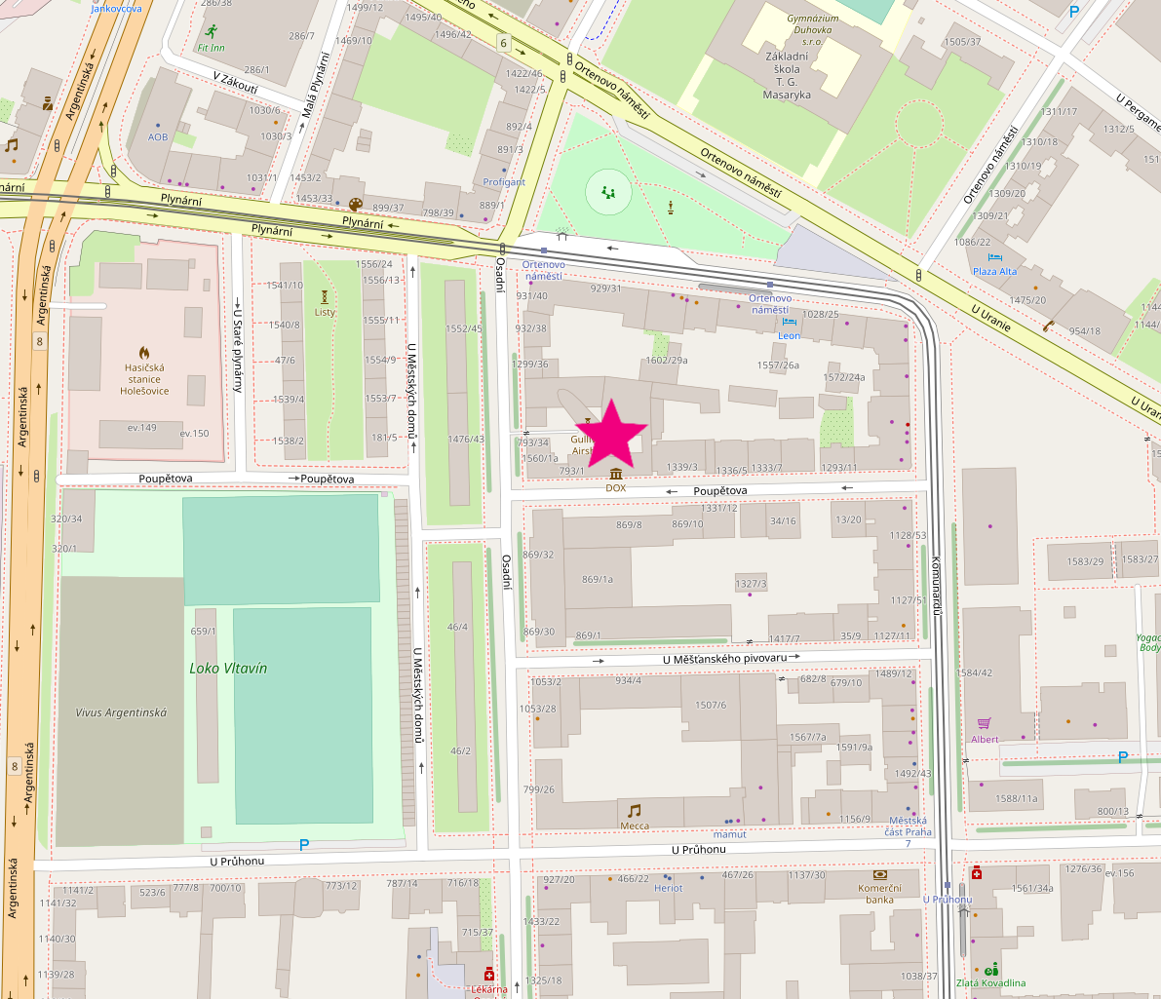
© OpenStreetMap contributors, visit openstreetmap.org

Program Index

Filming and Photography Page 2
Code of Conduct Page 3
Abstracts Page 5
DOX Center Map Page 8
#DATAMAZE Page 9
Schedule Page 10

APConf Website
Please visit our website https://redaktor.me/apconf/ to access etherpads for the sessions, a digital version of this program, and more resources for the conference. You can also participate at #apconf on irc.freenode.net

Filming and Photography

The talks for APConf will be recorded and released on peertube following the conference. We will also be taking candid photos throughout the event.


If you are ok being photographed at the conference, choose a black lanyard
to indicate your consent to be photographed.

If you do not wish to be photographed at the conference, please choose a red lanyard to indicate that you do not consent to be photographed.

Licensing
By default APConf media will be released under a CC BY license. The content of the presentations belongs to the presenters and therefore each talk will be released as either CC0, CC BY, or CC BY-SA per their wishes.

Code of Conduct
We have adopted the Contributer Covenant Code of Conduct for ActivityPub Conference 2019. By registering and attending the conference, you have agreed to follow the terms outlined below.
Our Pledge
In the interest of fostering an open and welcoming environment, we as contributors and maintainers pledge to make participation in our project and our community a harassment-free experience for everyone, regardless of age, body size, disability, ethnicity, sex characteristics, gender identity and expression, level of experience, education, socio-economic status, nationality, personal appearance, race, religion, or sexual identity and orientation.
Our Standards
Examples of behavior that contributes to creating a positive environment include:
- Using welcoming and inclusive language
- Being respectful of differing viewpoints and experiences
- Gracefully accepting constructive criticism
- Focusing on what is best for the community
- Showing empathy towards other community members
Examples of unacceptable behavior by participants include:
- The use of sexualized language or imagery and unwelcome sexual attention or advances
- Trolling, insulting/derogatory comments, and personal or political attacks
- Public or private harassment
- Publishing others’ private information, such as a physical or electronic address, without explicit permission
- Other conduct which could reasonably be considered inappropriate in a professional setting
Our Responsibilities
Project maintainers are responsible for clarifying the standards of acceptable behavior and are expected to take appropriate and fair corrective action in response to any instances of unacceptable behavior.
Project maintainers have the right and responsibility to remove, edit, or reject comments, commits, code, wiki edits, issues, and other contributions that are not aligned to this Code of Conduct, or to ban temporarily or permanently any contributor for other behaviors that they deem inappropriate, threatening, offensive, or harmful.
Scope
This Code of Conduct applies within all project spaces, and it also applies when an individual is representing the project or its community in public spaces. Examples of representing a project or community include using an official project e-mail address, posting via an official social media account, or acting as an appointed representative at an online or offline event. Representation of a project may be further defined and clarified by project maintainers.
Enforcement
Instances of abusive, harassing, or otherwise unacceptable behavior may be reported by contacting the project team at [activitypubconf@gmail.com]. All complaints will be reviewed and investigated and will result in a response that is deemed necessary and appropriate to the circumstances. The project team is obligated to maintain confidentiality with regard to the reporter of an incident. Further details of specific enforcement policies may be posted separately.
Project maintainers who do not follow or enforce the Code of Conduct in good faith may face temporary or permanent repercussions as determined by other members of the project’s leadership.
Attribution
This Code of Conduct is adapted from the Contributor Covenant, version 1.4, available at https://www.contributor-covenant.org/version/1/4/code-of-conduct.html
For answers to common questions about this code of conduct, see https://www.contributor-covenant.org/faq

Abstracts

Keynote: Mark Miller, Architectures of Robust Openness
As social systems grow, we need patterns to allow us to grow social connections while maintaining safety and trust. Ocaps (object capabilities) fill this void by allowing consensual connections between parties, and even allows participants to intentionally share those connections with others. But how can we allow for the establishing of new connections without opening us up to runaway abuse? This talk discusses Horton, a "whodunnit" layer built on top of object capabilities, allowing us to establish connections while preserving accountability and the ability to reason about trust with a reduction of fear.
Keynote: Christopher Lemmer Webber, ActivityPub: past, present, future
This talk gives an overview of ActivityPub: how did we get to this point? Where are we now? Where do we need to go? We'll paint a chart from past to a hopeful future with better privacy, richer interactions, and more security and control for our users.

Luc Didry, Advices to new fediverse administrators and developers

Hosting an ActivityPub service is not like hosting another service…
and it's the same for developing ActivityPub software. Here are some
advices based on Framasoft's experience (we host a Mastodon instance
and develop two ActivityPub software: PeerTube and Mobilizon - the
last one is not yet out), errors and observations.

Maloki, Is ActivityPub paving the way to web 3.0?

A talk about how we're walking away from Web 2.0, and paving the way to Web 3.0 with ActivityPub development. We'll discuss what this could mean for the future of the web, we'll look at some of the history of the web, and also consider the social implications moving forward.

Pukkamustard, The Semantic Social Network

ActivityPub uses JSON-LD as serialization. This means `@context` field all over
the place. But really there is more behind this: ActivityPub speaks Linked Data.
In this talk we would like to show what this means and how this can be used to
do cool things. We might even convince you that the Fediverse is a huge
distributed graph that could be queried in very interesting ways - that the
Fediverse is a Semantic Social Network.

Serge Wroclawski, Keeping Unwanted Messages off the Fediverse

Spam, scams and harassment pose a threat to all social networks, including the Fediverse. In this talk, we discuss a multilayered approach to mitigating these threats. We explore spam mitigation techniques of the past as well as new techniques such as OcapPub and Postage.

Schmittlauch, Decentralised Hashtag Search and Subscription in Federated Social Networks

Hashtags have become an important tool for organising topic-related posts in all major social networks, even having managed to spark social movements like #MeToo. In federated social networks, unfortunately so far the view on all posts of a hashtag is fragmented between instances.
For a student research paper I came up with an architecture for search and subscription of hashtag-posts in federated social networks. This additional backend for instances augments the Fediverse with a little bit of P2P technology.
As this architecture is still at a conceptual stage, after presenting my work I'd like to gather ideas and feedback from various Fediverse stakeholders: What do global hashtags mean for marginalised people and moderation, are they more a tool of empowerment or of harassment? How can this concept be represented in the ActivityPub protocol? And what stories do server devs have to tell about common attack scenarios?

Cristina DeLisle, OSS compliance with privacy by default and design

Privacy is becoming more and more central in shaping the future of tech and the data protection legislation has contributed significantly to making this happen. Privacy by default and design are core principles that are fundamental to how software should be
envisioned. The GDPR that came into the spotlight has a strong case to become a standard even outside European borders, influencing the way we protect personal data. However its impact might be, its implementation is still in its infancy. OSS has found itself facing the situation and one aspect which is particularly interesting on the tech side is how to incorporate the principles of privacy by default and design into the software that we build.
This talk is going to be an overview of how the GDPR has impacted FOSS communities, what do we mean by privacy by default and by design, how could we envision them applied in our OSS. It will bring examples from which we might find something interesting to learn from, regardless if we are looking at them as mistakes, best practices or just ways of doing things.

Caleb James DeLisle, The case for the unattributed message

Despite its significant contribution to internet culture, the archetype of the anonymous image board has been largely ignored by protocol designers. Perhaps the reason for this is because it's all too easy to conflate unattributed speech with unmoderated speech, which has shown itself to be a dead end. But as we've seen from Twitter and Facebook, putting a name on everything hasn't actually worked that well at improving the quality of discourse, but what it does do is put already marginalized people at greater risk.
What I credit as one of the biggest breakthroughs of the fediverse has been the loose federation which allows a person to choose their moderator, completely side stepping the question of undemocratic censorship vs. toxic free speech. Now I want to start a conversation about how we might marry this powerful moderation system to a forum which divorces the expression of thought from all forms of identity.

Matt Baer, Federated Blogging with WriteFreely

We're building out one idea of what federated blogging could look like with separate ActivityPub-powered platforms, WriteFreely and Read.as -- one for writing and and one for reading. Beyond the software, we're also offering hosting services and helping new instances spring up to make community-building more accessible, and get ActivityPub-powered software into more hands. In this talk I'll go over our approach so far and where we're headed next.

Michael Demetriou (qwazix), I don't know what I'm talking about: a newbie's introduction to ActivityPub

I have just started my development journey in ActivityPubLand and I hope to have a first small application ready before ActivityPubConf. I was thinking that since I have close to zero experience with ActivityPub development, I could document my first month of experience, describe the onboarding process and point out useful resources and common pitfalls. In the end I can showcase what I've done during this period.

DOX Centre for Contemporary Art
https://www.dox.cz
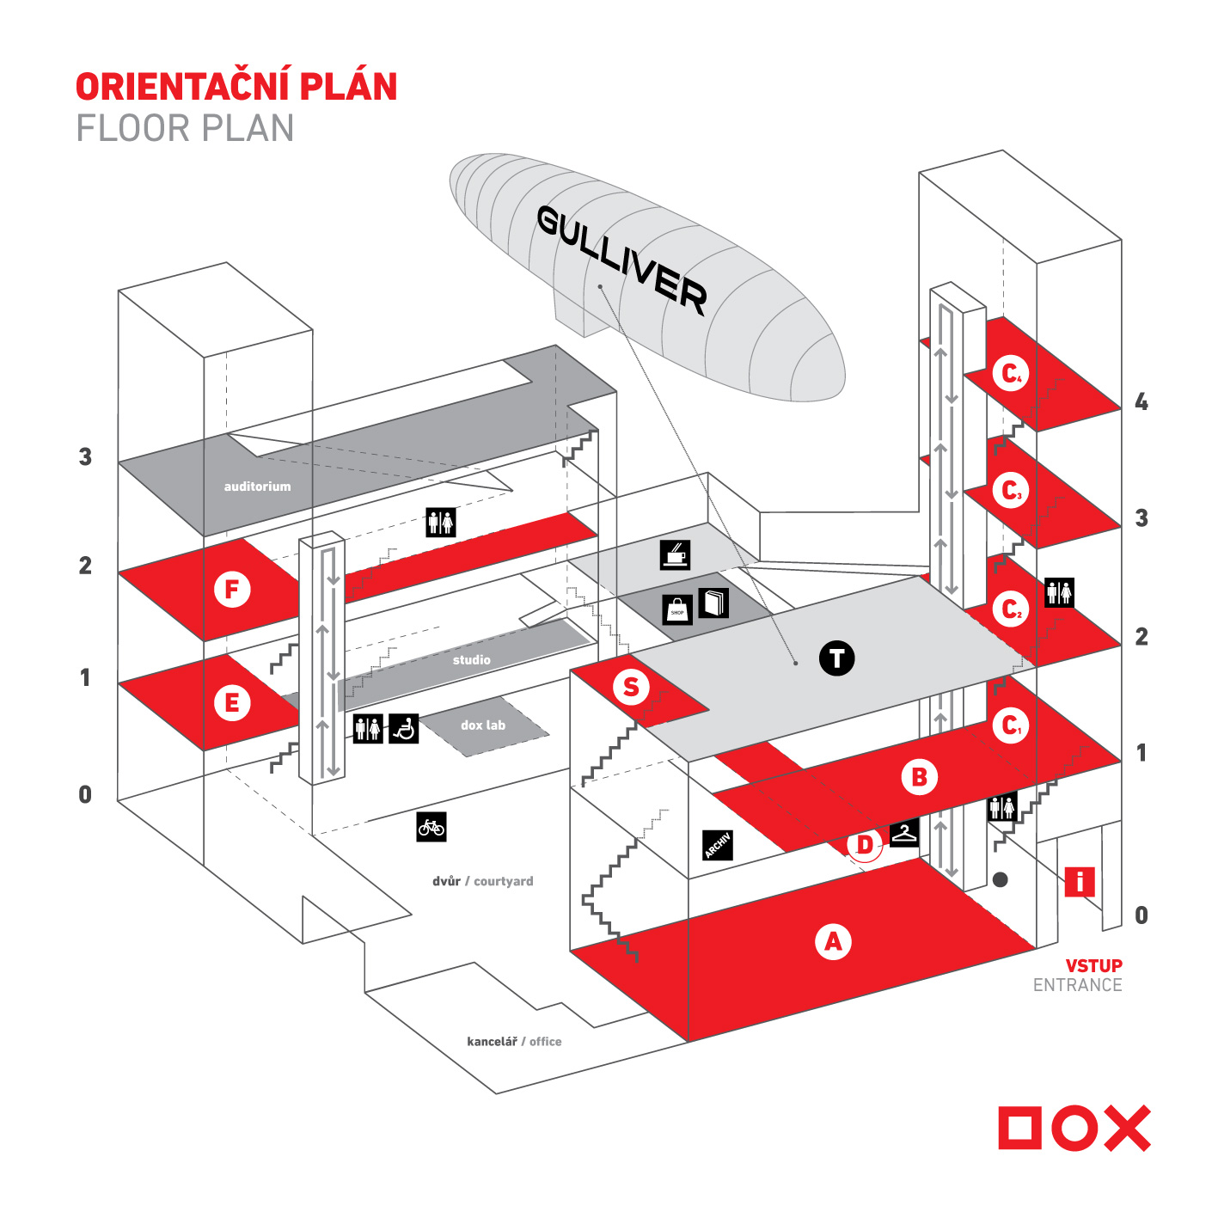
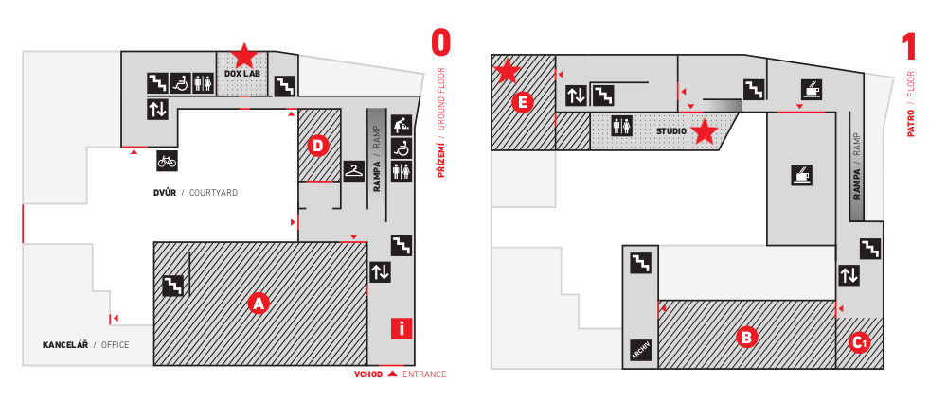
The primary room for ActivityPub Conference will be the #DATAMAZE workshop in Gallery E on the first floor. This is where all of the prepared presentations will be located. On Sunday we will be breaking into smaller groups for the unconference and will be using the studio on the first floor.
The DOX Lab, a small room on the ground floor, will also be available as a ‘quiet’ room for people to work individually.

#DATAMAZE
https://www.dox.cz/en/exhibitions/datamaze
We would like to thank the Dox Centre for providing us a location for our conference. They are hosting ActivityPub Conference in conjunction with the #DATAMAZE exhibition. This ongoing examination of how we are actors in our increasingly digital world has intersecting themes with decentralized social media. Below is a summary of the project from the centre’s website:

We are the internet! Our world is changing. We are witnessing a revolution that for the last thirty years has been changing how we think, communicate, work, and spend our free time. The internet has become a tool and instrument of daily life. It has created a world that we plumb and simultaneously run away from. This process is irreversible and has permanently changed how our society works. This is one of the reasons why it is important to reflect on our situation and our position within it: we aren’t only witnesses to the digital transformation, we are all a part of it, passive or active.
Welcome to the data world! The #DATAMAZE project presents an “extended exhibition”. It combines the concept of an exhibition that is a work in progress with a workspace and library intended for activities and developing collaboration across areas and topics related to a critical reflection on our existence environment, with a lecture space.
Here, art becomes an intermediary that allows us to examine and reflect on our situation from an unforeseen, new perspective: art projects dealing with the world of computers and the internet make us realize how they impact us and how they are changing our lives and the world around us. The entire project is defined by an effort to critically examine the impact of the computer and internet culture on our daily lives. It is defined by key topics that are developed on several levels: first and foremost primarily as educational programmes and other activities for students, then as presentations of contemporary art and projects straddling the border between of art, design, and technology, and finally as attendant events – lectures, workshops, meet-ups, and fab labs for various groups and the general public.
Schedule

Saturday September 7

10-10:30 Registration

10:30 – 10:45 Introductions

10:45 – 11:35 Keynote: Christopher Lemmer Webber,
ActivityPub: past, present, future

11:40 – 12:10 Luc Didry,
Advices to new fediverse administrators and developers

12:10 – 1:10 Lunch

1:10 – 1:40 Maloki,
Is ActivityPub paving the way to web 3.0?

1:45 – 2:15 Pukkamustard,
The Semantic Social Network

2:15 – 2:25 Break

2:25 – 2:55 Serge Wroclawski,
Keeping Unwanted Messages off the Fediverse

3:00 – 3:30 Schmittlauch, Decentralised Hashtag Search and Subscription in Federated Social Networks

3:35 – 4:05 Cristina DeLisle,
OSS compliance with privacy by default and design

4:05 – 4:15 Break

4:15 – 4:45 Caleb James DeLisle,
The case for the unattributed message

4:50 – 5:20 Matt Baer,
Federated Blogging with WriteFreely

5:25 – 5:55 Michael Demetriou, I don't know what I'm talking about: a newbie's introduction to ActivityPub

Sunday September 7

10:00 – 11:00 Keynote: Mark Miller, Architectures of Robust Openness

11:00 – 12:00 Unconf Planning Session

12:00 – 1:00 Lunch

1:00 – 2:00 Block 1

2:00 – 3:00 Block 2

3:00 – 4:00 Block 3

4:00 – 5:00 Block 4

5:00 – 6:00 Lightning Talks

