**GROUP - 6**

# **Title: Human Activity Recognition Using Smartphones Sensors**

**Problem Statement** – A Project that focuses on the developing a model for predicting human activities using Smartphone’s built-in Sensors. This approach involves Activity Recognition (AR) by monitoring a person’s movements through the sensors present in smartphones, such as the compass sensor, gyroscope, GPS sensor, and accelerometer. The collected sensor data is then analysed using deep learning techniques to recognize human activity

|  |  |  |  |  |
| --- | --- | --- | --- | --- |
| S. No | Name | Roll No. | Contribution | Technology Details |
| 1 | Saminathan R | CB.SC.P2AIE23003 | Developing models based on machine learning algorithm | * Smartphone sensors * Compass sensor * Gyroscope * GPS sensor * Accelerometer |
| 2 | Sebin Beebi Philip | CB.SC.P2AIE23020 |

**Methodology: -**

**Introduction - This project aims to develop a model for Human Activity Recognition based on Smart phone Sensors like Gyroscope, Accelerometers etc.**

**Data Collection -** The dataset is prepared by monitoring the activities of 30 volunteers within an age of 19-48 years. Each person performing six different kind of activities are listed below:

* WALKING
* WALKING_UPSTAIRS
* WALKING_DOWNSTAIRS
* SITTING
* STANDING
* LAYING

The acquired dataset has been arbitrarily partitioned into two sets, where 70% of the volunteers were chosen as preparing information and 30% test information.

Sensors in Smartphone –

**A. Accelerometer**

An accelerometer is one of the imperative gear in the smart phones and keen wardrobe. The essential limit is to identify the alterations in the orientation of smart gadget with respect to datum and adjust the introduction to suits the study edge of the client.

**B. Gyroscope**

The utilization of Gyroscope is to keep up and control the position, level or orientation subject to the standard of precise energy. At whatever point 'Gyros' used nearby accelerometer identifies development from 6-Axis for example right, left, up, down, forward and in invert.

**C. Compass Sensor**

The Smart Compass is a standard gadget to recognize the heading with respect to the north-south shaft of the attractive field. Compass helpfulness in mobile phones is increasingly unpredictable sensor called a magnetometer.

**D. GPS [Global Positioning Sensor] System**

GPS is a system which tracks the goal or 'explores' the things by picture or guide with the help of GPS satellites.

**E. Barometer**

Weight Sensors, otherwise called indicators that measures relative and outright height through the examination of changing air weight.

Algorithms -

1. **Support Vector Machine**

In machine learning, Support vector machines are models that are related with learning algorithms for investigating and grouping information. A SVM algorithm makes a model that assigns guides to one or other divisions of class. This model maps the precedents which isolate into the different classes.

1. **Random Forest**

Random Forest is an outfit of unpruned demand or descends like bootstrapping algorithm with various decision trees. Each tree depends upon the estimations of the vector picked unpredictably and independently. Random Forest reliably gives an immense improvement than the single tree classifier

1. **Convolutional Neural Network with LSTM**

The CNN Long Short-Term Memory Network design includes utilizing Convolutional Neural Network (CNN) layers for feature extraction on input information joined with LSTMs to help arrangement prediction. CNN LSTMs were created for visual time arrangement forecast issues and the utilization of producing literary depictions from successions of images.

1. **Recurrent Neural Network with LSTM**

Recurrent Neural Networks (RNN) are an amazing and vigorous sort of neural systems and have a place with the most encouraging algorithms since they are the main ones with an inside memory. In a RNN, the data pushes through a circle.

**Block Diagram: -**

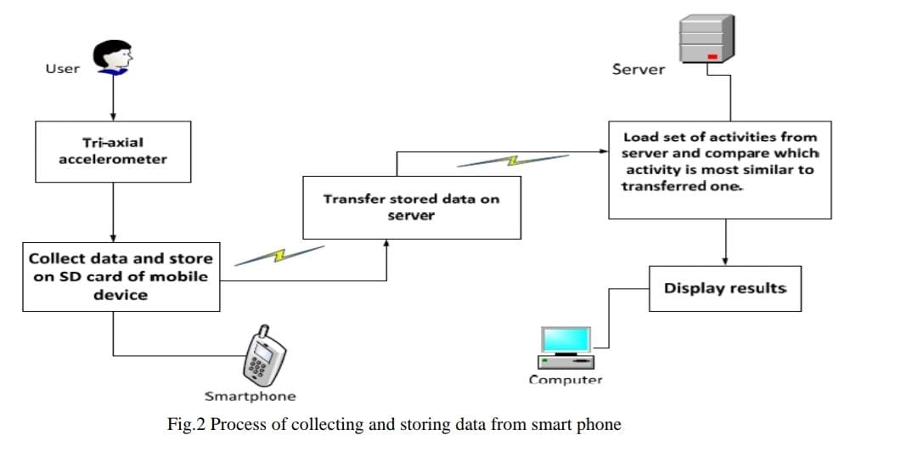

**Feature Engineering Table: -**

|  |  |
| --- | --- |
| **Approach name** | **Procedure** |
| Feature Extraction | Utilize signal processing techniques to extract time-domain and frequency-domain features from smartphone sensor data. This may include mean, standard deviation, energy, entropy, and various statistical measures. |
| Sensor Fusion | Combine data from multiple sensors (e.g., accelerometer, gyroscope, GPS) to create composite features that capture more complex aspects of human activities, such as orientation and trajectory. |
| Feature Scaling and Normalization | Scale and normalize the extracted features to ensure they have consistent units and statistical properties, aiding the machine learning algorithms. |
| Principal Component Analysis (PCA) | Apply PCA to reduce the dimensionality of the feature space while preserving the most relevant information. This can help reduce computational complexity and improve model performance. |
| Time Series Analysis | Analyze sensor data as time series and extract features related to patterns and trends over time, such as rolling statistics, autocorrelation, and Fourier transforms. |
| Recurrent Neural Networks (RNNs) | Use RNNs to capture temporal dependencies in the sensor data, allowing the model to consider the sequence of sensor readings for activity recognition. |
| Deep Learning Features | Employ deep learning models, like Convolutional Neural Networks (CNNs) or Long Short-Term Memory (LSTM) networks, to automatically learn feature representations from the raw sensor data. |