Software Requirements Specification (SRS)
Yoga Master

CHAPTER 1: INTRODUCTION

1.1 Introduction
Yoga Master is a web-based yoga learning and wellness platform developed using the MERN Stack (MongoDB, Express.js, React.js, and Node.js). The system connects users with certified yoga instructors through an interactive online platform where users can browse, purchase, enroll in, and download yoga classes. Instructors can publish and manage their yoga courses, while administrators supervise users, instructors, and class approvals. The enhanced version integrates intelligent features such as AI-powered chatbot assistance, personalized yoga plans, adaptive recommendations based on calendar routines, fitness assessment using uploaded photos, private one-to-one yoga sessions, and appointment scheduling. These features provide a personalized learning experience and improve user engagement while promoting healthy lifestyles.

1.2 Problem Statement
Many online yoga platforms only provide recorded classes and lack personalized guidance, instructor interaction, and intelligent recommendations. Users often struggle to identify suitable yoga sessions according to their fitness level and schedule. There is also limited support for private mentoring, progress tracking, and AI-assisted wellness guidance. Therefore, a centralized intelligent yoga platform is required to provide personalized learning, instructor interaction, secure payments, appointment booking, and fitness assessment.

1.3 Scope and Relevance of the Project
The Yoga Master platform provides three primary modules: Admin, Instructor, and User. Users can register, browse yoga classes, purchase premium content, enroll in courses, download purchased videos, and receive personalized recommendations. Instructors can publish and manage yoga classes, customize learning content, conduct private sessions, and manage appointments. Administrators manage users, instructor applications, classes, and payments. Future enhancements include AI-based posture analysis, chatbot support, adaptive recommendations, and personalized wellness planning.

1.4 Objectives
- Provide an online yoga learning platform.
- Enable instructors to publish and manage classes.
- Allow users to purchase and enroll in yoga courses.
- Provide secure payment processing.
- Support private 1-to-1 yoga sessions.
- Generate personalized yoga plans.
- Provide AI chatbot assistance.
- Recommend yoga sessions based on calendar routines.
- Assess fitness level from uploaded photos.
- Allow administrators to manage users, instructors, and classes.

CHAPTER 2: SYSTEM ANALYSIS

2.1 Introduction
System analysis identifies the limitations of existing online yoga platforms and proposes an intelligent solution that improves accessibility, personalization, security, and instructor interaction. The proposed Yoga Master platform offers a centralized environment for yoga learning, instructor management, AI-assisted guidance, secure payments, and wellness monitoring.

2.2 Existing System
Existing platforms such as YouTube and generic fitness applications provide yoga videos but offer limited personalization, instructor communication, progress monitoring, and appointment scheduling.

2.2.1 Limitations of Existing System
- Limited personalization.
- No AI recommendations.
- No private instructor sessions.
- Limited progress tracking.
- Lack of integrated appointment booking.
- Minimal instructor management.

2.3 Proposed System
The proposed Yoga Master system is developed using the MERN Stack with MongoDB Atlas. It includes Admin, Instructor, and User modules. MongoDB collections include Users, Classes, Cart, Enrolled, Payment, and Applied (Instructor Applications). Additional features include AI chatbot, personalized yoga plans, calendar-based recommendations, fitness assessment using uploaded photos, and appointment scheduling.

2.3.1 Advantages of Proposed System
- Centralized yoga learning platform.
- Secure authentication and payments.
- Easy instructor management.
- Personalized recommendations.
- AI-powered wellness support.
- Scalable cloud database architecture.

2.4 Feasibility Study

Technical Feasibility
The system is technically feasible using the MERN Stack, MongoDB Atlas, JWT authentication, and modern web technologies.

Operational Feasibility
The application offers a user-friendly interface for administrators, instructors, and learners.

Economic Feasibility
The project uses open-source technologies, reducing development and deployment costs.

CHAPTER 3: SYSTEM DESIGN
The Yoga Master system follows a three-tier architecture consisting of a React frontend, Express/Node backend, and MongoDB Atlas database. Core collections include Users, Classes, Cart, Enrolled, Payment, and Applied. The system is designed to support scalability, security, and future AI integration.

Database Collections
- Users
- Classes
- Cart
- Enrolled
- Payment
- Applied (Instructor Applications)

Object oriented design (UML diagrams)

• Activity diagram
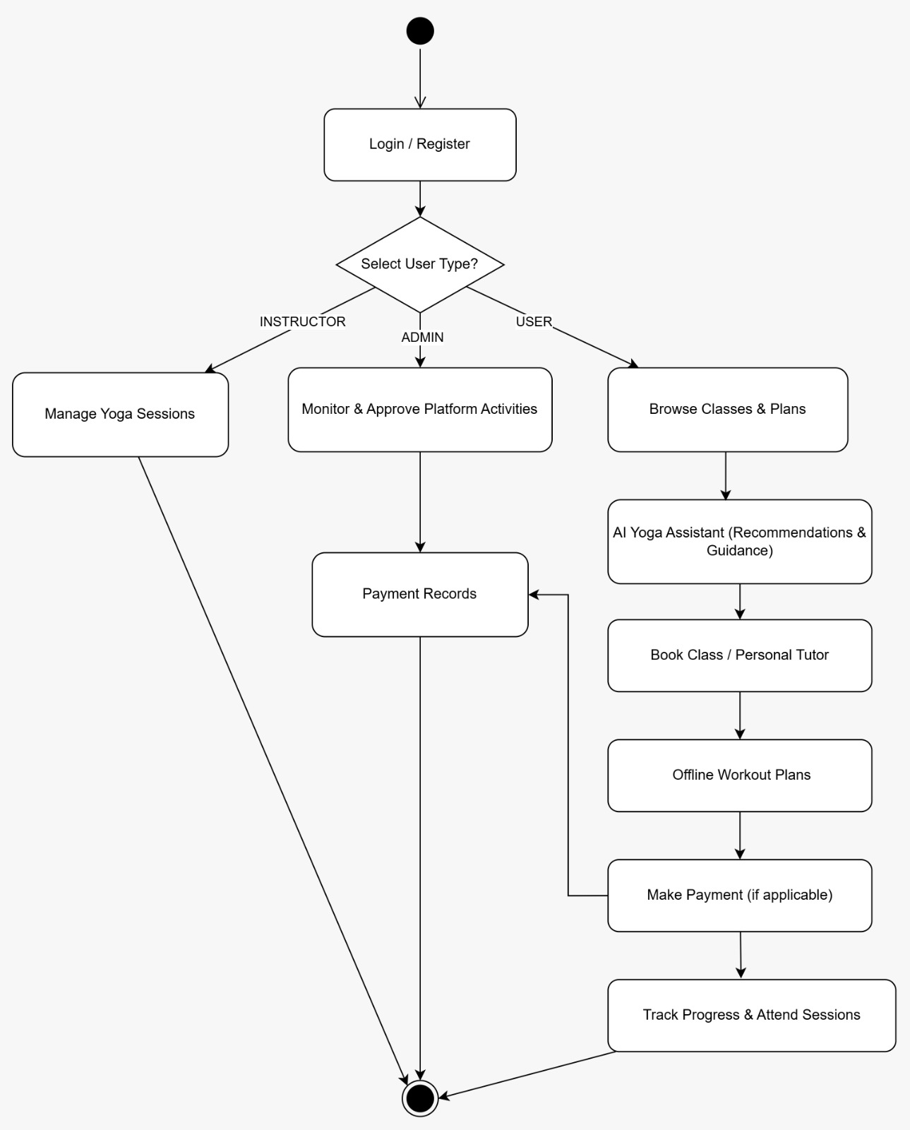

• Sequence diagram

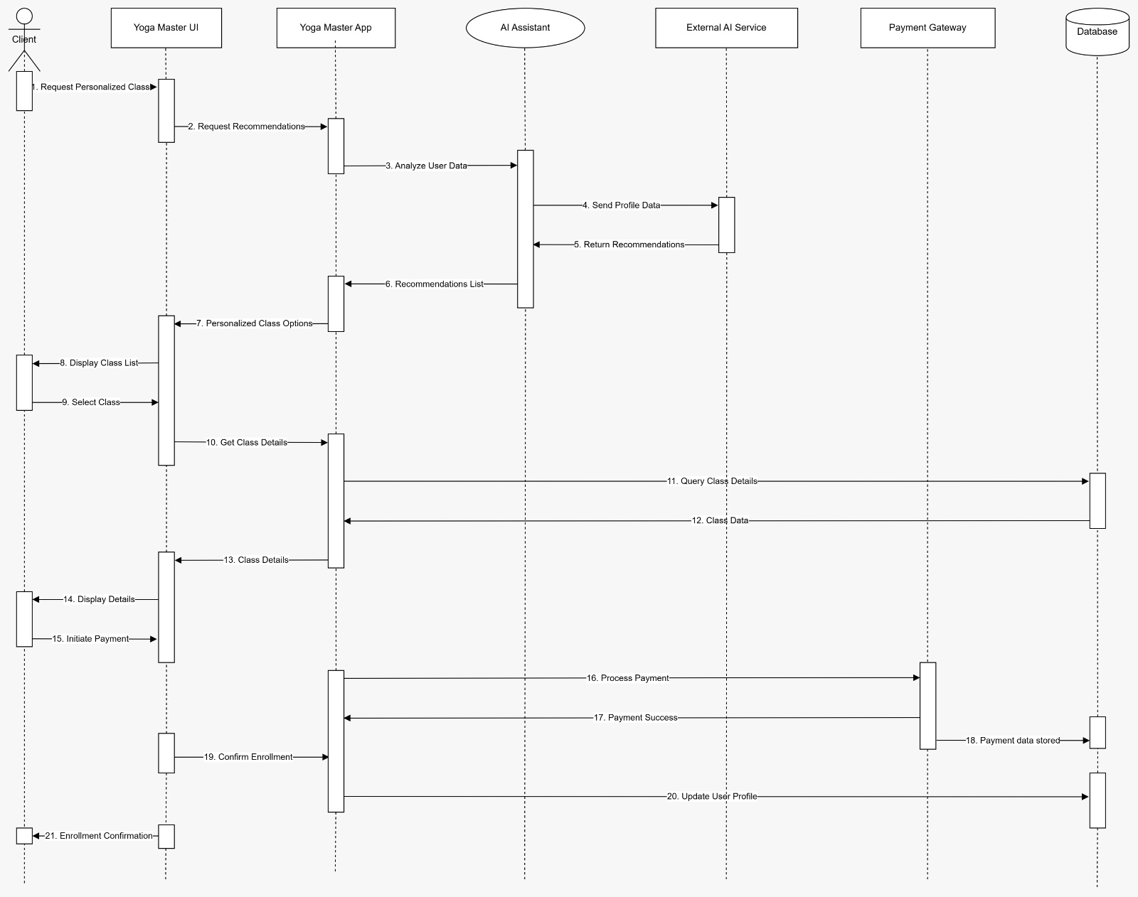

• Use case diagram

