2. Display future leap years from current year to a final year entered by user.

s=int(input("enter start year:"))

e=int(input("enter end year:"))

if(s<e):

print("leap years are:",end=" ")

for i in range(s,e):

if i%4==0 and i%100!=0:

print(i,end=" ")

**output**

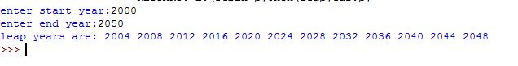

3.**List comprehensions:**

* **Generate positive list of numbers from a given list of integers**

l=[10,-2,2,9,-7,6]

r=[num for num in l if num>0]

print(r)

**output**

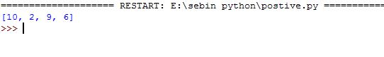

* **Square of N number**

n = int(input("Enter limit : "))

sql=[i**2 for i in range(1,n+1)]

print("square number",sql)

**output**

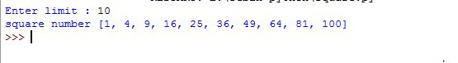

* **Form a list of vowels selected from a given word**

word =str(input("Enter the word :"))

print("The original string is "+word)

print("vowels are:",end="")

for i in word:

if i in 'aeiouAEIOU':

print([i],end=" ")

**output**

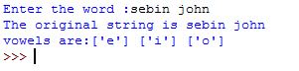

* **List ordinal value of each element of a word (Hint: use ord() to get ordinal values)**

w=input("Enter a word:")

print("Ordinal values corresponding to each element is:")

for i in w:

print(i,end=":")

print(ord(i),end=" ")

**output**

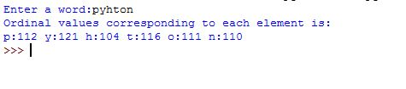

4.**Count the occurrences of each word in a line of text.**

str1 = input("Enter a string : ")

wordlist = str1.split()

count= []

for w in wordlist:

count.append(wordlist.count(w))

print("count of the occurrence:" + str(list(zip(wordlist, count))))

**output**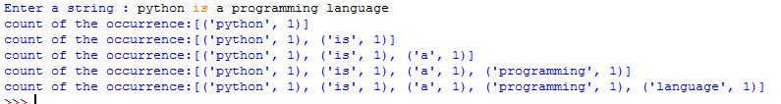

**5. Prompt the user for a list of integers. For all values greater than 100, store ‘over’ instead**

n=[]

s=int(input("Enter a limit:"))

print("Enter {s} values")

for i in range(0,s):

n.append(int(input()))

print("\nThe list after assinging:\n")

for i in range(0,len(n)):

if n[i]>=100:print("over")

else:

print(n[i])

**output**

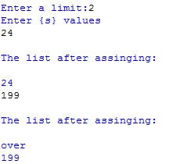

**6. Store a list of first names. Count the occurrences of ‘a’ within the list**

a_list = ["a", "b", "a"]

occ = a_list.count("a")

print("count of occurrences of a :",occ)



7. **Enter 2 lists of integers. Check (a) Whether list are of same length (b) whether list sums to same value (c) whether any value occur in both**

lst=[1,3,5,7,9,11,34]

lst1=[5,13,45,7,20,65,1]

s=int(0)

c=int(0)

if len(lst)==len(lst1):

print("Lists are of same length")

else:

print("Lists have different length")

for i in range(0,len(lst) and len(lst1)):

s=s+lst[i]

c=c+lst1[i]

if(s==c):

print("equal sum")

else:

print("not same sum")

print("Elements that matched are:")

l=[]

for i in range(0,len(lst)):

for j in range(0,len(lst1)):

if lst[i]==lst1[j]:

l.append(lst[i] and lst1[j])

else:

continue

print(l)

**output**

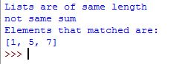

8.Get a string from an input string where all occurrences of first character replaced with ‘$’, except first character. [eg: onion -> oni$n]

str1="malayalam"

char = str1[0]

str1 = str1.replace(char, '$')

str1 = char + str1[1:]

print(str1)

**output**



**9.Create a string from given string where first and last characters exchanged. [eg: python -> nythop]**

str = input("Enter a string :")

new_str = str[-1:] +str[1:-1] + str[:1]

print("New string : ",new_str)

**output**

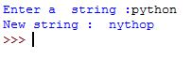

**10.Accept the radius from user and find area of circle.**

pi=3.14

r = float(input ("Input the radius of the circle : "))

result=3.14 * r**2

print ("The area of the circle with radius is: ", result)

**output**

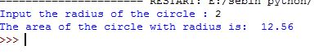

**11. Find biggest of 3 numbers entered**

x = int(input("Enter 1st number: "))

y = int(input("Enter 2nd number: "))

z = int(input("Enter 3rd number: "))

if (x > y) and (x > z):

largest = x

elif (y > x) and (y > z):

largest = y

else:largest = z

print("The largest number is",largest)

**output**

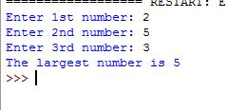

**12.Accept a file name from user and print extension of that**

file= input("Enter filename : ")

f=file.split(".")

print("Extension of the file is : " + f[-1])

**output**

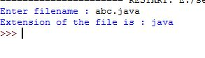

**13. Create a list of colors from comma-separated color names entered by user.Display first and last colors.**

a=[]

for i in range(3):

b=input("enter the color:")

a.append(b)

print(a)

print(a[0])

print(a[2])

**output**



**14.Accept an integer n and compute n+nn+nnn**

n = int(input("Enter a number : "))

x = int( "%s" % n )

y = int( "%s%s" % (n,n) )

z = int( "%s%s%s" % (n,n,n) )

print ("n + nn + nnn :",x+y+z)

**output**



**15.Print out all colors from color-list1 not contained in color-list2.**

color_list_1 = set(["White", "pink", "Red","Blue"])

color_list_2 = set(["Red", "Green","pink"])

print(color_list_1.difference(color_list_2))

**output**



**16.Create a single string separated with space from two strings by swapping the character at position 1.**

a="python"

b="java"

p1=a[0]

p2=b[0]

c=b[0]+a[1:len(a)]+" "+a[0]+b[1:len(b)]

print(c)

**output**



**17.Sort dictionary in ascending and descending order.**

import operator

d = {1: 2, 3: 4, 4: 3, 2: 1, 0: 0}

print('Original dictionary : ',d)

sorted_d = sorted(d.items(), key=operator.itemgetter(1))

print('Dictionary in ascending order by value ',sorted_d)

sorted_d = dict( sorted(d.items(), key=operator.itemgetter(1),reverse=True))

print('Dictionary in descending order by value : ',sorted_d)

**output**

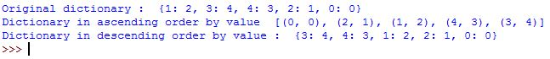

**18.Merge two dictionaries**

d1 ={ 'a': 100, 'b': 200}

d2 ={'x' : 300, 'y': 200}

print ("Dict ionary 1=:", d1)

print ("Dictionary 2=: ", d2)

d =d1. copy ()

d.update (d2)

print ("Merged Dictionary: ", d)

**output**

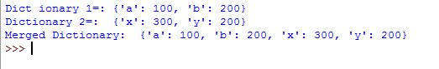

**19.Find gcd of 2 numbers**

x= int(input("Enter 1st number: "))

y= int(input("Enter 2nd number: "))

i = 1

while(i <= x and i <= y):

if(x % i == 0 and y% i == 0):

gcd = i

i = i + 1

print("GCD :", gcd)

**output**

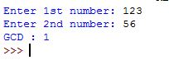

**20.From a list of integers, create a list removing even numbers**

num = [7,8, 120, 25, 44, 20, 27]

print( "Original list:",num)

num = [x for x in num if x%2!=0]

print("list after removing Even numbers:",num)

**output**

