SOUNDWAVE
Concert Booking System

A Comprehensive Technical Manual & Architecture Guide

Documenting full-stack components including Mongoose modeling, authentication layers with JWT token validation, administrative operational backends, and responsive client layouts built with Bootstrap 5.

DATE OF ISSUANCE:
July 2026

Executive Summary & Document Guide
Page 2 of 10

The SoundWave Concert Booking System is a robust web platform designed to facilitate real-time ticket bookings, seat availability updates, and concert event management. This document serves as the primary technical reference handbook detailing system architectures, schemas, authentication layers, APIs, front-end details, and setup flows.

Table of Contents
- Title & Metadata .................................................................................................. 1
- Table of Contents & Executive Summary ..................................................................... 2
- System Architecture & Component Interactions ............................................................ 3
- Database Schema Design (Mongoose Models) .............................................................. 4
- RESTful API Specifications & Endpoints ..................................................................... 5
- Authentication Guard, Hashing & Web Security ............................................................. 6
- Responsive Front-End SPA Layout & UX Themes ........................................................... 7
- Admin Control Center & Content Management Workflow .................................................. 8
- Ticket Booking Engine & Validations Rules .................................................................. 9
- Installation, Configuration & Startup Guide ............................................................... 10

System Architecture & Component Flow
Page 3 of 10

SoundWave is engineered using a decoupled, asynchronous Model-View-Controller (MVC) architectural design pattern, optimized for low latency and high scalability.

System Core Components
    - Client Tier (View): Bootstrap 5 SPA using Ajax Fetch API to dynamically fetch, manipulate, and present backend database catalogs without refreshing the page.
    - Routing / Application Tier: Express.js backend providing secure route points, token validations, schema middleware, and error-catching triggers.
    - Database Tier (Model): MongoDB database interacting through Mongoose ODM, utilizing strict schemas, auto-indexing, validation constraints, and aggregation streams.

Component Flow Diagram
The visual layout below illustrates data flows for API requests:
[ Client Browser ] =====> [ HTTP Routing Guard (cors) ]
|| ||
|| (Token Authorized) || (Verifies Origin Header)
\/ \/
[ verifyToken Middleware ] ===> [ Express API Endpoints (api.js) ]
||
|| (Validates Payload Schema)
\/
[ MongoDB Database ] <======== [ Mongoose Models (user, concert, ticket) ]

Technologies Stack Overview
Database
MongoDB Community Server v7.0
NoSQL documents storage, transactional persistence
Web Server
Node.js, Express.js framework
Handles HTTP methods, controls authorization flows
ODM Model
Mongoose ODM library
Schema definition, validator rules, model compilation

Layer | Technologies | Primary Function
Frontend | HTML5, CSS3, ES6 JS, Bootstrap 5 | Renders GUI, stores JWT token, handles SPA pages

Database Schema Design (Mongoose)
Page 4 of 10

The SoundWave database is composed of three collections compiled using Mongoose schemas. Mongoose validations guarantee that data types, minimum lengths, email patterns, and age limits are enforced at the database layer.

User Schema Details

Field | Type | Validators / Constraints | Default
name | String | Required, Min-length: 3, Max-length: 30, Trimmed | None
email | String | Required, Unique: true, Pattern: Regex Email | None
age | Number | Required, Min-value: 18 (Adults only) | None
password | String | Required, Min-length: 8, Upper/Lower/Special char regex | None
Admin | Boolean | Required | false
 |  |  | 4.2 Concert Schema Details
Field | Type | Validators / Constraints | Default
ConcertId | String | Unique: true, Required | None
ConcertName | String | Required | None
date | Date | Required, Custom Validator: Future date only | None
venue | String | Required | None
price | Number | Required, Min: 0 | None
TotalTickets | Number | Required, Min: 1 | None
userId | String | Required (ID of creator admin) | None
 |  |  | 4.3 Ticket Booking Schema Details
Field | Type | Validators / Constraints | Default
userId | String | Required (ID of booking user) | None
ConcertId | String | Required (Target concert ID) | None
nooftickets | Number | Required, Min: 1, Max: 3 | None
TotalAmount | Number | Required (Computed as price * quantity) | None

RESTful API Specifications & Endpoints
Page 5 of 10

All operations in SoundWave are driven by REST APIs. Requests are payload-validated, and responses are formatted as JSON packets.

Endpoints Catalog

Method | Endpoint | Secured? | Role | Primary Action
POST | /create_user_api | No | Any | Register new Admin/User
POST | /login_user_api | No | Any | Logs in user & returns JWT token
GET | /veiw_concert_api | Yes | Any | Fetch concerts with remaining tickets
POST | /concert_add_api | Yes | Admin | Add new concert event
PUT | /edit_concert_api/:id | Yes | Admin | Modify details of concert event
DELETE | /delete_concert_api/:id | Yes | Admin | Remove concert event from DB
POST | /Ticket_booking_api | Yes | User | Book concert tickets (max 3)
 |  |  |  | 5.2 API Payloads Sample
 |  |  |  | Below is a typical JSON response returned from the /login_user_api route upon successful sign-in:

Validation errors return a structured JSON packet mapping field names to error messages:
// HTTP/1.1 200 OK
{
"message": "Login successful",
"token": "eyJhbGciOiJIUzI1NiIsInR5cCI6IkpXVCJ9.eyJ1c2VySWQiOiI2NmZi..."
}
// HTTP/1.1 400 Bad Request
{
"errors": {
"age": "Age must be more than 18",
"password": "Password must be at least 8 characters..."
}
}

Security, Hashing & Authentications
Page 6 of 10

The SoundWave system implements multi-layered security. This protects user passwords in the database and ensures that clients can only access routes that correspond to their authorization levels.

Password Hashing with Bcrypt
To protect passwords against raw leaks, the system implements one-way hashing using `bcrypt`. Password hashing is executed prior to saving records to MongoDB:
// From create_user_api:
const saltRounds = 8;
const hashedPassword = await bcrypt.hash(password, saltRounds); const user = new User({ ...password: hashedPassword });

JSON Web Token (JWT) Authentications
    - Token Creation: Upon login, a signed JWT token is issued containing payload details `userId` and
`Admin`. The token has a 1-hour expiration limit.
    - Signature Security: The token signature is generated using a secure key fallback configured as
`process.env.JWT_SECRET = "userSecretKey"`.
    - Authorization Header: The front end stores the JWT in `localStorage` and appends it to subsequent API requests as a bearer token: `Authorization: Bearer <token>`.

verifyToken Router Guard Middleware
Secured API endpoints are wrapped with `verifyToken` middleware, which intercepts requests, verifies signatures, handles expiration checks, and exposes the authenticated payload directly to route controllers:
// Authentication route guard verifyToken:
jwt.verify(token.split(' ')[1], process.env.JWT_SECRET, (err, decoded) => {
if (err) return res.status(401).json({ message: "Invalid or Expired token" }); req.userId = decoded.userId;
next();
});

Page 7 of 10

User Interface Design & Themes
The SoundWave user interface is a responsive Single Page Application (SPA) styled with Bootstrap 5. It uses a modern dark-slate theme designed to provide a premium feel.

Color Palette & Theme Tokens

Token Name | Hex Value | Usage in UI Layout
Deep Slate Background | #090d16 | Body base background, modals wrapper, headers

Card background | #172033 | Concert grid items, dialog containers, form controls
Accent Purple | #8b5cf6 | Primary action buttons, active navigation bars, date tags
Accent Pink | #ec4899 | Hover indicators, border highlights, warnings
Cyan Badge | #06b6d4 | Real-time remaining ticket counts, status indicators
 |  | 7.2 Landing Page Layout Screenshot
 |  | Below is the visual mockup of the guest view showing the landing layout, brand header, and action cards:
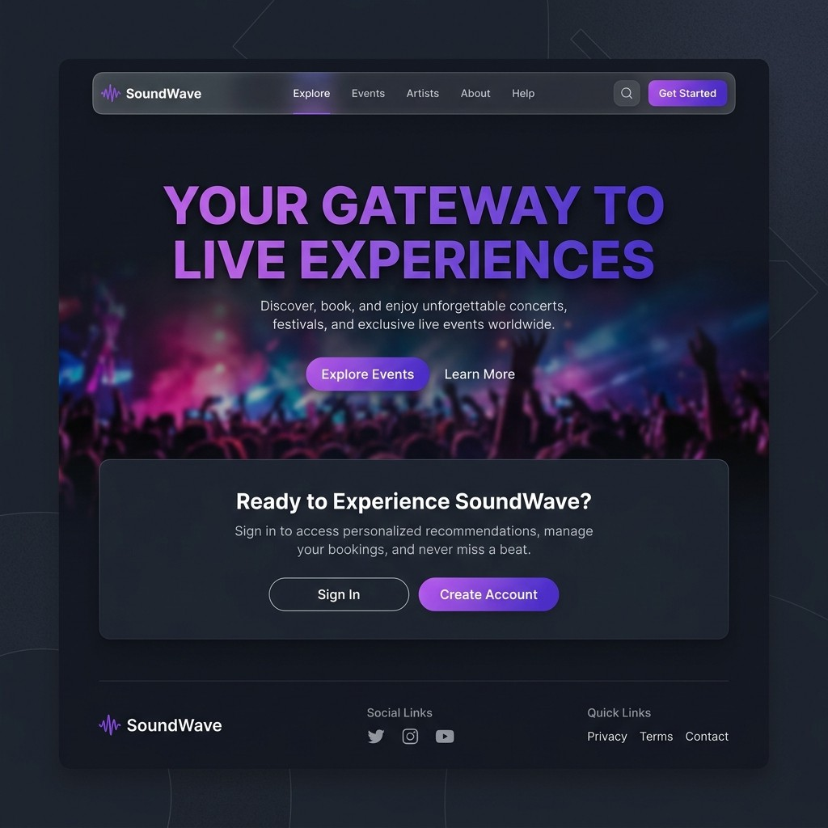

Admin Control Center Operations
Page 8 of 10

SoundWave enforces role-based access. Administrators have unique privileges to schedule new concerts, edit venue/pricing configurations, and delete events.

Event Creation & Update Walkthrough
    - ConcertId: Unique string identifier assigned by the admin (e.g. METALLICA2026).
    - ConcertName: Title of the event (e.g. Hardwired Live Tour).
    - Future Date Guard: System validator checks dates in real-time. Past dates are rejected with a validation error.
    - Capacity & Pricing: Admins define ticket counts and price tags. Prices are saved in MongoDB as float fields.

Admin Dashboard Layout Screenshot
Visual representation of the admin view, displaying edit/delete controls and creation buttons:
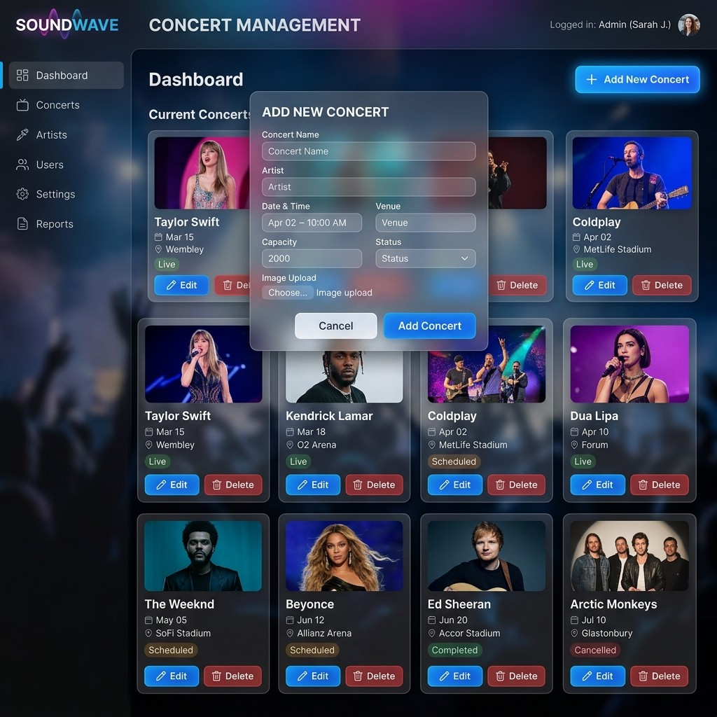

Ticket Booking Engine & Validations
Page 9 of 10

The Ticket Booking Engine enforces transactional rules to guarantee data consistency and ticket availability. Transactions are protected using MongoDB aggregation frameworks.

Core Booking Rules
    - Purchase Restriction: A single user account is limited to a maximum of 3 tickets per concert to prevent ticket scalping.
    - Inventory Control: The system calculates the remaining tickets by aggregating the total bookings for a concert in real-time. If tickets run out, the button is disabled and marked "Sold Out".
    - Dynamic Calculation: The frontend UI dynamically multiplies single ticket prices by the chosen quantity (1, 2, or 3) and displays the total amount before booking.

Booking Dialog Layout Screenshot
Visual representation of the booking form modal showing calculations in Indian Rupees ( ¹):
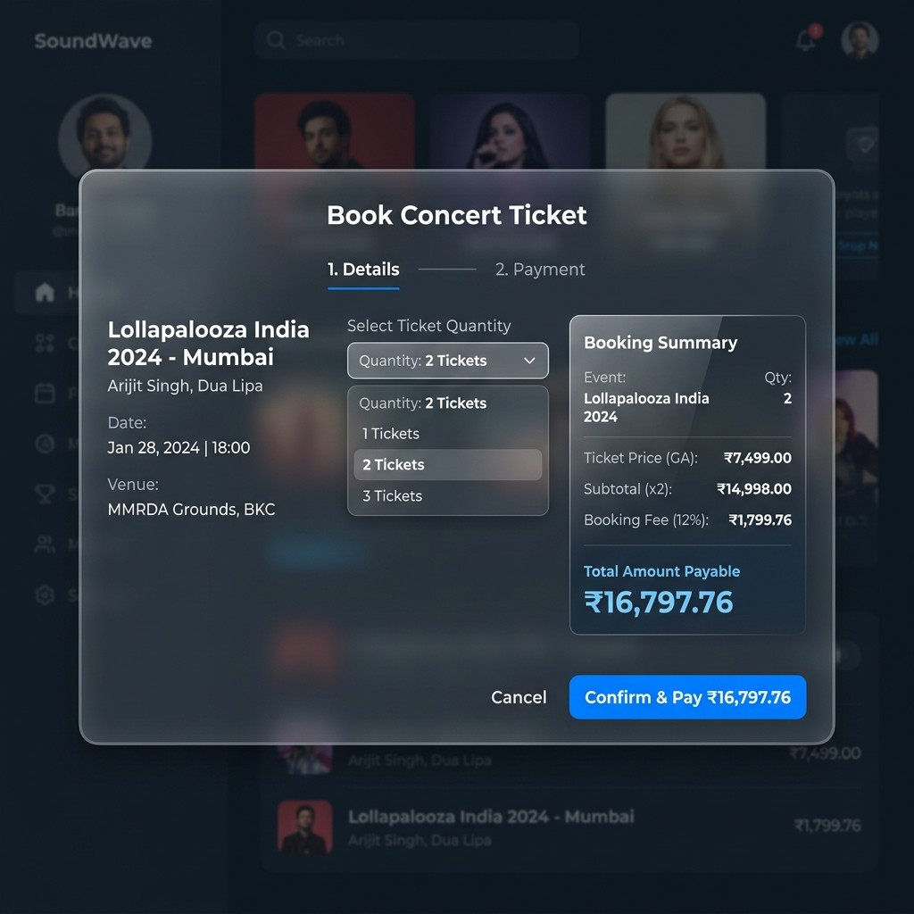

Installation, Configuration & Startup
Page 10 of 10

Follow these steps to deploy and run the SoundWave system in a local development environment.

Pre-requisites & Local Environment
    - Node.js Environment: Make sure Node.js (version 18.x or above) is installed globally.
    - Database Instance: Run a local instance of MongoDB server on port 27017 (`mongodb://localhost:27017/ concertDetails`).

Installation Steps
- Navigate to the project folder and install Node packages:
cd Concert-project npm install

- Launch the backend Express application:
npm start

- (Optional) Navigate to the React directory and launch the React development server:
cd react-frontend npm install
npm start

Troubleshooting Port Conflicts
If you see a "Port 3000 is already in use" error, a background process might be running. Find and stop the process, or update the listening port in `bin/www` by changing `3000` to a different value (e.g. `3500`).

