TouchDeck: User Guide

TouchDeck is a revolutionary new application that lets you to play card games on your Android device, either by yourself or with other players connected to the same local network.


Starting or joining a game

When you launch the TouchDeck application you'll be greeted by the main menu. Here you have the option to either create a new game session, making your device the host for other players to potentially connect to, or join an existing session by entering the IP address of a host device connected to the same local network as you.

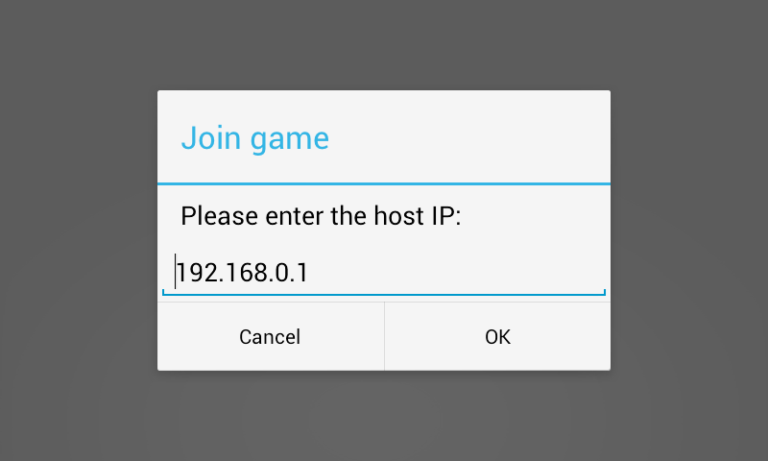

Playing a card game

So you just started or joined a game session and you're ready to play a game of cards. You may be asking yourself: ”What card games can I play with this app?”. Well, the beauty of TouchDeck is that you can play any card game you want! The deck is right there when you start and most properties that apply to a physical deck of cards also apply to this one.
Getting familiar with the TouchDeck environment

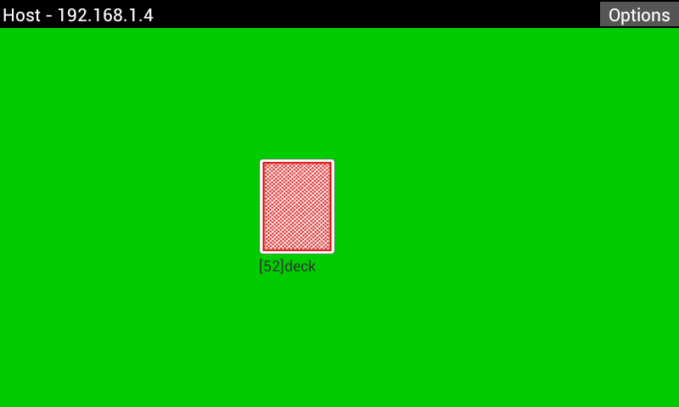
In essence, TouchDeck revolves around two different perspectives during play. We'll refer to these as the Table View and the Pile View respectively. The Table View is illustrated in the picture above and is what you'll see when you first start a game. From the Table View you're able to perform actions on existing piles, as well as create new piles to hold cards. The name of a pile and the number of cards currently in it is displayed below said pile.

The “Options” button in the top-right corner allows you to restart the game, effectively resetting the Table View, or terminate the session and return to the main menu.

The top-left corner indicates if you're a host or client and also shows your personal IP address. The host of the game session can examine this text field to find out what address to distribute amongst other players that want to join the session.

Tapping on a pile will bring you to the Pile View, which is illustrated below. Here you can scroll through the pile you selected and view the cards that are currently in it. Tapping a card will bring up a menu, displaying actions that you can perform on the chosen card. The name of the pile and the number of cards in it is displayed at the top of the screen.

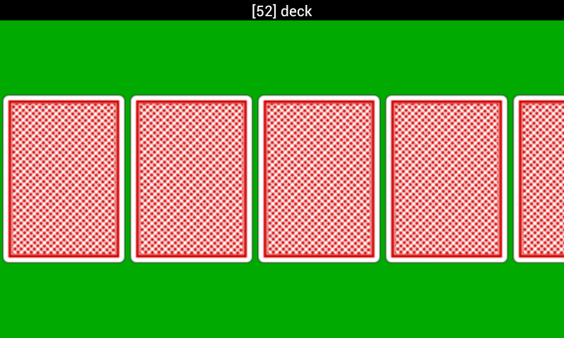
Performing actions on piles and cards

The actions you can perform from the Table View are centered around piles as a whole. By tapping somewhere on the table where there isn't already a pile, you're prompted to create an empty pile with a unique name. If no name is given, a default name will be applied.
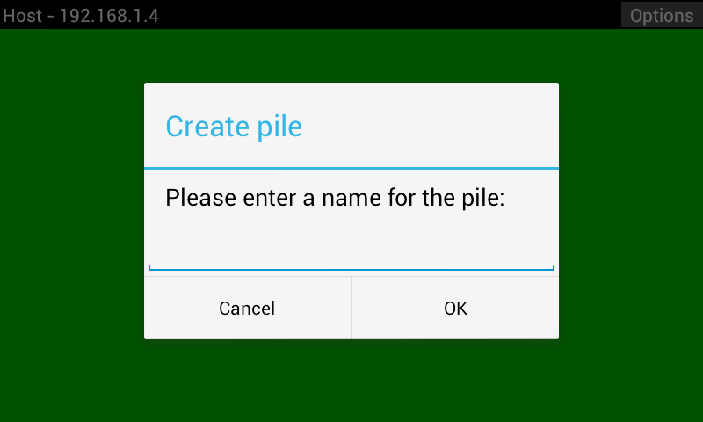
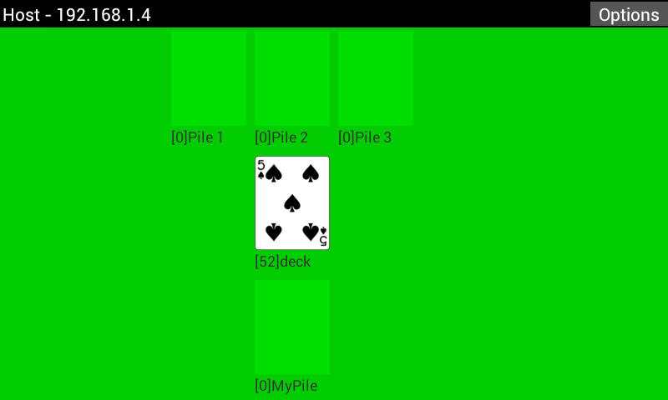
By tapping and holding down on a pile, a menu with pile-specific actions will be shown. These actions include:
- Shuffle pile
  - The order of the cards in the pile will be rearranged in a random fashion
- Rename pile
  - Allows you to set a new name for the pile
- Face all cards up
  - All cards in the pile will be set to face upwards, revealing suit and rank
- Face all cards down
  - All cards in the pile will be set to face downwards, hiding suit and rank
- Move all cards
  - Allows you to move all the cards in the pile to a different pile of your choice
- Protect pile
  - Allows you to lock the pile, preventing other players from performing actions on the pile, as well as inspecting it in the Pile View
  - Protected piles are marked with a blue backside in the Table View
- Deal cards from pile
  - Allows you to repeatedly move the top card in this pile to another pile by tapping a different pile
  - The dealing will end if the Back-button is pressed, or if there are no more cards in the pile
- Move this pile
  - Allows you to move this pile to an empty position on the table
  - If there are cards in the pile, they will be transferred over as well
- Delete pile
  - Removes this pile from the table
  - Only displays for empty piles
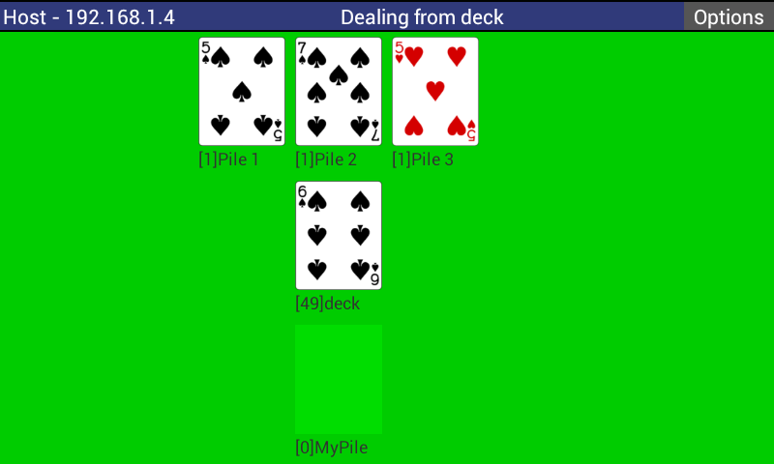
The same principle applies to the Pile View, where you can tap on a card to view the actions that can be performed. These include:
- Flip card
  - Sets the card to face either upwards or downwards, depending on its current state
- Move card
  - Allows you to move this card to the top of another pile of your choice
  - When selecting this action you will be shown the Table View, where you can tap the pile you wish to send the card to
  - Tapping the same pile you're moving the card from will place it at the top of the pile
- Peek card
  - An upwards-facing version of the card will be displayed on top of the chosen card, revealing the suit and rank to you only
  - This action does not alter the face state of the card
- Peek all cards
  - Performs “Peek card” on all cards in the Pile View
