Sprint backlog (2013-09-30)
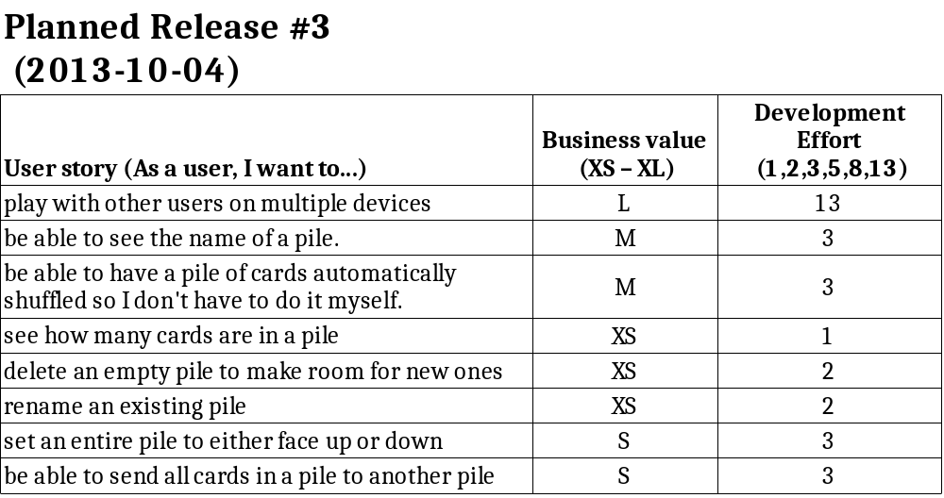

Sprint review (2013-10-04)

- 7 user stories completed, 1 left for next week.
- 28 story points completed this sprint.
- 1 big refactoring completed and 1 new found and added to github.
- Next sprint should focus on usability and product quality.
- 3 stories added to Product Backlog from Icebox.
