Sprint backlog (2013-09-23)

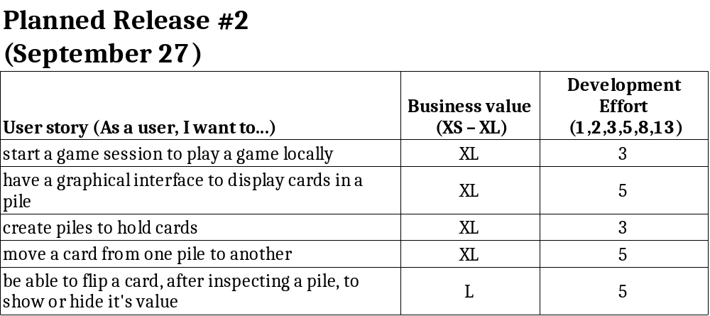

Sprint review (2013-09-27)

- All stories in sprint backlog are completed.
- 21 story points completed this sprint.
- 3 refactoring needs found and added in git repository.
- Next sprint should focus on multiplayer and refactoring.
- No changes to the product backlog.
