**Vaadin workshop preparation**

1. Install the Vaadin plugin in IntelliJ (if not installed/activated; <https://www.jetbrains.com/student/>). Search for the plugin ‘Vaadin designer’ (8) in the plugin tab in the settings: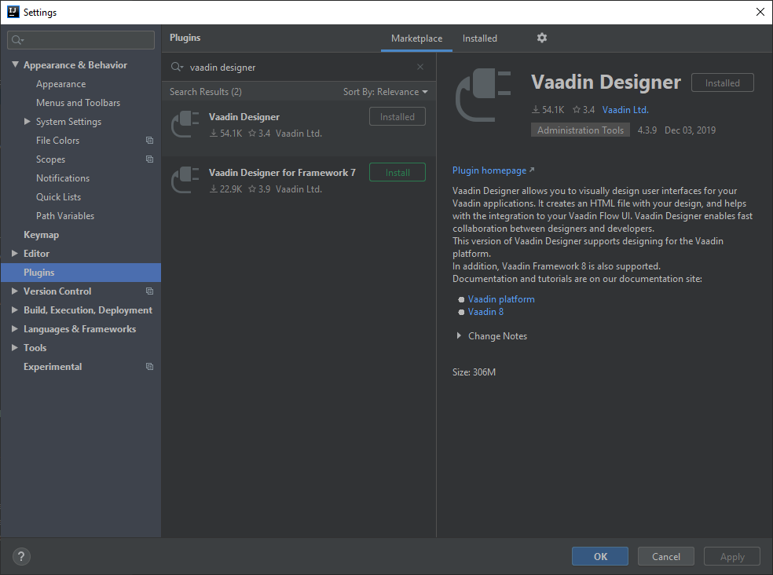
2. To use this plugin the first time it will ask for a subscription, create an account and activate a free 14-day trail.
3. Install docker, if not still installed from previous workshops.
4. Use JDK 8 or above
5. To run our project, check out the readme file on GitHub in the Vaadin-workshop repository.