How to set everything up for the Workshop

You can either use Eclipse or IntellijIDEA

- Setting up project with Eclipse:

1. install Eclipse IDE, choose Eclipse IDE for Java Developers
2. go to https://github.com/sebivenlo/drools, click on “clone or download”, copy URL
3. click on ‘import projects’- Git- projects from Git-next
4. click ‘clone url’-next
5. insert URL at the top-next
6. next-next-next
7. choose ‘import as general project’-next-finish

8. right click on project-configure-convert to Maven project
9. on the top click on help-install new Software
10. at top insert: http://download.jboss.org/drools/release/7.23.0.Final/org.drools.updatesite/
11. press enter, check box at drools and jbpm-next
12. finish-install anyway
13. Check if it works: open file Src-main-java-io.github(…)-section03-statelesspassport, and click on “run” and look if it prints “Section 3. Enter step (1...6):”
14. Then open this file 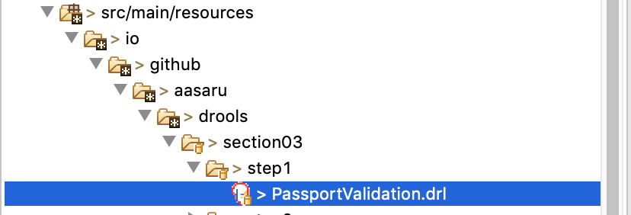
And check if it has this drools icon ^

- With IntellijIDEA

- Install IntellijIDEA Ultimate Edition (free for students)
- go to https://github.com/sebivenlo/drools, click on “clone or download”, copy URL
- Open Intellij, click on “check out from version control”-git
- Paste URL,click on clone
- Click on pop up “add as maven project”
- If pop up maven projects need to be imported, click on import changes
- In project folder Open Src-main-java-io.github(…)-section03-statelesspassport
- There should be a pop up “SDK is not defined”, click on Setup SDK
- Choose 1.8., if you don’t have it take newest version

- Check if it works: open file Src-main-java-io.github(…)-section03-statelesspassport, right-click in code and click on “run” and look if it prints “Section 3. Enter step (1...6):”
- Then open this file
And check if it has this drools icon ^

