## Vs Maui

Introduction to MAUI

Before we dive into Avalonia, let's briefly discuss MAUI. MAUI, which stands for Multi-platform App UI, is Microsoft's framework for developing cross-platform applications. It's designed to allow developers to create apps for iOS, Android, macOS, and Windows using a single codebase. It is also an evolution of Xamarin.Forms. I don’t know if anyone here has ever worked with Xamarin. I did back in 2018. It was a bit of a hassle to make it perform well in my experience. Maybe that’s why it is no longer supported as of May this year.

Avalonia UI differs from MAUI in several key aspects:

1.Rendering Approach

First up is rendering approach. Avalonia uses a custom rendering engine across all platforms. This allows it to have a consistent appearance across different operating systems. It also allows developers to have a greater control over its UI design. Users across platforms will also have the same user experience because of it.

In contrast, MAUI uses native UI controls, which can lead to a more platform-specific look and feel. IOS will use UIkit and Android will have the native Android UI toolkit. This might be preferable if you are looking to create a native application experience. However when specific platforms update their design language or introduce new UI components, these need to be considered when supporting your application long term. If you for instance decide to program platform specific implementations, these would probably have to be updated manually.

2. UI Design Flexibility

Avalonia's custom engine allows for more control over UI elements. This allows developers to create unique UI components more easily. This way more unique UI could be implemented that would be harder or maybe even impossible to do when using native UI toolkits.

This flexibility comes at the cost of not using native UI elements, which some users might prefer.

3. Code Maintenance

With Avalonia, the UI code remains largely the same across platforms. This can simplify maintenance and updates. However, it may require more effort to implement platform-specific features when needed.

4. Platform Support

Avalonia supports a wider range of platforms compared to MAUI:

It works on older versions of Windows and macOS.

Avalonia offers Linux support, which MAUI currently lacks.

Both support iOS and Android, but with different minimum version requirements.

5. Web Compatibility

As of now, Avalonia supports WebAssembly, allowing web deployment. MAUI doesn't currently offer this feature, though it may in future versions.

Framework Evolution

Avalonia's independent nature allows for:

* Faster implementation of new features and bug fixes.
* Less dependence on native platform updates.

However, this also means that Avalonia might not always align with the latest platform-specific UI trends.

## Vs Flutter

Avalonia and Flutter are both frameworks used for building user interfaces, but they have distinct characteristics and target different platforms. Let's break down their differences to help you understand which might be more suitable for your projects.

**Programming Language**

Avalonia:

Avalonia uses C# as its primary programming language. This makes it an excellent choice for developers already familiar with the .NET ecosystem

Flutter:

Flutter uses Dart, a language developed by Google specifically for building user interfaces. While it might require learning a new language, Dart is designed to be easy to pick up, especially if you have experience with object-oriented programming

**User Interface Approach**

Avalonia:

Avalonia uses a tree-based approach for building UIs. Controls are nested within parent controls, creating a hierarchy. This approach might feel familiar to those who have worked with other .NET UI frameworks

Flutter:

Flutter employs a widget-based approach. Everything in Flutter is a widget, from layout elements to styling and animations. This modular approach allows for highly customizable and reusable UI components

**Rendering**

Like Avalonia, Flutter also uses Skia as a rendering approach.

**Development Experience**

Avalonia:

Avalonia leverages existing .NET tools and IDEs, making it comfortable for .NET developers. It offers features like XAML for UI design, which might be familiar to WPF or UWP developers

Flutter:

Flutter is known for its "hot reload" feature, which allows developers to see changes in real-time without restarting the app. This can significantly speed up the development process

Community and Ecosystem

Avalonia:

While growing, Avalonia's community is smaller compared to Flutter. It benefits from the broader .NET ecosystem but has fewer specific resources and third-party libraries

Flutter:

Flutter has a large and active community. It offers a wide range of third-party packages and plugins, which can speed up development by providing ready-made solutions for common tasks

## Vs Electron

**Architecture and Technology Stack**

Avalonia:

Avalonia is a fully native, XAML-based framework written in C#. It's designed to work seamlessly with .NET technologies, making it an excellent choice for developers familiar with the Microsoft ecosystem. Avalonia renders user interfaces using DirectX, OpenGL, or Skia graphics libraries, allowing for high-performance, hardware-accelerated graphics.

Electron:

Electron, on the other hand, is built on web technologies. It combines Chromium for rendering and Node.js for backend operations.

This means you can build desktop applications using HTML, CSS, and JavaScript – the same technologies used for web development.

**Performance**

Avalonia:

Being a native framework, Avalonia generally offers better performance, especially in terms of memory usage and startup time. It leverages native hardware acceleration, which can result in smoother animations and more responsive interfaces, particularly for complex applications.

Electron:

Electron applications tend to use more memory due to the inclusion of a full Chromium browser and Node.js runtime in each application. However, for less resource-intensive applications, this difference may not be noticeable on modern hardware.

**Development Experience**

Avalonia:

Avalonia provides a rich set of Visual Studio extensions and design-time support. This integration allows for a smooth development experience, including features like:

* XAML-based UI design
* Integrated debugging
* IntelliSense support for XAML and C#

Electron:

Electron offers flexibility in terms of development environment. Developers can use:

* Popular web development tools and IDEs (e.g., Visual Studio Code, WebStorm)
* A wide range of JavaScript frameworks (e.g., React, Vue, Angular)
* Hot reloading for quick UI iterations
* DevTools for debugging, just like in web development

**Platform Compatibility**

Avalonia:

Avalonia supports a wide range of desktop platforms including Windows, macOS, and Linux. It also offers experimental support for mobile platforms through Xamarin and web platforms through WebAssembly.

Electron:

Electron primarily targets desktop platforms (Windows, macOS, Linux). While it's possible to create mobile applications using Electron with additional frameworks like Capacitor or Cordova, this isn't its primary use case.

**User Interface and Styling**

Avalonia:

Avalonia uses XAML for defining user interfaces, which might be familiar to developers with experience in WPF or UWP. It supports:

* Data binding
* MVVM pattern
* Custom styling and theming
* Rich set of built-in controls

**Electron:**

With Electron, you have the entire web ecosystem at your disposal for creating UIs:

* Use any CSS framework or custom styling
* Leverage popular JavaScript UI libraries
* Easily incorporate web-based visualizations and components

**Community and Ecosystem**

**Avalonia:**

While Avalonia has a growing community, it's smaller compared to Electron. However, it benefits from the broader .NET ecosystem, which provides a wealth of libraries and tools.

Electron:

Electron boasts a large and active community. This translates to:

* Extensive documentation and tutorials
* A wide range of third-party packages and plugins
* Many successful, high-profile applications (e.g., Visual Studio Code, Atom, Slack)

**Learning Curve**

Avalonia:

For developers already familiar with C# and XAML, Avalonia has a gentler learning curve. However, those new to .NET technologies might find it more challenging.

Electron:

Web developers can quickly get started with Electron due to its use of familiar web technologies. However, understanding the intricacies of desktop application development and Electron's architecture may take some time.

## WPF integration using XPF

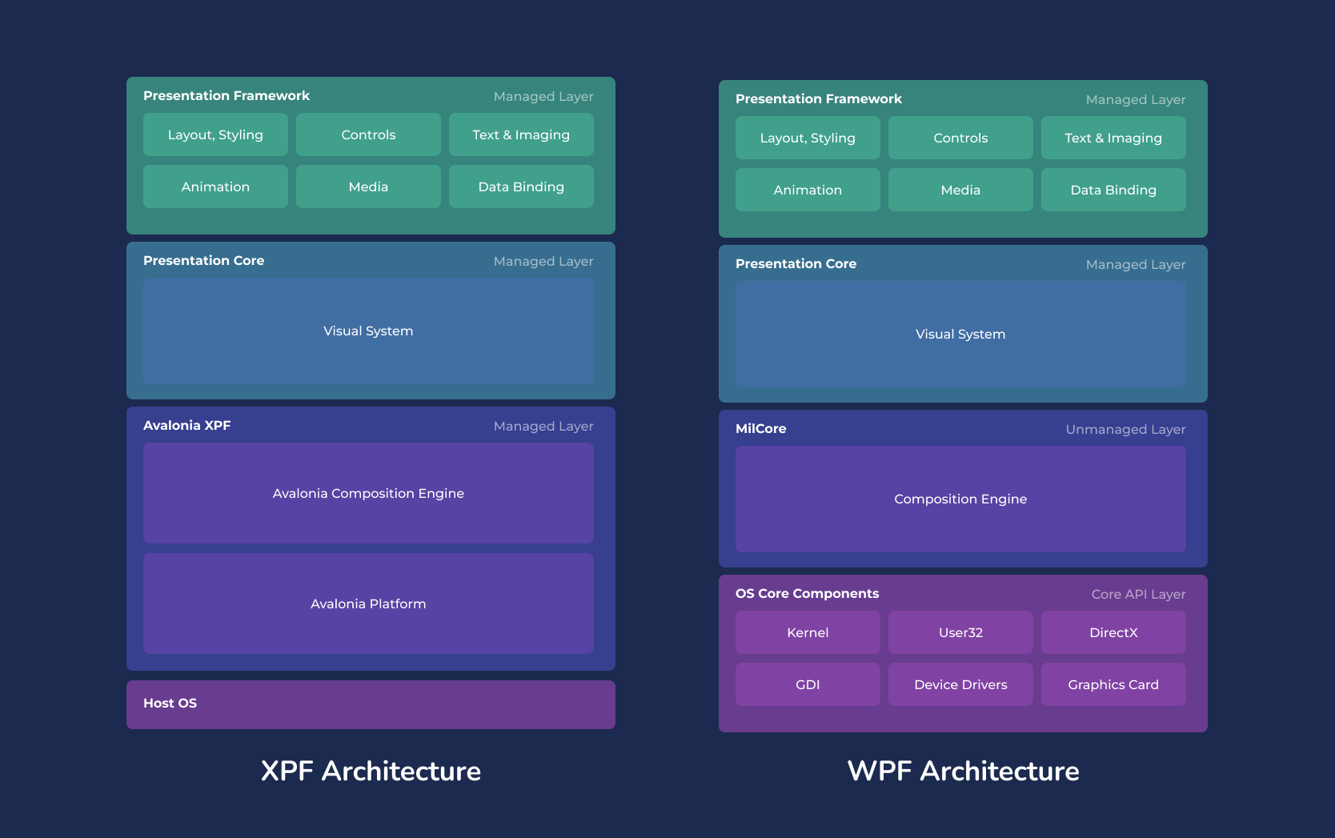

Avalonia XPF offers several significant benefits over traditional WPF development, particularly for developers and businesses looking to extend their WPF applications beyond Windows. Here are the key advantages:

**Cross-Platform Compatibility**

The primary benefit of Avalonia XPF is its ability to run WPF applications on multiple platforms:

It enables WPF apps to run on Windows, macOS, and Linux (both desktop and embedded).

Support for WebAssembly, iOS, and Android is planned for 2024.

This cross-platform capability allows developers to reach new markets and users without extensive rewrites or maintaining separate codebases for different operating systems.

**Preservation of Existing Investments**

Avalonia XPF allows developers to:

Reuse existing WPF code with minimal changes.

Preserve investments in third-party controls from popular vendors like Telerik, Actipro, DevExpress, Infragistics, Syncfusion, and SciChart.

This compatibility significantly reduces the time and resources needed to port applications to new platforms.

**Rapid Porting**

Avalonia XPF boasts a remarkably quick porting process:

Developers can port their WPF apps to new platforms with little effort. [ELABORATE]

The process involves simple steps like adding the Avalonia XPF NuGet feed and replacing the SDK reference in the project file.

**Familiar Development Experience**

Avalonia XPF maintains compatibility with existing WPF development tools and practices:

Developers can continue using familiar environments like Visual Studio on Windows or JetBrains Rider on any supported platform.

It supports XAML-based UI design, integrated debugging, and IntelliSense for XAML and C#.

**Performance Benefits**

Compared to other cross-platform solutions:

* Avalonia XPF offers better performance, especially in terms of memory usage and startup time.
* It leverages native hardware acceleration for smoother animations and more responsive interfaces.