Launch a python program on startup

Source: http://www.instructables.com/id/Raspberry-Pi-Launch-Python-script-on-startup/

1. Make a launcher script
“camera_reader_launcher.sh” for our program

----------------------------------------
#!/bin/sh
# launcher.sh

cd /
cd home/pi/Github/RPi_Camera_Reader
sudo python mainVideoCapture.py
cd /
-----------------------------------------

2. Make it executable
$ chmod 755 camera_reader_launcher.sh

Test it with following command:
$ sh camera_reader_launcher.sh

3. Add auto-launch at startup using Crontab
create a log folder in home directory
$ cd
$ mkdir logs

add to crontab:
$ sudo crontab -e

enter the line at the end of the file:
@reboot sh /home/pi/..../camera_reader_launcher.sh >/home/pi/logs/cronlog 2>&1

4. Reboot
The program should now start automatically at reboot:
$ reboot

Important Note:
the function “raw_input” only works for Python 2 which is the default version in raspberry pi. If the version changes to Python 3, this function should be replaced by “input()”.

Camera V2

The specs can be found in the following website:
https://www.element14.com/community/docs/DOC-81672/l/new-pi-camera-and-pi-camera-noir-v2

In a nutshell, the camera resolution and frame rate are 1080p at 30fps, 720p at 60 fps, and 640 by 480p at 90 fps.

Important Note:
There is a trade-off between high-resolution and file of view as described in:
https://picamera.readthedocs.io/en/release-1.10/fov.html

Specifically, a 1080p resolution (HD) limits the field of view.

To convert the default h264 video format to MP4, AVI, or others, follow the steps below:

- Download “gpac”
$ sudo apt-get install gpac

- Call command to convert
MP4Box -add original_video converted_video

Remote Access to Rpi
There are 2 methods to access the Rpi from a computer.

Source: https://www.raspberrypi.org/documentation/remote-access/

- SSH (terminal)

Download Putty.exe for Windows.

- VNC (graphic)

Source: https://www.raspberrypi.org/documentation/remote-access/vnc/README.md

GPS Tracker

Model: Ultimate GPS Breakout v3 (from adadfruit)
Communication: Serial
Source 1:
https://learn.adafruit.com/adafruit-ultimate-gps-on-the-raspberry-pi/using-uart-instead-of-usb

Source 2:
https://frillip.com/raspberry-pi-stratum-1-ntp-server/

Source 3:
http://www.satsignal.eu/ntp/Raspberry-Pi-quickstart.html

Connecting GPS tracker to Rpi3
Fig 1 shows the connection between the RPi3 and the GPS tracker. Only the following pins in the GPS tracker are used: VIN, GND, RX, TX and PPS.
If the Ultimate GPS Pi Hat is used, the connection is already made.
VIN is the power supply that should be connected to the +5V pin on the RPi3 (Pin 2 or 4).
GND is the ground connected to pin 6 on RPi3
For the transmission (TX) and reception (RX), they must be cross-connected, meaning TX in GPS tracker should be connected to RX in raspberry, and vice-versa. The TX and RX pins in the RPI3 are located in pin 8 (GPIO 14) and 10 (GPIO 15), respectively.
ADD SECTION ON CONNECTING THE PPS....
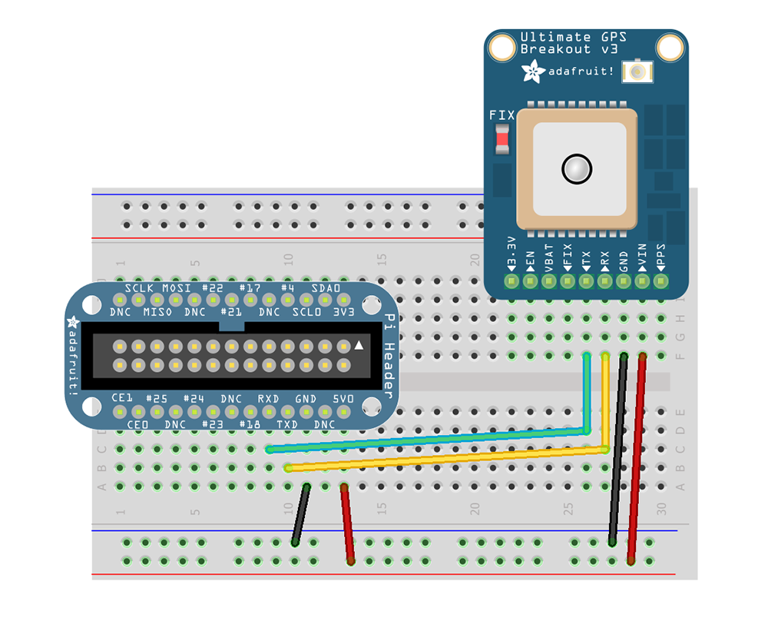Fig 1. Connection diagram of GPS tracker to RPi3
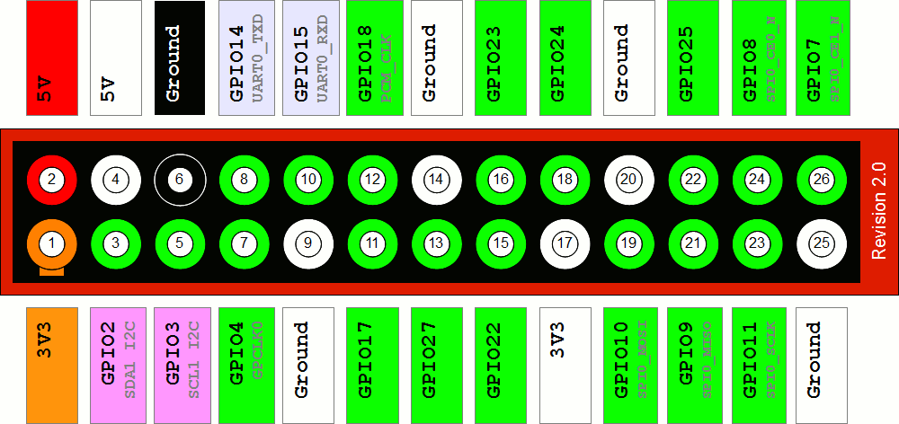
Fig 2. Connector Pinout of RPi3
Enabling Serial Communication in Raspberry Pi 3
By default, the serial port on the RPi3 is reserved for console (terminal) output. Thus, the raspberry must be reconfigured to allow serial communication on the pins 8 (TX) and 10 (RX) as shown in fig 2. Follow the steps below in the order.

- Edit /boot/cmdline.txt
Next, enter the following command from the command line:
$ sudo nano /boot/cmdline.txt

And change:
dwc_otg.lpm_enable=0 console=serial0,115200 console=tty1 root=/dev/mmcblk0p2 rootfstype=ext4 elevator=deadline fsck.repair=yes rootwait
to:
dwc_otg.lpm_enable=0 console=tty1 root=/dev/mmcblk0p2 rootfstype=ext4 elevator=deadline fsck.repair=yes rootwait
(eg, remove console=serial0,115200 and if there, kgdboc=serial0,115200)

- Service the tty service
Run the following two commands to stop and disable the tty service:
$ sudo systemctl stop serial-getty@serial0.service
$ sudo systemctl disable serial-getty@serial0.service

- Reboot your Pi
After rebooting the Pi for the above changes to take effect, you can proceed with running gpsd.

- Restart GPSD with HW UART
Restart gpsd and redirect it to use HW UART instead of the USB port we pointed it to earlier. Simply entering the following two commands:
$ sudo killall gpsd
$ sudo gpsd /dev/serial0 -F /var/run/gpsd.sock

- Test GPS data reception
After the GPS tracker gets a fix (the onboard LED should not be blinking at 1s interval), enter the following command
$ cgps -s

- Set GPS module as Real Time Clock (RTC)
Raspberry Pi does not have an onboard clock, so the default behavior is the Pi connects to NTP servers at each startup. But for our application, the Pi has no internet connection when used in the car. Therefore, the GPS module can be used as the Pi's RTC.
Source 2 and 3 provide instructions to set the GPS as a clock reference (RTC) at the Pi's startup.

Configuring the Pi
We need to get the Pi to load the pps-gpio kernel module on boot with
sudo apt-get install picocom pps-tools ntp
sudo sh -c "echo pps-gpio >> /etc/modules"

And then tell it to use GPIO18 as a PPS input with
sudo sh -c "echo dtoverlay=pps-gpio,gpiopin=4 >> /boot/config.txt"

If we reboot at this point, we can check everything is working as expected. If we open a serial console with
picocom -b 9600 -f n /dev/ttyS0

we should see some output from the GPS module, specifically we are looking for lines that start with $GPRMC.
Next, we need to check our PPS has been configured correctly. Make sure you GPS module has a fix (usually indicated by an LED), and execute the command sudo ppstest /dev/pps0. You should get an output similar to below:
~ $ sudo ppstest /dev/pps0
trying PPS source "/dev/pps0"
found PPS source "/dev/pps0"
ok, found 1 source(s), now start fetching data...
source 0 - assert 1457361736.999999817, sequence: 4986 - clear 0.000000000, sequence: 0
source 0 - assert 1457361737.999997945, sequence: 4987 - clear 0.000000000, sequence: 0

Finally, we need to configure udev to create some symlinks in /dev/ to make our gps serial and PPS interfaces easier to find. Create a new file with
sudo nano /etc/udev/rules.d/10-pps.rules
with the following contents:
KERNEL=="ttyS0", SYMLINK+="gps0"
KERNEL=="pps0", OWNER="root", GROUP="tty", MODE="0660", SYMLINK+="gpspps0"

Getting an ntpd with PPS support
The version of ntpd that ships with the Pi doesn't include PPS (or ATOM, as the clock is called) support. So, we must compile our own!
First, we need to enable the source repositories with
sudo nano /etc/apt/sources.list
and then uncomment the line containing deb-src. Then run
sudo apt-get update
to get the package lists.
We're not going to get the source for the ntp package this way, but we do need the required build tools, so install them with
sudo apt-get build-dep ntp.
Grab the latest version of ntp from the project home page, extract it, and change directory into the source directory. Configure with
./configure --enable-linuxcaps --prefix=/usr, else use ./configure --prefix=/usr

Then compile and install with
make -j5
sudo service ntp stop
sudo make install

As we've just overwritten the package version of ntp with our own compiled version, we need to stop apt-get upgrade from overwriting it with
echo "ntp hold" | sudo dpkg --set-selections.

Stopping dhcpcd from interfering
Later Raspian versions ship with the dhcpcd5 package. This has a nasty habit of interfering where it's not wanted. Specifically, in this instance, if your DHCP server specifies an NTP server, it will start ntpd with it's own version of ntp.conf. Not what we want at all if we're setting up our own NTP server! So, to stop this behavior, remove the offending script with
sudo rm /lib/dhcpcd/dhcpcd-hooks/50-ntp.conf
and remove any configuration files it may have created with
sudo rm /var/lib/ntp/ntp.conf.dhcp.

Editing NTP Configuration
sudo nano /etc/ntp.conf

Replace its content with:
# /etc/ntp.conf, configuration for ntpd; see ntp.conf(5) for help
# Drift file etc.
driftfile /var/lib/ntp/ntp.drift
# GPS with PPS enabled
server 127.127.22.0 minpoll 4 maxpoll 4
fudge 127.127.22.0 refid PPS
server 127.127.28.0 minpoll 4 maxpoll 4 iburst prefer
fudge 127.127.28.0 time1 +0.105 flag1 1 refid GPSD stratum 1
# Internet time servers for sanity
server 0.debian.pool.ntp.org iburst prefer
server 1.debian.pool.ntp.org iburst
server 2.debian.pool.ntp.org iburst
server 3.debian.pool.ntp.org iburst
restrict source notrap nomodify nopeer
restrict 127.0.0.1
restrict ::1
restrict 192.168.0.0 mask 255.255.255.0

GPSD software
Now install the GPSD software:
$ sudo apt-get install gpsd gpsd-clients python-gps

Now try and start the gpsd service temporarily.
$ sudo gpsd /dev/ttyS0 -n -F /var/run/gpsd.sock

At this point, you should be able to see a text-mode output from your GPS receiver by running the command "cgps -s", something like the following. Type "q" to exit the cgps program.
$ cgps -s

Configuring gpsd to auto-start
Likely with a fresh install of Raspbian Jessie instead of the GPS output showing you may get a "GPS timeout" message. Try editing the startup file and linkage for GPSD as follows. Thanks to A Carver: The gpsd needs to be started with the "-n" option. These options are set in the directory /etc/default, so you need to edit the file
$ sudo nano /etc/default/gpsd

to change the line:
- GPSD_OPTIONS="" to GPSD_OPTIONS="-n"
- USBAUTO="false"
- DEVICES="/dev/ttyS0".
With Raspbian Jessie, gpsd doesn't appear to auto-start properly, but Tomasz Torcz on the comp.sys.raspberry-pi Usenet group suggested trying:
$ sudo ln -s /lib/systemd/system/gpsd.service /etc/systemd/system/multi-user.target.wants/

and that appears to do the trick. You should then find that gpsd restarts after a reboot.

9-D Motion Sensor

Model: BNO055
Communication: I2C
Tutorial:
https://learn.adafruit.com/bno055-absolute-orientation-sensor-with-raspberry-pi-and-beaglebone-black/overview
Note: Even though the tutorial recommends using UART, the RPi3 has only one port available and already reserved for the GPS tracker. Thus, this motion sensor must use the I2C port.

Connecting motion sensor (BNO) to Rpi3
BNO | RPi 3
VIN | Pin 2 or 4 (+5V)
GND | Any GND (Pin 6/14/...)
SDA | Pin 3 (SDA1)
SCL | Pin 5 (SCL1)

Enable I2C on the RPi 3
By default, the I2C is not enabled. Follow the procedure described in the following website:
https://learn.sparkfun.com/tutorials/raspberry-pi-spi-and-i2c-tutorial#i2c-on-pi
The steps are as follow:
- Run $ sudo raspi-config.
- Use the down arrow to select 9 Advanced Options
- Arrow down to A7 I2C
- Select yes when it asks you to enable I2C,
- Also select yes when it asks about automatically loading the kernel module.
- Use the right arrow to select the <Finish> button.
- Select yes when it asks to reboot.
The system will reboot. when it comes back up, log in and enter the following command
$ ls /dev/*i2c*

The Pi should respond with
> /dev/i2c-1

Which represents the user-mode I2C interface.

Software Installation
To install the software for this project you'll need to make sure your Raspberry Pi is running the latest Raspbian operating system.
Connect to your board in a command line terminal and run the following commands to install the necessary dependencies:
$ sudo apt-get update
$ sudo apt-get install -y build-essential python-dev python-smbus python-pip git

Next run the following commands to download and install the latest version of the BNO055 Python module code from GitHub
$ cd ~
$ git clone https://github.com/adafruit/Adafruit_Python_BNO055.git
$ cd Adafruit_Python_BNO055
$ sudo python setup.py install

If you see the installation fail with an error message go back and check the dependencies above were installed and try again. Also make sure your board is connected to the internet as the installation will download and install some required Python modules.
Once the module is installed you're ready to start using it. See the section below for details on running the examples and using the BNO055 module.

Running Example
Connect to the board in a command terminal and navigate to the library examples folder by running the following command:
$ cd ~/Adafruit_Python_BNO055/examples

Before you run the example you might need to change the code to intialize the BNO055 sensor depending on how it's connected to your board. Open the file using the nano text editor by running:
$ nano simpletest.py

Then navigate down to this section of the example code:
# Create and configure the BNO sensor connection. Make sure only ONE of the
# below 'bno = ...' lines is uncommented:
# Raspberry Pi configuration with serial UART and RST connected to GPIO 18:
bno = BNO055.BNO055(serial_port='/dev/ttyAMA0', rst=18)

Change the last line of the code snippet to:
bno = BNO055.BNO055()

If you're using a different I2C bus you can specify it by adding a bus= parameter to the call, like bus=0 for using the /dev/i2c0 bus. You can also change the reset pin to any free digital GPIO (just be careful that the chosen pin is available as a GPIO with the current device tree overlays--if in doubt stick with the default P9_12 pin).
If you're not using the reset line with the sensor you can remove the rst=... part of the initializer call. In this mode a software reset command will be sent to reset the board instead of using the hardwired reset pin.
Once you've finished modifying the file save it and exit nano by pressing Ctrl-S, enter, and then Ctrl-X.
Now run the code as a root user with sudo by executing:
$ sudo python simpletest.py

If everything is working correctly you should see something like the following after a few seconds:
System status: 5
Self test result (0x0F is normal): 0x0F
Software version: 776
Bootloader version: 21
Accelerometer ID: 0xFB
Magnetometer ID: 0x32
Gyroscope ID: 0x0F

Reading BNO055 data, press Ctrl-C to quit...
Heading=0.00 Roll=0.00 Pitch=0.00 Sys_cal=0 Gyro_cal=0 Accel_cal=0 Mag_cal=0
Heading=0.00 Roll=-0.69 Pitch=0.81 Sys_cal=0 Gyro_cal=3 Accel_cal=0 Mag_cal=0
Heading=0.00 Roll=-0.69 Pitch=0.81 Sys_cal=0 Gyro_cal=3 Accel_cal=0 Mag_cal=0
Heading=0.00 Roll=-0.69 Pitch=0.81 Sys_cal=0 Gyro_cal=3 Accel_cal=0 Mag_cal=0
Heading=0.00 Roll=-0.69 Pitch=0.81 Sys_cal=0 Gyro_cal=3 Accel_cal=0 Mag_cal=0
Heading=0.00 Roll=-0.69 Pitch=0.81 Sys_cal=0 Gyro_cal=3 Accel_cal=0 Mag_cal=0

If you see an error message carefully check that the BNO055 is connected to the hardware as shown on the previous page. Make sure the software and its dependencies are installed as shown above too.

