Fianl POE
Network Egineering NWEG5112
ST10443510
GROUP 1
Atlegang Keasmogetswe Seboge

Activity 1
Task 1
A.Maked POE Part 1 with the final mark and Lecture’s feedback

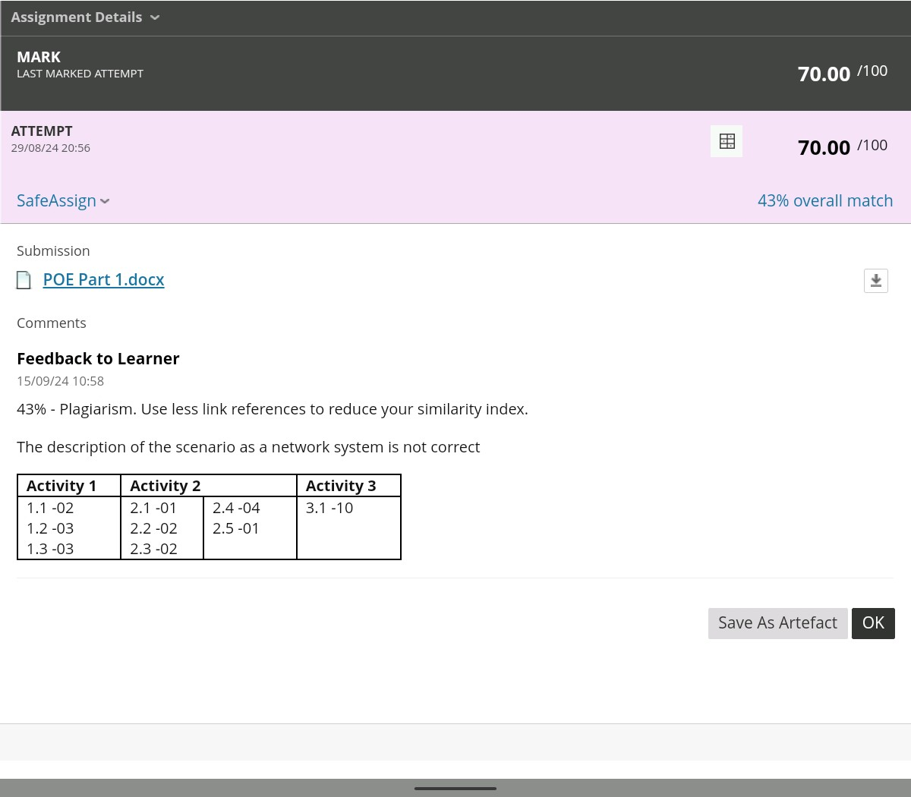

Updated and corrected POE Part 1
Network Protocols: TCP/IP for general network communication MQTT for IoT device communication BACnet for building automation systems Functional Requirements: Real-time monitoring of building systems Remote control capabilities for facility managers Data collection for analytics and reporting Network Systems (Core): Building Management System (BMS) Security System Integration Energy Management System Performance Requirements (Network Traffic): Response time less than 1 second for critical operations 99.9% system uptime requirement Minimum bandwidth of 100Mbps to handle all systems Implementation Constraints (Embedded Systems): Various IoT sensors with limited processing power Integration with legacy building systems Power consumption constraints for battery-operated devices

Task 2
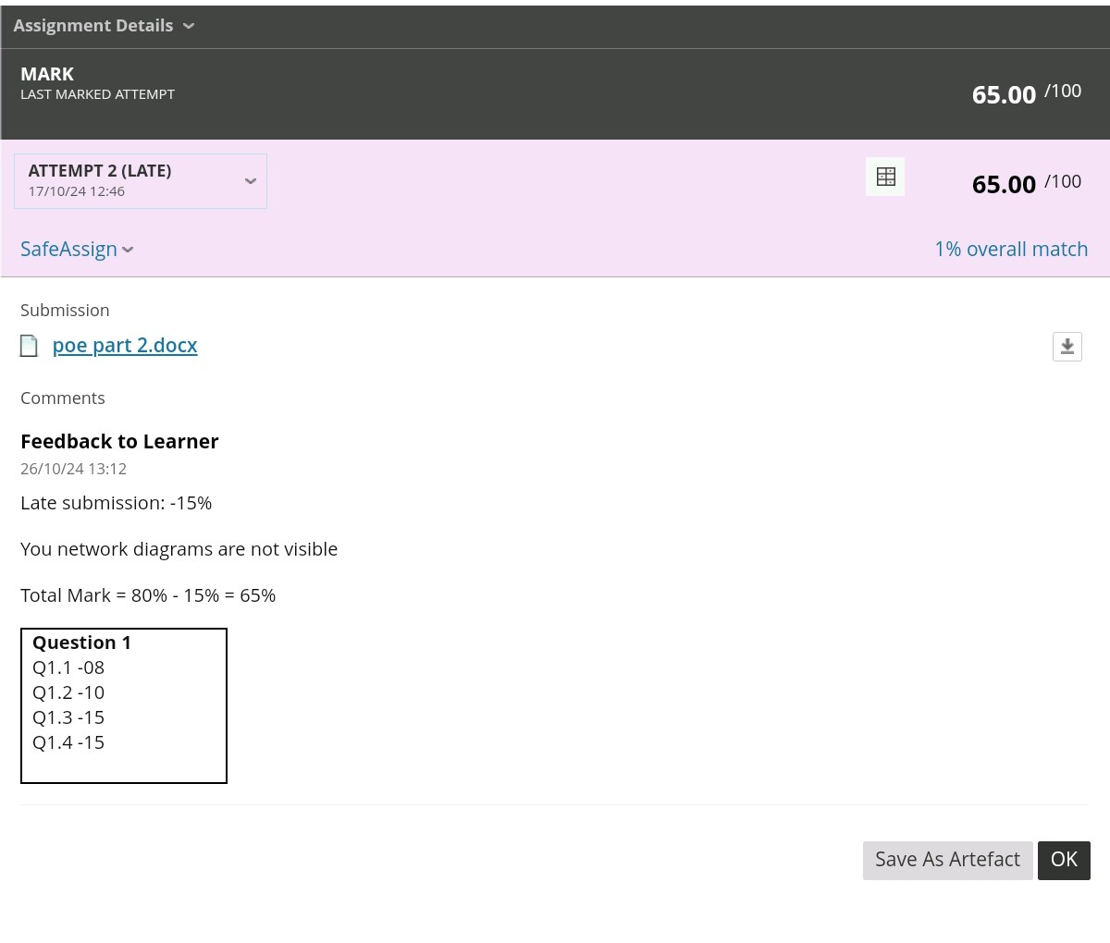
Corrected Wan Diagram
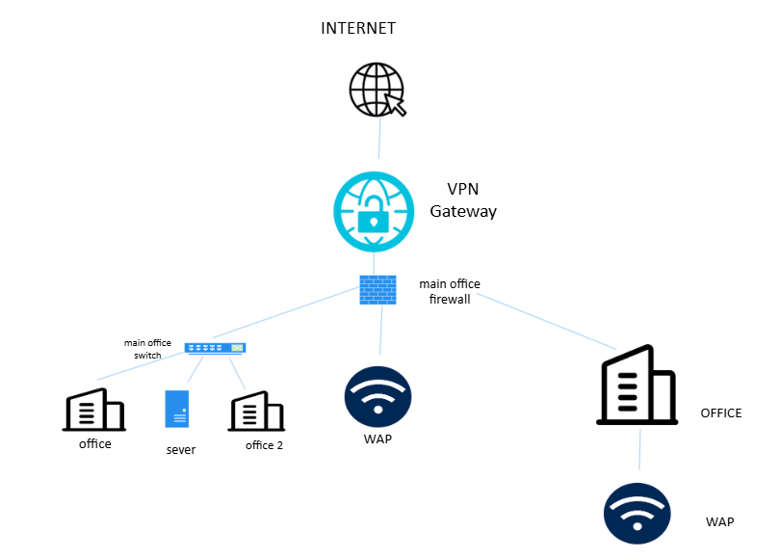
Corrected LAN Diagram
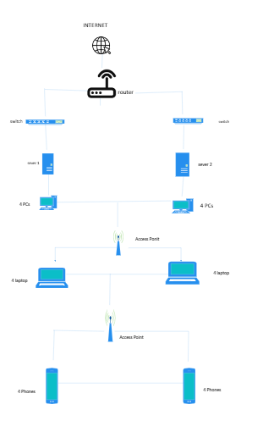
It was recommended that I should fix my diagram and make it more visible. I implemented this buy using a different website to create the network diagrams. And I used better proportions in terms of space size and the icons

Activity 2
The goal of this proposal is to design an updated network solution for Mr Khoza’s business. Mr Khoza’s business has been making progress in terms of growth, and with this plan of opening new branches in Roodepoort and Pretoria North, a good, robust, secure and scalable network solution is required. The network solution should enable all offices to seamlessly connect, communicate and potentially work remotely. The solution will reach these specific objectives; it will be scalable to accommodate future growth, it will be secure to protect the business data, there will be redundancy to maintain service availability and it will provide efficient communication across offices. The proposal will also give updated WAN diagrams and WAN diagrams, justifications for selected devices and protocols, and the Quality of Service (QoS).

The updated network will be able to connect all three offices (Midrand HQ ,Roodepoort, and Pretoria North) using a secure WAN.it will ensure security for remote workers and BYOD devices using a VPN, it will also be able to Leverage cloud services for data redundancy and centralized management. The network will also provide sever redundancy to ensure that there is high availability and it will enable scalability via infrastructure for future growth. Scalability will allow for the ability to expand, by adding more devices, offices, or users. Security will allow for VPN, Firewalls and access control to protect the business sensitive data. Sever Redundancy uses load balancers and mirrored severs to prevent downtime if one severs breaks down. And Quality of Service (QoS) will prioritize VoIP, video conferencing, and business-critical traffic. Each office should have wireless network powered by a high-performance AP, the wireless network should support both employees and guest devices.
Local Area Networks (LAN)
Each office has its own dedicated LAN that provides connectivity for devices such as PCs, laptops, printers, and wireless devices.

Midrand HQ (Existing Setup):
15 Desktop PCs connected via two switches to ensure redundancy.
Wireless Access Point (AP) for BYOD devices and mobility.
Centralized Servers: that will be used for file server for data sharing and a printer sever for managing netwok printer
Firewall: Protects the network from unauthorized access and external threats.
Roodepoort Branch:
10 Desktop PCs connected via a managed switch.
Wireless AP for BYOD and guest connectivity.
A single router connects the LAN to the WAN via the VPN.
Pretoria North Branch:
25 Users with devices connected via two managed switches for load balancing and redundancy.
Wireless AP for BYOD and mobility.
A router connects the branch LAN to the WAN, and the VPN ensures secure communication with HQ and other branches.
Updated LAN
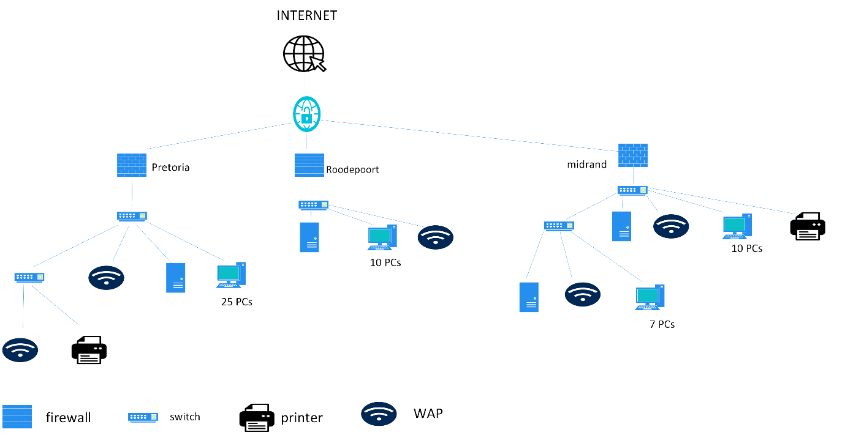
Updated WAN
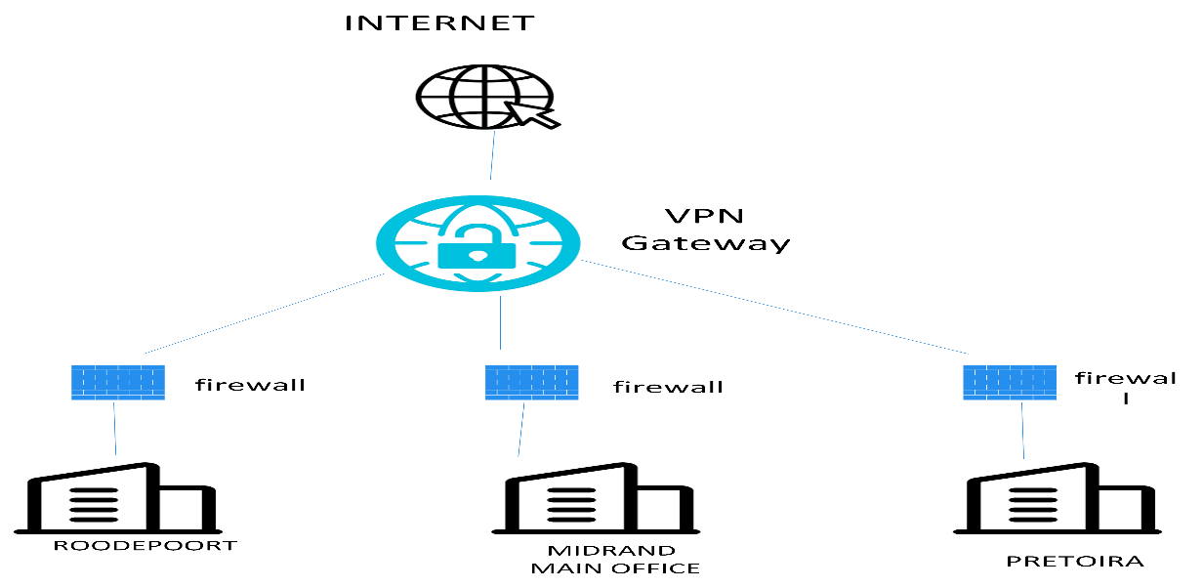

One of the main considerations is Network performance, this is extremely critical for smooth business operation, multiple branches and users. High Speed connections should be ensured by using high-performing router, fiber-based ISP and managed switches to ensure high- speed data transfer. Traffic prioritization polices must prioritize business-critical applications to avoid latency. Wireless Access Points should be strategically placed for the best signal strength.
Routing is important for data flow between devices and offices. OSPF(Open Shortest Path First) dynamically adjust routes between branches, making sure that the best path selection and redundancy in case of link failure. The business should also integrate VPN to secure route traffic between brunches over the internet
Scalability is also a very import object for Mr Khoza because his business is bound to expand. There should be managed switches and router support and VLANs. They should also integrate cloud-based application and storage to remove the need for physical sever expansion as the user grows. Additional Aps can deployed seamlessly to support increased BYOD or mobile users.
Security is one of the main considerations because it is top priority you protect business data and commutation. The way this can be achieved is by using firewall protection to block unauthorized traffic. The isolation of guest traffic from internal business operations, reducing risks. Access control should also be heavily monitored, devices should authenticate before accessing network and all hardware and software should be updated to avoid any patch vulnerabilities
Sever Redundancy makes sure that the business continuity in case of hardware failure and this can be achieved by mirrored severs (multiple severs up and if one fails the other is there for support) and cloud backups (critical data is backed up on the cloud) these methods also offer load balancing.
One of the considerations is Standard protocols are used to ensure seamless communication and security. This will be possible through OSPF (dynamic routing protocol that ensure efficient routing across WAN.
SNMP (monitors network devices to ensure smooth operation and detect issues.)
Compliance and QoS are important considerations. Compliance refers to the adherence of the network industry standards and regulations (Data Protection, Guest Network Polices). QoS makes sure that the most critical applications receive priority over less import traffic (Traffic Prioritization, Bandwidth Allocation)
Connection is the most important consideration because a reliable connection is the backbone of the network solutions. This can be achieved through many ways like: Site-to-site VPN which allows secured connection between branches over the internet. Wireless connect via access point provide robust coverage in each office

Justification for Hardware and Infrastructure
High preforming routers are vital for handling VPNs and routing traffic. Managed switch allows for traffic prioritization and redundancy. Cloud Services reduces the dependency on physical infrastructure. Firewalls protect the network from the external threats and unauthorized access

The network proposal touches on the all the important points like connectivity, security and scalability for Mr Khoza business. It connects all offices via site-to-site VPNs, prioritizes critical traffic using QoS, and supports BYOD and remote work with robust wireless infrastructure. The solution is a long term that offer reliability, efficiency and business continuity

Activity 3
Reflection is when one critically assess their learning experience to understand what they have learned, and what way they have learned it and possible was for it to be applied in the real world.
Throughout doing Part1, Part 2 and POE I have learned the importance of network systems how they work and I have also learned how to apply what I learned in theory in to real life situations. I have also learned how to also alter and manipulate network diagrams, network systems. I have learnt the principles of a good network design which are scalability, redundancy and centralized management. I have also learned the most efficient connectivity which is WAN connectivity, LAN design and the importance of wireless networks. I also learned the necessary security measures one has to take and the importance of high-performance hardware and many more things.
I learned how to make more visible network diagrams and making more understandable examples that can be understood by the average person.
The project was assigned well, it had great continuity.
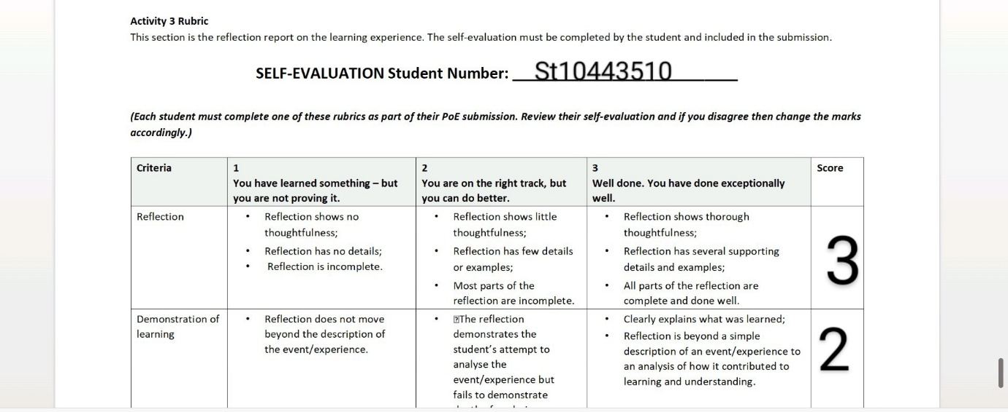

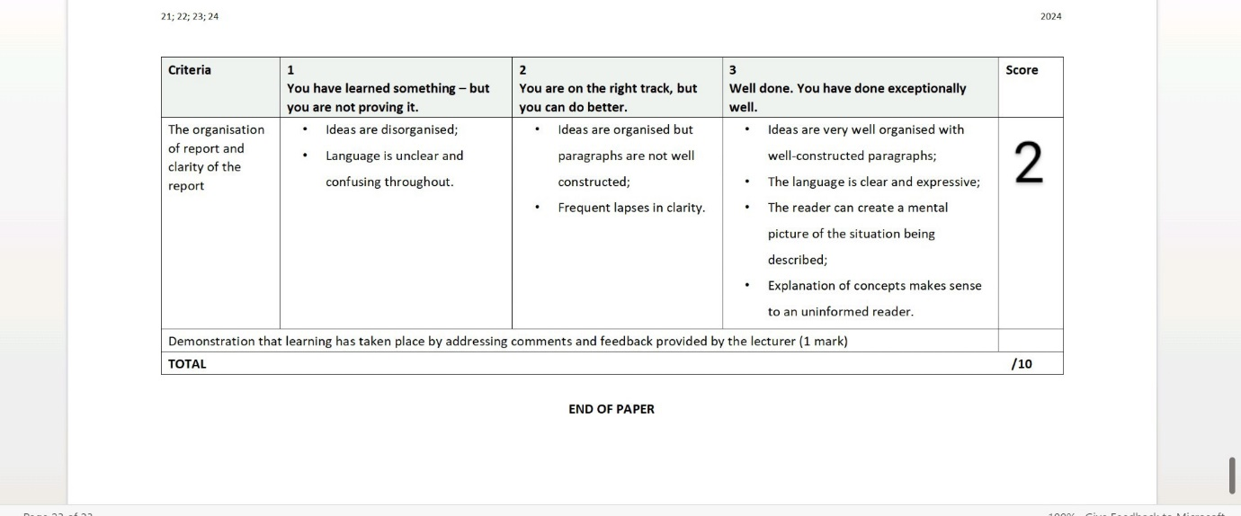

Referencing
Scarpati, J. (2021). What is Simple Network Management Protocol (SNMP)? Definition from SearchNetworking. [online] SearchNetworking. Available at: https://www.techtarget.com/searchnetworking/definition/SNMP.
IBM (2021). Open Shortest Path First. [online] www.ibm.com. Available at: https://www.ibm.com/docs/en/i/7.4?topic=routing-open-shortest-path-first.
Howard (2022). Server Redundancy: Types, Benefits & Design | FS Community. [online] Knowledge. Available at: https://community.fs.com/article/server-redundancy-types-benefits-and-design.html.
WhatIs.com. (n.d.). What is an Internet Service Provider (ISP)? [online] Available at: https://www.techtarget.com/whatis/definition/ISP-Internet-service-provider.
Serpanos, D. and Wolf, T. (2011). Architecture of Network Systems. Elsevier, p.268.

