**Reasons for a NoSuchElementException**

**Latency** - The HTML element is not yet present in the web page, just when the desired element is rendered asynchronously.

**Occurs after an event** - The HTML element appears in the web page only after certain operations are performed.

**Present inside an iframe** **or Shadow DOM**- The HTML element you are trying to locate is inside an [**<iframe>**](https://developer.mozilla.org/en-US/docs/Web/HTML/Element/iframe) element or Shadow DOM

**Element is not there or incorrect** - The HTML element is not present in the web page, no matter what.

Both **iframe**s and the **shadow DOM** provide **encapsulation** in the DOM.

An HTML iframe is a web page or an inline frame which is embedded in another web page or an HTML document embedded inside another HTML document. The iframe is often used to add content from other sources like an advertisement into a web page. The iframe is defined with the <iframe> tag.

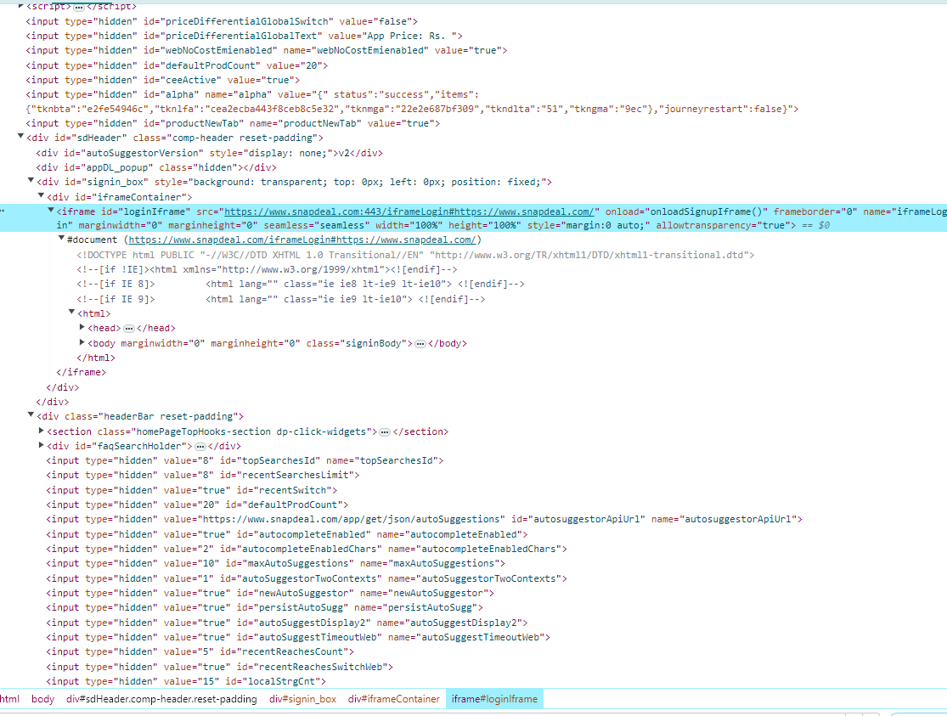

**Shadow** **DOM**: DOM within a DOM. The Shadow DOM is a way to achieve encapsulation in the HTML document. By implementing it, you can keep the style and behaviour of one part of the document hidden and separate from the other code of the same document so that there is no interference.

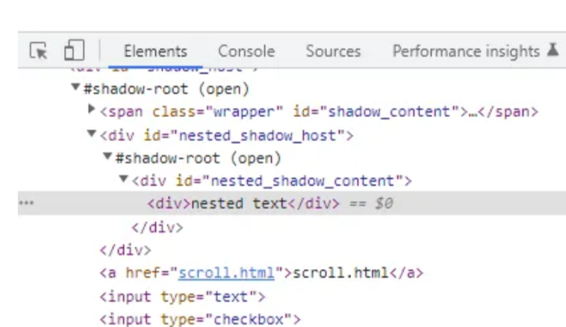

We can switch over the frames in Selenium using 3 ways.

* **By Index**
* **By Name or Id**
* **By Web Element**

### Method 1: Switch to the iframe by index

Index is one of the attributes of the iframe and can be switched through it.

Index of the iframe starts with ‘0’.

if there are 10 frames in a page, we can switch to a frame in Selenium by using index.

* driver.switchTo().frame(0);
* driver.switchTo().frame(1);

### Method 2: Switch to the frame by Name or ID

Name and ID are attributes for handling frames in Selenium through which we can switch to the iframe.

* driver.switchTo().frame("iframe1");
* driver.switchTo().frame("id of the element");

### Method 3: Switch to the frame by Web Element

We can even switch to the iframe using a web element .

* driver.switchTo().frame(WebElement);

**How to switch back to the Main Frame?**

We have to come out of the iframe. To move back to the parent frame, you can either use switchTo().parentFrame() or if you want to get back to the main (or most parent) frame, you can use switchTo().defaultContent();

* driver.switchTo().parentFrame();
* driver.switchTo().defaultContent();