**What are iframes?**

* An ***iframe*** is a space on the web page that embeds different kinds of media like images, documents, videos inside the main web page.
* The media can be internal images or documents related to the website or external sources from other websites.
* The full form of the ***iframe*** is ***Inline Frame*** and is defined using ***<iframe> tag in HTML.***
* You can insert an iframe element by using the ***<iframe>*** tag in an *HTML* document.
* The ***'src'*** attribute of the tag specifies the *URL* of the media we have to embed in the*** iframe.***
* The syntax of using the *iframe*  in the HTML document is: <iframe src="URL"></iframe>

Though websites widely use *iframes,* they bring in security risks. Moreover, websites can become vulnerable to ***cross-site attacks*** as the pages generally host on an external domain.

Thus, an *iframe* requires a developer to trust the content that has been embedded in the *iframe.*

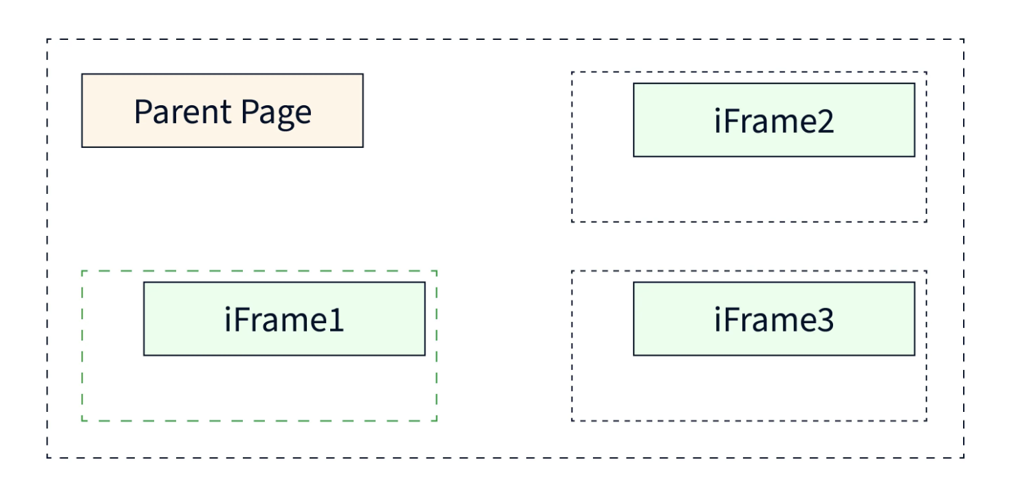

**Handling iframes:**

To handle an iframe, first the driver should switch to the iframe

Switching over to the frames in Selenium can be done in 3 ways.

* **By Index** 
  + driver.switchTo().frame(0);
* **By Name or Id** 
  + driver.switchTo().frame("iframe1");
  + driver.switchTo().frame("id of the element");
* **By Web Element**
  + driver.switchTo().frame(WebElement);