HTML (HyperText Markup Language) is the code that is used to structure a web page and its content. For example, content could be structured within a set of paragraphs, a list of bulleted points, or using images and data tables.
HTML is a markup language that defines the structure of your content. HTML consists of a series of elements, which you use to enclose, or wrap, different parts of the content to make it appear a certain way or act a certain way. The enclosing tags can make a word or image hyperlink to somewhere else, can italicize words, can make the font bigger or smaller, and so on
Element
An element is a part of a webpage. In XML and HTML, an element may contain a data item or a chunk of text or an image, or perhaps nothing. A typical element includes an opening tag with some attributes, enclosed text content, and a closing tag.
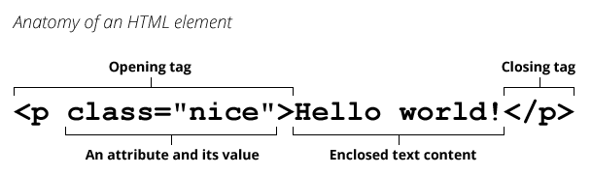
Attribute
An attribute extends an HTML or XML element, changing its behaviour or providing metadata.
An attribute always has the form name="value" (the attribute's identifier followed by its associated value).
You may see attributes without the equals sign or a value. That is a shorthand for providing the empty string in HTML, or the attribute's name in XML.
HTML with Sample element and attribute:
<input required />
<!-- is the same as… -->
<input required="" />
<!-- or -->
<input required="required" />

CSS (Cascading Style Sheets) is the code that styles web content. It is used to decorate my webpage with background images and colors. Like HTML, CSS is not a programming language. It's not a markup language either. CSS is a style sheet language.

Structure Tag | Syntax | Description
<html> | <html> Statements... </html> | The root of the HTML document specifies it as HTML.
<head> | <head> Statements... </head> | Contains head elements such as title, style, and meta tags in the HTML file.
<title> | <title> Statements... </title> | Defines the title of an HTML document.
<body> | <body> Statements... </body> | Defines the body of an HTML document, containing content like images, tables, and lists.
HTML Tag | Syntax | Description
<div> | <div>...</div> | Defines a division or section in an HTML document.
<p> | <p>...</p> | Defines a paragraph.
<a> | <a href="...">...</a> | Defines a hyperlink.
<img> | <img src="..." alt="..."> | Embeds an image.
<ul> | <ul><li>...</li></ul> | Defines an unordered list.
<ol> | <ol><li>...</li></ol> | Defines an ordered list.
<li> | <li>...</li> | Defines a list item.
<table> | <table>...</table> | Defines a table.
<tr> | <tr>...</tr> | Defines a table row.
<th> | <th>...</th> | Defines a table header cell.
<td> | <td>...</td> | Defines a table data cell.
<form> | <form>...</form> | Defines an HTML form for user input.
<input> | <input type="..."> | Defines an input control within a form.
<button> | <button>...</button> | Defines a clickable button.
<h1>–<h6> | <h1>...</h1> | Define headings of different levels.
<span> | <span>...</span> | Defines a generic inline container.
<label> | <label for="...">...</label> | Defines a label for an input element.
<iframe> | <iframe src="..."></iframe> | Embeds an inline frame for external content.

