Many popular websites still use them for embedded content like advertisements, payment gateways, video players, or even entire sections of a page.
Selenium's default focus is always on the main HTML document (the "default content"). When you encounter elements inside a frame, Selenium won't be able to find them until you explicitly tell it to switch its focus into that frame.

What are iframes?
- An iframe is a space on the web page that embeds different kinds of media like images, documents, videos inside the main web page.
- The media can be internal images or documents related to the website or external sources from other websites.
- The full form of the iframe is Inline Frame and is defined using <iframe> tag in HTML.
- You can insert an iframe element by using the <iframe> tag in an HTML document.
- The 'src' attribute of the tag specifies the URL of the media we have to embed in the*** iframe.***
- The syntax of using the iframe in the HTML document is: <iframe src="URL"></iframe>

Though websites widely use iframes, they bring in security risks. Moreover, websites can become vulnerable to cross-site attacks as the pages generally host on an external domain.
Thus, an iframe requires a developer to trust the content that has been embedded in the iframe.
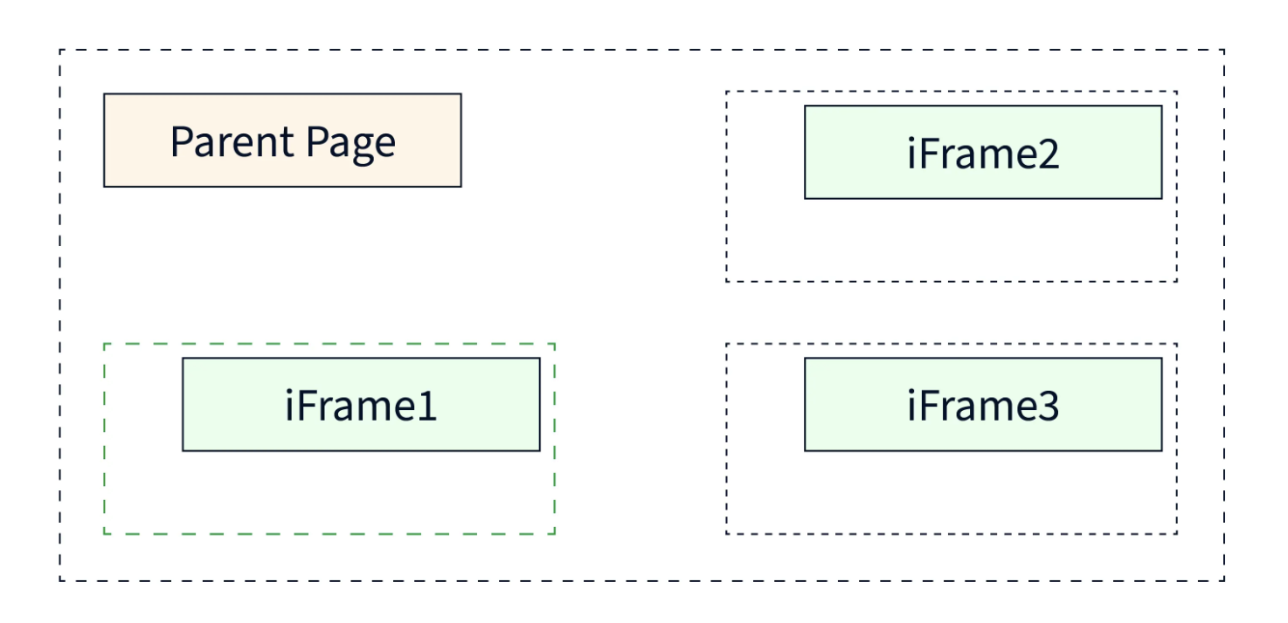

Handling iframes:
To handle an iframe, first the driver should switch to the iframe
Switching over to the frames in Selenium can be done in 3 ways.
- By Index
  - driver.switchTo().frame(0);
- By Name or Id
  - driver.switchTo().frame("iframe1");
  - driver.switchTo().frame("id of the element");
- By Web Element
  - driver.switchTo().frame(WebElement);

Both iframes and Shadow DOM are techniques used to encapsulate HTML, CSS, and JavaScript within a web page
Iframe:
- Purpose: To embed an independent document (HTML, CSS, and JavaScript) within another document.
- Encapsulation: Complete isolation, forming a separate browsing context.
- Styling: Styles within the iframe are isolated and do not affect the parent document.

Shadow DOM:
- Purpose: To encapsulate HTML, CSS, and JavaScript within a specific part of a document, creating a "shadow" DOM tree.
- Encapsulation: Partial isolation, allowing for component-based development and style encapsulation.
- Styling: Styles within the Shadow DOM are scoped and do not affect the parent document's styles

When to Use Which:
- Use iframes when:
  - You need complete isolation for security or performance reasons.
  - You want to embed external content that you don't control.
- Use Shadow DOM when:
  - You want to create reusable web components.
  - You want to encapsulate complex UI elements.
  - You want to improve code organization and maintainability.

