HTML (**H**yper**T**ext **M**arkup **L**anguage) is the code that is used to structure a web page and its content. For example, content could be structured within a set of paragraphs, a list of bulleted points, or using images and data tables.

HTML is a *markup language* that defines the structure of your content. HTML consists of a series of **elements**, which you use to enclose, or wrap, different parts of the content to make it appear a certain way or act a certain way. The enclosing tags can make a word or image hyperlink to somewhere else, can italicize words, can make the font bigger or smaller, and so on

**Element**

An **element** is a part of a webpage. In XML and HTML, an element may contain a data item or a chunk of text or an image, or perhaps nothing. A typical element includes an opening tag with some attributes, enclosed text content, and a closing tag.

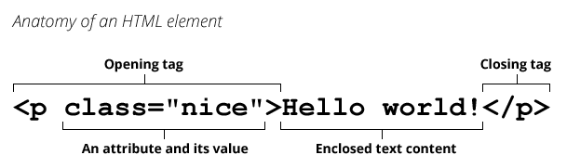

**Attribute**

An **attribute** extends an HTML or XML element, changing its behaviour or providing metadata.

An attribute always has the form name="value" (the attribute's identifier followed by its associated value).

You may see attributes without the equals sign or a value. That is a shorthand for providing the empty string in HTML, or the attribute's name in XML.

HTML with Sample element and attribute:

**<input required />**

*<!-- is the same as… -->*

**<input required="" />**

*<!-- or -->*

**<input required="required" />**

CSS (Cascading Style Sheets) is the code that styles web content. It is used to decorate my webpage with background images and colors. Like HTML, CSS is not a programming language. It's not a markup language either. **CSS is a style sheet language.**

| **Structure Tag** | **Syntax** | **Description** |
| --- | --- | --- |
| **<html>** | <html> Statements... </html> | The root of the HTML document specifies it as HTML. |
| **<head>** | <head> Statements... </head> | Contains head elements such as title, style, and meta tags in the HTML file. |
| **<title>** | <title> Statements... </title> | Defines the title of an HTML document. |
| **<body>** | <body> Statements... </body> | Defines the body of an HTML document, containing content like images, tables, and lists. |
|  |  |  |
| **HTML Tag** | **Syntax** | **Description** |
| **<div>** | <div>...</div> | Defines a division or section in an HTML document. |
| **<p>** | <p>...</p> | Defines a paragraph. |
| **<a>** | <a href="...">...</a> | Defines a hyperlink. |
| **<img>** | <img src="..." alt="..."> | Embeds an image. |
| **<ul>** | <ul><li>...</li></ul> | Defines an unordered list. |
| **<ol>** | <ol><li>...</li></ol> | Defines an ordered list. |
| **<li>** | <li>...</li> | Defines a list item. |
| **<table>** | <table>...</table> | Defines a table. |
| **<tr>** | <tr>...</tr> | Defines a table row. |
| **<th>** | <th>...</th> | Defines a table header cell. |
| **<td>** | <td>...</td> | Defines a table data cell. |
| **<form>** | <form>...</form> | Defines an HTML form for user input. |
| **<input>** | <input type="..."> | Defines an input control within a form. |
| **<button>** | <button>...</button> | Defines a clickable button. |
| **<h1>–<h6>** | <h1>...</h1> | Define headings of different levels. |
| **<span>** | <span>...</span> | Defines a generic inline container. |
| **<label>** | <label for="...">...</label> | Defines a label for an input element. |
| **<iframe>** | <iframe src="..."></iframe> | Embeds an inline frame for external content. |