## 1) Create Database

MySQL create database is used to create a database.

**create** **database** college;

## 2) Select/Use Database

MySQL use <database> is used to select a database.

**use** college;

## 3) Create Query

MySQL create query is used to create a table,

**CREATE** **TABLE** customers

(id **int**(10), **name** **varchar**(50), city **varchar**(50), **PRIMARY** **KEY** (id ) );

Using foreign key:

**CREATE** **TABLE** customers

(id **int**(10), **name** **varchar**(50), city **varchar**(50), **PRIMARY** **KEY** (id ), **FOREIGN KEY( id) REFERENCES** Table_Name(field_Name) );

## 4) Alter Query

MySQL alter query is used to add, modify, delete or drop columns of a table. Let's see a query to add column in customers table:

**ALTER** **TABLE** customers

**ADD** age **varchar**(50);

## 5) Insert Query

MySQL insert query is used to insert records into table

**insert** **into** customers **values**(101,'rahul','delhi');

## 6) Update Query

MySQL update query is used to update records of a table.

**update** customers **set** **name**='bob', city='london' **where** id=101;

## 7) Delete Query

MySQL update query is used to delete records of a table from a database.

**delete** **from** customers **where** id=101;

## 8) Select Query

Oracle select query is used to fetch records from the database.

**SELECT** * **from** customers;

9) Truncate Table Query

MySQL update query is used to truncate or remove records of a table. It doesn't remove structure.

**truncate** **table** customers;

10) DROP Table

MYSQL uses a Drop Table statement to delete the existing table. This statement removes the complete data of a table along with the whole structure or definition permanently from the database

**drop** **table** customers;

11) JOIN tables

**SELECT table1.OrderID, table2.CustomerName, table1.OrderDate**

**FROM table1**

**INNER JOIN table2 ON table1.CustomerID=table2.CustomerID;**

**12) Searching for Null values in the DB**

**Select * from INDIANTEAM WHERE passowrd is not Null;**

**13) Search use partial values**

**Select * from INDIANTEAM where firstName like '%T';**

**/* ‘%’ is a wildcard and it accepts anything - do search for a name starting with ‘D’ then**

**Use ‘D%’ to search, to search for a name ending with ‘D’ then use ‘%D’**

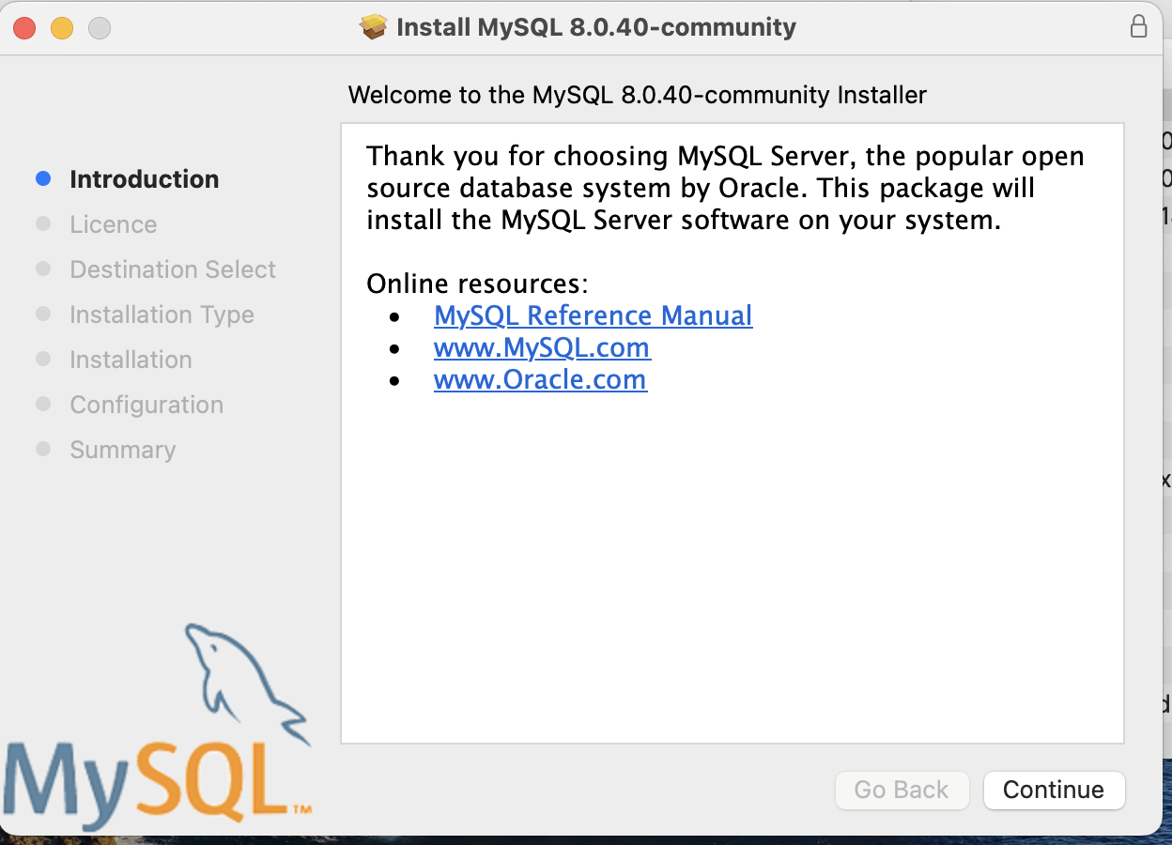

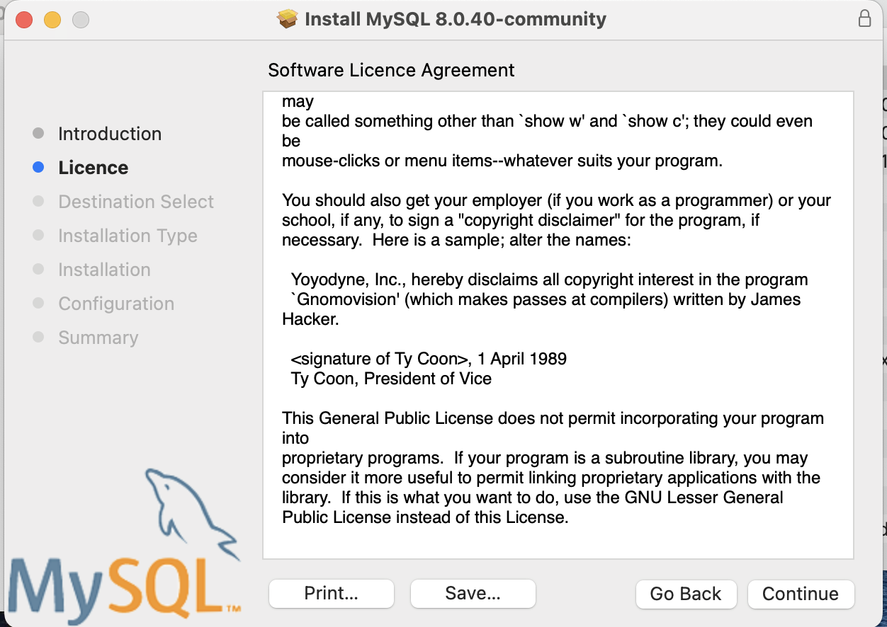

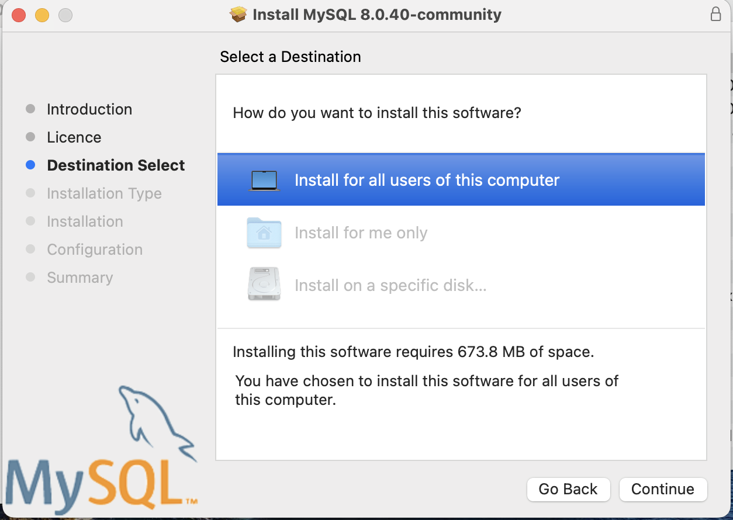

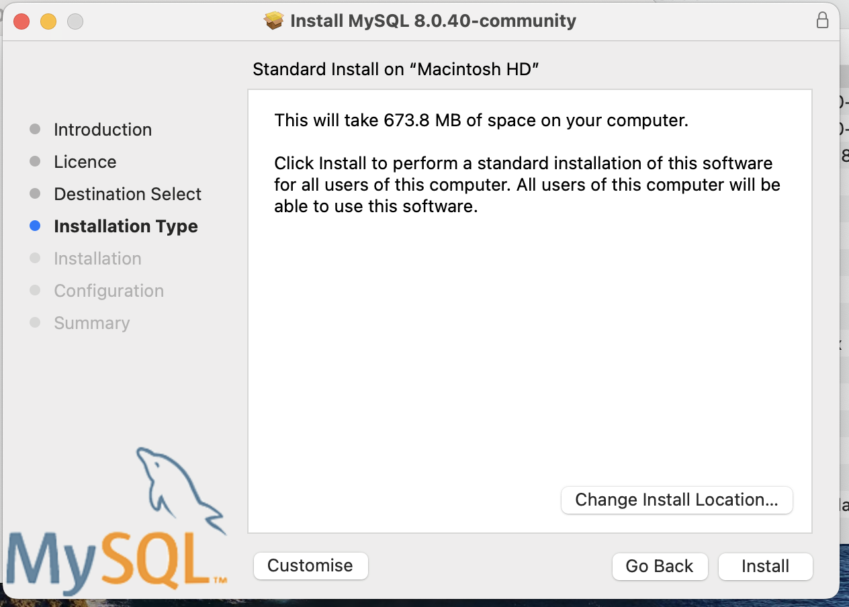

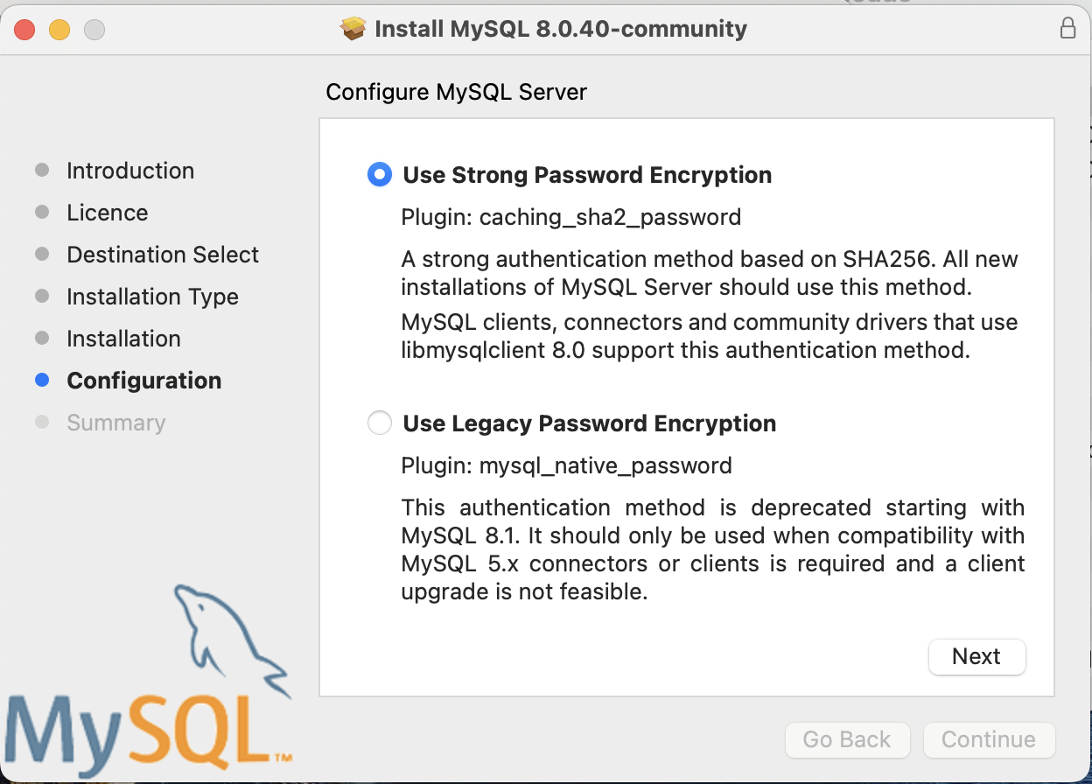

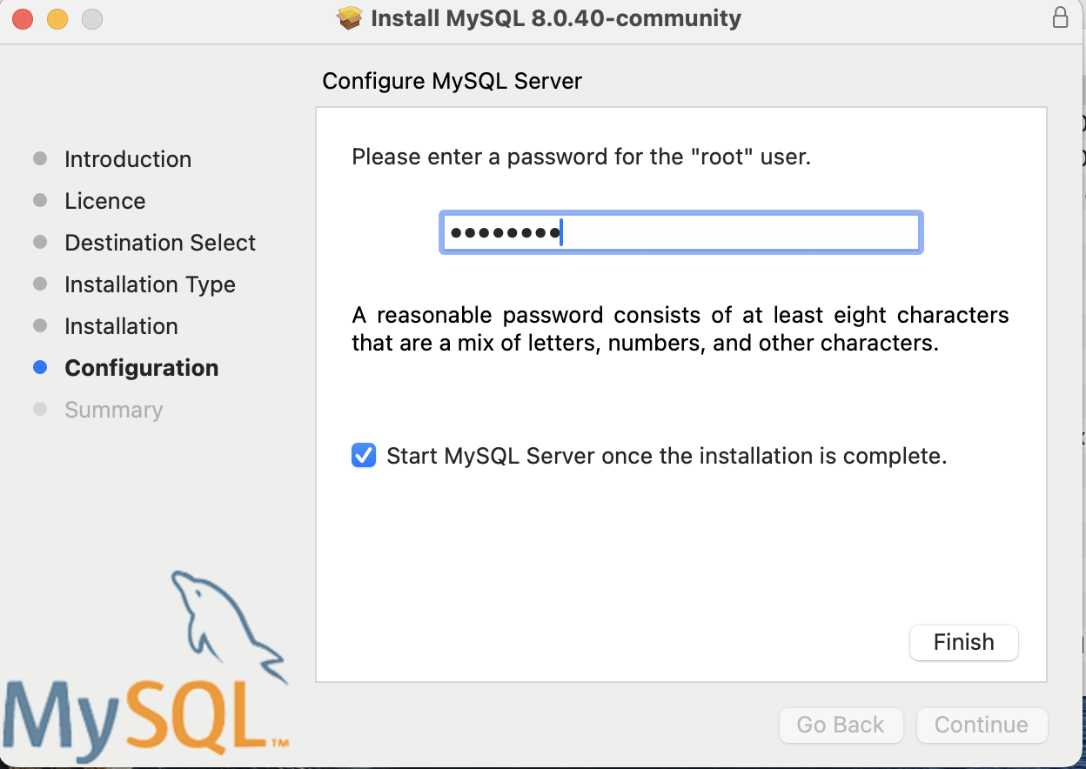



CREATE DATABASE COLLEGE;

USE COLLEGE;

CREATE TABLE DEPARTMENTS (DEPT_NO int(10), DEPT_NAME varchar(20), HOD_NAME varchar(20), PRIMARY KEY(DEPT_NO));

USE COLLEGE;

CREATE TABLE STUDENTSINFO (STUDENT_ID int(10), STUDENT_NAME varchar(20), DEPT_NO int(10), CITY varchar(20),

PRIMARY KEY(STUDENT_ID), FOREIGN KEY(DEPT_NO) REFERENCES DEPARTMENTS(DEPT_NO) );

ALTER TABLE STUDENTSINFO ADD AGE int(10);

SELECT AGE, STUDENT_NAME FROM STUDENTSINFO;

SELECT * FROM STUDENTSINFO where AGE >= 19;

SELECT * FROM DEPARTMENTS;

INSERT INTO DEPARTMENTS (HOD_NAME, DEPT_NAME, DEPT_NO) VALUES

('ASHOK', 'ECE', 3),

('NIRMALA', 'BTECH.IT', 4),

('RAJESH', 'CIVIL', 5),

('PRAVEEN', 'MECH', 6);

INSERT INTO STUDENTSINFO VALUES(1, 'AJAY', 2, 'DEHLI', 19),

(2, 'VIJAY', 2, 'DEHLI', 19),

(3, 'SANJAY', 1, 'KOKATTA', 18),

(4, 'SAMSON', 3, 'CHENNAI', 19),

(5, 'SARA', 4, 'CHENNAI', 19),

(6, 'SANGEETHA', 5, 'HYDERABAD', 18),

(7, 'SOWMIYA', 5, 'DEHLI', 20),

(8, 'VIVEK', 1, 'CHENNAI', 19),

(9, 'AJAY', 2, 'HYDERABAD', 18),

(10, 'RAHUL', 3, 'BANGALORE', 19),

(11, 'RAJESH', 4, 'BANGALORE', 18),

(12, 'RIYA', 5, 'MUMBAI', 20);

SELECT * FROM STUDENTSINFO INNER JOIN DEPARTMENTS ON STUDENTSINFO.DEPT_NO = DEPARTMENTS.DEPT_NO;

USE COLLEGE;

UPDATE STUDENTSINFO SET CITY='KOLKATTA' WHERE STUDENT_ID =3;

DELETE FROM STUDENTSINFO WHERE STUDENT_ID =3;

TRUNCATE TABLE STUDENTSINFO;

DROP TABLE STUDENTSINFO;

USE COLLEGE;

CREATE TABLE INDIANTEAM (firstName varchar(20), lastName varchar(20), email varchar(20), passowrd varchar(20), confirmPassword varchar(20), PRIMARY KEY(email));

SELECT * FROM INDIANTEAM where email ='PANT@bcci2411.com';

INSERT INTO INDIANTEAM VALUES( 'Yuvi', 'Singh', 'Yuvi@bcci2411.com', 'YouKnowMe123', 'YouKnowMe123'),

( 'DHONI', 'MS', 'DHONI@bcci2411.com', 'YouKnowMe123', 'YouKnowMe123'),

( 'VIRAT', 'K', 'VIRAT@bcci2411.com', 'YouKnowMe123', 'YouKnowMe123'),

( 'ROHIT', 'S', 'ROHIT@bcci2411.com', 'YouKnowMe123', 'YouKnowMe123'),

( 'PANT', 'R', 'PANT@bcci2411.com', 'YouKnowMe123', 'YouKnowMe123');

INSERT INTO INDIANTEAM VALUES( 'Yash', 'Jaiswal', 'Jaiswal@bcci2411.com', NULL, 'YouKnowMe123');

Select * from INDIANTEAM WHERE passowrd is Null;

Select * from INDIANTEAM WHERE passowrd is not Null;

/* firstName lastName email passowrd confirm Password