# Documentation

Stuff to remember if you use the code

* Remember to write the correct host, password, database name and username
* \033[“number”m selects a different text color based on number

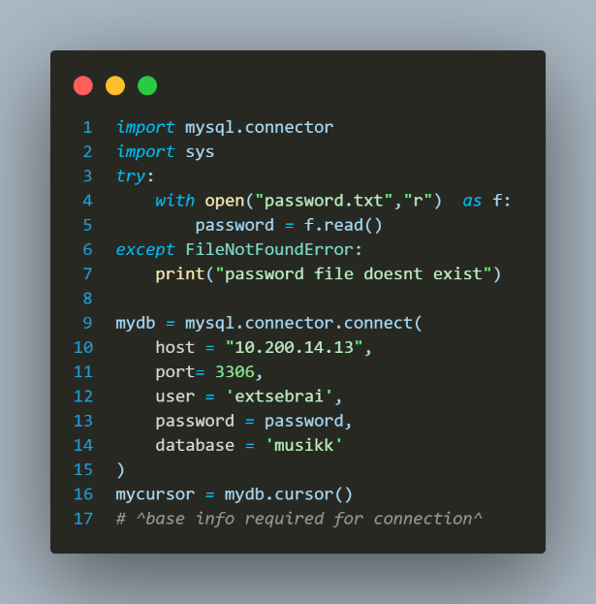This is how I connect to the database

Mysql connecter is vital

Sys is yoused in some of my programs to exit the program without triggering the rest of the code since it would cause multiple errors

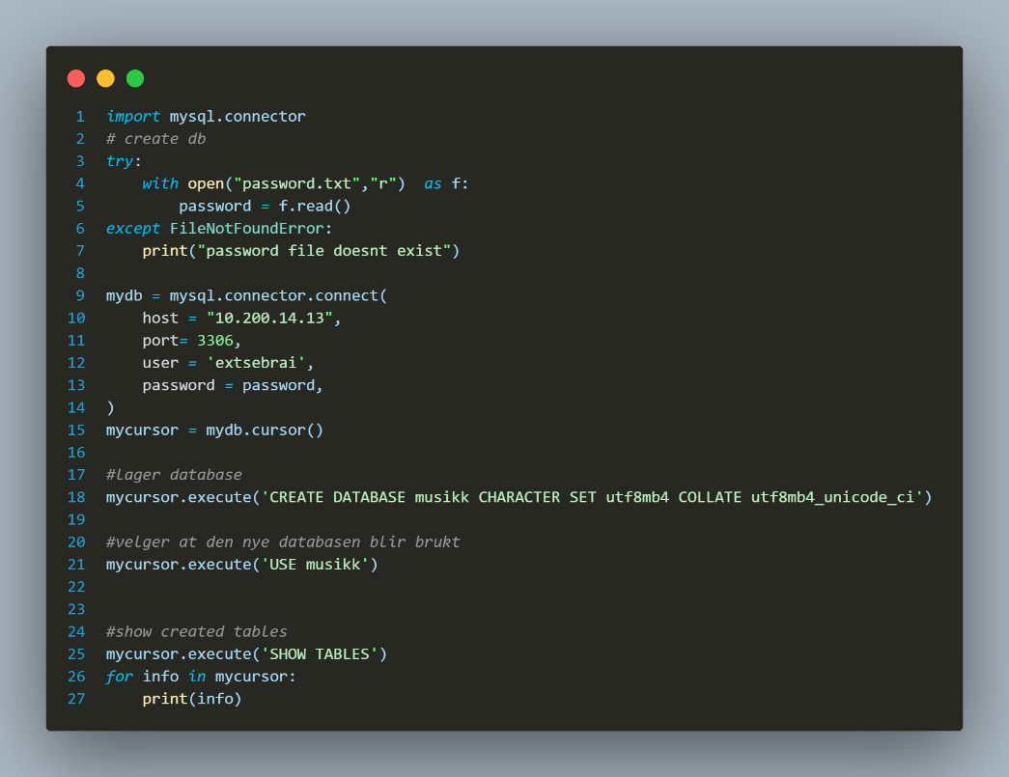

this code includes connect code this creates the database “musikk”

it also shows that there are no tables in the database this was to check for errors

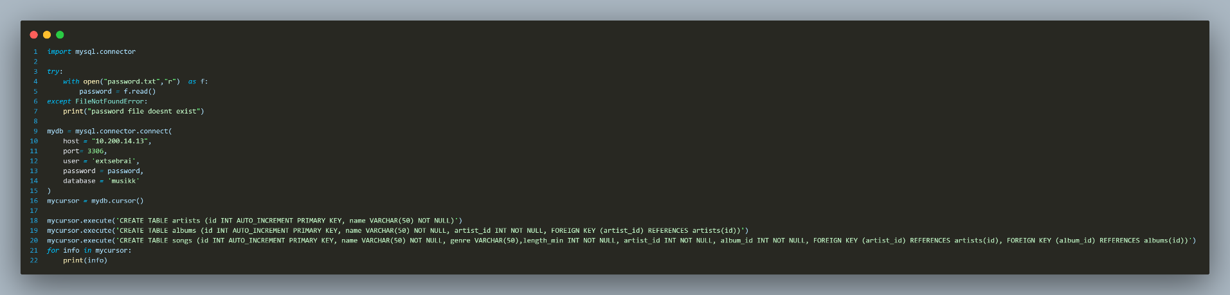This script creates the tables artists, albums, songs. Albums has a foreign key with artist and songs have one with both the other tables

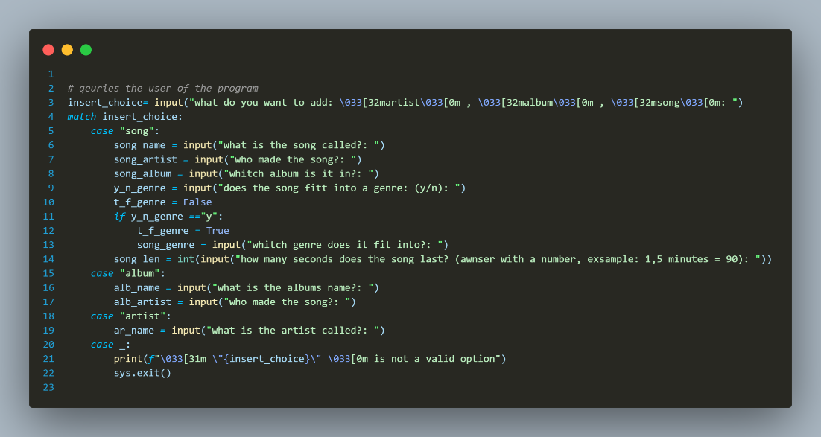This code asks the user what they want to add and ask questions accordingly

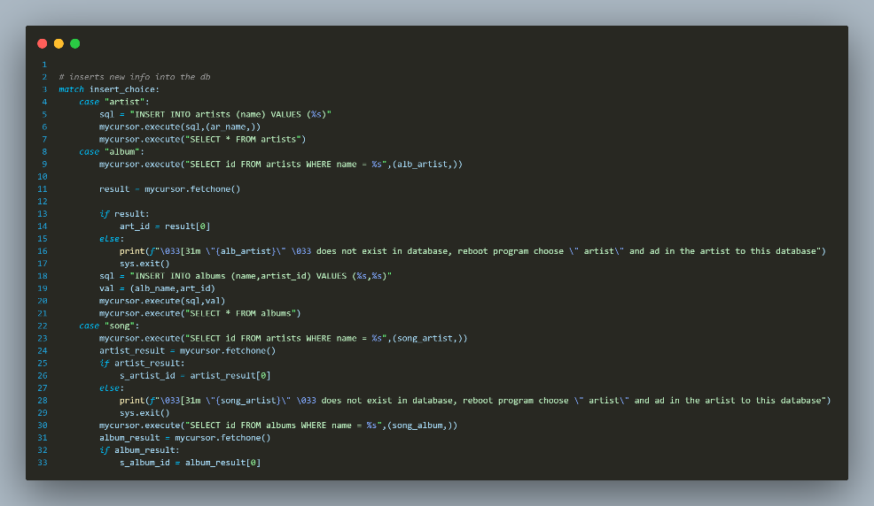

if the user typed in the correct album and artist names, the code successfully inserts new rows into the database and shows what the table currently looks like.

If names were typed in incorrectly the user gets an error

what it looks like in the python terminal

Sql code used in the terminal showing data having been inserted

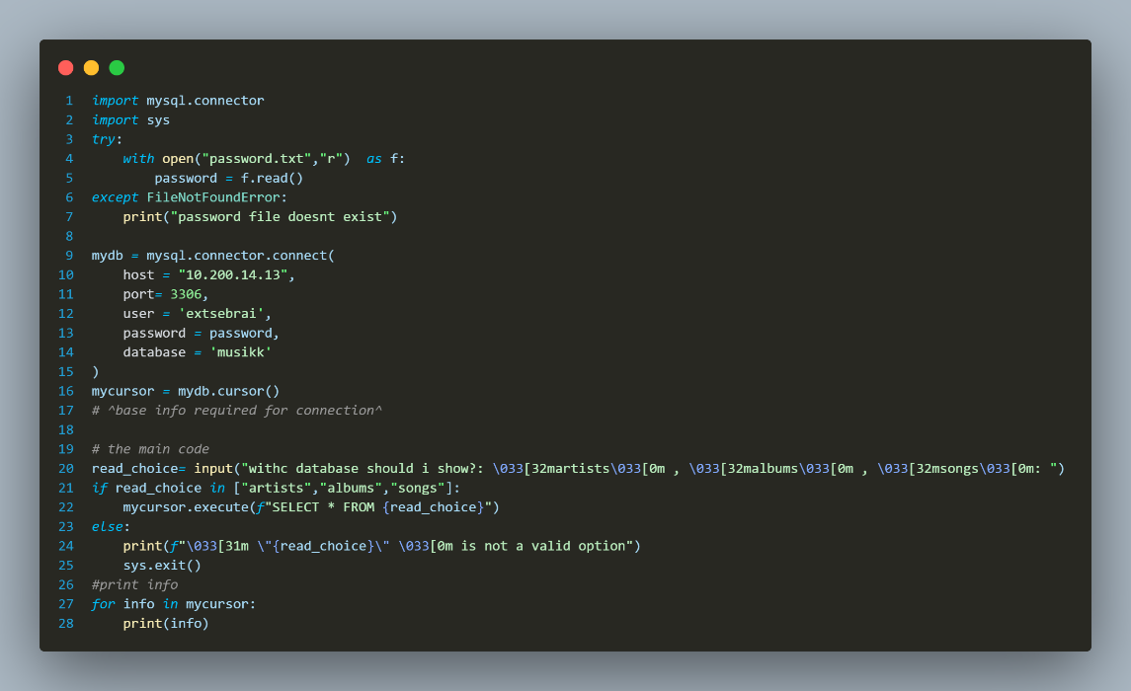

Code that shows contents of chosen table