Virtual Prototyping Exercise 3

HW/SW Co-design of Analog to Digital Converter (ADC) in SystemC AMS.

Sebastian Lee Barrera
Matrikel-Nr: 403072

Introduction

This document explains the Programmers View interface developed to model an Atmel ATSAM3S4A microcontroller (ADC peripheral only).
The first part will explain the SystemC AMS components developed to model the analog part of the system, then we will cover the TLM interface developed to model the register bank of the microcontroller and the initiator. The third part will discuss the Programmers View (PV) interface developed, with the set of functions provided to develop plain C code and allow re-usability and/or early development. Finally we will present the testing methodologies and test-suites that were used to validate the model.

SystemC AMS components

The ADC SystemC AMS model consists of the following components:

Analog Mux: This component takes the analog inputs to the ADC (in this case we only use channels 3, 5 and 7) and muxes according the active channel programmed on the register bank. This module is also responsible to wait for the programmed settling time in case a different channel is enabled.

Offset : This stage adds the programmed offset to the incoming muxed analog signal.

Sample and hold: This stage samples the signal and holds it according to the timing programmed on mode register (tracking time and transfer time). After holding a sample it issues a valid sample for gain stage.

Gain: This stage applies the programmed gain to the incoming sampled signal. It issues a sampled amplified value to the cyclic pipeline to convert the analog value.

Cyclic pipeline: This is the main component of the ADC cell. It mimics the behavior of a cyclic type ADC. It is similar in principle to the successive approximation ADC type (modified binary search), it takes 12 ADC clock cycles to resolve a single conversion (with one bit resolved in each cycle). The ADC will issue a value between 0 and 2^RESOLUTION (in this case 12), meaning that values less than 0 or more than VREF will be truncated (use offset and/or gain and then restore on SW).

User Interface: This is the boundary between the TLM target and the AMS model. This model takes a set of input signals coming from register target (which is in charge of decoding) and provides meaningful values to the different components of the ADC subsystem, such as tracking time, settling time, active channel, etc.

SystemC TLM Interface

The model developed aims for a Losely Timed (LT) programming style, which means it includes some sense of timing but of course is not cycle nor pin accurate.
The internal MCU ADC register bank is modeled as an array of 32 bit registers ranging from ADC_BADR to MAX_OFFSET.
The register address map is avaiable on $ROOT/include/defines.h. This file includes all the available target addresses supported (though not all functionalities implemented) and some useful defines.

The TLM interface is divided in two components :
Register file TLM target:
TLM target that responds TLM transactions. Memory is modeled as a char array. We use the function memcpy to return values. This module also performs decoding and provides all the useful signals to user interface. Target uses a system clock and updates read registers on every clock edge.

TLM initiator :
This function provides two basic functions to read and write registers. Both functions expect a register address (which is provided on defines file) and a write value (unsigned int) and return an unsigned integer if a read is performed. This functions are available as a public interface, though it is recommended to use the programmers view functions provided at high level.

Finally a wrapper was developed to create an adc_system model. This wrapper creates an instance of each component (including TLM target/initiator) to be instanced on the programmers view interface provided. The wrapper and all the components are parameterizable via the file $ROOT/defines.h.

Programmers View (PV) Interface

The PV Interface developed creates an instance of the ADC complete system as well as three wave generators connected to ADC Channels 3,5 and 7 (sine, cosine and saw respectively).

Three functions are provided via this interface:

ADC_Configuration:
Takes the value of the three main configuration register of ADC (Mode register, Offset/Gain and Channel enable/disable) and generates the TLM transactions to configure the system. At the end of configuration it also triggers conversion by setting the start bit on Control Register.

ADC_GetStatus:
Returns current configuration by performing back to back TLM read transactions. The three values are passed by reference.

ADC_GetData:
Performs TLM read on the specified channel data register and return its value.

Testing

Comprehensive testing is beyond the scope of this project, nevertheless the system was tested at some acceptable level. Unit testing was performed on each unit to validate its individual performance as well as system level.
The following tests were developed:

ADC/SystemC AMS: Aside from unit tests on each stage, on ADC system debug information is provided. At this level the sample and hold signal is captured with its time stamp, then after ADC conversion this value is “reversed” and compared against the digitalized value. We set an error treshold of 0.001 and report any value that is beyond this error treshold.

TLM simple test: After TLM target/initiator development a set of simple write/read transactions was written to verify correct functionality.

ADC Complete system without TLM: In this test-bench we manually introduce values on the pins of the user interface. This was done to test the whole ADC system functionality and decouple any error coming from the TLM portion of the code.

Finally the most important test is located in SW, where a sample test program is provided. The program is written in “pure C” (though it needs SystemC function calls to advance time) and has some debugging code embedded. The purpose of this test is to show the whole system in action. To do so, we connect the data read by the PV function read data to plot (after ADC proper re-shaping). We program Mode register and test each individual channel, we also read the status registers on each iteration and compare the programmed value. Here we show the console output of the final system test as well as a wave form capture:

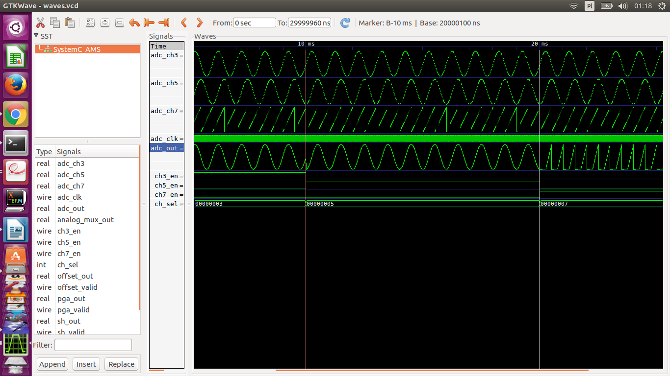

NOTE: This waveform can be loaded by opening the file $ROOT/adc_sys_test.vcd and using the wave save adc_sys.gtkw

In this waveform we can see how the output changes after we program the mode register and we change channel enable on three iterations.

The output log shows some useful information of transactions and configuration as it is happening over time:

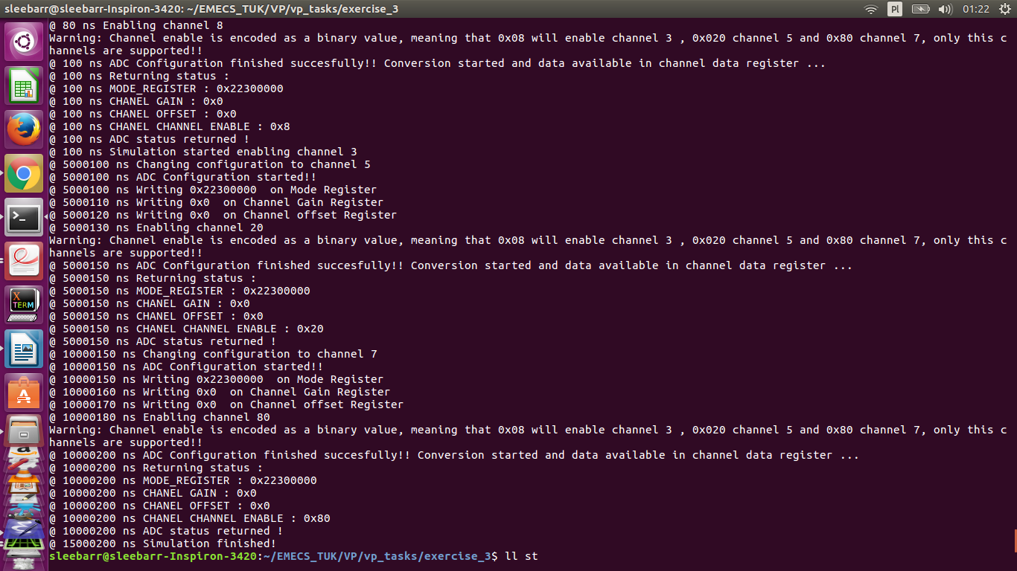

NOTE : This log can be re-generated by running $ROOT/test_sw.

Directory structure and compilation instructions

The repo is divided in the following subdirectories:

$ROOT/src : contains all source files for all the modules.
$ROOT/include: contains all header files as well as the parameters and register map defined on defines.h
$ROOT/tb : Incudes unit and system level test-benches for all the components developed.
$ROOT/sw : Contains sample software.
$ROOT/bin : Contains all the excutables generated (tb). Need to compile.

Set environment: source setenv.sh

Compile instuctions:
Requirements: Cmake and GCC.

Generate make files:
cd $ROOT && cmake CmakeLists.txt

Compile:
cd $ROOT && make

Run:
./bin/$YOUR_BINARY

Files are already compiled on server. If there is any problem try erasing Cmake cache generated files and recompiling from scratch. SystemC and SystemC AMS environment variables must be set as well.

