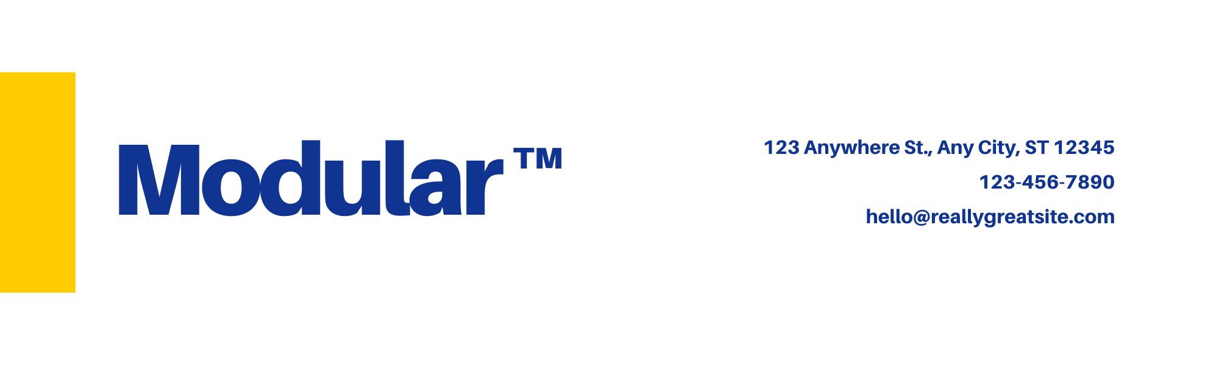

**Dear Ms. Olsson,**

A letterhead is the heading at the top of a sheet of letter paper (stationery). That heading usually consists of a name and an address, and a logo or corporate design, and sometimes a background pattern.

The term "letterhead" is often used to refer to the whole sheet imprinted with such a heading. Many companies and individuals prefer to create a letterhead template in a word processor or other software application. This generally includes the same information as pre-printed stationery but without the additional costs involved.

Letterhead can then be printed on stationery (or plain paper) as needed on a local output device or sent electronically. That heading usually consists of a name and an address, and a logo or corporate design, and sometimes a background pattern.

This generally includes the same information as pre-printed stationery but without the additional costs involved.

**Sincerely,**

Andres Sörensson

**Andres Sörensson**

**Marketing Communications**

