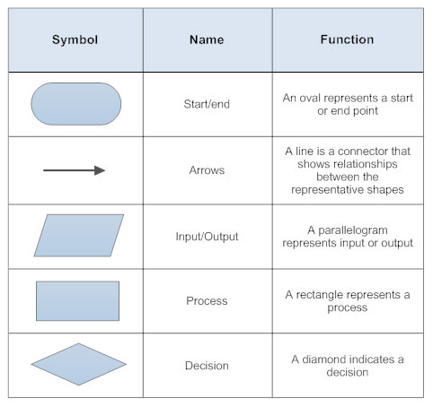Flowchart symbols and their meanings

[*https://www.smartdraw.com/flowchart/flowchart-symbols.htm#*](https://www.smartdraw.com/flowchart/flowchart-symbols.htm#)

Look at the above site for more information on flowcharts