**Lists**

There are lots of occasions when we need to use lists. HTML provides us with three different types:

* **Ordered lists** are lists where each item in the list is numbered. For example, the list might be a set of steps for a recipe that must be performed in order or a legal contract where each point needs to be identified by a section number.
* **Unordered lists** are lists that begin with a bullet point
* **Definition lists** are made up of a set of terms along with the definitions for each of those.

**Exercise – ordered lists**

**ORDERED LISTS <ol>**

The ordered list is created with the <ol> tag

<li> each item in the list is placed between an opening <li> tag and a closing </li> tag. The li stands for list item.

**Coding**

<!DOCTYPE html>

<head>

<title>Order Lists</title>

</head>

<body>

<body style="font-family:calibri;color:green;font-size:24px;"> (add in your own font, size & colour)

<ol>

<li> Logon</li>

<li> Open Notepad++ </li>

<li> write some code</li>

<li> Save it as a html file using the All Types file type</li>

<li> Run it using Chrome</li>

</ol>

</body>

</html>

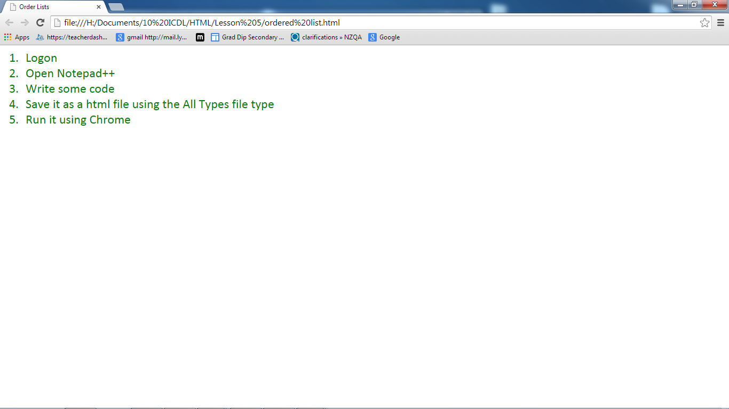

**UNORDERED LISTS <ul>**

The unordered list is created with the <ul> element. <li> each item in the list is placed between an opening <li> tag and a closing </li> tag. The li stands for list item.

**Exercise – unordered lists**

**Coding**

<!DOCTYPE html>

<head>

<title>Unordered Lists</title>

</head>

<body>

<ul>

<li>Eggs</li>

<li>Milk</li>

<li>Carrots</li>

<li>Bananas</li>

<li>Cheese</li>

</ul>

</body>

</html>

**Result**

* Eggs
* Milk
* Bread
* Carrots
* Bananas

**DEFINITION LISTS <dl>**

The definition list is created with the <dl> element and usually consists of a series of terms and their definitions.

Inside the <dl> element you will usually see pairs of <dt> and <dd> elements.

<dt> is used to contain the term being defined (the definition term).

<dd> is used to contain the definition.

Sometimes you might see a list where there are two terms used for the same definitions for the same term.

**Exercise – Definition lists**

**Coding**

<!DOCTYPE html>

<head>

<title>Definition Lists</title>

</head>

<body>

<dl>

<dt> Red</dt>

<dd> A great colour for restaurant walls. Red stimulates the appetite and encourages people to spend more. Do you have trouble getting out of bed in the morning? Paint the bedroom red. Chances are you will leap out of bed.<dd>

<dt>Blue</dt>

<dd>If you’re on a diet, eating areas should be blue. This is a colour that suppresses the appetite. However, blue is a bad colour for living rooms or party rooms because it encourages people to relax and not talk to each other.</dd>

<dt>Yellow</dt>

<dd>Although yellow may seem like a happy colour, it increases irritability.</DD>

<dd> Avoid painting a room bright yellow, Instead use light yellow in a small area if contrast is needed.</dd>

<dd></dd>

<dt>Green</dt>

<dd>This is the colour of perfect balance. It encourages feelings of relaxation and comfort. Actors are often asked to wait in the green room before they perform. It’s also great for a bedroom.</dd>

<//dl>

</body>

</html>

**Result**

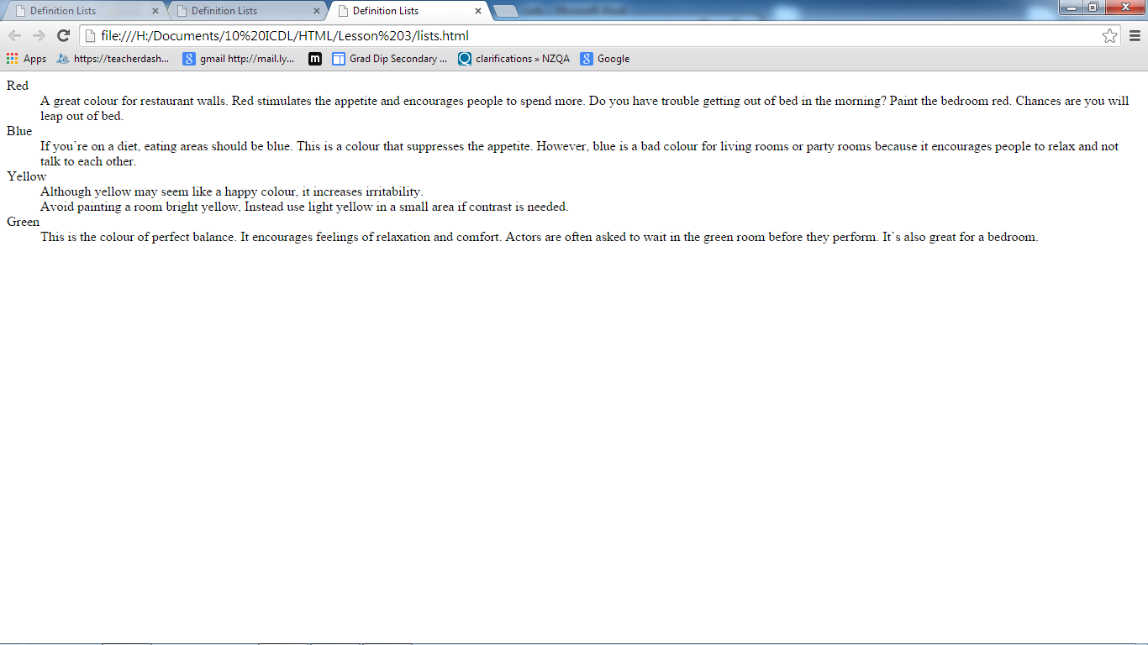

**Task 1**

Edit the code to

* Change the font style
* Use the font colour to that of the colour of the paragraph
* Add a blank line between each section
* Choose another colour and write your own description.

**Task 2 Houses at Lynfield**

Make a web page showing the houses at Lynfield College as shown below.

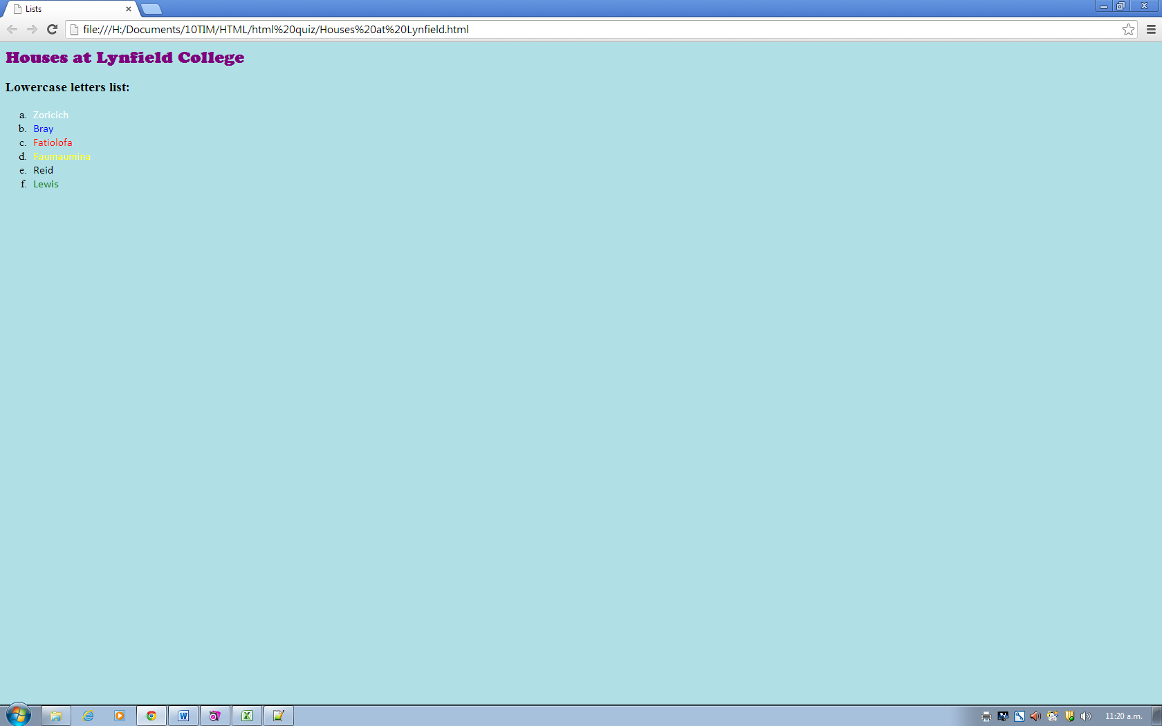

* The title for this is lists
* To add a background colour <body style=”background-color:powderblue”>
* The main heading - houses at Lynfield College is h1 style, font is cooper black size 24px, colour is purple
* The subheading is also a heading style – h3
* To get it show lower case letters for the numbering use this code <ol type="a">
* To change the colour of the houses you need this code <li <font color="white" face="calibri">Zoricich</font></li>
* Remember to use copy and paste where appropriate.

**Task 3**

Make a web page with three separate lists. The first is to be your top all-time 5 movies; the second your top 5 favourite foods; the third your top 5 music artists. The main heading is My Top 5. Use subheadings for all the lists.

*You must use the following tags in your page.*

* background colour
* font colours
* heading tag
* order list
* unordered list
* horizontal rule (between each list)
* bold subheadings