4.8.2 The **kwargs List
Name: Sebastian Torres
Course: COP2373
Date: March 01, 2026

IPython Screenshot
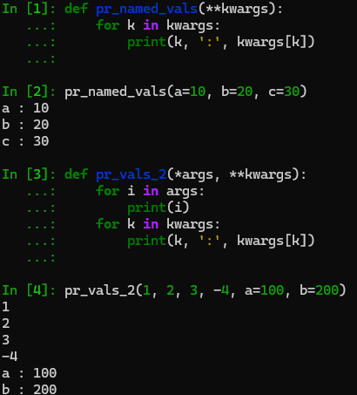

Advantages and Disadvantages of Using **kwargs

Advantages
1. Flexibility – Allows a function to accept any number of named arguments without knowing them in advance.
2. Improves Readability – Named arguments make function calls clearer because parameter names are visible.
3. Extensibility – Makes it easier to update or expand a function later without changing its structure.
4. Useful for Forwarding Arguments – Can pass keyword arguments directly to another function using **kwargs.

Disadvantages
1. Less Explicit – It may not be immediately clear what arguments a function expects.
2. Harder to Debug – Typos in keyword names may cause unexpected behavior.
3. Reduced Code Clarity – Overusing **kwargs can make code harder to understand.
4. No Automatic Argument Validation – The function must manually check whether required keys exist.

