

Home e-paper screen v2 guide.

New on v2 :

- Use it with or without touch screen.
- First install is easyest
- Update if new version is available by web page (no need arduino IDE)
- More customize your display than the v1
- Choose about 52 icons
- Control device with touch screen
- Display value is optimized than v1
- Card action need to display values are (very) reduced
- Button on board are implemented
- And few little options...

Installation :

You have 2 possible way to install Homey e-paper v2 :
- With Arduino IDE
- With Flash Download Tool

Arduino IDE :

Download arduino IDE (1.8.X or 2.X), and install ESP32 board.

If you don't know how install ESP32 board in Arduino IDE you can follow this guide :
https://randomnerdtutorials.com/installing-the-esp32-board-in-arduino-ide-windows-instructions/

On arduino IDE, install AsyncElegantOTA library in the library manager.
Then go to → file → examples → AsyncElegantOTA → Demo
Change SSID and PASSWORD in the code and upload with this parameters.
Be sure « Erase all flash content... » is enable to clear all the memory.
(If you are on Windows, you can set Upload Speed to 921600):
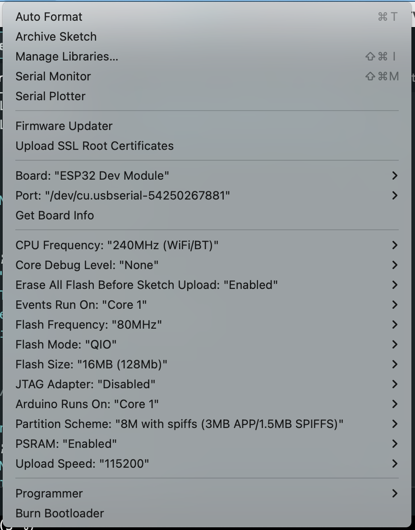
Then dowload the Homey e-paper .bin file here :
https://github.com/sebyldino/Homey-e-paper-v2
To install it, go to http://IP-ADDRESS-OF-YOUR-ESP32/Update.
you will have the page bellow. Select 'Firmware', choose the .bin file and upload will start automatically.
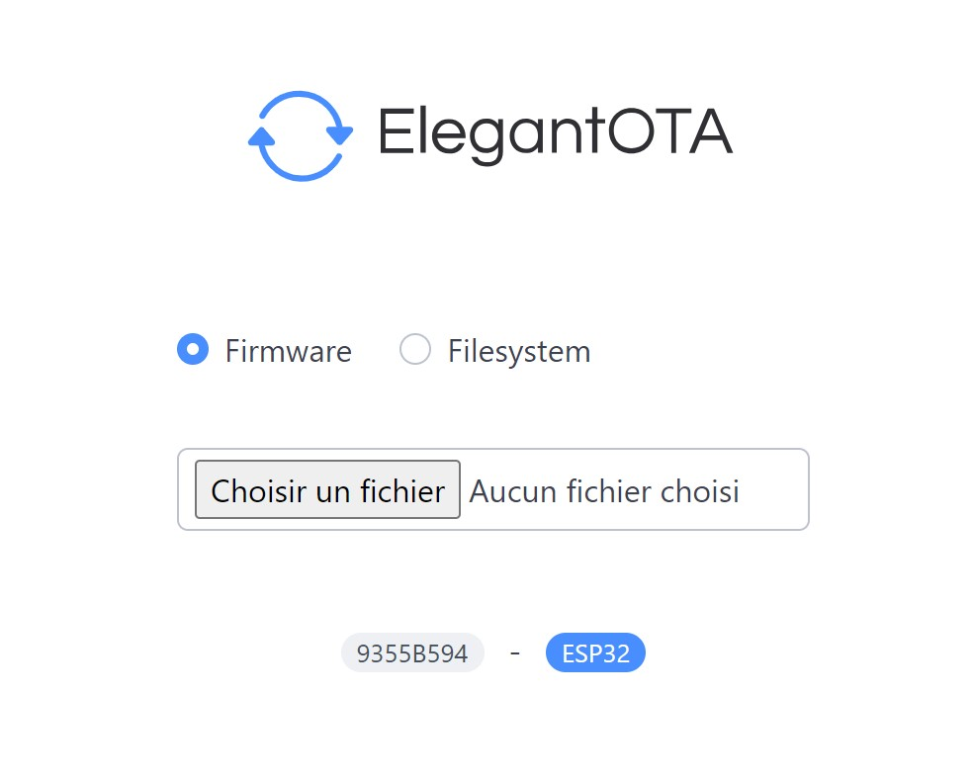
That all ! See your Homey e-paper screen to continue.

Flash Download Tool:

Download Flash Download Tool here : https://www.espressif.com/en/support/download/other-tools
and run it.

Erase you Lilygo : Click "ERASE" you will see green square pass to "SYNC", put your Lilygo in boot mode (in my case i need to press S6 button on my board), green square pass to "downloading" and wait for blue square pass to "FINISH"

Then, select the differents files and define the addresses to write them like this :
(I dont know if the addresses will change with future releases. If it is, i will define them in the release description.)
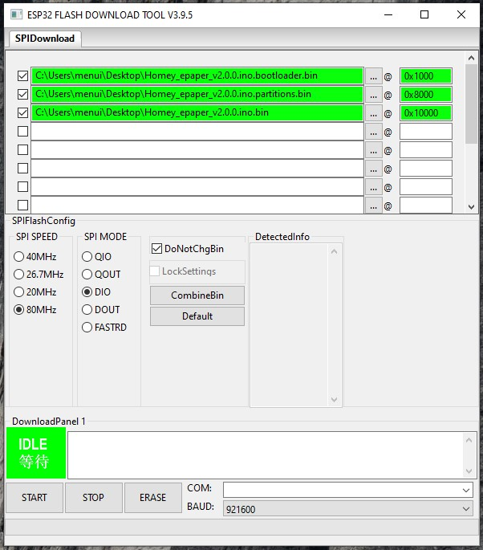
That all ! See your Homey e-paper screen to continue.

Updating :
If new version is avalaible. To install it, go to
http://IP-ADDRESS-OF-YOUR-ESP32/Update
Select 'Firmware' an choose the .bin file of version you want to install.
This does not affect the saved values.

Connect to Wifi :
Normally, you will show this screen :
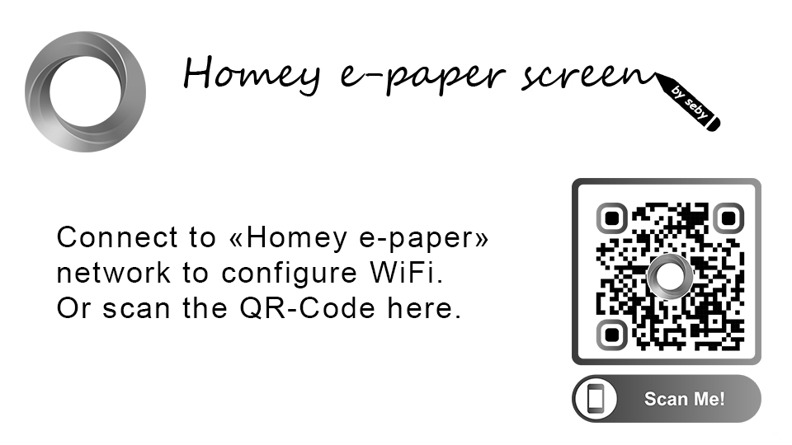
Select the Wifi network or scan QR code (on iPhone, you need unlock your iPhone before scan QR code. Dont know about this on Android).
Wait for the captive portal ask you WiFi settings. Set and send them.

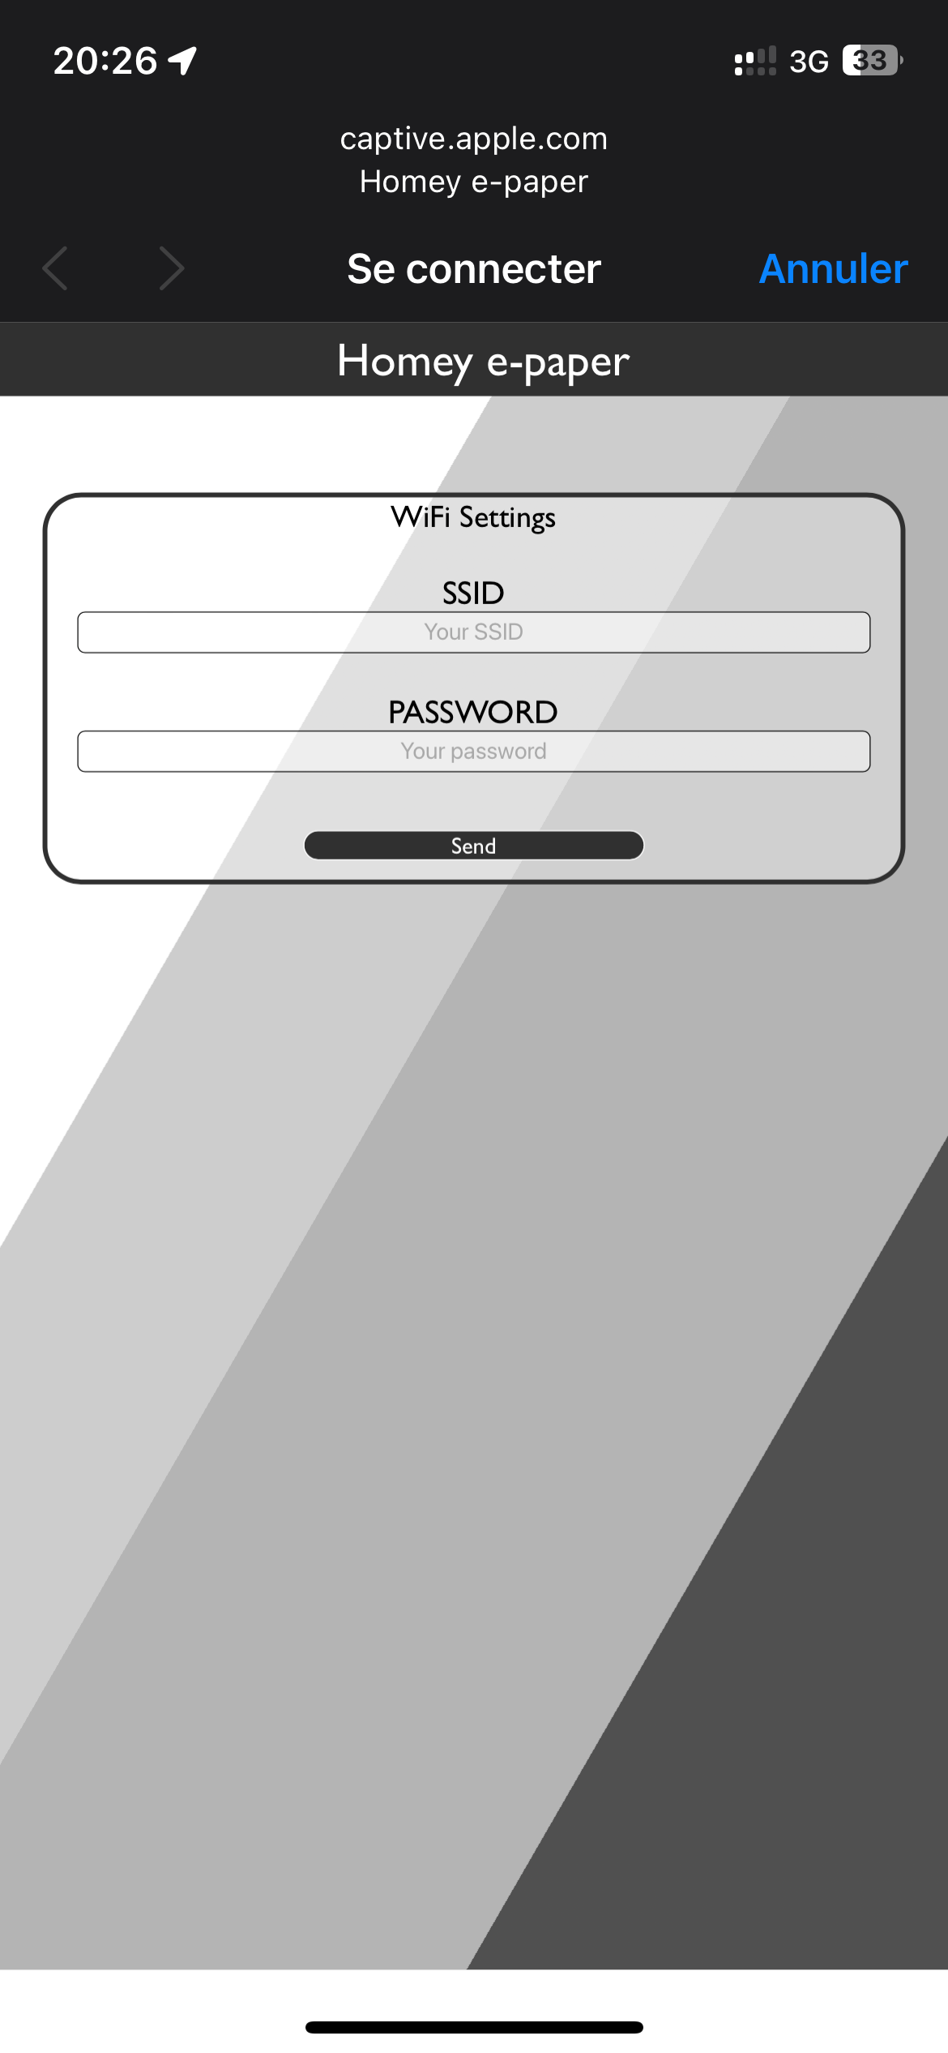

If Wifi success, you will see :
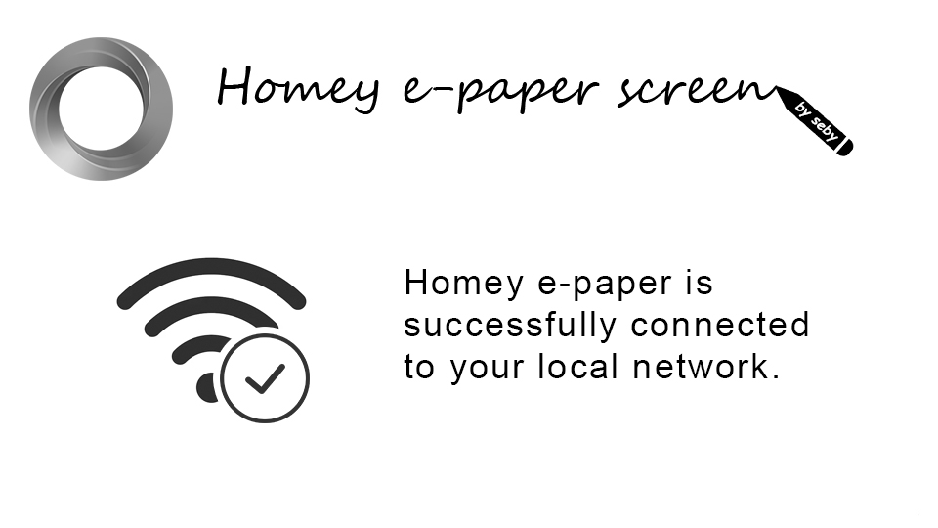

Integration in Homey :
Download Homeyduino app on the Homey store.
Add a device like a classical device and Homeyduino will automatically detect Homey e-paper.

Specification of differents cards you will found :

Note :
- Respect hyphens “_” commas “,” semicolons “; » upper and lower case letters, spaces.
- All cards are of type [text]

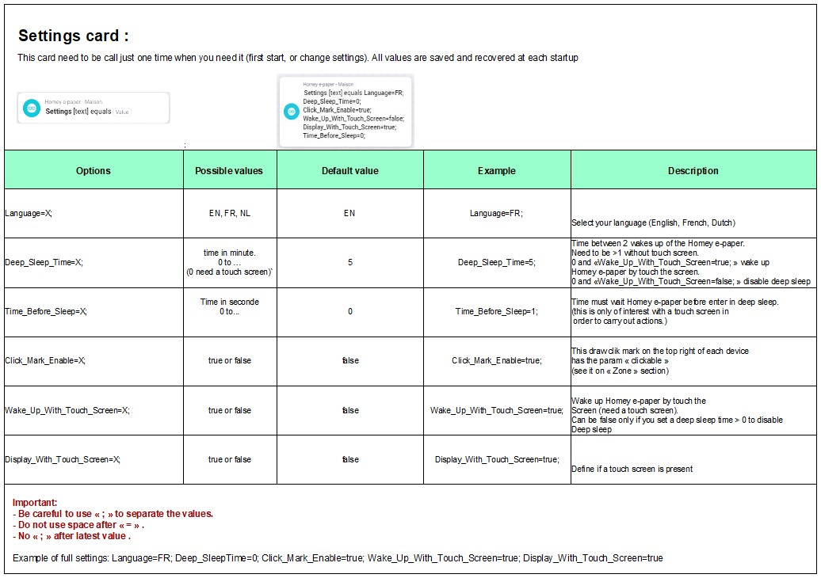

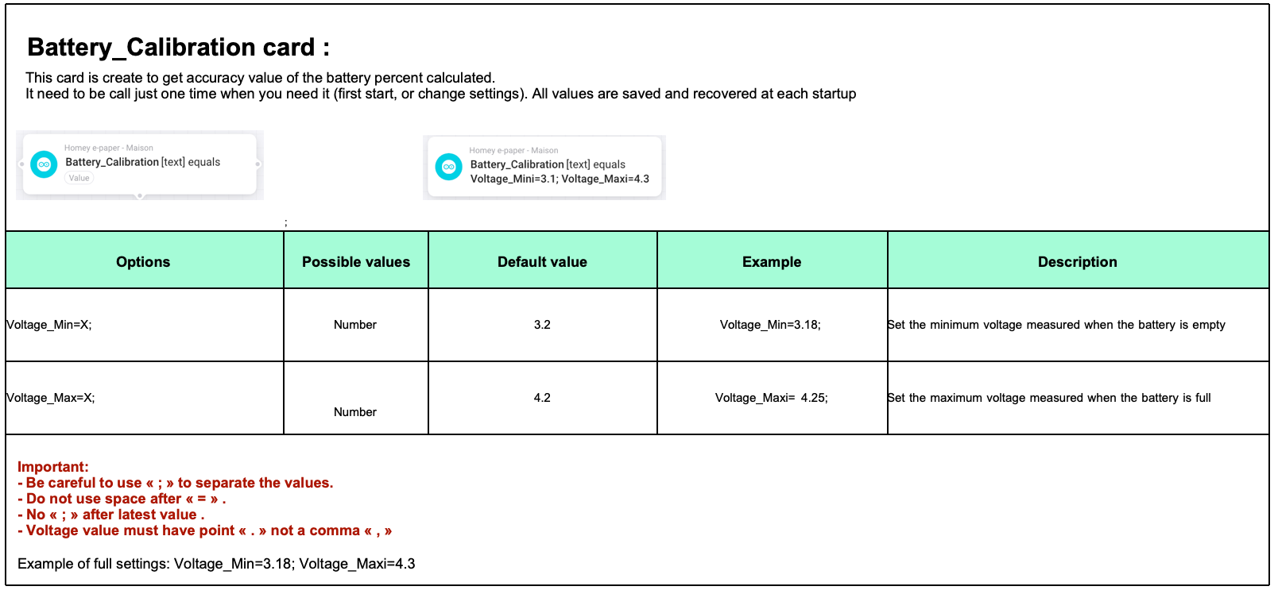
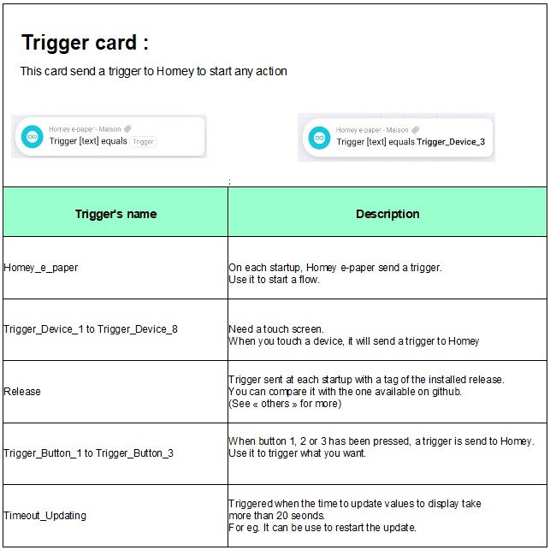

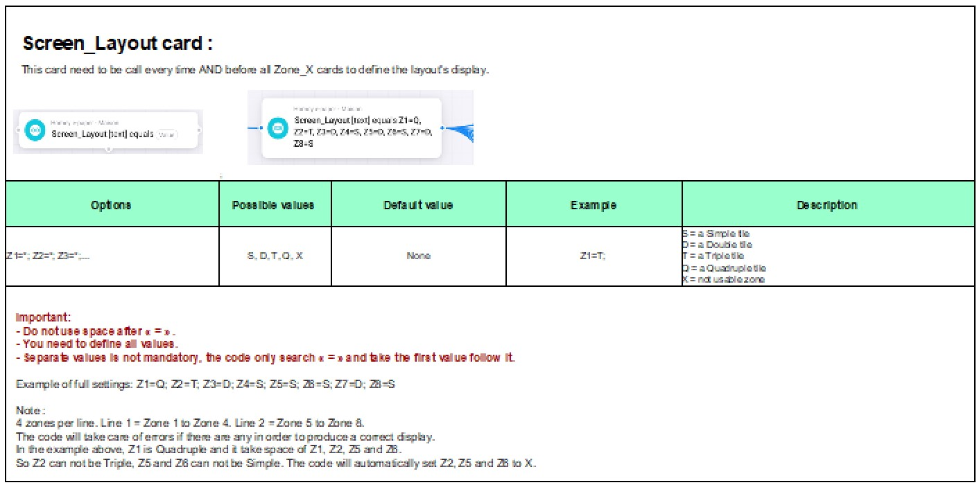

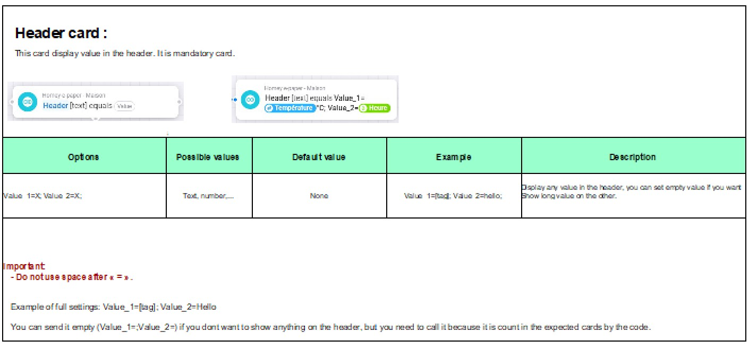

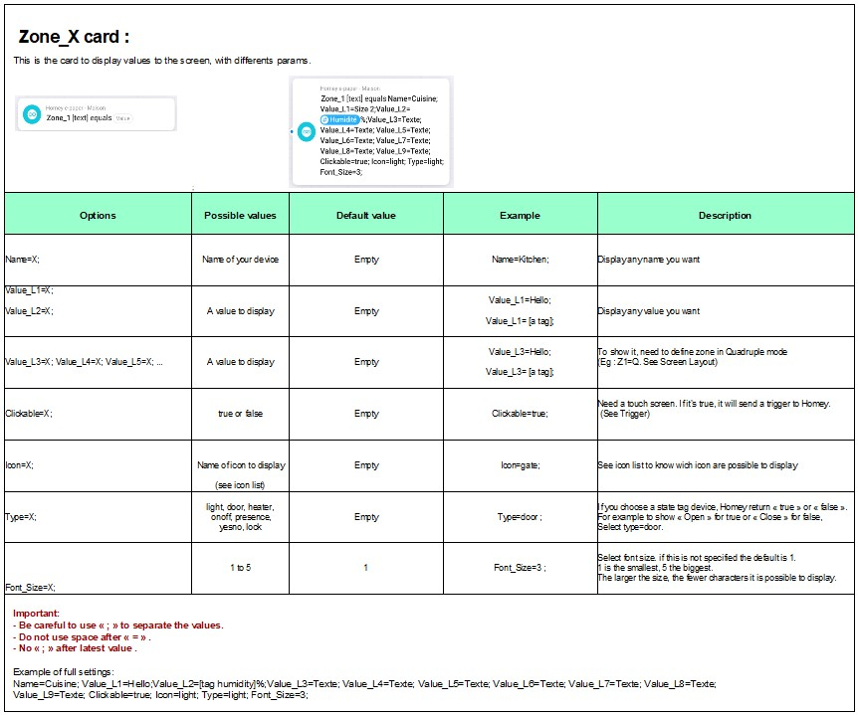

Screen_Repair card :

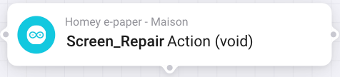
If you get wrong display or if you see previous image you can call it.

Special option for touch screen :
By long press (5 sec) on the header, you will run Screen Repair

Flow example :
Note :
After the “Screen_Layout” card, you must send at least the “Header” card + the number of cards
“Zone” you defined in “Screen_Layout”
In the example below, the zones are defined as follows: Z1=D, Z2=S, Z3=D, Z4=S, Z5=D, Z6=S, Z7=D, Z8=S
Zones 2, 4, 6 and 8 will not be taken into account because the zones preceding them are double and
therefore take their place.
The code will therefore define them as X and will not expect anything from them and will calculate that it
will have 5 zones to display
(Header + Zones 1, 3, 5, and 7) You MUST therefore send at least these 5 zones.

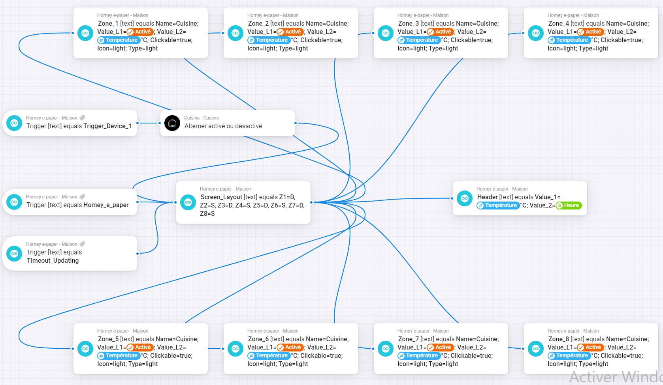

How it works :

On start up Homey e-paper try to connect to wifi. If failed it creates an Access Point wifi named "Homey e-paper". When you connect to it, it will open a captive portal to get SSID and PASSWORD, then restart and retry to connect.
Same thing if you move it outside of this network, change param of your network...
In Access Point mode, Homey e-paper will restart every 5 minutes, and try to reconnect with previous SSID and PASSWORD saved.
This is to avoid any blockage because the loss of connection may be due to a technical incident (work on the network, power outage, etc.)
When it is successfully connected to your local network and added to Homey, it will send a trigger on each startup, and you can (not mandatory but recommended) use it to send values ​​to the display.
You need to call "Screen_Layout" card first before all others. When you call this card, the code knows that an update will arrive, define how many zones are expected and start a timer to wait for them.
If successful, it display values. If failed, it reset timer, set number expected zones to 0 and a "Timeout_Update" trigger is send to Homey. Use this trigger to send another time the values.

After that it goes to deep sleep (if you enable it), or wait before goes to sleep (if you configure it). If it must go to deep sleep with a defined "Time_Before_Sleep", every time the screen was touched, timer restart to 0.

When Homey e-paper is in deep sleep, it show an icon « zzz » on the header.

If you have not defined a deep sleep, you must call your flow or trigger it to display values.

After "Deep_Sleep_Time" defined, Homey e-paper wake up, send trigger "Homey e-paper", get values...

If you have a touch screen and if you enable "Wake_Up_With_Touch_Screen" you can wake up Homey e-paper by touch it.

Battery state is sent at startup to Homey, and periodically if Homey e-paper is not in deep sleep.

Enjoy !

Icon list :

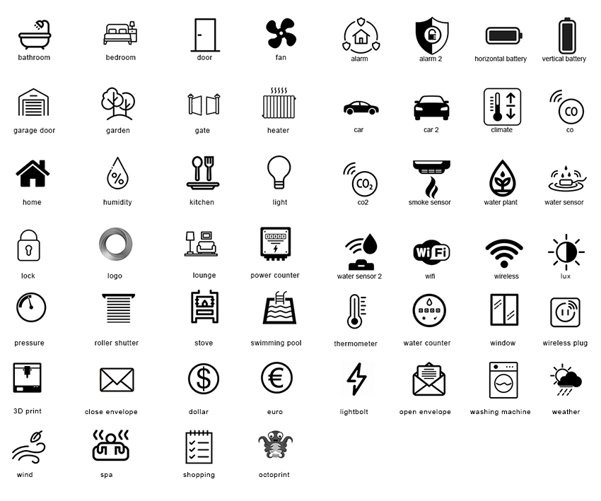

Others:

- It is possible to have serial debugging. With the Arduino IDE and your Homey e-paper connected via USB, go to “Tools → Serial Monitor”, select the baud rate to 115200, restart your
Homey e-paper. (Select a port if not detected automatically)
- It is obviously impossible to communicate with Homey e-paper when it is in deep sleep.
You must wake it up (touch screen, reset button, wait for wake-up) before sending it information.
- Spaces are taken into account. You can shift a value to the right for example:
« 20°C » by shifting it like this « 20°C »
- It is possible to check the version available on the github with the current one with homeyscript.
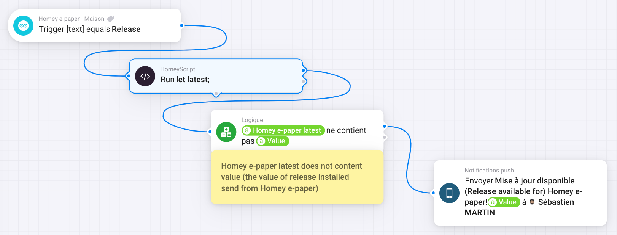
You can create a flow like this

In the « Run (code) » card, put this :

let latest;
const url = 'https://api.github.com/repos/sebyldino/Homey-e-paper-v2/releases/latest';
const res = await fetch(url)
if (!res.ok) {
throw new Error(res.statusText);
}
const body = await res.json();
latest = body.tag_name;
await tag('Homey e-paper latest',latest);
return true;

“Homey e-paper latest” is the tag created by the Homeyscript card, but it must be executed 1 time before the tag appears in the list. Run the Homeyscript card alone the first time. (or right-click “Test from here”).
Take note that the trigger is sent at each startup so the flow like this will trigger at each startup. Add conditions.

