http://spencerechon.com/web120/fp

ITC240 final project

I was making a website for my web120 class so i decided to combine the two.

In the end the database interaction was going to be the newsletter sign up and the reviews page, but i decided to just ditch the reviews page and implement another way to signup for the newsletter on the contact form.

You will see the contact form here:

<http://spencerechon.com/web120/fp/contact.php>

The footer will contain the newsletter signup as well.

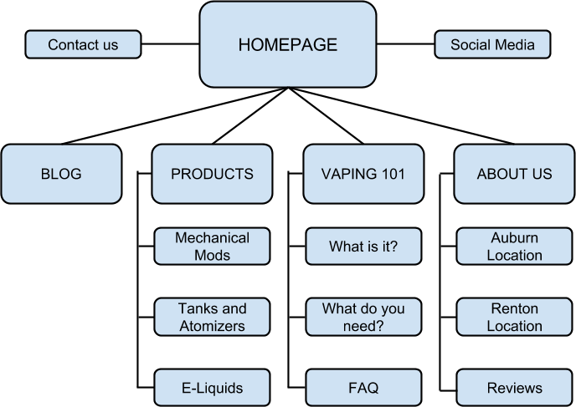

Home page

database interaction - newsletter signup

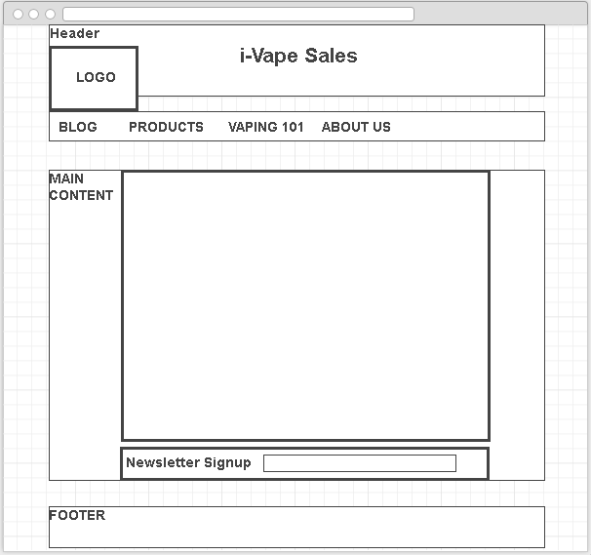

Reviews page

database interaction - form submission

