# Chapter 1: Installation- 18th Aug 2023

* Anaconda (<https://www.geeksforgeeks.org/how-to-install-anaconda-on-windows/>)
  + **Wiki:** <https://www.geeksforgeeks.org/how-to-install-anaconda-on-windows/>
  + Direct Link: <https://repo.anaconda.com/archive/Anaconda3-2023.07-2-Windows-x86_64.exe>
* Launch Jupyter NotebooK- To do
* Git account creation:
  + <https://github.com/signup?ref_cta=Sign+up&ref_loc=header+logged+out&ref_page=%2F&source=header-home>
* Git Desktop installation: <https://git-scm.com/downloads> <https://git-scm.com/download/win>
  + 32 Bit: <https://github.com/git-for-windows/git/releases/download/v2.41.0.windows.3/Git-2.41.0.3-64-bit.exe>
  + 64 Bit <https://github.com/git-for-windows/git/releases/download/v2.41.0.windows.3/Git-2.41.0.3-64-bit.exe>
* IntelliJ Community version:
  + <https://www.jetbrains.com/idea/download/?fromIDE=#section=windows>

Why to Use these all tools:

* **Anaconda**
  + **XX**
* **Jupyter Notebook**
  + **XX**
* **Git:**
  + Git is a **DevOps tool** used for **Source Code Management**. It is a free and **Open-Source** **version control system** used to handle small to very large projects efficiently.
  + Git is used for tracking changes in the source code, enabling multiple developers to work together.
* **IntelliJ:**
  + IntelliJ IDEA is the leading IDE for Java and Kotlin development.
  + It helps you stay productive with a suite of efficiency-enhancing features:
  + Intelligent coding assistance
  + Reliable refactorings
  + Instant code navigation
  + Built-in developer tools
  + Web and enterprise development support

1. **Install anaconda**

* You will be navigating to <http://localhost:8888/tree> - here you can see all files in your current directory
* Create a folder to keep all session related file in one place ([ipynb](http://localhost:8888/notebooks/Data%20Science%20-%20Python%2C%20ML/Python/Python%20Basics.ipynb)) - Suggested
* To create a new notebook, Go to New and select Python 3

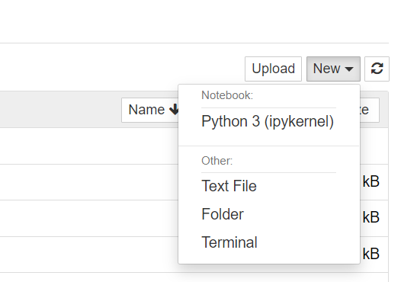

1. Install intellij

<https://www.jetbrains.com/idea/download/?fromIDE=#section=windows>

Add python plugin (youtube)

1. Install github

<https://git-scm.com/downloads>

1. Install github desktop

<https://desktop.github.com/>

**How to add a local repository?**

* Go to Git Bash (Terminal)
* Check your current directory using command: Pwd
* Go to desired location where your local folder is saved
* Enter command to Initialize : $ git init
* Check the status : $ git status
* To include the changes: $ git add .
* To commit the changes: $ git commit -m “Remarks”
* $ git push origin master ( It can be done directly to Git Desktop using Publish Repository)
* Now you check the uploaded local folder into your github account.

1. Create your github account (similar to creating a social media account)
2. Open jupyter notebook
   1. Interactive platform
   2. Testing
   3. Quick line by line code
3. Read csv file in python
4. Read csv file in intellij IDE
5. Create git hub