Market Analysis in Banking Domain

Domain: Banking (Market Analysis)

**Background and Objective:**

Your client, a Portuguese banking institution, ran a marketing campaign to convince potential customers to invest in a bank term deposit scheme.   
The marketing campaigns were based on phone calls. Often, the same customer was contacted more than once through phone, in order to assess if they would want to subscribe to the bank term deposit or not. You have to perform the marketing analysis of the data generated by this campaign.

**Analysis to be done:**

1. Load data and create a Spark data frame
2. Give marketing success rate (No. of people subscribed / total no. of entries)
3. Give marketing failure rate
4. Give the maximum, mean, and minimum age of the average targeted customer
5. Check the quality of customers by checking average balance, median balance of customers
6. Check if age matters in marketing subscription for deposit
7. Check if marital status mattered for a subscription to deposit
8. Check if age and marital status together mattered for a subscription to deposit scheme
9. Do feature engineering for the bank and find the right age effect on the campaign.

**Approach:**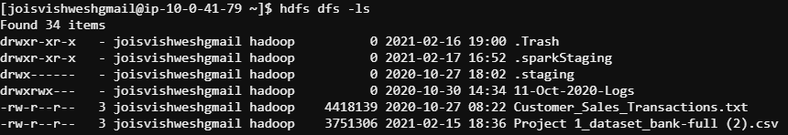

* + Load data and create a Spark data frame

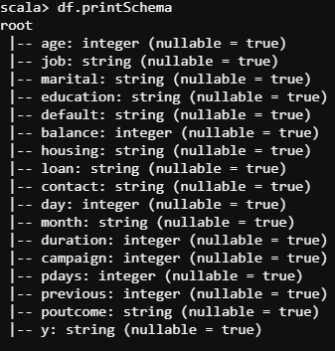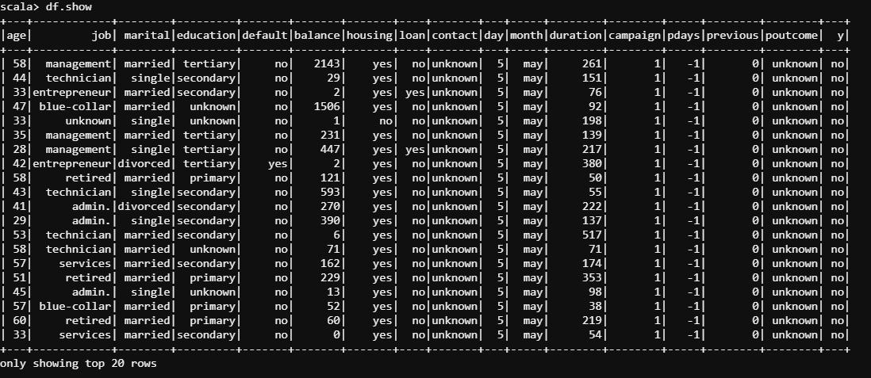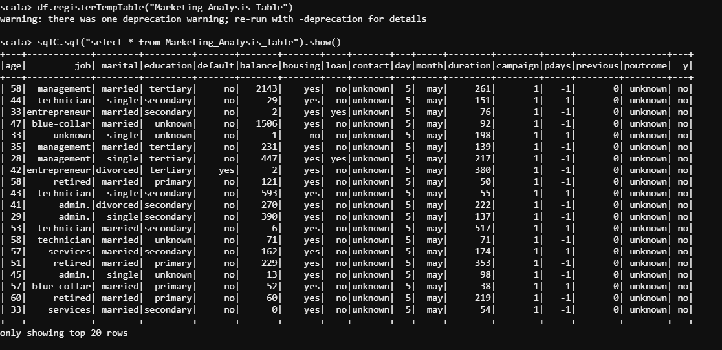

* Give marketing success rate (No. of people subscribed / total no. of entries)=11.70%

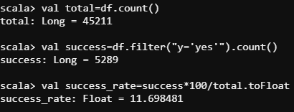

* Give marketing failure rate=88.30%

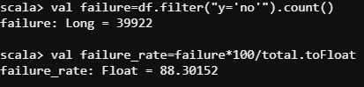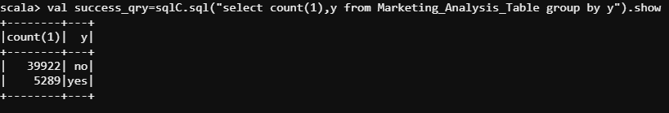

* Give the maximum, mean, and minimum age of the average targeted customer

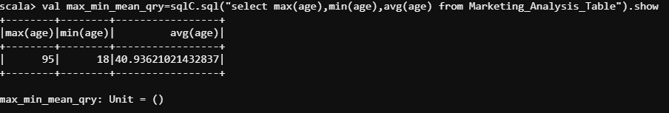

* Check the quality of customers by checking average balance, median balance of customers

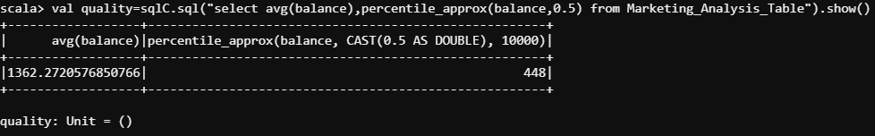

* Check if age matters in marketing subscription for deposit ( as we can see average age of both the classification is similar, so age doesn’t matter)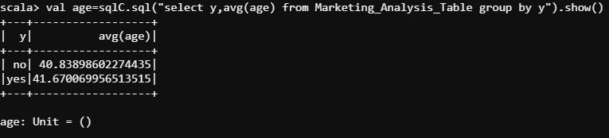
* Check if marital status mattered for a subscription to deposit (we can see that single and married people have high change of not investing)

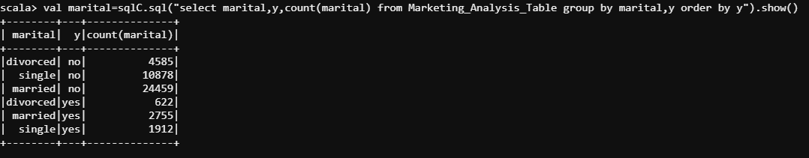

* Check if age and marital status together mattered for a subscription to deposit scheme ( age and marital together does not bring out a huge difference as outcome is similar to above)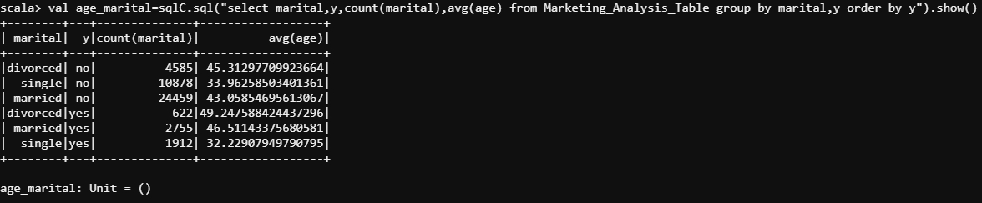
* Do feature engineering for the bank and find the right age effect on the campaign.(People are grouped into

Age<20 are Teen

Age>=20 and age<30 are Young

Age>=30 and age<45 are Middle Aged

Age>=45 and age<60 are Senior

Age<=60 are Old

And we can observe that the rate of success increases with increase in age, with Middle aged and old people being the top investors)

