PANDUAN PEMBUATAN
SMART GREENHOUSE IoT
Step-by-Step dari Nol sampai Jadi
ESP32-S3-N16R8 Soldered

Panduan ini dirancang untuk orang awam.
Ikuti step-by-step dari atas ke bawah.
Jangan loncat step — setiap step bergantung pada step sebelumnya.

13525004@std.stei.itb.ac.id | April 2026

DAFTAR ISI
FASE 0: Persiapan Software (Step 1-3)
FASE 1: Rakit Hardware (Step 4-10)
FASE 2: Upload & Test Firmware (Step 11-15)
FASE 3: Setup Supabase (Step 16-19)
FASE 4: Test Sistem Lengkap (Step 20-24)
FASE 5: Web Dashboard (Step 25-27)

FASE 0: Persiapan Software
Sebelum menyentuh hardware, siapkan software dulu.

Step 1: Download & Install Arduino IDE
1. Buka browser, pergi ke arduino.cc/en/software
2. Download Arduino IDE 2.x (pilih sesuai OS: Windows/Mac/Linux)
3. Install seperti biasa (Next > Next > Finish)
4. Buka Arduino IDE setelah install selesai

Step 2: Install ESP32 Board Support
Arduino IDE default hanya kenal Arduino Uno. Kita perlu menambahkan ESP32.

1. Buka Arduino IDE
2. File > Preferences
3. Di "Additional Board Manager URLs", paste:
https://espressif.github.io/arduino-esp32/package_esp32_index.json
4. OK > Tools > Board > Board Manager
5. Cari "esp32" > "esp32 by Espressif Systems" > Install
6. Tunggu selesai (5-10 menit)

Step 3: Install Library yang Dibutuhkan
Library = kode tambahan supaya ESP32 bisa berkomunikasi dengan sensor.
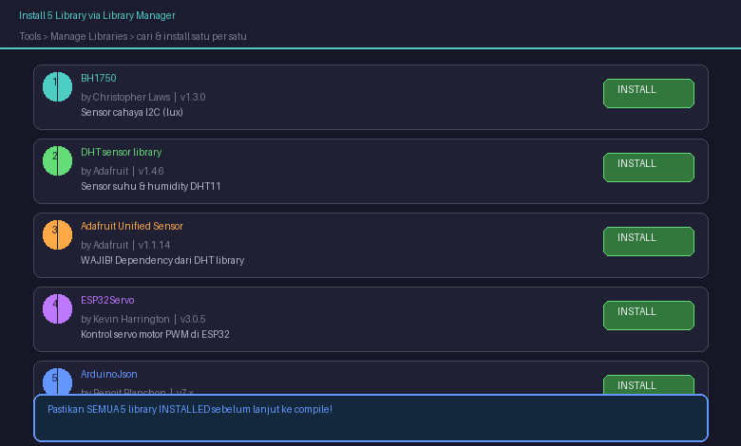

Tools > Manage Libraries, cari & install:
a. "BH1750" by Christopher Laws
b. "DHT sensor library" by Adafruit
c. "Adafruit Unified Sensor" by Adafruit
d. "ESP32Servo" by Kevin Harrington
e. "ArduinoJson" by Benoit Blanchon

FASE 1: Rakit Hardware
Rakit rangkaian elektronik di breadboard.
PERINGATAN: Jangan colok adaptor/USB sampai semua wiring selesai dan dicek!

Step 4: Pasang ESP32 di Breadboard
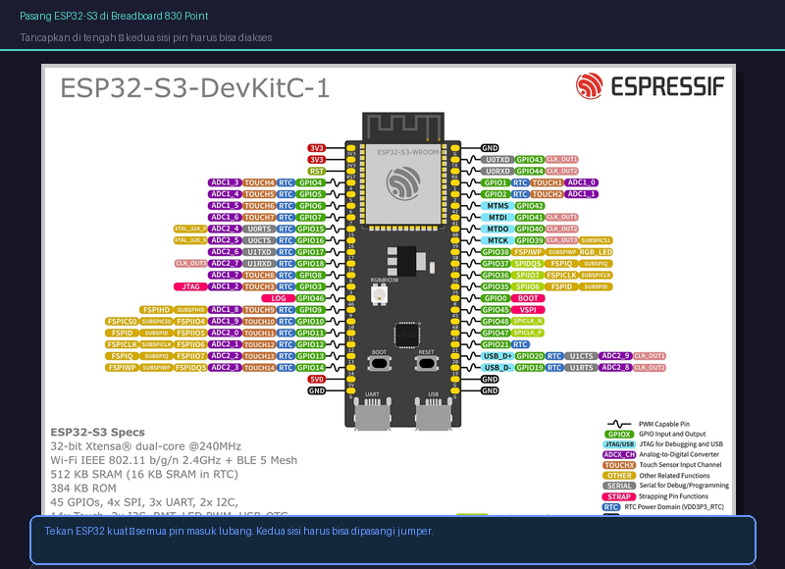

1. Ambil breadboard 830 point
2. Tancapkan ESP32-S3 di TENGAH breadboard
3. Kedua sisi pin harus bisa diakses untuk jumper wire
TIP: Tekan kuat tapi hati-hati. Semua pin harus masuk.

Step 5: Sambung Power Supply
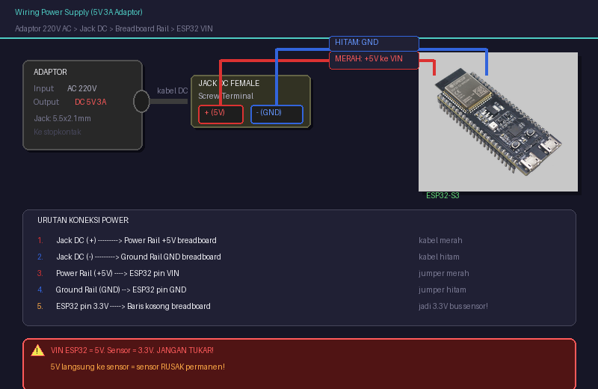

1. Adaptor 5V 3A > jack DC female screw terminal (belum colok!)
2. Terminal (+) > power rail (+) breadboard = +5V
3. Terminal (-) > ground rail (-) breadboard = GND
4. Power rail (+) > ESP32 pin VIN
5. Ground rail (-) > ESP32 pin GND
6. ESP32 pin 3.3V > baris baru breadboard (jadi 3.3V bus sensor)
PERINGATAN: VIN ESP32 = 5V. Sensor = 3.3V. Jangan tukar!

Step 6: Sambung Sensor Cahaya (BH1750)
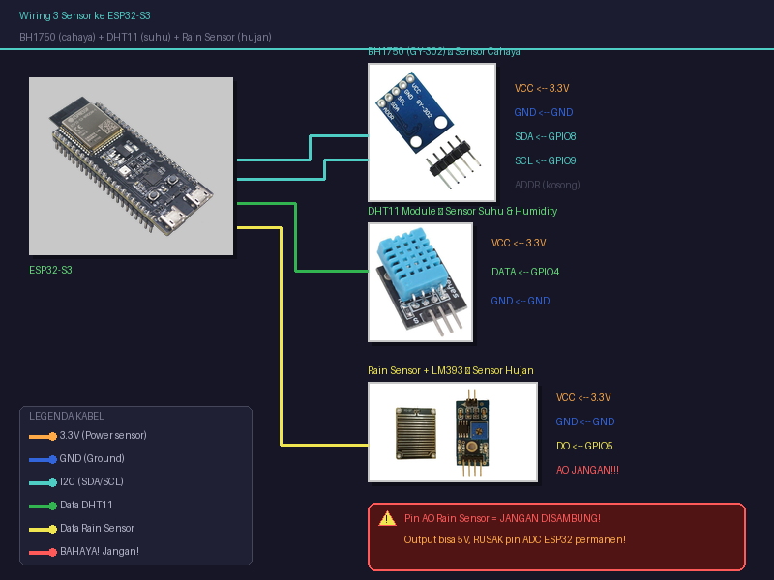

BH1750 pakai I2C (SDA + SCL):
VCC --> 3.3V bus
GND --> GND bus
SDA --> GPIO8
SCL --> GPIO9
ADDR --> kosong

Step 7: Sambung Sensor Suhu (DHT11)
DHT11 module 3-pin:
VCC --> 3.3V bus
GND --> GND bus
DATA --> GPIO4
TIP: Beli yang MODULE 3-pin (ada PCB), bukan komponen telanjang 4-pin.

Step 8: Sambung Sensor Hujan (Rain Sensor)
Dari control board LM393:
VCC --> 3.3V bus
GND --> GND bus
DO --> GPIO5
AO --> JANGAN DISAMBUNG!
PERINGATAN: Pin AO bisa output 5V. ESP32 ADC max 3.3V. Disambung = RUSAK PERMANEN.

Step 9: Sambung Servo Motor (MG996R)
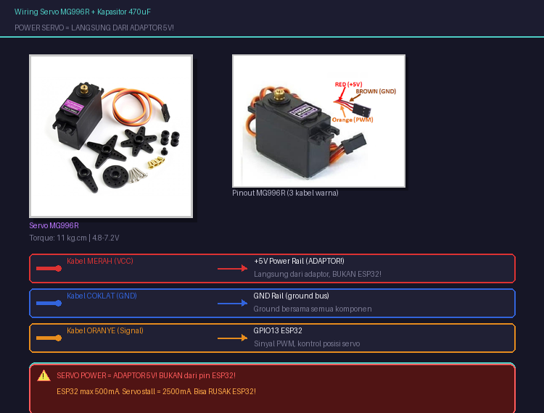

MERAH (VCC) --> +5V Rail (ADAPTOR!)
COKLAT (GND) --> GND bus
ORANYE (Signal) --> GPIO13

Capacitor 470uF dekat servo:
Kaki panjang (+) --> +5V Rail
Kaki pendek (-) --> GND Rail
PERINGATAN: Servo power WAJIB dari adaptor. BUKAN ESP32! Servo butuh 2.5A, ESP32 max 500mA.

Step 10: Sambung LED Warning + Resistor
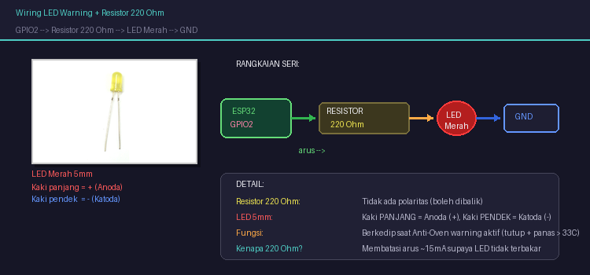

GPIO2 > Resistor 220 Ohm > LED Merah > GND
Resistor: tidak ada polaritas. LED: kaki panjang = (+).

FASE 2: Upload & Test Firmware

Step 11: Checklist Sebelum Power On
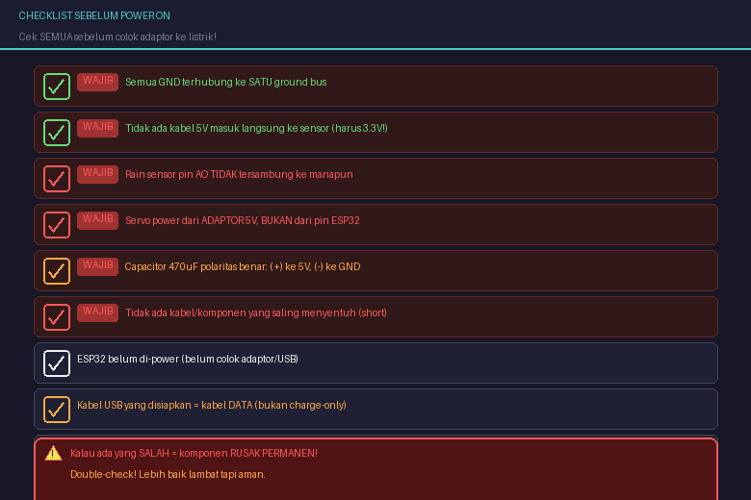

Cek SEMUA item sebelum colok adaptor!
Setelah yakin:
1. Colok adaptor > cek LED power ESP32 menyala
2. Tunggu 10 detik > sentuh komponen
3. Kalau ada yang PANAS > CABUT SEGERA

Step 12: Colok ESP32 ke Laptop via USB
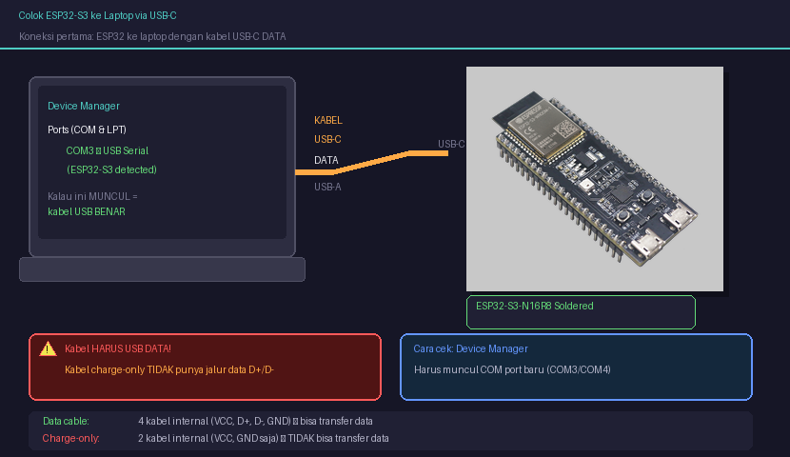

1. Kabel USB-C DATA (bukan charge-only!)
2. Colok ke ESP32 dan laptop
3. Device Manager harus muncul COM port baru

Tidak muncul? Ganti kabel USB atau install driver CH340/CP2102.

Step 13: Konfigurasi Arduino IDE
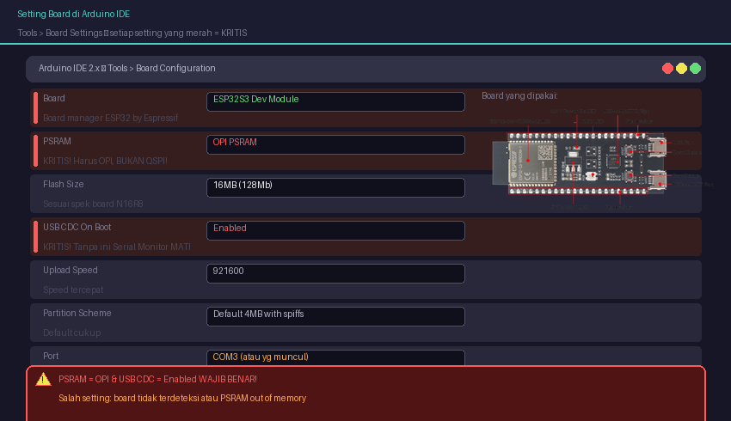

Board: ESP32S3 Dev Module
PSRAM: OPI PSRAM
Flash Size: 16MB (128Mb)
USB CDC On Boot: Enabled
Upload Speed: 921600
Port: COM yang muncul
PERINGATAN: PSRAM = OPI & USB CDC = Enabled WAJIB BENAR!

Step 14: Siapkan File Firmware
1. Clone/download folder firmware/ dari repo
2. Buka smart_greenhouse.ino di Arduino IDE
3. Copy credentials.h.example > credentials.h
4. Edit credentials.h:
#define WIFI_SSID "nama_wifi"
#define WIFI_PASSWORD "password_wifi"
#define SUPABASE_URL "https://xxx.supabase.co"
#define SUPABASE_KEY "eyJ..."
TIP: Isi WiFi dulu. Supabase nanti. Sistem tetap jalan offline.

Step 15: Upload Firmware ke ESP32
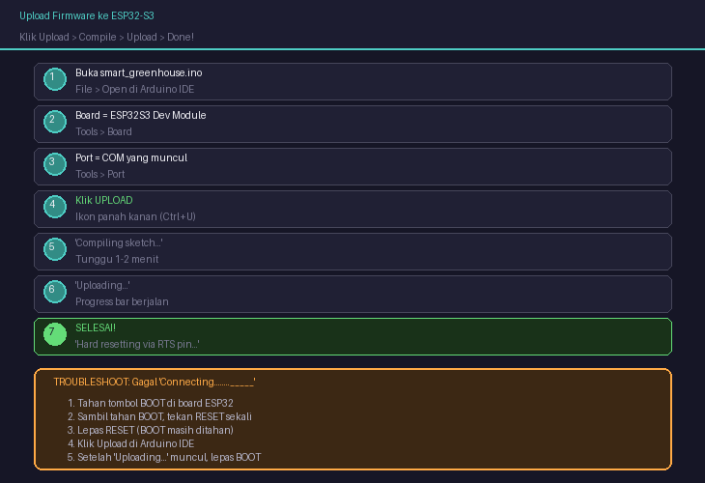

Klik Upload > tunggu compile > tunggu upload.
Kalau gagal "Connecting...": tahan BOOT > tekan RESET > lepas > upload > lepas BOOT

Step 16: Buka Serial Monitor
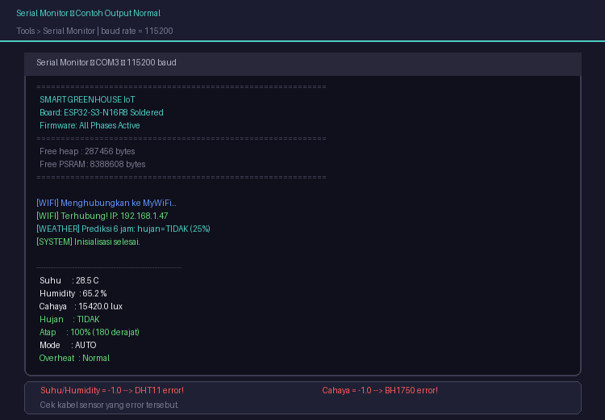

Tools > Serial Monitor, baud rate 115200.
Tekan RESET di ESP32. Harus muncul data sensor.
Kalau ada -1 = sensor error, cek kabelnya.

FASE 3: Setup Supabase

Step 17: Buat Akun & Project Supabase
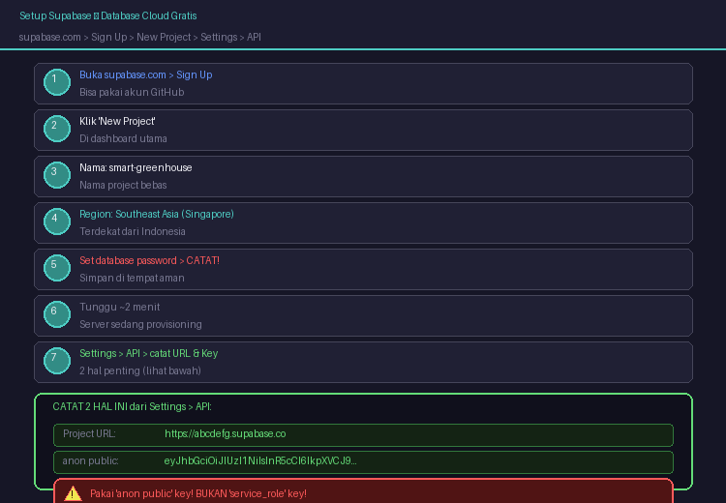

supabase.com > Sign Up > New Project > smart-greenhouse
Region: Southeast Asia (Singapore)

Step 18: Catat URL dan API Key
Settings > API:
Project URL: https://xxxxx.supabase.co
anon public key: eyJ...
Update credentials.h > upload ulang firmware.
PERINGATAN: Pakai "anon public" BUKAN "service_role" key!

Step 19: Buat Tabel Database
SQL Editor > New Query > paste & Run:
CREATE TABLE sensor_logs (
id BIGSERIAL PRIMARY KEY, temperature FLOAT, humidity FLOAT,
lux FLOAT, is_raining BOOLEAN DEFAULT FALSE,
vent_position INTEGER DEFAULT 0,
roof_angle INTEGER DEFAULT 0,
mode TEXT DEFAULT 'auto', overheating BOOLEAN DEFAULT FALSE,
created_at TIMESTAMPTZ DEFAULT NOW()
);
CREATE TABLE commands (
id BIGSERIAL PRIMARY KEY,
vent_position INTEGER CHECK (vent_position BETWEEN 0 AND 100),
mode TEXT DEFAULT 'auto',
executed BOOLEAN DEFAULT FALSE,
created_at TIMESTAMPTZ DEFAULT NOW(), executed_at TIMESTAMPTZ
);
ALTER TABLE sensor_logs ENABLE ROW LEVEL SECURITY;
ALTER TABLE commands ENABLE ROW LEVEL SECURITY;
CREATE POLICY "read" ON sensor_logs FOR SELECT USING (true);
CREATE POLICY "insert" ON sensor_logs FOR INSERT WITH CHECK (true);
CREATE POLICY "all" ON commands FOR ALL USING (true) WITH CHECK (true);

Step 20: Verifikasi Data Masuk
Tunggu 60 detik > Table Editor > sensor_logs > harus ada data baru!

FASE 4: Test Sistem Lengkap

Step 21: Test: Sensor Baca Normal
Serial Monitor tiap 5 detik: suhu (20-35C), humidity (40-90%), cahaya (0-65000 lux).

Step 22: Test: Hujan = Atap Tutup (Rule 1)
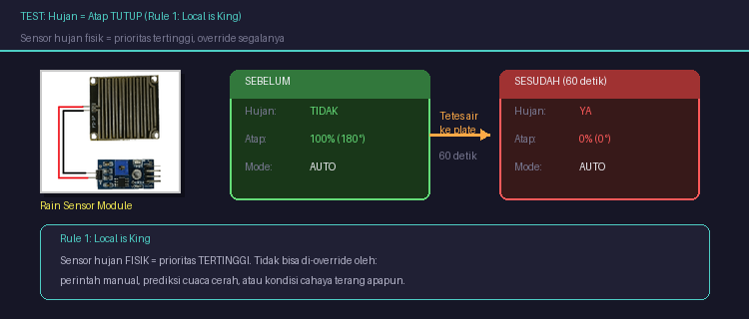

Teteskan air ke rain plate > "Hujan: YA" > tunggu 60 detik > servo ke posisi 0% (0°).
Rule 1: Local is King. Tidak bisa di-override.

Step 23: Test: Cerah = Atap Buka
Keringkan rain plate > arahkan senter ke BH1750 > tunggu 60 detik > servo ke posisi 100% (180°).

Step 24: Test: Hysteresis
Tetes air > tunggu 30 detik > keringkan > servo TIDAK BOLEH bergerak!

Step 25: Test: Anti-Oven (Rule 4)
Hujan aktif + suhu > 33C: LED berkedip, atap tetap tutup.

FASE 5: Web Dashboard (Opsional)

Step 26: Setup Next.js
npx create-next-app@latest greenhouse-dashboard
npm install @supabase/supabase-js
.env.local: NEXT_PUBLIC_SUPABASE_URL & NEXT_PUBLIC_SUPABASE_ANON_KEY

Step 27: Deploy ke Vercel
Push ke GitHub > vercel.com > Import > Add env vars > Deploy

Step 28: Test Dashboard
Data sensor muncul, slider posisi ventilasi 0-100% berfungsi, tombol AUTO/MANUAL aktif.

SISTEM LENGKAP
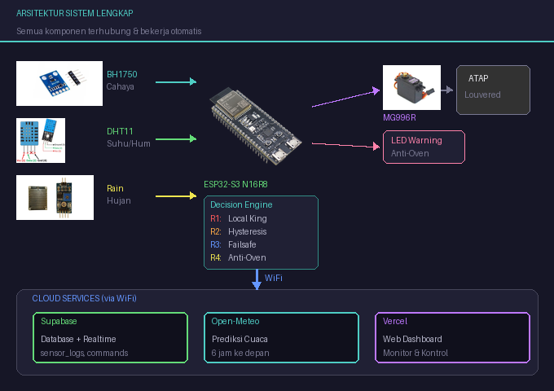

Selamat! Smart Greenhouse IoT sudah berjalan.
Sensor tiap 5s | Supabase tiap 60s | Command tiap 10s | Weather tiap 30min | Servo 0-100% | Offline OK

13525004@std.stei.itb.ac.id | Smart Greenhouse IoT | April 2026

