Economics of User Segmentation, Profiling, and Detection in Security

Bin Mai
College of Business Administration
Northwestern State University
Natchitoches, LA 71497
maib@nsula.edu

Huseyin Cavusoglu, Srinivasan Raghunathan, and Byungwan Koh
School of Management
The University of Texas at Dallas
Richardson, TX 75083
{sraghu,huseyin,byungwan.koh}@utdallas.edu

User profiling is regarded as an effective and efficient tool to detect security breaches because it allows firms to target attackers by deploying a more stringent detection system for them than for normal users. The absence of profiling restricts the firm to use the same detection system for all users. While profiling can be a useful tool, we show that it induces attackers to fake their identity and trick the profiling system into misclassifying their type, and that this incentive is higher if the profiling accuracy is higher. By faking, an attacker reduces the likelihood of being classified as an attacker by the profiling system; a higher profiling accuracy decreases this likelihood more. Further, a higher disparity in detection rates for attackers and normal users employed by the firm to take advantage of a higher profiling accuracy makes faking even more attractive. If faking is sufficiently easy, the profiling accuracy is sufficiently poor, or if faking degrades the profiling accuracy sufficiently, then the firm realizes a lower payoff when it uses profiling than when it does not. For profiling to offer maximum benefit, faking cost should be higher than a threshold value, which is increasing in the profiling accuracy. If faking is not an issue, then, consistent with our intuition, it is optimal for a firm to deploy a more stringent detection system for an attacker and a less stringent detection system for a normal user when profiling accuracy improves. However, when faking is an issue, if the profiling accuracy is higher than a threshold value, then the firm should design less differentiated detection systems by degrading the detection rate for an attacker or by enhancing the detection rate for a normal user when profiling accuracy improves.

May 2007
1. Introduction
Detection systems are an integral part of many security architectures. Metal detectors, X-ray scanners, and physical inspections are a few such systems used in aviation security. Intrusion Detection Systems (IDSs) detect hacking in computer systems. Providing adequate and cost-effective security in domains such as aviation and information security is challenging because only a small fraction of users have any incentive to attack. Subjecting every user to a costly detection procedure is inefficient, but selecting a sub set of users randomly is likely to be ineffective. If potential attackers can be identified, then it may be beneficial to employ a more rigorous detection procedure on actions of these individuals compared to those of others. Thus, user profiling, which attempts to classify users into different risk classes, is considered to be a potentially useful tool in security contexts. According to Oxford English Dictionary, one of the definitions of profiling is the “selection for scrutiny by law enforcement officials, etc., based on superficial characteristics (as ethnic background or race) rather than on evidentiary criteria.” In this paper, we adopt this definition to distinguish between profiling and detection; while profiling uses criteria pertaining to individuals, detection uses criteria related to criminal behavior. For instance, in aviation security, a Computer Assisted Passenger Prescreening System (CAPPS), s profiling system in our definition, classifies passengers into different risk classes based on characteristics such as gender whereas a metal detector, a detection system, looks for evidence of metal to detect security breaches.
While proponents of profiling tout its ability to offer improved detection at a lower cost, critics have pointed out that users may be able to game the profiling system through trial-and-error sampling and learning. For instance, Chakrabarti and Strauss (2002) demonstrate how a terrorist can circumvent the CAPPS and reduce his chances of being detected. Dalvi et al. (2004) discuss how spammers can alter their strategies to trick spam filters in the information security context. In this paper, we analyze the problem of cost-effective design of multi-level detection systems in the presence of user profiling and potential gaming of it by attackers and seek to answer the following questions about detection systems design:
When attackers have the ability to fake their type, perhaps after incurring a cost, or when profiling cannot perfectly classify a user’s type,
- Does the firm benefit from profiling?
- What should be the detection rate of each of the detection systems used, and how does attackers’ gaming affect these optimal detection rates?
- How do different parameters of profiling, such as its accuracy, the cost of faking it, and the degradation in its performance under faking, affect detection systems design and the firm’s payoff?
Our analysis has led to the following main insights. We show that profiling induces attackers to fake their identity and trick the profiling system into misclassifying their type, and that the incentive to fake is more when profiling is more accurate. By faking, an attacker can reduce the likelihood of being classified as an attacker, and a higher profiling accuracy reduces this likelihood more (“direct effect”). The indirect effect is that a higher disparity in detection rates employed for attackers and normal users to take advantage of a higher profiling accuracy enhances the attractiveness of faking. If faking is sufficiently easy, faking degrades the profiling accuracy significantly, or the profiling accuracy is sufficiently low, then the firm realizes a lower payoff when it uses profiling than when it does not. For profiling to offer maximum benefit, faking cost should be higher than a threshold value. The threshold value is increasing in the profiling accuracy, a consequence of higher incentive to fake when the profiling accuracy is higher.
Profiling also has significant implications for detection systems design. If faking cost is sufficiently high or faking does not degrade the profiling accuracy significantly, then it is optimal to increase the detection rate for an attacker and decrease the detection rate for a normal user when profiling accuracy increases. Hence, when faking is not an issue, an increase in profiling accuracy differentiates the detection systems more. However, when faking is an issue, it becomes optimal to design less differentiated systems as profiling accuracy increases, by reducing the detection rate for an attacker or increasing the detection rate for a normal user and, thereby, reducing the incentives of attackers to fake. That is, contrary to conventional wisdom, we find that as the firm becomes better at discriminating attackers and normal users, it may be optimal for the firm to design less stringent detection system for an attacker and a more stringent detection system for a normal user.
In Section 2, we discuss the literature on detection systems in security domains and the relevant literature from economics. We describe our model for the detection game in Section 3. We analyze the impact of profiling on detection systems in Section 4. The impact of profiling on the firm’s payoff is discussed in Section 5. Section 6 compares the socially optimal solution to that when a firm maximizes its own payoff. We conclude with a summary, limitations of our model, and directions for future research in Section 7.
2. Literature Review
Researchers have studied the economics of security and detection systems in diverse domains such as aviation, information security, and general crime prevention and detection. Research in aviation security has investigated the effectiveness of airport security systems using discrete optimization, probabilistic, and simulation models. Kobza and Jacobson (1997) analyzed the effectiveness of different architectures of access control systems using probability models. Jacobson et al. (2001, 2003, 2005) and McLay et al. (2005a) analyzed the performance of baggage screening systems, The cost effectiveness of screening passengers using CAPSS for checking baggage was analyzed by Virta et al. (2003). Chakrabarti and Strauss (2002) demonstrated that terrorists can trick CAPPS by learning its classification algorithm through a trial-and-error approach. Barnett (2003) argued that passenger screening systems are unlikely to be cost effective given the nature of constraints they might operate under. Models in this literature assumed exogenous quality parameters of detection systems and did not analyze either optimal configuration of these systems or the impact of profiling accuracy, faking cost, and other parameters related to profiling on the firm. The literature also did not address the impact of gaming by attackers.
The information security community has recently initiated research on game theoretic models for the intrusion detection game. Cavusoglu et al. (2005) showed that when hackers game an IDS, it offers a positive value only if it deters hackers and that an optimally configured IDS deters hackers. Ulvila and Gaffney (2004) proposed a decision theory approach to configure an IDS. Cavusoglu and Raghunathan (2004) compared game theory and decision theory approaches and showed that the game theory approach results in a superior configuration. Cavusoglu et al. (2006) studied the configuration of IDSs when the access is controlled by a firewall. Tunca and August (2006) analyzed incentives of users to apply software security patches, and Arora et al. (2006) showed that software vendors may have an incentive to release buggier product first followed by a patch later. Dalvi et al. (2004) studied the problem of designing spam filters for an environment where spammers are capable of manipulating data to pretend to be normal email senders.
In the economics literature, our work relates to inspection games, which includes arms control and disarmament (Maschler 1966, 1976; Kilgour 1992, Weissenberger 1992), environmental control (Mishra et al. 1997, Russell 1990), crime control (Thomas and Nisgav 1976, Feichtinger 1983), and crime deterrence (Becker 1968; Stigler 1970, Polinsky and Shavell 1979, Sethi 1979, Shavell 1991, Mookherjee and Png 1992). In accounting, the emphasis of related research has been on auditor’s decision rules for various audit sampling outcomes (Fellingham and Newman 1985, Newman et al. 1996) and on the design of contracts between principals and agents (Baiman 1982, Kanodia 1985, Dye 1986). This literature did not consider either design of detection system or profiling.
Our model is similar to those in the product line design literature (e.g., Mussa and Rosen 1978, Moorthy 1984, Moorthy and Png 1987). The product line design problem addresses the optimal quality of products when a firm faces a heterogeneous group of consumers with different valuations of quality. The challenge arises from the fact that if quality levels are improperly set, a high valuation consumer may find the product designed for a low valuation consumer to be more attractive, causing cannibalization. In our problem, if detection systems are improperly designed, a user with a high incentive to attack may fake his type and may go through a detection system designed for a user with a low incentive. We consider profiling which identifies (imperfectly) the user type. The product line design literature did not analyze the impact of identifying consumer type on design decisions.
3. The Model
We use aviation security to develop our model for detection system design. In this context, the security architecture has CAPPS as the profiling system, X-ray machines and metal detectors as detection systems, and physical inspection. A firm wishes to protect an asset from attacks. When the asset is utilized by a normal user, the user derives a positive utility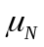, and the firm derives a positive utility. An attacker derives a utility 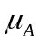 and the firm incurs a loss d when the asset is attacked. Attackers constitute fraction of the user population. If the firm detects an intended attack, then the firm will avoid the loss, and the attacker’s utility will be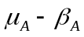. >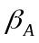 so that an attacker has an incentive to attack always.
The firm uses one or more detection systems to detect attacks before they are realized. A detection system raises an alarm if it suspects a threat. The accuracy of a detection system is denoted by its detection (true-positive) probability,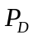, and its false-positive probability, 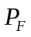. A detection system can be configured to operate at a specific combination of (,) values on its Receiver Operating Characteristics (ROC) curve, which specifies the permissible combinations for the detection system (Trees 2001). An ROC curve represents as an increasing concave function of (Durst et al. 1999, Lippman et al. 2000, McHugh 2000). We assume that the ROC curve is given by the equation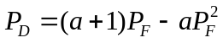, where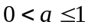. A detection system only raises alarms; the firm confirms or rules out intended attacks by a manual inspection. The firm undertakes a manual inspection if and only if the detection system raises an alarm. This assumption is consistent with how detection systems are employed in many security domains. The firm incurs a cost c for each manual inspection. We assume that c < d, so that the firm’s cost of manual inspection is smaller than the benefit it gets from preventing an attack. A normal user incurs a cost of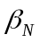when he is subjected to a manual inspection. The cost of operating a detection system is.
The firm may use a profiling system to route a user through a specific detection system. The profiling system classifies a user as either normal (N) or attacker (A) based on his characteristics. For example, popular press suggests that CAPPS uses information such as a passenger’s demography, flight information, frequent flyer status, and the mode of payment for the ticket to screen passengers. The accuracy of the profiling system is denoted using two parameters: 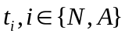, which represents the probability that a user of type i is classified correctly. We assume that the accuracy of the profiling system is not worse than that of a random guess, i.e., 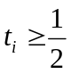.
An attacker may fake his characteristics, by incurring a cost W, to trick the profiling system. W could be viewed as the cost incurred by an attacker to sample and learn about the profiling system and to alter his characteristics. Though a normal user can also potentially fake his type to pretend to be an attacker, it is never optimal for him to do so. If an attacker fakes his type, then the accuracy of the profiling system in classifying him as an attacker degrades to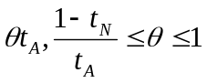. 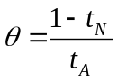 implies that faking is perfect and the profiling system cannot distinguish between a normal user and an attacker that fakes, and 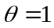implies that faking has no effect on the profiling system. While an attacker may be able to trick the profiling system into classifying him as a normal user, he cannot manipulate the outcome of either the detection system or the manual inspection.
We model the detection system design problem as a sequential game between the firm and attackers. The objective of the firm is to minimize the overall expected cost by optimally designing its detection system(s). The firm and users are risk neutral. The timeline of the game is in Figure 1. The same timeline applies whether or not the firm employs a profiling system, i.e., profiling is exogenous to our model, so that we can determine the impact of profiling on detection systems design. Finally, we assume all parameters to be public knowledge.

Stage 1: firm configures its detection system(s)
Stage 2: Normal users and attackers decide their strategy
Stage 3: payoffs are realized
Figure 1. Timeline of the Game
4. Impact of Profiling on Detection Systems Design
Consistent with the timeline of the game, we use backward induction to determine the optimal strategy for the firm, i.e., we first determine the optimal strategy for normal users and attackers given firm’s decisions, followed by firm’s design decisions by anticipating normal users’ and attackers’ strategies. We normalize the number of users to one for our analysis.
4.1. User-Firm Interaction and Normal Users’ and Attackers’ Optimal Strategies
The payoffs to a normal user, an attacker, and the firm depend on whether the firm employs profiling. The firm will use two detection systems, and, hence, attackers may have an incentive to fake their identity, if and only if the firm employs profiling. Figure 2 shows the computation of payoffs when the firm does not employ profiling.
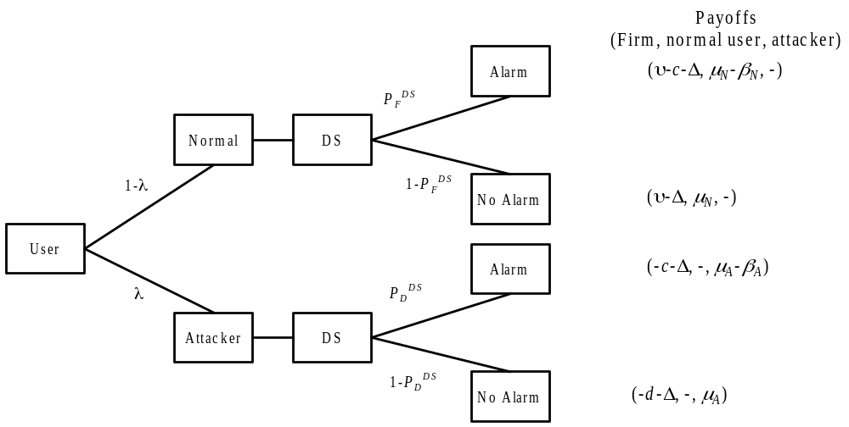
Figure 2. Payoffs When the Firm Does Not Use Profiling
Figure 3 shows the computation of payoffs when the firm employs profiling, but attackers do not fake. In Figure 3, we denote the detection system intended for users classified as attackers (normal users) as DS^{A} (DS^{N}). Parameters associated with these detection systems have been superscripted accordingly.
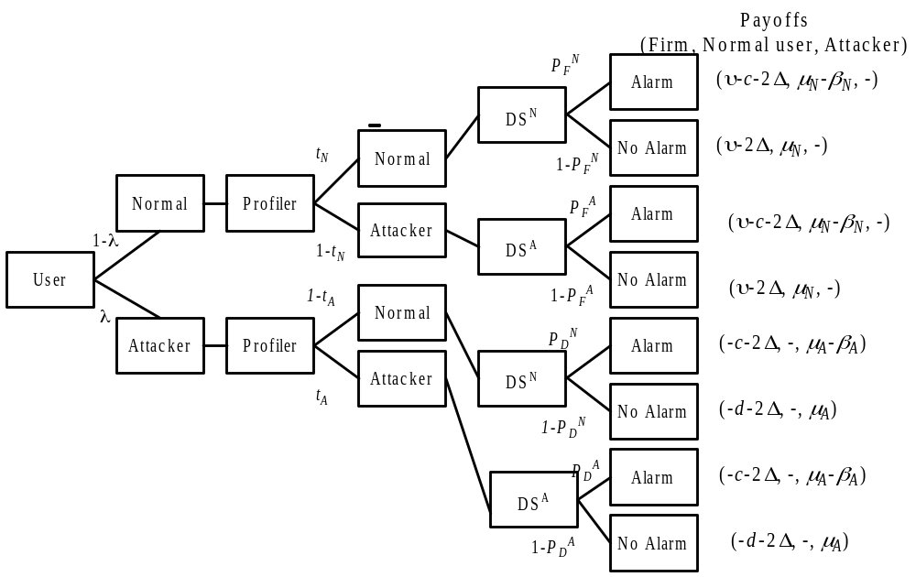
Figure 3. Payoffs When the Firm Uses Profiling and Attackers Do Not Fake
The decision tree for the computation of payoffs when attackers fake their type can be derived by substituting 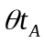for 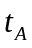in Figure 3. The expected payoffs under the three scenarios are as follows.
No Profiling:
Attacker: 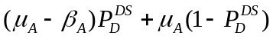
Normal User: 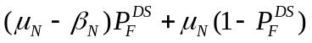
Firm: (1)
Profiling, but no faking:
Attacker:
Normal User:
Firm: 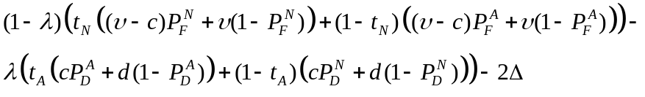 (2)
Profiling, and faking:
Attacker:
Normal User:
Firm: 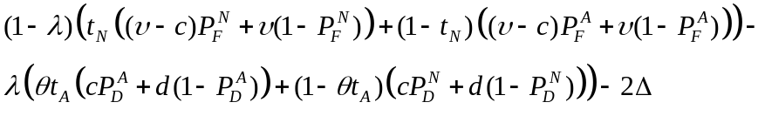 (3)
The strategies of an attacker and a normal user are in the following result.
Lemma: An attacker will choose to fake if and only if the firm uses profiling and
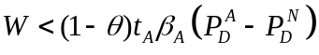. (4)
A normal user will utilize the firm’s service if and only if
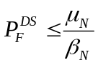when the firm does not use profiling, and 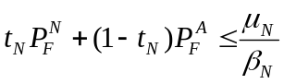 otherwise. (5)
{Proofs for all results are in the Appendix}

It is apparent from (4) that, for a given faking cost, an attacker will fake when the detection rate for an attacker significantly exceeds that for a normal user, the profiling accuracy is high, or faking degrades the profiling accuracy significantly. From (5), we note that high false positive rates (and, thus, high detection rates) will force normal users to abandon the service, which will hurt the firm.
4.2. Optimal Detection System Design
We derive firm’s optimal decisions when it does not employ profiling and when it does. We then compare results in these cases to derive insights about the impact of profiling on firm’s decisions.

4.2.1. Firm Does not Use Profiling
Maximizing (1), after substituting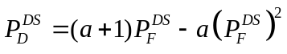, we obtain the interior solution as:
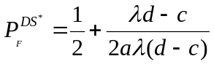. (6)
The interior solution is optimal only when 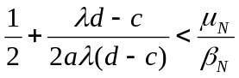because a normal user will not use the firm’s service otherwise. If this condition is not satisfied, then the firm will set the detection rate to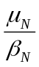.
4.2.2. Firm Uses Profiling, but Faking Cost is High
In this case, the faking cost is sufficiently high such that (4) is satisfied in the equilibrium, so faking is not an issue for the firm. We refer to this scenario as the ‘high-faking-cost’ scenario. Maximizing (2) w.r.t. 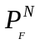and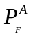, we obtain the interior solution as:
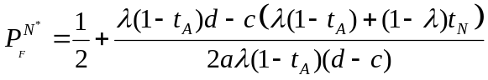 (7)
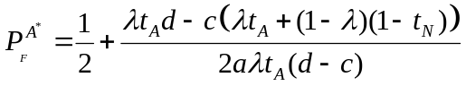 (8)
Substituting (7) and (8) in (4), we obtain the minimum faking cost, W_{min}, required for the high-faking-cost scenario as:
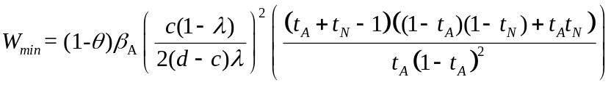 (9)
If the above interior solution does not satisfy (5), then it is optimal for the firm to derive the solution by maximizing (2) subject to (5), which yields the following boundary solution.
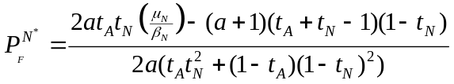 (10)
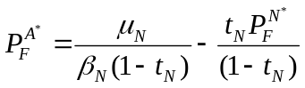 (11)
We have the following result for the high-faking-cost scenario.
Proposition 1: When the faking cost is sufficiently high to prevent attackers from faking, and the firm uses profiling,
- if 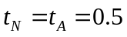, detection rates of the two detection systems are identical and is equal to the detection rate when the firm uses a single detection system with no profiling.
- if either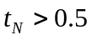or 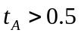, the detection rate for an attacker is greater than that for a normal user.
- if the profiling accuracy increases, the detection rate for an attacker increases and that for a normal user decreases, and detection systems become more differentiated.

Figures 4(a) and 4(b) show graphically the impact of t_{N} on the quality of detection systems (assuming that μ_{N} and β_{N} are such that the interior solution holds) for the values: d = 1000, c = 1, λ=0.01, ν=10, W=1000, θ=0.8, μ_{A}=10000, β_{A}=1500. The graphs for t_{A} are similar to these figures. Proposition 1 confirms our intuition that profiling enables the firm to design a more stringent detection system for suspected attackers than for normal users, and that the difference in the two detection rates increases as the profiling accuracy improves. Proposition 1 and other results of the paper hold whether the interior or the boundary solution is optimal. For brevity and expositional clarity, we discuss only the interior solution in the rest of the paper.
Proposition 1 holds only when the faking cost is higher than W_{min}, so that faking is not an issue. W_{min} depends on the profiling accuracy and the degree of degradation of profiling accuracy when attackers fake. W_{min} is increasing linearly in the degree of degradation of profiling accuracy. Further,
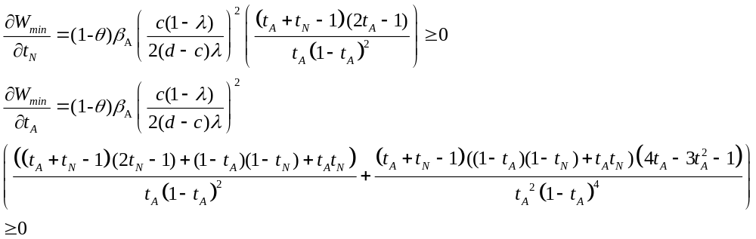.

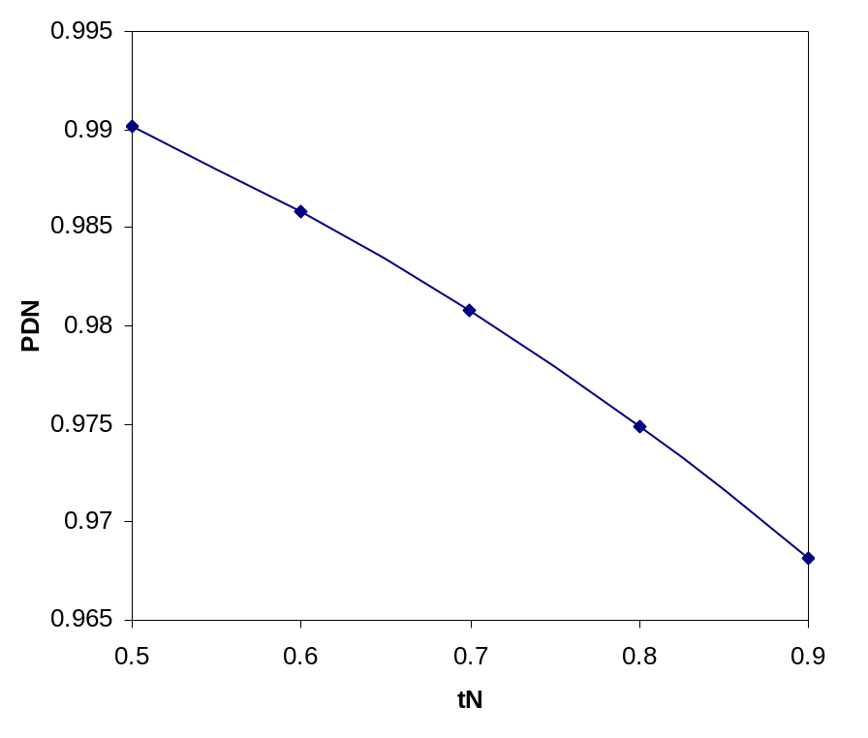
Figure 4(a). Impact of t_{N} on 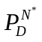(High-Faking-Cost Scenario: t_{A} = 0.75)
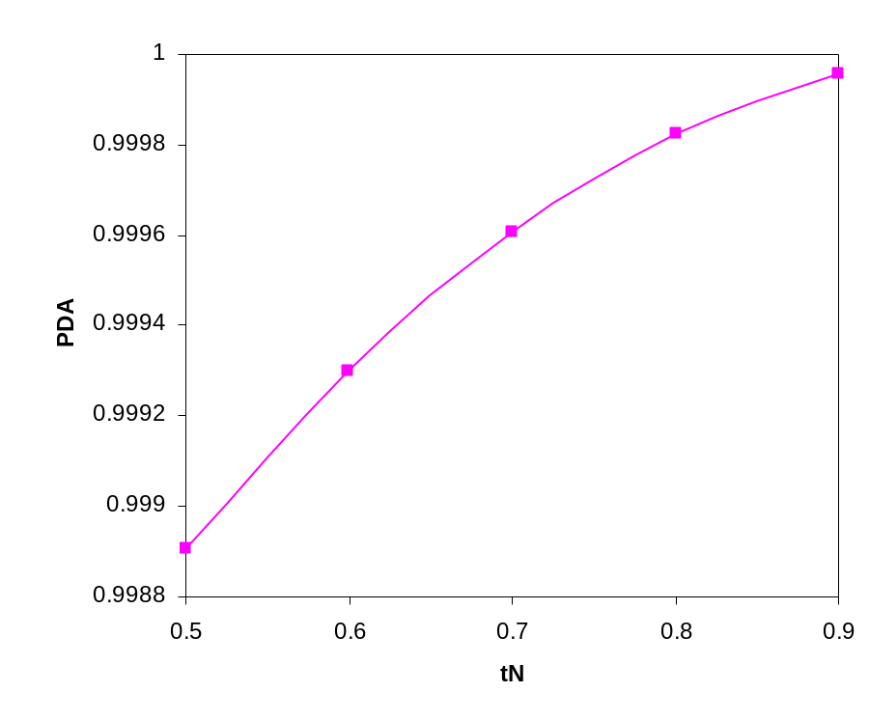
Figure 4(b). Impact of t_{N} on 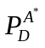(High-Faking-Cost Scenario: t_{N} = 0.75)
Figures 5(a) and 5(b) show W_{min} as a function of the profiling accuracy for the same set of parameter values used for Figure 4. The behavior of W_{min} as a function of the profiling accuracy is the result of two effects. A higher probability of being correctly classified as an attacker by the profiling system makes faking more attractive to an attacker. Further, a higher detection rate for an attacker and a lower detection rate for a normal user at a higher profiling accuracy enhance an attacker’s incentive to fake. Since W_{min} is decreasing in, if faking degrades the classification accuracy for attackers more, then attackers will have more incentives to fake. Thus, we have the following result.
Proposition 2: W_{min} is increasing in the profiling accuracy and in the degree of degradation of classification accuracy because of faking.

4.2.3. Firm Uses Profiling, but Faking Cost is Low
We consider faking cost to be low when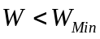. The firm has two options in this case. In the first option, the firm allows attackers to fake and designs its detection systems, fully aware that attackers will fake in the equilibrium. In the second option, the firm designs its detection systems such that attackers are prevented from faking in the equilibrium.
If the firm allows faking, then the firm maximizes (3) and solves for and . The solution is similar to that for the high faking cost scenario except t_{A} will be replaced by . The solution is given by:
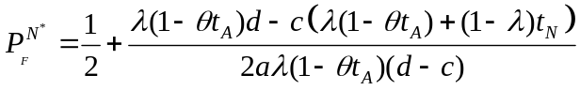
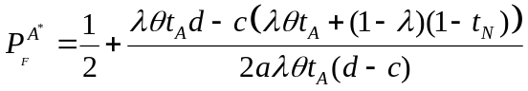
If faking is perfect, i.e., if , then 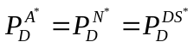. Comparing the above detection rates with those when there is no faking (equations (7) and (8)), we conclude that the detection rate for attackers (normal users) will be lower (higher) when there is faking than when there isn’t. The impact of profiling accuracy on detection rates when attackers fake is qualitatively identical to that when faking is not an
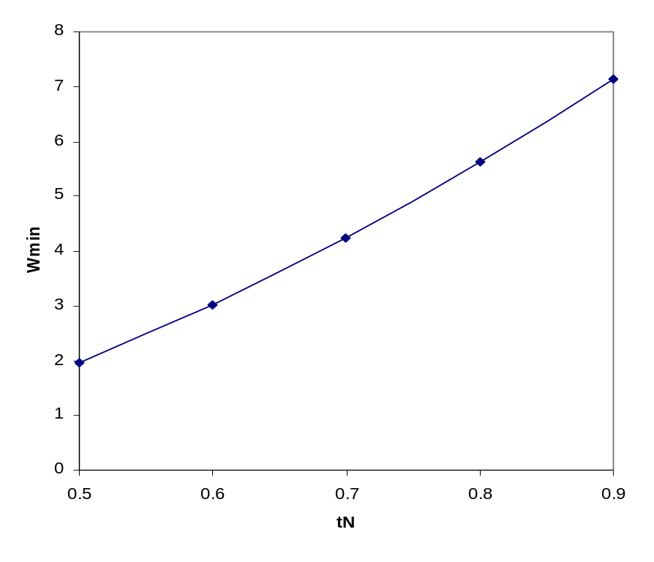
Figure 5(a). Impact of t_{N} on W_{Min}
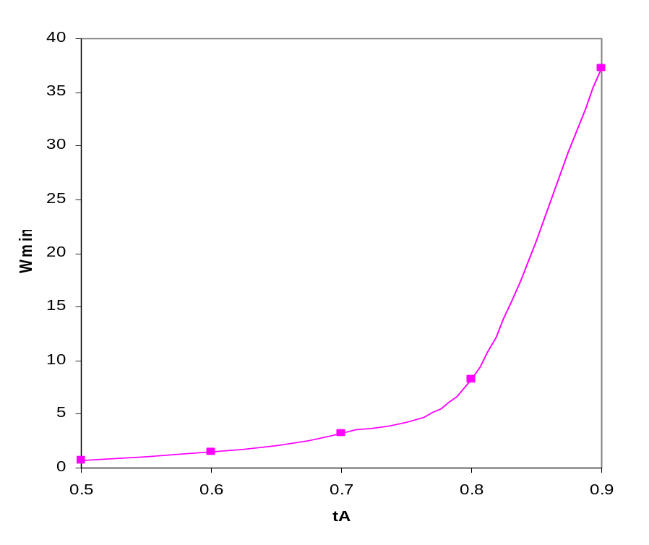
Figure 5(b). Impact of t_{A} on W_{Min}
issue ( as given in Proposition 1). The only difference in the payoff expressions when the firm allows faking and when it does not is in the term corresponding to the profiling accuracy for attackers: accuracy of classifying an attacker is lower when attackers fake.
In option 2, when the firm prevents attackers from faking, the firm solves the following model:
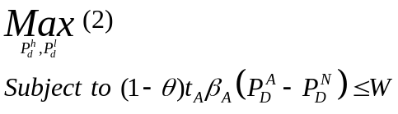
The constraint in the model ensures that the benefit from faking is not higher than from not faking for attackers. Solving the above constrained optimization model using the Lagrangean technique, we find that the constraint is binding in the optimal solution. The optimal solutions satisfy the following equations.
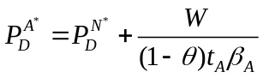 (12)
` 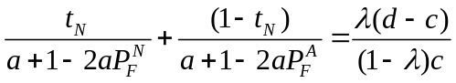 (13)
Now, we can show the following result.
Proposition 3: If the firm uses profiling, the faking cost is low, and the firm prevents attackers from faking, then
- the two detection systems become less differentiated when the profiling accuracy improves.
- the decrease in the difference between detection systems because of an increase in the profiling accuracy is more if the degradation in classification accuracy caused by faking is higher.
- detection rates increase when the profiling accuracy improves.

If the profiling accuracy improves, then detection systems become less differentiated, i.e., 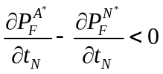 and 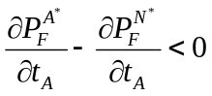, which is in contrast to the result we showed for the high-faking-cost scenario. The reason is that if the profiling accuracy improves, then attackers that would have been prevented from faking would fake if the firm keeps the same detection rates. Recall from Lemma 1 that attackers have more incentive to fake if detection systems are more differentiated. Consequently, the firm has to reduce the differentiation between detection systems in order to prevent attackers from faking when profiling accuracy increases. Further, if faking degrades profiling accuracy more, then the incentive to fake is enhanced, which causes the firm to reduce the differentiation more. The result that an improved profiling accuracy increases the detection rate for attackers is intuitive, but the result that it increases the detection rate for normal users also seems counter-intuitive. This is a direct consequence of the firm needing to design less differentiated systems, when profiling accuracy improves in order to prevent attackers from faking.
4.3. Comparison of Detection Systems in High- and Low-Faking-Cost Scenarios
In our analysis of the impact of profiling accuracy discussed in Sections 4.1 and 4.2, we implicitly assumed that when the profiling accuracy changes, the firm still operates in the same scenario, i.e., either the low- or the high-faking-cost scenario. However, we showed in (9) that an increase in profiling accuracy could force the firm to shift from the high- to the low-faking-cost scenario. An analysis of the impact of profiling accuracy on firm’s decisions should account for such a shift in the operating scenario. Further, in the low-faking-cost scenario, whether it is optimal for the firm to allow or prevent faking depends on the value of. An analytical derivation of conditions under which allowing faking is superior to preventing when the faking cost is low proved to be intractable. However, we could derive significant insights about the impact of profiling on the quality of detection systems in high- and low-faking-cost scenarios by restricting to either of its extreme values, 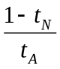or one. We discuss these cases next.
4.3.1. Faking Does not Degrade Profiling Accuracy (=1)
If faking does not impair the profiling system at all (i.e., the profiling system is capable of detecting faking perfectly), then it is never optimal for attackers to fake because (4) will never be satisfied. Thus, the analysis and the optimal strategy derived for the high-faking-cost scenario hold when =1. Further, it is apparent that if faking does not degrade profiling accuracy, then faking cost does not affect firm’s decisions.
4.3.2. Faking is Perfect (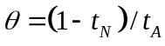)
Substituting in (9), we find that the firm operates in the low-faking-cost scenario when
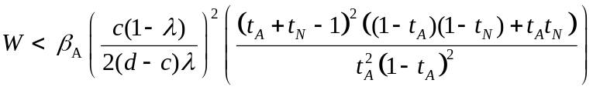. (14)
If faking is perfect and if the firm allows faking, then, as shown in Section 4.2.3, it is optimal for the firm to set the same detection rate for both detection systems, and consequently, the firm will not use profiling. Thus, when faking is perfect, if the firm uses profiling, then it will design its detection systems to prevent faking. Further, the right hand side of (14) is increasing in both t_{N} and t_{A}, which implies that the firm may operate in a high-faking-cost (low-faking-cost) scenario when the profiling accuracy is lower (higher) than a threshold value.
Proposition 4: If , then the firm designs more (less) differentiated detection systems when profiling accuracy increases if the profiling accuracy is lower (higher) than a critical value.

Proposition 4 is a direct consequence of an increased incentive to fake created by an increase in the profiling accuracy. As long as the incentive to fake does not outweigh the faking cost, the firm can still differentiate the detection systems more when profiling accuracy improves. However, once the incentive to fake outweighs the faking cost, the firm can no longer ignore the possibility of faking and is forced to reduce the differentiation between the detection systems. This necessity arises when faking is an issue because if the firm allows faking, then profiling becomes meaningless as it cannot distinguish between attackers and normal users. Figures 6(a) and 6(b) illustrate the impact of profiling accuracy on detection rates when faking is perfect for the parameter values: d = 1000, c = 1, λ=0.01, ν=10, W=10, θ=0.8, μ=10000, β=1500.
The impact of W on detection systems design when faking is perfect is given by the following result.
Proposition 5: If 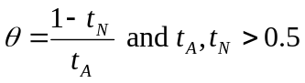 then as W increases, the differentiation between detection systems increases if W < W’ and remains constant, otherwise.
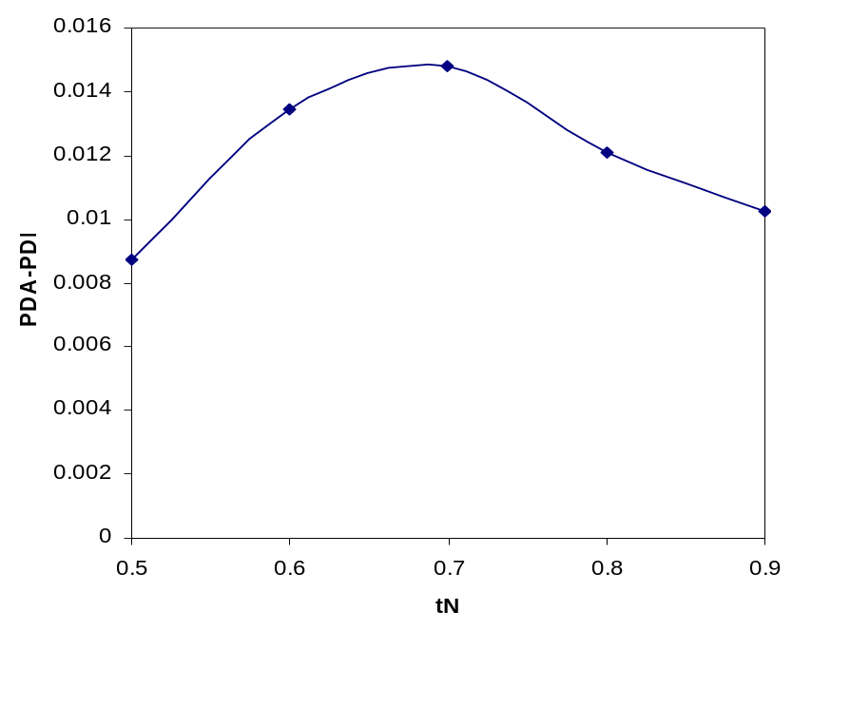
Figure 6(a). Impact of t_{N} on the Difference in Detection Rates under Perfect Faking (t_{A}=0.75)
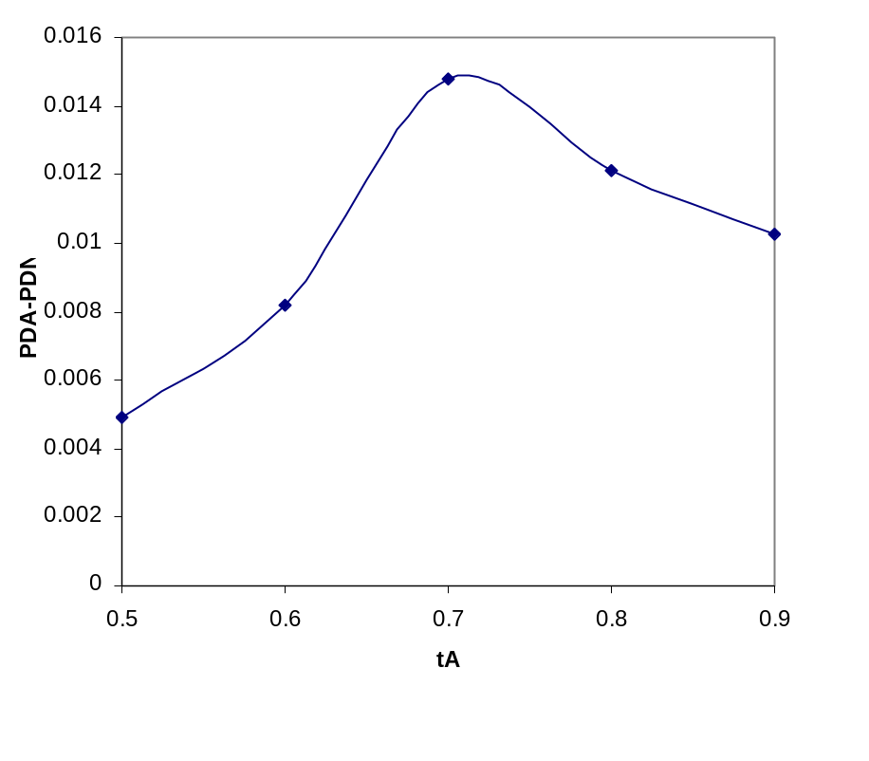
Figure 6(b). Impact of t_{A} on the Difference in Detection Rates under Perfect Faking(t_{N}=0.75)
Using (9), we can conclude that if 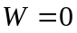, then the firm operates in the low-faking-cost scenario and hence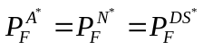. When W > 0, the firm does not have to make detection rates identical to prevent faking, and thus differentiates the detection rates. This differentiation increases as W increases because the incentive to fake decreases. When W > W_{min}, then the firm operates in the high-faking-cost scenario, and W ceases to affect firm’s decisions. The impact of faking cost on detection systems when is in Figures 7(a) and 7(b) for the parameter values: d = 1000, c = 1, λ=0.01, ν=10, t_{A} = t_{N} = 0.75, μ=10000, β=1500.
4.3.4. Imperfect Faking (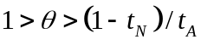)
Our analysis of the model for the extreme values of shows that, in the low-faking-cost scenario, allowing faking does not hurt the firm when =1, but preventing faking is better than allowing it when . Consequently, we hypothesize that for sufficiently low values of, preventing faking is better than allowing. Our extensive numerical analysis supports our hypothesis. Table 1 shows the firm’s payoffs when it allows/prevents faking for various values of when d = 1000, c = 1, λ=0.01, ν=10, t_{A} = t_{N} = 0.8, μ=10000, β=1500, Δ=0.01. We find that the firm’s payoff is higher when it prevents faking compared to when it allows faking at values less than or equal to 0.35. Thus, we conclude that if faking does not impair the profiling accuracy significantly, then the impact of profiling is similar to that in a high-faking-cost scenario; otherwise, the impact of profiling is similar to that in a low-faking-cost scenario in which the firm prevents faking.
θ | Payoff When Faking Is Allowed | Payoff When Faking is Prevented
0.95 | 8.9666 | 8.9452
0.85 | 8.9504 | 8.9324
0.75 | 8.9408 | 8.9293
0.65 | 8.9345 | 8.9280
0.55 | 8.9302 | 8.9272
0.45 | 8.9272 | 8.9267
0.35 | 8.9253 | 8.9264
0.25 | 8.9245 | 8.9261
Table 1. Illustration of when Preventing Faking is Better than Allowing

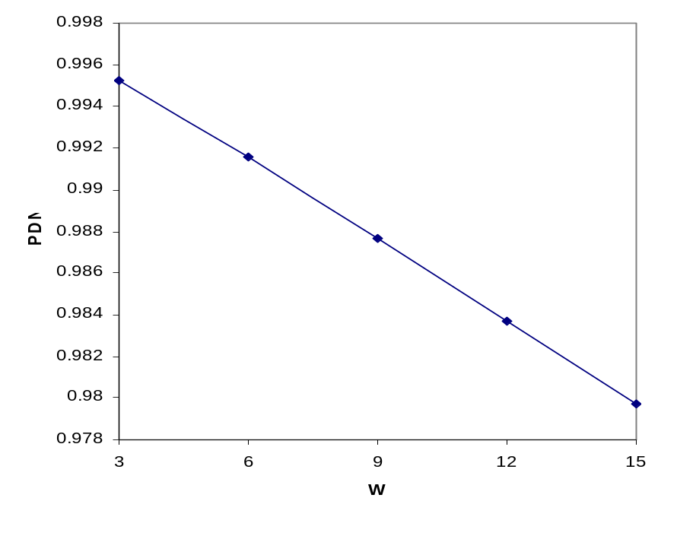
Figure 7(a). Impact of W on
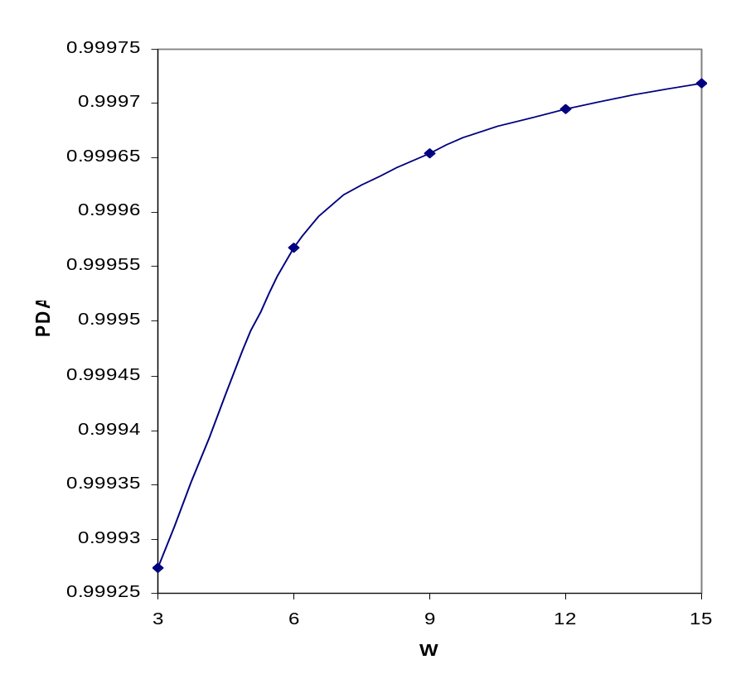
Figure 7(b). Impact of W on
5. Impact of Profiling on the Firm
We analyzed the impact of profiling accuracy, faking cost, and the degree of degradation in profiling accuracy because of faking on detection rates in Section 4. The following result shows the impact of profiling accuracy and faking cost on the firm’s payoff.
Proposition 6: Within the high-faking-cost and low-faking-cost scenarios, the firm’s payoff is increasing in (i) t_{N} and (ii) t_{A}, and (iii) non-decreasing in W.

While an increase in the profiling accuracy or the faking cost benefits the firm as long as the firm operates in the same scenario, the derivation of when the operating scenario will change as the profiling accuracy or the faking cost changes, and, consequently, the exact condition under which profiling is better than not profiling proved to be intractable, forcing a numerical analysis to gain insights. Before presenting our numerical analysis, we provide some of the intuitions that can be derived analytically. If faking does not degrade the profiling accuracy at all, then the firm always operates in the high-faking-cost scenario, and the firm’s payoff improves with profiling accuracy. Further, if profiling is not better than random guessing, then it is optimal for the firm to not use profiling. Thus, for profiling to be better than not profiling, the profiling accuracy has to be above a threshold value if faking does not degrade profiling accuracy. If faking degrades the profiling accuracy, and preventing is better than allowing faking in the low-faking-cost scenario, then we know from (14) that the firm is better off not using profiling when W = 0, and the firm’s payoff (weakly) increases as W increases, which implies that for profiling to be better than not profiling the faking cost has to be above a threshold. We illustrate the interplay of profiling accuracy, faking cost, and the degree of profiling accuracy degradation because of faking in determining whether profiling is better than not profiling using a numerical example.
For numerical illustration, we use the following parameter values: d = 1000, c = 1, λ=0.01, ν=10, μ=10000, β=1500, Δ=0.01. Tables 2(a)-(d) reports the firm’s payoff when it uses profiling and when it does not use profiling and the value of profiling for 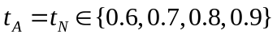 and various values of and W. We report results for two extreme values of . When 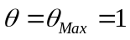, W does not affect the payoff from profiling. When 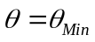, W affects the payoff from profiling. Further, when 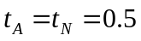, neither W nor affects the payoffs from profiling. For our parameter values, when , the payoff with profiling is -0.0054 and the payoff without profiling is 0.0045. Clearly, the firm does not benefit from profiling in this case.
Figure 8 illustrates the region in which profiling is beneficial. Clearly, profiling is beneficial only when profiling accuracy is higher than a threshold value and faking cost is higher than a threshold value, which depends on the profiling accuracy as well as the extent of degradation of profiling accuracy caused by faking. The region in which profiling is beneficial expands as increases.
6. Comparison with a Welfare Maximizing Solution
In the previous analysis, we assumed that the firm maximized its own payoff. In many security contexts, the firm may be a social planner such as a government agency that would maximize the social welfare. The social welfare is equal to the sum of the firm’s payoff and a normal user’s payoff and is given by the following.
No Profiling:
Profiling, but no faking:
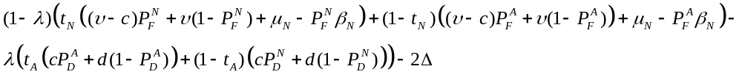
Profiling, and faking:
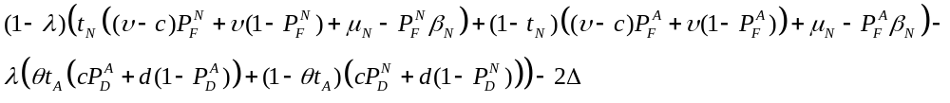

Θ, W | Payoff w/  Profiling | Payoff w/o  Profiling | Benefit of  Profiling | Θ, W | Payoff w/  Profiling | Payoff w/o  Profiling | Benefit of  Profiling
Θ_{Max}, - | -0.0013 | 0.0045 | -0.0059 | Θ_{Max}, - | 0.013214 | 0.004527 | 0.008687
Θ_{Min}, 1.32 | 0.0005 | 0.0045 | -0.0040 | Θ_{Min}, 7.75 | 0.013214 | 0.004527 | 0.008687
Θ_{Min}, 1.0 | -0.0015 | 0.0045 | -0.0061 | Θ_{Min}, 5.0 | 0.011812 | 0.004527 | 0.007285
Θ_{Min}, 0.5 | -0.0028 | 0.0045 | -0.0073 | Θ_{Min}, 2.0 | 0.005031 | 0.004527 | 0.000504
Θ_{Min}, 0.1 | -0.0048 | 0.0045 | -0.0093 | Θ_{Min}, 1.0 | 0.00052 | 0.004527 | -0.00401
Table 2(a): t_{A}=t_{N} = 0.6 Table 2(b): t_{A}=t_{N} = 0.7
Θ, W | Payoff w/  Profiling | Payoff w/o  Profiling | Benefit of  Profiling | Θ, W | Payoff w/  Profiling | Payoff w/o  Profiling | Benefit of  Profiling
Θ_{Max}, - | 0.049713 | 0.004527 | 0.045186 | Θ_{Max}, - | 0.168941 | 0.004527 | 0.164414
Θ_{Min}, 35.2 | 0.049713 | 0.004527 | 0.045186 | Θ_{Min}, 238 | 0.168941 | 0.004527 | 0.164414
Θ_{Min}, 25 | 0.047787 | 0.004527 | 0.04326 | Θ_{Min}, 100 | 0.14425 | 0.004527 | 0.139723
Θ_{Min}, 10 | 0.032851 | 0.004527 | 0.028324 | Θ_{Min}, 50 | 0.110563 | 0.004527 | 0.106036
Θ_{Min}, 1.0 | 0.000956 | 0.004527 | -0.00357 | Θ_{Min}, 1.0 | 0.001113 | 0.004527 | -0.00341
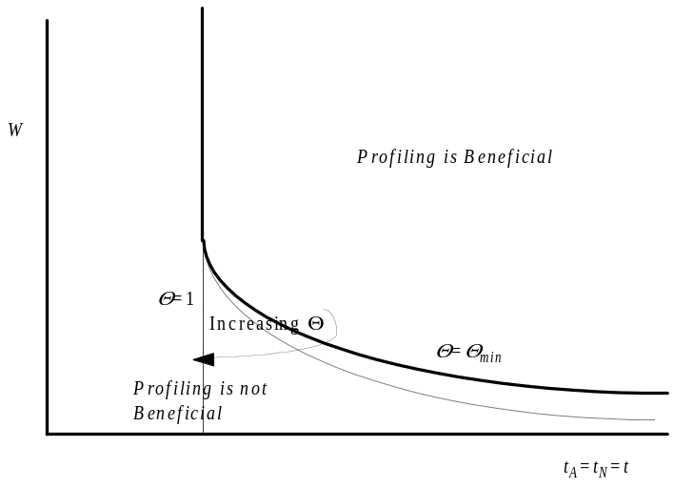
Table 2(c): t_{A}=t_{N} = 0.8 Table 2(d): t_{A}=t_{N} = 0.9

Figure 8. When is Profiling Beneficial to the Firm?

Comparing the above expressions for social welfare to the respective firm’s payoffs given in (1), (2), and (3), we find that the social welfare is equivalent to summation of 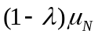 and the payoff obtained by the firm if it were to have an investigation cost of c +. Now, we have the following result that compares the solutions under social welfare maximization and firm’s payoff maximization.
Proposition 7: (i) The detection rate for a user is lower under social welfare maximization than under firm’s payoff maximization, whether or not the firm uses profiling. (ii) A firm that operates in the low-faking-cost scenario under firm’s payoff maximization may operate in the high-faking-cost scenario under social welfare maximization.(iii) Propositions 1 – 6 hold under social welfare maximization.

A social planner sets a lower detection rate than a firm that maximizes its own payoff because the cost of a false alarm is higher for a social planner; the cost of a false alarm for a normal user does not affect the payoff of the firm but affects the social welfare. The lower detection rates reduce the differentiation between the two detection systems if profiling is used, reducing an attacker’s incentive to fake. Consequently, an attacker that does not fake when the firm’s payoff is maximized will not fake when the social welfare is maximized. Proposition 7(i) and 7(ii) reveal that the firm’s payoff is lower and a normal user’s payoff is higher in the socially optimal solution compared to the firm’s optimal solution. The impact of profiling accuracy, faking cost, and the degree of degradation of profiling accuracy because of faking on detection systems design do not change qualitatively.
7. Conclusions
In this paper, we studied how user profiling affects the design of detection systems in a security context. One of the drawbacks of profiling is that users may be able to learn through trial-and-error and fake their identity to defeat the profiling system. While profiling may allow the firm to tailor different detection systems for users of different risk classes, we found that an increase in the profiling accuracy increases the incentive of attackers to fake. Consequently, the firm is unable to reap the full benefits of profiling when users have the ability to fake their identity, and further, profiling is actually worse than not profiling when the faking cost or the profiling accuracy is sufficiently low. In particular, profiling is never optimal when either the faking cost or the profiling accuracy is negligible. When profiling is better than not profiling and faking is not a problem, it is optimal for the firm to make the detection system for attackers (normal users) more (less) stringent as the profiling accuracy improves. However, if the firm is unable to increase the faking cost along with an improvement in profiling accuracy, then the firm may have to reverse its strategy and degrade the detection rate for an attacker and enhance the detection rate for a normal user when profiling accuracy improves beyond a threshold level. That is, contrary to conventional wisdom, we find that as the firm becomes better at discriminating the high- and low- risk users, it becomes optimal for the firm to design less differentiated detection systems for the two groups when the profiling accuracy is sufficiently high.
The managerial insights we derive relate to the complex interplay among profiling accuracy, faking cost, and the degree of degradation in the profiling accuracy because of faking in determining how detection systems should be designed to address security. For profiling to be maximally effective, either the profiling criteria should be such that attackers cannot easily fake their type or the profiling system should be able to detect faking so that its accuracy does not degrade. Some examples of good profiling criteria include biometric features and those based on historical behavior. For instance, in information security, while source IP address is a weak profiling criterion because of IP spoofing, historical usage pattern is a stronger profiling criterion. In fact, anomaly-based IDSs that employ usage patterns are able to detect novel attacks better than others. Our findings support the recent criticism (e.g., ACLU 2003, Barnett 2003) of CAPPS for their use of profiling criteria that can be easily learned and faked by terrorists.
Even if strong profiling criteria are unavailable or cannot be used for legal or other reasons, profiling can lead to better security than not profiling if detection systems are designed to discourage faking. While a higher profiling accuracy leads to more differentiated detection systems when attackers do not fake, the firm will actually be worse off with more differentiated systems when attackers have the ability to successfully fake. In order to take advantage of improved profiling accuracy, in the absence of strong profiling criteria, a firm may have to design less differentiated detection systems to reduce faking.
If profiling accuracy is sufficiently high, then not only does the firm but also the normal users benefit from profiling. Profiling helps normal users because they are more likely to be sent through a less stringent detection system and be subjected to less manual inspections. Further, the use of multiple detection systems is likely to reduce the average waiting time for normal users. While it is true that some of the normal users may be sent through a more stringent detection system because of profiling errors, the normal users as a whole benefit from profiling and, therefore, should encourage, rather than decry, the use of profiling.
Our research has limitations. We used a model that has two groups of users: one group that never breaches the security and another that will always breach security. However, in reality, there may be several groups of users with different levels of incentives to commit security breaches. While we do not expect the qualitative nature of our results to change when we consider more than two groups of users, a fruitful extension of our research lies in modeling and analyzing this case. This enhanced model could also use stochastic utility from breaches and/or stochastic faking cost instead of deterministic utility and faking cost we assumed in our model. We assumed that in the case of two detection systems, they use the same technology and, hence, have the same ROC curve, but are configured to operate at different points within the ROC curve. However, in a more general scenario, the two detection systems could use two different technologies and, hence, have two different ROC curves. Extending our model to this more general scenario is straightforward. While the algebra is likely to be more complex, we do not expect to see qualitatively different results. Finally, our findings were based on a theoretical analysis of a detection system model. The results could be validated using empirical data.
References

ACLU, "The five problems with CAPPS II: Why the airline passenger profiling proposal should be abandoned,” http://www.aclu.org/safefree/general/16769leg20030825.html, August 2003, accessed on July 2006.
Arora, A., J. Caulkins, and R. Telang, “Sell First, Fix later: Impact of Patching on Software Quality,” Management Science, Vol. 52, No. 3, 2006.
Baiman, S., “Agency research in managerial accounting: A survey,” Journal of Accounting Literature, 1982
Barnett, A. and M. Higgins, “Airline safety: The last decade,” Management Science, Vol. 35, January 1989.
Barnett, A., "Trust no one at the airport," OR/MS Today, Vol. 30, No. 1, pp. 72. 2003
Becker, G. “Crime and punishment: An economic approach,” Journal of Political Economy. 76 169–217. 1968.
Cavusoglu, H. and S. Raghunathan, “Configuration of detection software: A comparison of decision and game theory approaches,” Decision Analysis, Vol. 1, No. 3, September 2004.
Cavusoglu, H., S. Raghunathan and H. Cavusoglu, “Are Two Security Technologies Better than One?,” Working Paper, The University of Texas at Dallas, TX. 2006
Cavusoglu, H., B. Mishra, and S. Raghunathan, “The value of intrusion detection systems in information technology security architecture,” Information Systems Research, Vol. 16, No. 1, March 2005.
Chakrabarti, S. and A. Strauss, “Carnival booth: An algorithm for defeating the computer-assisted passenger screening system,” First Monday, Vol. 7, 2002.
Dalvi, N, P. Domingos, Mausam, S. Sanghai, and D. Verma, “Adversarial classification,” Proceedings of the tenth ACM SIGKDD international conference on Knowledge discovery and data mining, Seattle, WA, USA, 2004
Durst, R., T. Champion, B. Witten, E. Miller, and L. Spagnuolo, “Testing and evaluating computer intrusion detection systems,” Communications of the ACM, Vol. 42, No. 7, 1999
Dye, R. A., “Optimal monitoring policies in agencies,” The RAND Journal of Economics, Vol. 17, No. 3. Autumn, 1986.
Feichtinger, G., “A differential games solution to a model of competition between a thief and the police,” Management Science. 29 686–699. 1983.
Fellingham, J. C. and D. P. Newman, “Strategic considerations in auditing,” The Accounting Review, Vol. 60, No. 4. pp. 634-650. Oct., 1985.

Jacobson, S. H., J. E. Kobza and A. Easterling, “A detection theoretic approach to modeling aviation security problems using the knapsack problem,” IIE Transactions, Vol. 33, pp 747, 2001.
Jacobson, S. H., J. E. Virta, J. M. Bowman, J. E. Kobza, and J. J., Nestor, "Modeling aviation baggage screening security systems: a case study," IIE Transactions, Vol. 35, pp. 259-269. 2003.
Jacobson, S. H., T. Karnani, and J. E. Kobza, "Assessing the impact of deterrence on aviation checked baggage screening strategies," International Journal of Risk Assessment & Management, Vol. 5, No. 1, pp. 1-15. 2005,
Kanodia, C., “Stochastic monitoring and moral hazard,” Journal of Accounting Research, Vol. 23, 1985.
Kilgour, D. M., “Site selection for on-site inspection in arms control,” Arms Control: Contemporary Security Policy, 13, 3, 439-462. 1992.

Kobza, J. E. and S. H. Jacobson, “Probability models for access security system architectures,” Journal of the Operational Research Society, Volume 48, Number 3, 1 March 1997.
Lippmann, R. P., D. J. Fried, I. Graf, J. W. Haines, K. R. Kendall, D. McClung, D. Weber, S. E. Webster, D. Wyschogrod, R. K. Cunningham, and M. A. Zissman, “Evaluating intrusion detection systems: The 1998 DARPA off-line intrusion detection evaluation,” Proceedings of 2000 DARPA Information Survivability Conference Exposition (DISCEX) Vol. 2, 2000
Maschler, M., “The inequalities that determine the bargaining set,” Israel Journal of Mathematics, Vol. 4. 1966
Maschler, M. “An advantage of the bargaining set over the core,” Journal of Economic Theory Vol. 13, pp 184–192, 1976.
McHugh, J., “Testing intrusion detection systems: A critique of the 1998 and 1999 DARPA intrusion detection system evaluations as performed by Lincoln Laboratory,” ACM Transactions on Information System Security, Vol. 4, No.4, 2000
McLay, L., S. Jacobson, and J. Kobza, “A multilevel passenger screening strategies for aviation security systems,” Technical Report University of Illinois, 2005(a).
McLay, L., S. Jacobson, and J. Kobza, “Making skies safer,” OR/MS Today, Vol. 32, No. 5, October 2005(b).
Mishra, B. K., P. Newman, D. Stinson and Christopher H., "Environmental regulations and incentives for compliance audits," Journal of Accounting and Public Policy, Vol. 16(2), 1997.
Mookherjee, D., I. P. L. Png., “Monitoring vis-à-vis investigation in enforcement of law,” America Economic Review 82(3) 556–565. 1992.
Moorthy, K., “Market segmentation, self-selection, and product line design,” Marketing Science, Vol. 3, No. 4, Fall 1984.
Mussa, M. and S. Rosen, “Monopoly and product quality,” Journal of Economic Theory, Vol. 18, 1978
Newman, P., “Allocating audit resources to detect fraud,” Review of Accounting Studies, Volume 1, Number 2, 1996.
Polinsky, A., S. Shavell, “The optimal trade-off between the probability and magnitude of fines,” American Economic Review. 69 880–891. 1979.
Russell, C., “Monitoring and enforcement,” in P. Portney, Ed., Public Policy for Environmental Protection, Washington D.C.: Resource for the Future, John Hopkins University Press, 1990.
Sethi, S. P., “Optimal pilfering policies for dynamic continuous thieves,” Management Science. 25(6) 535–542. 1979.
Shavell, S., “Specific versus general enforcement of the law,” J. Political Economy, Vol. 99 1991.
Stigler, G. “The optimum enforcement of laws,” Journal of Political Economy. 78 526–536. 1970.
Thomas, M. and Y. Nisgav, “An infiltration game with time dependent payoff,” Naval Research Logistics Quarterly, 23:297 1976.
Trees, H. V. Detection, Estimation and Modulation Theory—Part I, New York: John Wiley, 2001
Tunca, T. and T. August, “Network Software Security and User Incentives,” Forthcoming, Management Science, 2006.
Ulvila, J. and J. Gaffney, “A decision analysis method for evaluating computer intrusion detection systems,” Decision Analysis, Vol. 1, No. 1, 2004.
Virta, J. E., S. H. Jacobson, and J. E. Kobza, "Analyzing the cost of screening selectee and non-selectee baggage," Risk Analysis, Vol. 23, No. 5, pp. 897-908. 2003.
Weissenberger J, “The environmental conditions in the brine channels of Antarctic sea-ice,” Ber Polarforsch, Vol. 111 1992.
Appendix

Proof for Lemma
Comparison of attacker payoffs when an attacker fakes and when he does not fake results in (4) stated in the Lemma. The conditions for a normal user follow directly from restricting his payoff to be non-negative.

Proof for Proposition 1
Proposition 1(i) follows from substituting in (7) and (8) (or (10) and (11) for the boundary solution). For the interior solution, the rest of the proposition follows from the following partial derivatives.
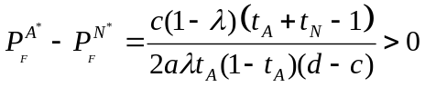
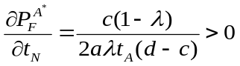
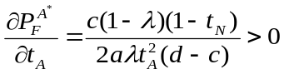
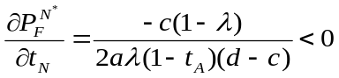
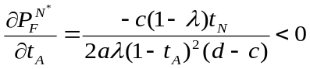
The signs of derivatives for the boundary solution are identical to those of the interior solution.
Proof for Proposition 2
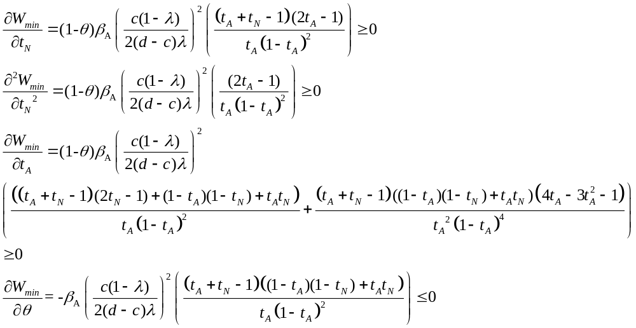
Proof for Proposition 3
Implicit differentiation of (13) yields the following, which prove the result:
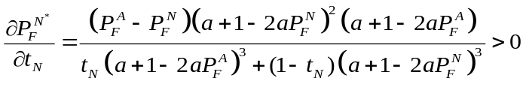
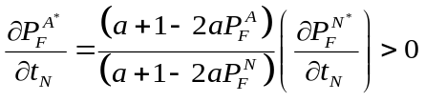
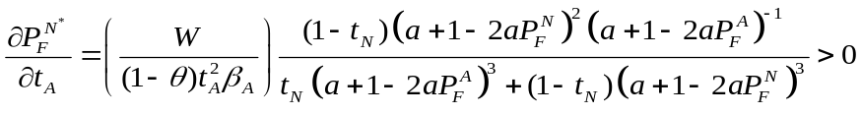
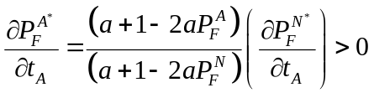
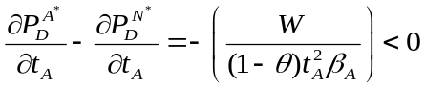
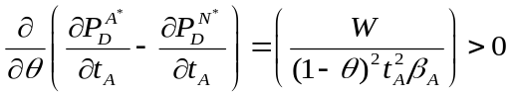

Proof for Proposition 4
The derivatives of the R.H.S. of (14) w.r.t. t_{A} and t_{N} are:
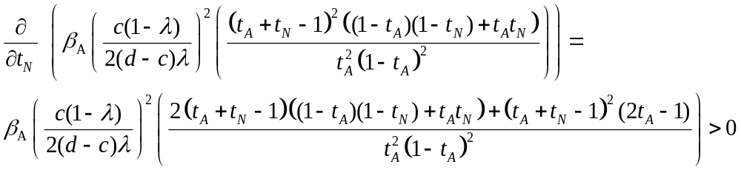
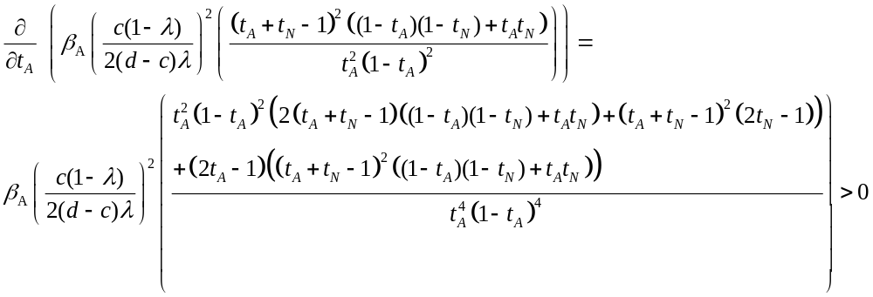
Further, when t_{A} approaches one, the R.H.S. of (19) approaches infinity. Thus, for a given W, there exists a threshold for t_{A} above which the firm operates in a low-faking-cost scenario. Thus, the result follows for t_{A} from Proposition 1 and Proposition 3. For t_{N}, the existence of a threshold depends on other parameter values. If such a threshold exists for t_{N}, then the result follows from Proposition 1 and Proposition 3.

Proof for Proposition 5
Using (7), we can conclude that if , then the firm operates in the low-faking-cost scenario and hence. Further, for the low-faking-cost scenario, we have:
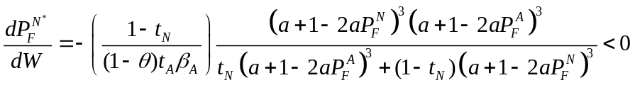
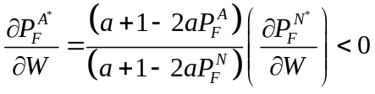
When W > W_{min}, then the firm operates in the high-faking-cost scenario, and it ceases to affect firm’s decisions.

Proof for Proposition 6
(i) We first show that the firm’s payoff is increasing in t_{N}.
Assume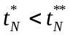. Let the optimal detection rates and firm payoff when 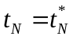 be 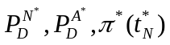, respectively.
(a) High faking cost scenario:
Let the firm still operate in a high faking cost region when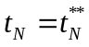. Consider the firm’s payoff if the firm does not alter its detection systems, 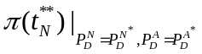Using (2), we obtain
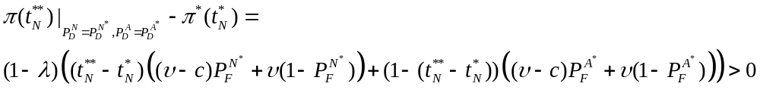
Thus, the optimal firm’s payoff is also strictly higher than 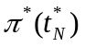when .
(b) Let the firm operate in a low faking cost region when. Now, there are two cases. It may be optimal for the firm to allow or prevent faking. The firm’s payoff is given by (3) and (4), respectively, for the former and latter cases. A proof similar the one given (a) applies to both these cases.
(ii) The proof for the result that the firm’s payoff is increasing in t_{A} is similar to that given in (i).
(iii) An increase in W does not affect the firm’s payoff if the firm is operating either in a high faking cost scenario, or in a low faking cost scenario and the firms allows faking. If the firm operates in a low faking cost scenario and prevents faking, then an increase in W has the sole effect of relaxing the constraint in the firm’s maximization model. Consequently, the firm can never be worse off when W increases.

Proof for Proposition 7
(i)The derivatives of detection rates with respect to c are negative, which, combined with the fact that social welfare maximization is equivalent to an increase in c, yield the result.
(ii)The derivative of W_{min} with respect to c is negative, whish shows that for a given W, a shift from firm’s payoff maximization to social welfare maximization could cause W to exceed W_{min}.
(iii)Propositions 1-6 hold for all values of c, and social welfare maximization is equivalent to only an increase in c.

For a discussion on the history of CAPPS and its successor CAPPS II, the readers are referred to the vast literature on aviation security (e.g., McLay et al. (2005b) and the references therein)
Critics have also pointed out that profiling is illegal because it is discriminatory, but we do not focus on the legality of profiling in this paper.
This assumption models the scenario in which attackers are not deterred by penalty.
Though we use a quadratic function for tractability, our results can be shown to hold for any increasing concave function.
We assume that faking by an attacker degrades the profiling system’s accuracy in classifying him, but does not affect the accuracy of classifying normal users. We also analyzed a model in which faking by an attacker degrades the accuracy of classifying a normal user also and found that our results about the impact of faking were strengthened in that model.
The profiling accuracy is captured by two parameters, t_{A} and t_{N}, but in (4), only t_{A} is explicit. We show later that 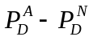is increasing in t_{A} and t_{N} in the equilibrium. We say the profiling accuracy increases when either both parameters increase or one increases and the other remains the same.

