# Task 8: VPN Setup and Privacy Protection

Objective: Understand the role of VPNs in protecting privacy and secure communication.

Tools Used: ProtonVPN (Free Tier), Windscribe VPN (Free Tier)

Date: 04 October 2025

Prepared By: Prince Goswami

## Step-by-Step Process

1. Chose ProtonVPN as a reliable free VPN service.

2. Signed up on ProtonVPN official website (https://protonvpn.com).

3. Downloaded and installed the VPN client on Windows system.

4. Logged into the ProtonVPN client and selected the nearest VPN server (Singapore).

5. Connected to the VPN and confirmed successful connection.

6. Verified IP address change using https://whatismyipaddress.com.

7. Browsed websites to ensure encrypted communication (HTTPS lock symbol verified).

8. Disconnected VPN and compared browsing speed and IP location before and after connection.

9. Researched VPN encryption, IP masking, and privacy features.

10. Summarized VPN benefits and limitations based on practical observation.

## Connection Verification

Before connecting to VPN: IP shown as India (Original ISP).

After connecting to VPN: IP changed to Singapore (ProtonVPN server).

Connection status: Verified and secure (see attached screenshot placeholder).

## VPN Features Observed

• AES-256 bit encryption ensures secure data transmission.

• IP masking hides the user's real location and identity.

• No-logs policy ensures browsing data is not stored.

• Kill switch feature prevents data leaks if VPN disconnects suddenly.

• Slight reduction in internet speed due to encryption overhead.

## Screenshot Placeholder

[Insert Screenshot Here: VPN connected status and IP verification page]

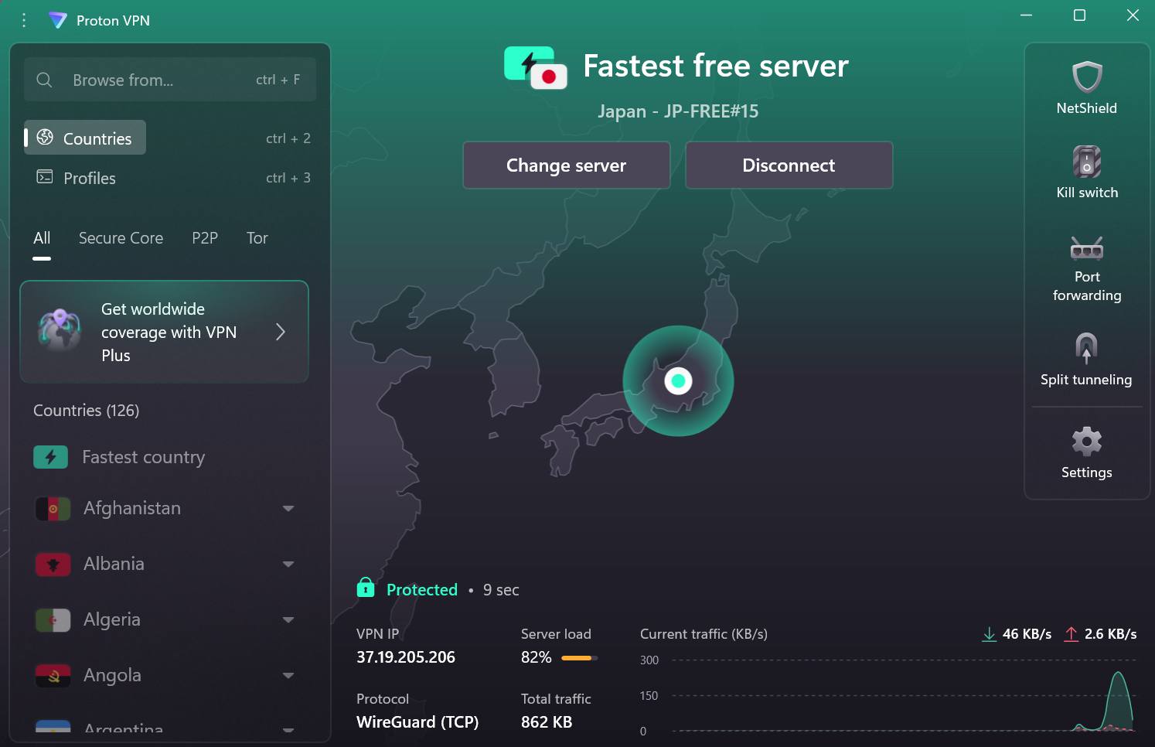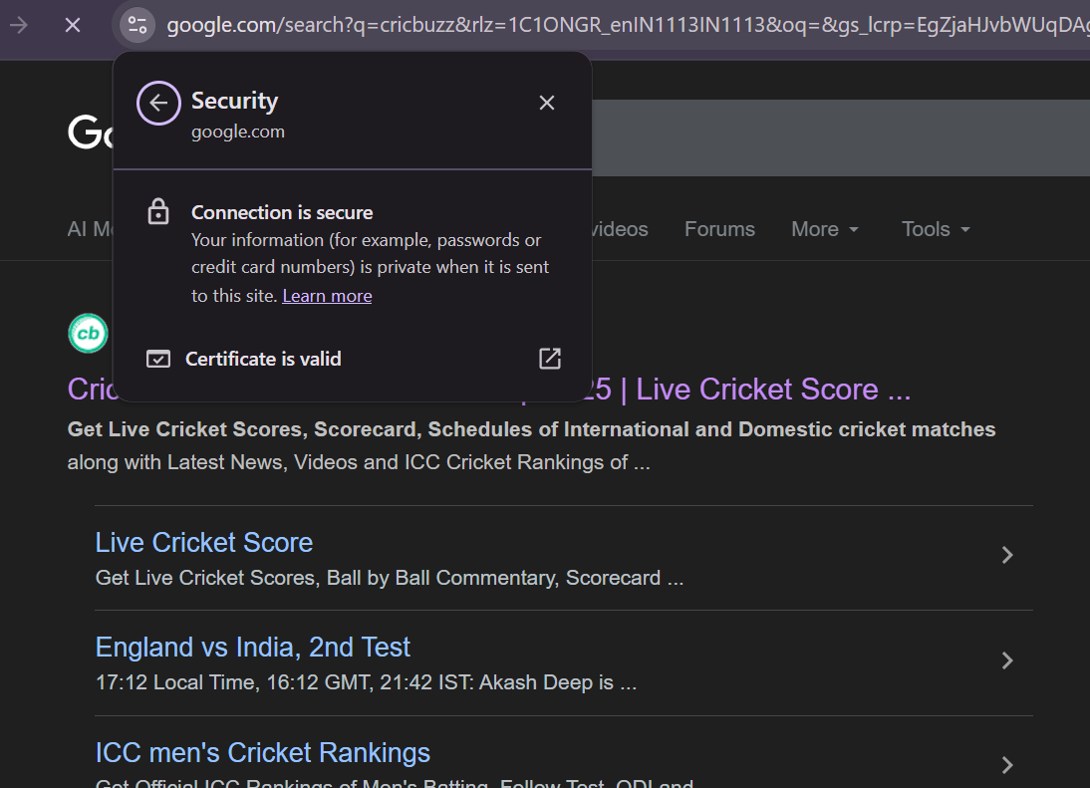

## Outcome

Successfully configured and connected to ProtonVPN. Verified IP address change and encryption status. Understood how VPN protects user privacy by encrypting communication and hiding IP identity.

## Interview Preparation Notes

What is the main purpose of a VPN? → To create a secure and encrypted tunnel between the user and the internet.

How does VPN protect privacy? → By hiding the user’s IP and encrypting internet traffic.

What are common VPN encryption protocols? → OpenVPN, WireGuard, IKEv2/IPSec.

What are VPN limitations? → Slower speeds, possible logging by untrusted VPNs, and restrictions in some countries.