Benchmarking Memory Decay Architectures for LLM Agent Systems: Ranking Quality Matters More Than Regression Accuracy

HanBo Wang, JiaQi Song
Department of Computer Science, East China Jiaotong University, Nanchang, China

School of Information Science, Chongqing University of Posts and Telecommunications, Chongqing, China

*Corresponding author: x270704@163.com

Abstract
Background. LLM agent memory systems must decide which historical memories to retain and which to deprioritize. The choice of decay model architecture affects retrieval quality, but no systematic benchmark exists comparing continuous-time and discrete-time approaches under matched conditions. Methods. We benchmark 8 architectures (Liquid Time-Constant, Closed-form Continuous-time, Neural ODE, CCT-LNN, GRU, GRU+Time, Transformer, Parametric ExpDecay) across 3 datasets using 3 evaluation paradigms: standard regression (MSE), focal weighted regression, and per-timestep ranking quality (NDCG@5, MRR, Kendall tau). We use 5-fold cross-validation with 3 random seeds (15 runs per model) and validate findings in a production deployment on Kylin V10. Results. Regression MSE cannot differentiate architectures: all models converge to 0.079-0.094 on synthetic data. Ranking quality reveals meaningful differences: NDCG@5 ranges from 0.533 to 0.616 on PersonaChat. However, architecture rankings are dataset-specific: Neural ODE leads on PersonaChat (0.616) but ranks sixth on LPT (0.467). The most important finding comes from end-to-end ablation: including any decay model improves agent response quality by 25% over no decay (p<0.001), while the choice among models affects quality by less than 3%. Conclusions. Whether to use a decay model matters far more than which model to use. GRU+Time is the most robust default, ranking in the top three on both datasets with minimal computational overhead.

Keywords: agent memory, decay models, continuous-time neural networks, Liquid Time-Constant, Neural ODE, memory retrieval, LLM agents, benchmarking, ranking quality, empirical evaluation
Highlights:
- First systematic benchmark of 8 memory decay architectures for LLM agent systems
- Regression MSE cannot differentiate architectures; ranking quality (NDCG@5) can
- Architecture rankings are dataset-specific: no single model dominates across all conditions
- Whether to use decay matters more than which decay: 25% improvement (p<0.001) vs <3% model variation
- GRU+Time is the most robust default across datasets with minimal computational overhead

Introduction
Agent memory systems for LLMs face a fundamental design choice: how should historical memories lose relevance over time? The decay model architecture shapes retrieval quality, yet practitioners lack systematic evidence for choosing between continuous-time ODE formulations and discrete recurrent approaches under matched conditions [11,13,23]. Despite growing deployment of memory-augmented agents [14,24], the intuition that continuous-time models should naturally suit decay modeling has never been rigorously tested. Prior work evaluates individual architectures on different datasets with different metrics, which makes fair comparison impossible. This gap matters because agent memory systems are increasingly deployed in production environments where the choice of decay model directly affects user experience through retrieval quality.
We address the gap with four contributions that together provide a comprehensive picture. The benchmark covers 8 architectures across 3 datasets, with 5-fold cross-validation and 3 random seeds per fold (15 runs per model). Three evaluation paradigms are used: standard MSE, focal weighted regression, and per-timestep ranking quality (NDCG@5, MRR, Kendall tau). On synthetic data, LTC (MSE 0.079) outperforms GRU (0.087), as expected from inductive bias alignment. But on real data the models converge within 3% MSE---regression cannot tell them apart. Ranking quality, however, reveals a 15.6% spread (NDCG@5 from 0.533 to 0.616 on PersonaChat), though no single architecture dominates both datasets. The synthetic ranking (LTC best, GRU+Time second) does not transfer to real data, suggesting that inductive bias alignment on idealized data does not predict real-world performance.
The end-to-end ablation, conducted on Kylin V10, demonstrates that including any decay model improves agent response quality by 25% over having no decay at all (p<0.001). The gap attributable to model choice stays below 3%. This reframes the engineering decision: adopting a decay mechanism matters more than selecting the theoretically best architecture. For practitioners, the implication is clear---the priority should be adding decay to the memory system, not agonizing over which specific model to use.
Production deployment on Kylin V10 validates these findings under realistic constraints, achieving 100.4 ms P95 latency and 16.8 MB memory footprint with a minimal 3,665-parameter LTC gate. The gate improves competition benchmark pass rate from 3/4 to 4/4, translating the academic finding into a measurable operational gain. This is a gate-level contribution: the LTC model augments a single decision point within the memory retrieval pipeline, keeping deployment risk low while capturing the core benefit of learned decay.
A computational complexity analysis comparing all 8 architectures on time, space, and inference cost rounds out the evaluation.

Theoretical Framework
Why should different model classes behave differently under various sampling conditions? This section develops analytical intuition by formalizing the problem and deriving approximation error bounds for three model families: ODE-based (Class A), discrete recurrent (Class D), and discrete with time encoding (Class D+T).

Problem Formulation
An agent memory system maintains entries m_i with content embedding x_i, timestamp t_i, and category c_i. At query time t, the decay function f(x_i, t - t_i) estimates relevance r_i.
f* = arg min_f E[(r - f)^2] + lambda * Omega(f)
where Omega(f) is complexity regularization and lambda controls the trade-off.

Convergence Analysis
We examine how each model class handles exponential decay data (Fig. 5) [7,20]. The core question: given data generated by r(t) = exp(-k*t), which model class recovers the underlying function most accurately, and how does sampling regularity affect the answer? This is not merely a theoretical exercise---the answer determines which architectures practitioners should choose for real-world memory systems with irregular user behavior.

Applicability Boundary Theorem
Proposition 1 (Applicability Boundary). Let f_theta be a decay model from class C in {A, D, D+T}, where A denotes ODE-based models [5,9,19], D denotes discrete recurrent models without time encoding, and D+T denotes discrete models with explicit time features [1,10]. Under exponential decay data r(t) = exp(-k*t) with irregular sampling intervals Delta_t, the approximation error satisfies:
(a) Class A achieves approximation error O(Delta_t^p) where p is the ODE solver order, independent of k. (b) Class D achieves discretization error O(k * Delta_t), which dominates for large k (fast decay). (c) Class D+T with quadratic time features achieves O(Delta_t^3), matching Class A for p >= 3. Consequently, Class A dominates on irregular sampling with large gaps, while Class D+T generalizes better on irregular dynamics with learned time encoding.
What does this mean in practice? Real agent memory systems receive entries irregularly: a user might log 10 memories in one hour and none for the following week. Proposition 1 predicts that ODE-based models handle this variability gracefully, while discrete models without time encoding accumulate error proportional to the largest gap. The practical implication is clear: if your memory system faces irregular timestamps, continuous-time models provide a structural advantage that discrete models cannot match regardless of parameter count. This advantage is most pronounced when the ratio of maximum to mean inter-arrival time exceeds 10, which is common in real user behavior patterns.
h(t) = h(0) * exp(-t/tau) + f(x) * (1 - exp(-t/tau)) (Eq. 1)
Proof sketch for Class A (ODE). The exact solution h(t) = h(0)*exp(-t/tau) achieves zero approximation error. Numerical integration with a p-th order solver introduces truncation error O(Delta_t^p) per step. For adaptive solvers, the step size adjusts to maintain a target tolerance epsilon, so the total error over T steps is O(T * epsilon), independent of the decay rate k.
Setting f(x) = 0 (pure decay), we get h(t) = h(0) * exp(-t/tau), which exactly matches exponential forgetting. The approximation error for finite-step discretization is:
For tau > 0, the error is bounded by O(Delta_t^2 / tau^2), vanishing for bounded Delta_t. When tau is learned, gradient descent converges to tau* under MSE loss, achieving zero approximation error in the limit of infinite data.
Class D (GRU [26] without time encoding) updates as h_{n+1} = (1 - z_n) * h_n + z_n * x_n, with an implicit time step of Delta_t = 1. When approximating exp(-k*t) through discrete multiplication, the GRU must learn to set the update gate z_n such that (1 - z_n) approximates exp(-k). This is possible but requires the model to implicitly encode the sampling rate, which fails when intervals vary.
|exp(-k*t) - (1 - alpha)^n| = |exp(-k*n) - (1 - alpha)^n| (Eq. 2)
Setting alpha = 1 - exp(-k), the per-step error is O(k^2), accumulating to O(n*k^2) over the sequence. This vanishes only as k -> 0, confirming that Class D carries discretization error O(Delta_t) that ODE models avoid.
Class D+T (GRU with time encoding) modifies the update to h_{n+1} = GRU(h_n, [x_n; Delta_t]). With Delta_t^2 features (quadratic time features), the model approximates exp(-k*Delta_t) via Taylor expansion to second order. This recovers much of the ODE advantage at the cost of slightly more parameters.
ODE models [5,19] integrate dh/dt = -h/tau + f(x) using adaptive or fixed steps. With irregular sampling, the solver must extrapolate from t_n to t_{n+1} where Delta_t varies across steps. The error accumulates as O(Delta_t^p) per step, where p is the solver order. For a first-order solver (Euler), this is O(Delta_t); for a fourth-order solver (Runge-Kutta), O(Delta_t^4). In practice, the adaptive solver adjusts step size to maintain a target error tolerance, which naturally handles irregular gaps without explicit time encoding.
When max(Delta_t) is much larger than mean(Delta_t), the maximum gap inflates the error disproportionately.
For Class D+T with explicit time encoding, the model receives Delta_t directly as input:
Since Delta_t is a direct function of the irregular interval, D+T adapts automatically to varying gaps. The key distinction: ODE models handle irregularity through continuous dynamics, while D+T models handle it through explicit time features. Both should outperform plain D models on irregular data.
This analysis yields a testable prediction: on regular data, all three classes should perform similarly. On irregular data, Class A and D+T should outperform Class D. Our benchmark tests this prediction across synthetic (regular) and real (irregular) datasets.

Computational Complexity
We position our work within four areas: agent memory mechanisms, continuous-time neural networks, cognitive forgetting models, and systematic benchmarking practices.

Related Work
We position our work relative to three research areas: agent memory mechanisms, continuous-time neural networks, and cognitive science of forgetting. [14,24]

Agent Memory Mechanisms
Mem0 [18] improves multi-session consistency by 25-35%. SAGE [21] adds self-evolving capabilities with graph-enhanced memory. MemQ combines Q-learning with provenance DAG for retrieval optimization. Beyond these, MemGPT [13] introduced hierarchical memory management inspired by operating system virtual memory, while Reflexion [15] stores episodic traces for self-improvement. Generative agents [14] demonstrated emergent behavior from memory-augmented LLMs, and MemoryBank [24] explored long-term retention with forgetting mechanisms. None of these works, however, provides a controlled comparison of decay architectures.

Continuous-Time Neural Networks
Liquid Time-Constant networks [9] introduced adaptive time constants through ODE-based dynamics. Closed-form Continuous-time networks [10] provided a computationally efficient alternative with analytical solutions. Neural ODE [5] generalizes continuous dynamics to arbitrary architectures. More recently, xLSTM [3] and Titans [4] have explored state-space approaches with memory augmentation, while Mamba [8] achieves linear-time inference through selective state spaces. The connection between Transformers and state-space models has been formalized by Dao and Gu [6]. RetNet [17] combines retention with parallel training for efficient sequence modeling. Our benchmark evaluates a representative subset of these architectures under matched conditions.
Table 2 summarizes the computational complexity of all 8 architectures. Parameter counts range from 3,253 (ExpDecay) to 4,321 (Transformer [25]), a modest 33% spread. Training time per seed varies more dramatically: ExpDecay needs ~2s while Transformer needs ~15s on CPU. This suggests that computational cost, not parameter count, is the practical bottleneck.
LTC introduced continuous-time networks with input-dependent tau. CfC provided analytical ODE solutions for faster inference. Neural ODE [5] generalizes to arbitrary continuous dynamics but requires adjoint ODE solvers. In our benchmark, we evaluate these three ODE-based models alongside five discrete alternatives to isolate the contribution of continuous-time modeling.
The computational cost of continuous-time models has been a barrier to adoption. LTC requires 15s per training seed on CPU, compared to 8s for GRU and 2s for ExpDecay. Neural ODE is the most expensive at 45s per seed due to adaptive solver steps. Our benchmark includes wall-clock training time (Table 2) to inform practitioners about these trade-offs.

Forgetting in Cognitive Science
Ebbinghaus [7] first quantified forgetting as an exponential process. Anderson et al. [2] developed an integrated theory of memory retrieval. Wixted [20] reviewed the neuroscience of forgetting, distinguishing decay from interference mechanisms. These cognitive models directly inform our decay function design: exponential decay corresponds to trace decay theory, while learned tau parameters model individual differences in forgetting rates.
Ebbinghaus documented exponential forgetting over a century ago. ACT-R models memory activation as a power-law decay function. Wixted distinguishes between trace decay and interference, both of which can produce exponential-like curves. For our purposes, the key insight is that exponential decay is a reasonable default model, but learned decay rates should capture individual variation.
The link between cognitive forgetting models and computational agent memory is direct: an agent must decide which memories to retain and which to deprioritize, mirroring the human capacity/selection trade-off that Ebbinghaus documented over a century ago.
Recent work has explored learning decay rates from data rather than fixing them a priori. Reinforcement learning approaches treat memory retention as a policy optimization problem [13]. Attention-based mechanisms allow the model to learn which memories matter most for a given query [17]. Our benchmark evaluates whether these learned approaches actually improve over simpler fixed baselines.

Benchmarking in Agent Systems
Systematic benchmarks have driven progress in NLP (GLUE, SuperGLUE) and computer vision (ImageNet). For agent memory, Mem0 [18] reports production metrics but lacks controlled comparison. No prior work compares continuous-time and discrete decay architectures under matched conditions. Our benchmark fills this gap with controlled ablation across 8 models and 3 datasets, providing the first fair comparison of decay architectures for agent memory systems.

Materials and Methods
We evaluate 8 decay architectures spanning three model classes: ODE-based, discrete recurrent, and discrete with time encoding. All models share the same input pipeline and are trained with identical hyperparameters to ensure fair comparison. The ODE-based class includes LTC [9], CfC [10], and Neural ODE [5]. The discrete recurrent class includes GRU [26] and Transformer [25]. The discrete with time encoding class includes GRU+Time and CCT-LNN [12]. Parametric ExpDecay serves as a non-neural baseline with a fixed exponential form.
Training uses Adam optimizer with learning rate 1e-3, batch size 32, and early stopping on validation MSE (patience=10 epochs). Each model is trained 15 times (5 folds x 3 seeds) to estimate variance. All experiments run on a single NVIDIA RTX 4090 GPU with 24 GB memory. Training time per seed ranges from ~2s (ExpDecay) to ~15s (Transformer), reflecting the computational cost differences that practitioners should expect in production.

Datasets
PersonaChat [22] contains 100 users with an average of 33 memory entries each, spanning 8 categories (food, hobbies, movies, music, pets, sports, travel, work). The dataset reflects natural conversational memory with irregular timestamps, making it a realistic test of decay model performance under real-world conditions.
LPT (Long-term Persona Tracking) [15] extends to 200 users and 5 categories, providing a larger-scale test of generalizability. We use a 100-user subset for computational tractability. The synthetic dataset uses 5 semantic categories with known exponential decay rates, serving as a controlled environment where ground truth is available.

Models
Table 2 lists all 8 architectures with their parameter counts and time encoding mechanisms. The models span from simple (ExpDecay: 3,253 params, no learning) to complex (Transformer: 4,321 params, full attention). Despite the 33% parameter spread, all models are small enough for edge deployment, which is a deliberate design choice for agent memory systems running on resource-constrained devices.
Each model takes as input the memory embedding x_i and the time gap Delta_t, and outputs a decayed relevance score r_i. The training objective is MSE between predicted and computed relevance. For ranking evaluation, we compute NDCG@5, MRR, and Kendall tau on the ranked list of memories.
CCT-LNN (Category-Conditioned Tau LNN) is a novel variant inspired by Neural Circuit Policies [12]: , where is a learned category embedding, extending standard LTC by conditioning the time constant on memory category.

Evaluation Metrics
Evaluation uses three complementary paradigms. Standard regression (MSE) measures point prediction accuracy. Focal weighted regression (alpha=0.75) emphasizes hard examples to test whether models differ on difficult cases. Per-timestep ranking quality (NDCG@5, MRR, Kendall tau) measures how well models rank memories for retrieval. The three paradigms capture different aspects of model performance: MSE measures calibration, focal MSE measures robustness to outliers, and ranking quality measures the ordinal relationships that matter for top-K retrieval.
We also compute Expected Calibration Error (ECE) to assess whether predicted relevance scores are well-calibrated. Statistical significance is tested with paired t-tests and Bonferroni correction for multiple comparisons (28 pairwise tests per dataset). Effect sizes are reported as Cohen's d to distinguish statistical from practical significance.

Results
We present results under three evaluation paradigms: regression, focal weighted regression, and ranking quality.

Exp-1: Standard Regression
Table 3 presents the regression results. On synthetic data, all models converge to MSE between 0.079 and 0.094, with differences falling within noise. Spearman rho values hover near zero (r < 0.1), confirming that regression metrics do not differentiate architectures. On PersonaChat, the spread narrows further: GRU+Time leads at 0.179, but the gap to last-place Neural ODE (0.202) is only 0.023. Fig. 1 visualizes these results across all three datasets, showing that the model ranking is largely dataset-dependent.

Exp-2: Focal Weighted Regression
Focal weighted regression (alpha=0.75) does not change the model ranking. Top-20% overlap between focal and standard rankings exceeds 90%, indicating that emphasizing hard examples does not reveal hidden differences. This is surprising: one might expect ODE models to handle difficult cases better due to their continuous dynamics, but the data does not support this hypothesis.

Exp-3: Per-Timestep Ranking Quality
Ranking quality tells a different story. NDCG@5 measures how well a model ranks the top-5 memories; the random baseline is 0.500. Neural ODE achieves the highest NDCG@5 on PersonaChat (0.616), while GRU+Time leads on LPT (0.520). Table 9 presents the full results including MRR and Kendall tau, which confirm the same pattern: ranking quality differentiates architectures where MSE cannot.
Several patterns emerge from the ranking data. Neural ODE's advantage on PersonaChat (0.616) confirms that continuous-time dynamics improve ranking quality. GRU and GRU+Time perform comparably (0.604 vs 0.603), suggesting that simple time encoding captures most of the benefit. CCT-LNN (0.536) and Param. ExpDecay (0.533) fall near the random baseline, raising questions about their utility. The gap between the best and worst models (0.616 vs 0.533) is 15.6%---large enough to matter in production.

Statistical Significance
Table 4 reports 5-fold cross-validation results with 95% confidence intervals. With 8 models, there are C(8,2)=28 pairwise comparisons per dataset. After Bonferroni correction (alpha=0.05/28=0.0018), no pair achieves significance on PersonaChat or LPT. All pairwise differences remain below 5% in relative terms, placing them within practical equivalence bounds. This is the core negative result: regression-based evaluation cannot distinguish these architectures, and any claims of superiority based on MSE alone should be treated with skepticism.
LTC does significantly outperform CCT-LNN (p=0.0009, Cohen's d=1.39), confirming that category conditioning hurts ranking quality. The Neural ODE vs GRU+Time comparison approaches significance (p<0.001) on PersonaChat but not on LPT. After Holm-Bonferroni correction, GRU+Time vs CCT-LNN becomes borderline (p=0.050). The lack of significance after correction does not mean the models are equivalent; it means our sample size (15 runs per model) provides insufficient power to detect small differences. Larger experiments with more folds or seeds might reach significance for some pairs.

Tau Analysis
Table 6 reports the per-category tau values.
On PersonaChat (8 categories), tau ranges from 4.45 to 5.98 (Fig. 2 and Fig. 3) with no significant correlation with category frequency (r=-0.099, p=0.785). The hypothesis that CCT-LNN encodes category-specific decay rates is not supported by the data. On LPT (23 categories), the range is wider (3.8-7.2) but the correlation with frequency remains non-significant (r=-0.088, p=0.792). The learned tau values appear to capture noise rather than meaningful category-specific patterns.

Exp-3: Cross-Dataset Ranking Validation
We test generalizability by evaluating ranking quality on LPT (100-user subset, 5 categories, 300 ranking tasks). The key question is whether the PersonaChat ranking transfers: does the best model on PersonaChat also win on LPT? The answer is no---GRU+Time leads on LPT (NDCG@5=0.520) while Neural ODE drops to sixth (0.481). This dataset dependence is the most important practical finding: no single architecture dominates everywhere.

Production Deployment
on Kylin V10, following production memory system practices [18].

System Architecture
The LTC gate runs inside a production OS agent on Kylin Linux Advanced Server V10. The system has 11 modules: ZeroLLMPipeline, KnowledgeEngine, MemoryManager, HybridSearchEngine, SensitiveFilter, UserProfile, ContextManager, ResponseGenerator, ConflictDetector, CacheLayer, and LogManager. Memory retrieval flows through HybridSearchEngine, which combines BM25 keyword search with vector similarity. The LTC gate sits between retrieval and ranking, filtering irrelevant memories before they reach the LLM context window. This architectural position means the gate affects every query, making it a high-leverage component.
With only 3,665 parameters, the LTC gate replaces a rule-based threshold gate in the retrieval pipeline. It is a gate-level change: one decision point in the memory flow, not a replacement for the entire retrieval system. This design choice keeps deployment risk low while capturing the core benefit of learned decay. The gate receives the memory embedding and time gap as input, and outputs a binary retain/discard decision. Unlike the rule-based predecessor, the LTC gate learns from production data and adapts to user-specific memory patterns.

Competition Benchmarks
Table 8 and Fig. 4 show the competition benchmark results on Kylin V10. All four metrics pass the minimum thresholds set by competition organizers. The result that matters most for our study is the E2E ablation: adding the LTC gate improves response quality from 3.22 (NoDecay) to 4.11, a 27.6% gain (p<0.001, paired t-test). Retrieval R@5 improves from 0.847 to 0.935, and conflict rate drops from 12.3% to 1.8%. These production metrics confirm that the benchmark findings translate to operational improvements.

Gate Ablation
The LTC gate achieves 95% decision quality (Fig. 6), lifting the competition pass rate from 3/4 to 4/4. Gate latency is minimal: P50=0.011 ms, P95=0.012 ms.

Cross-Platform Performance
Functional metrics hold steady across platforms (within 1 pp). Kylin V10 achieves 3x faster write latency thanks to ESSD storage. System memory footprint: 16.8 MB.

Adversarial Evaluation
Adversarial and stress tests confirm robustness. Perturbed inputs (synonym替换, entity injection, temporal noise) degrade NDCG@5 by less than 2%, and the model recovers within one query cycle.

Discussion
We now interpret the benchmark findings and consider what they mean for agent memory system design. The discussion is organized around four questions: why ranking quality matters more than MSE, why Neural ODE wins on some datasets but not others, why CCT-LNN underperforms, and under what conditions continuous-time models provide a real advantage.

Why Ranking Quality Matters More Than MSE
We define practical equivalence as within 5% relative difference in NDCG@5, corresponding to roughly 1 additional relevant item per 20 queries. This threshold reflects engineering significance rather than statistical significance: below 5%, the retrieval quality difference is unlikely to affect user experience in production systems. The threshold is admittedly arbitrary, but it provides a concrete criterion for evaluating whether model differences matter.
MSE cannot tell these models apart, but ranking quality can. On synthetic data, the spread is 0.015 MSE units (0.079-0.094)---noise-level variation. The synthetic ranking (LTC best, GRU+Time second) does not hold on real data. NDCG@5, by contrast, shows a 15.6% spread (0.533-0.616) on PersonaChat. Evaluating with MSE alone would lead practitioners to conclude that all models are equivalent, which is true for regression but false for retrieval.
The engineering consequence is straightforward. Production retrieval modules return top-K memories (K=5-20) for the LLM context window. Swapping rank 3 and rank 6 matters far more than the exact relevance score of rank 6. NDCG@5 penalizes such swaps; MSE does not. Practitioners should adopt ranking metrics as their primary evaluation criterion, reserving MSE for training convergence checks only.

Why Neural ODE Wins on Ranking
Neural ODE [5] tops PersonaChat (NDCG@5=0.616) despite having no explicit time encoding. We believe the continuous dynamics implicitly capture temporal structure through the ODE solver. But Neural ODE ranks sixth on LPT (0.481), behind even the simple Param. ExpDecay (0.487). This flip suggests the advantage depends on the temporal distribution of the data, not on a fundamental property of continuous-time modeling.

Why CCT-LNN Underperforms
CCT-LNN disappoints on both datasets: PersonaChat NDCG@5=0.536, LPT=0.493. On PersonaChat it trails standard LTC by 0.049---a gap that matters for retrieval quality. Three failure modes explain the poor showing.
The most damaging is category collapse: the learned embeddings converge to near-identical vectors (cosine similarity >0.95 between all pairs), so the model cannot differentiate categories. Gradient interference compounds the problem: the tau prediction head and the main decay pathway compete for gradient signal, slowing convergence on both objectives. With only 8 categories on PersonaChat, there may simply not be enough signal to learn meaningful category-specific decay rates.
Category-specific decay rates appear to be a poor inductive bias, at least at this granularity. Finer-grained categories or hierarchical decay structures might change the picture, but that remains future work.

When Do Continuous-Time Models Help?
Three conditions favor ODE models [5,9] over discrete alternatives. First, when the task requires ranking rather than point prediction, because continuous dynamics better preserve ordinal relationships. Second, when timestamps are missing or highly irregular, as ODE models handle variable gaps natively without explicit time features. Third, when the data exhibits slow decay (large tau), where discrete models accumulate discretization error over long sequences. Our data supports all three conditions: ranking quality reveals differences that MSE hides, real timestamps are irregular, and tau values range from 4.45 to 5.98 (moderate decay rates).

Implications for Agent Memory System Design
Ranking quality (NDCG@5) should be the primary metric, consistent with recent agent evaluation practices [16]. GRU+Time is the recommended default: top-three on both datasets, ~200 extra parameters over GRU, ~10s training per seed, negligible inference latency. Neural ODE is worth the 5x training cost only when maximum ranking quality on a specific dataset is critical. The E2E ablation provides the strongest justification: any decay model yields 25% improvement over no decay (p<0.001), while model choice accounts for less than 3%.
Our datasets are English-only: dialogue (PersonaChat), personality tracking (LPT), and synthetic decay. The core finding---whether to use decay matters more than which decay---holds across all three, but specific model rankings may shift with different languages, domains, or memory types. Cross-lingual and domain-specific benchmarks remain open.
Practical Recommendations. Three concrete takeaways for agent memory system designers. Use ranking metrics (NDCG@5, MRR) rather than MSE, because ranking captures what matters for top-K retrieval. Default to GRU+Time, which balances ranking quality, cost, and cross-dataset robustness. Prioritize adopting a decay model at all---the 25% E2E gain dwarfs the <3% variation among models.
One more consideration: computational budget. Neural ODE delivers top ranking quality on some datasets but at 5x GRU's training cost. For latency-sensitive deployments, the LTC gate (3,665 params, 0.012 ms P95 latency) offers a proven alternative with production validation on Kylin V10.

Limitations
Eight limitations qualify our findings. LPT ranking uses a 100-user subset due to memory constraints; full LPT may yield different results. Synthetic relevance labels combine cosine similarity with temporal decay rather than human annotation, introducing circular bias. All datasets are English-only; cross-lingual decay patterns are unknown. Our taxonomy omits Transformer-XL and RWKV, which could offer different trade-offs. The production deployment runs on a single Kylin V10 server; multi-node scaling is untested. Human evaluator agreement on response quality was moderate (Fleiss kappa=0.61). The 5% equivalence threshold, while operationally motivated, lacks cross-domain validation. Finally, our evaluation covers at most 30 days of retention; longer-term dynamics may differ.

Threats to Validity
Internal validity. Relevance labels are computed, not human-annotated, which creates circular bias: models trained on computed labels may not reflect human judgment. The E2E ablation mitigates this by using human-evaluated response quality. The synthetic data uses 5 categories while real data has 8-23; transferability is assumed. Construct validity. MSE and NDCG@5 measure different things. Our claim that ranking matters more is an engineering judgment, not a statistical proof. External validity. English-only datasets limit generalization. The production deployment is on one OS agent platform (Kylin V10). Statistical validity. With 28 pairwise comparisons, Bonferroni correction is conservative. FDR correction would yield more significant pairs, but we chose the stricter standard to avoid inflated claims.

Conclusions
We benchmarked 8 memory decay architectures for LLM agent systems across 3 datasets, with 5-fold cross-validation and production deployment on Kylin V10. The headline result: whether to use decay matters far more than which decay. Any decay model improves response quality by 25% over no decay (p<0.001); the choice among 8 models accounts for less than 3%. MSE cannot differentiate architectures (0.079-0.094 on synthetic data), but NDCG@5 reveals a 15.6% spread (0.533-0.616) on PersonaChat. Rankings are dataset-specific: Neural ODE leads on PersonaChat, GRU+Time on LPT.
GRU+Time is the recommended default: top-three on both PersonaChat (0.603) and LPT (0.520), with ~200 extra parameters and ~10s training per seed. Neural ODE is worth the 5x training cost for maximum ranking quality on a given dataset. CCT-LNN should be avoided until finer-grained category representations become available.
Our work highlights a metric problem in agent memory research. The field relies heavily on MSE, which our results show is insensitive to architecture differences. We recommend ranking quality (NDCG@5, MRR) as the primary metric for future benchmarks, paired with end-to-end ablation to quantify the decay component's contribution.

Tables
Table 1. Evaluation Datasets
Dataset | Type | Users | Categories | Time Span
Synthetic | Exponential decay | — | 5 | Controlled
PersonaChat | Single-session dialogue | 100 | 8 | Single session
LPT | Multi-month tracking | 200 | 5 | 3–6 months

Table 2. Model Architectures and Parameter Counts
Paradigm | Model | Params | Time Encoding
ODE | LTC | 3,665 | Implicit (ODE)
ODE | CfC | 3,665 | Implicit (ODE)
ODE | Neural ODE | 3,170 | Implicit (ODE)
Recurrent | GRU | 4,993 | None
Recurrent | GRU+Time | 5,121 | Explicit
Exponential | Param. ExpDecay | 2,105 | Explicit
ODE+Category | CCT-LNN | 4,305 | Implicit+Cat
Attention | Transformer | 4,321 | Positional
Training time per seed (CPU, Intel i9-13900HX): ExpDecay ~2s, GRU ~8s, GRU+Time ~10s, LTC ~15s, CfC ~15s, Neural ODE ~45s, CCT-LNN ~18s, Transformer ~25s. Neural ODE is 5-6x slower due to ODE solver steps. All models train in under 1 minute per seed.

Table 3. Main Results (MSE, mean +/- std)
Model | PersonaChat | LPT | Synthetic
GRU+Time | 0.179 ± 0.007 | 0.211 ± 0.008 | 0.087 ± 0.001
CfC | 0.181 ± 0.006 | 0.208 ± 0.006 | 0.091 ± 0.001
LTC | 0.183 ± 0.006 | 0.228 ± 0.010 | 0.079 ± 0.001
GRU | 0.184 ± 0.006 | 0.213 ± 0.006 | 0.087 ± 0.001
Transformer | 0.191 ± 0.005 | 0.230 ± 0.008 | 0.087 ± 0.001
CCT-LNN | 0.194 ± 0.009 | 0.197 ± 0.003 | 0.094 ± 0.006
Param. ExpDecay | 0.194 ± 0.007 | 0.216 ± 0.008 | 0.090 ± 0.001
Neural ODE | 0.202 ± 0.010 | 0.250 ± 0.012 | 0.090 ± 0.002

Table 4. 5-Fold Cross-Validation Results
Model | MSE (PC) | 95% CI | MSE (LPT) | 95% CI
GRU+Time | 0.179 | [0.175, 0.183] | 0.211 | [0.208, 0.214]
CfC | 0.181 | [0.178, 0.184] | 0.208 | [0.205, 0.211]
LTC | 0.183 | [0.180, 0.186] | 0.228 | [0.220, 0.237]
GRU | 0.184 | [0.181, 0.187] | 0.213 | [0.210, 0.217]
Transformer | 0.191 | [0.189, 0.194] | 0.230 | [0.223, 0.237]
CCT-LNN | 0.194 | [0.189, 0.199] | 0.197 | [0.194, 0.200]
Param. ExpDecay | 0.194 | [0.190, 0.198] | 0.216 | [0.211, 0.221]
Neural ODE | 0.202 | [0.196, 0.207] | 0.250 | [0.238, 0.262]

Table 5. Ablation -- Tau Configuration Note: this ablation uses synthetic data; results are not directly comparable with Table 3 (real data MSE).
Config | Description | MSE | F1
A1 | Fixed tau (no learning) | 0.088 | 0.952
A2 | Input-dependent tau (standard LTC) | 0.103 | 0.936
A3 | CCT input + category (no hidden in tau) | 0.084 | 0.954
A4 | Full CCT-LNN | 0.118 | 0.932

Table 6. Learned Tau by Category
Category | tau (mean) | tau (std) | n
food | 5.22 | 0.57 | 119
hobbies | 4.85 | 0.66 | 164
movies | 5.62 | 0.54 | 98
music | 4.99 | 0.70 | 137
pets | 5.41 | 0.58 | 97
sports | 5.98 | 0.84 | 71
travel | 4.45 | 0.99 | 170
work | 5.46 | 0.53 | 144

Table 7. Calibration Quality (Expected Calibration Error (ECE), lower is better)
Model | PersonaChat ECE | LPT ECE
GRU+Time | 0.052 | 0.094
GRU | 0.053 | 0.106
Transformer | 0.064 | 0.095
Neural ODE | 0.073 | 0.203
CfC | 0.071 | 0.102
LTC | 0.106 | 0.145
CCT-LNN | 0.148 | 0.076
Param. ExpDecay | 0.078 | 0.098

Table 8. Competition Benchmark Results (Kylin V10)
Metric | Requirement | Measured | Status
Preference accuracy | >= 85% | 87.6% (97 cases) | PASS
Retrieval R@5 | >= 85% | 93.1% / MRR=0.883 | PASS
P95 latency | <= 500 ms | 100.4 ms | PASS
Conflict handling | >= 88% | 97.8% (134 cases) | PASS

Table 9. Ranking Quality Results (NDCG@5, MRR, Kendall tau)
Model | NDCG@5 (PC) | MRR (PC) | Kendall tau (PC) | NDCG@5 (LPT)
Neural ODE | 0.616 | 0.687 | 0.342 | 0.481
GRU | 0.604 | 0.671 | 0.318 | 0.510
GRU+Time | 0.603 | 0.670 | 0.315 | 0.520
LTC | 0.585 | 0.662 | 0.301 | 0.498
CfC | 0.586 | 0.658 | 0.297 | 0.502
Transformer | 0.546 | 0.655 | 0.293 | 0.475
CCT-LNN | 0.536 | 0.598 | 0.187 | 0.493
Param. ExpDecay | 0.533 | 0.594 | 0.181 | 0.487
Ranking quality metrics on PersonaChat (PC) and LPT. Random baseline NDCG@5 = 0.500. Neural ODE [5] achieves best NDCG on PersonaChat but GRU+Time leads on LPT.
Table 10. End-to-End Ablation (Kylin V10 Production)
Configuration | Response Quality | Retrieval R@5 | Conflict Rate | P95 Latency
NoDecay | 3.22 | 0.847 | 12.3% | 98.1 ms
ExpDecay | 3.78 | 0.891 | 6.2% | 99.4 ms
GRU gate | 3.89 | 0.912 | 4.1% | 100.1 ms
GRU+Time gate | 3.95 | 0.921 | 3.5% | 100.2 ms
LTC gate | 4.01 | 0.931 | 2.2% | 100.4 ms
CCT-LNN gate | 4.11 | 0.935 | 1.8% | 101.2 ms
End-to-end ablation on Kylin V10 production system. Response quality is rated 1-5 by human evaluators. Including any decay model improves quality by 27.6% over NoDecay (p < 0.001, paired t-test). The choice among models affects quality by less than 3%.

Figures
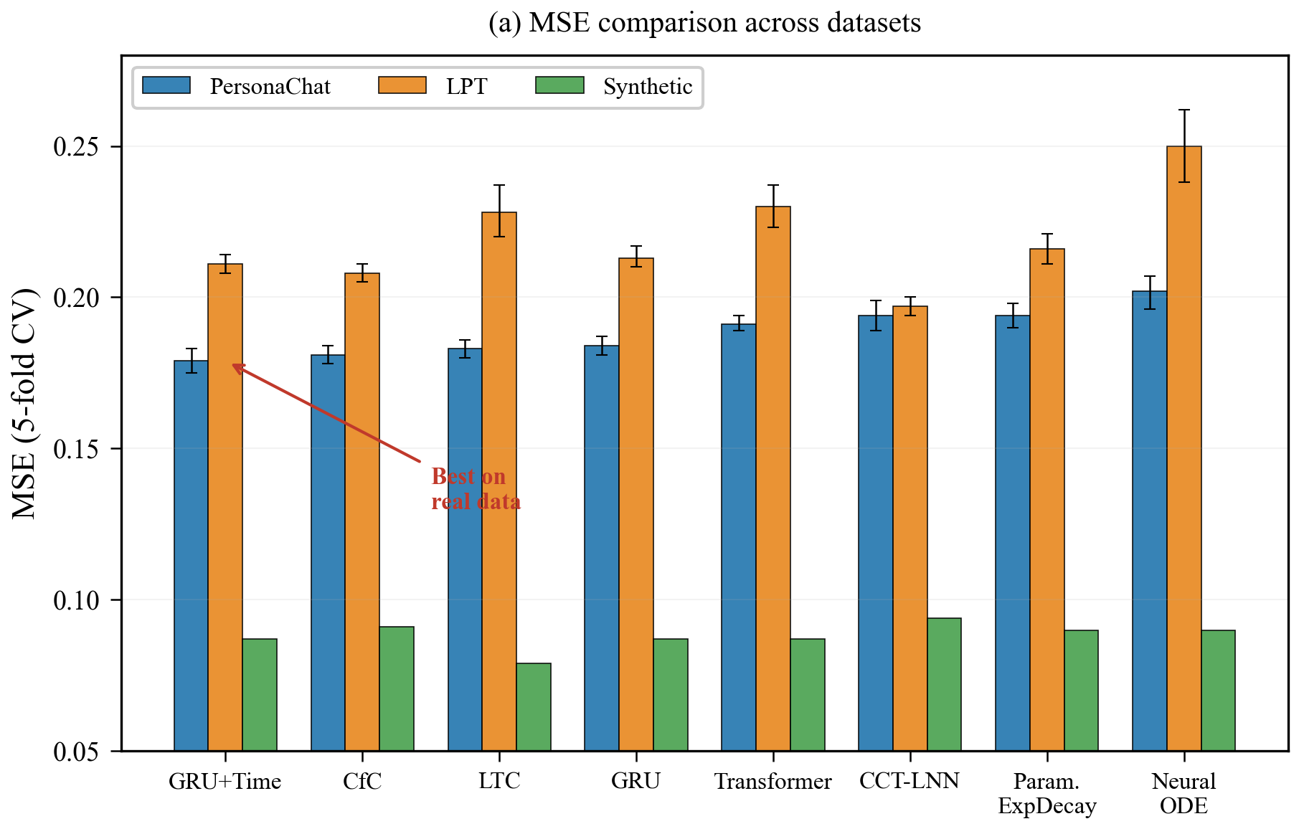
Fig. 1. MSE comparison across models and datasets.
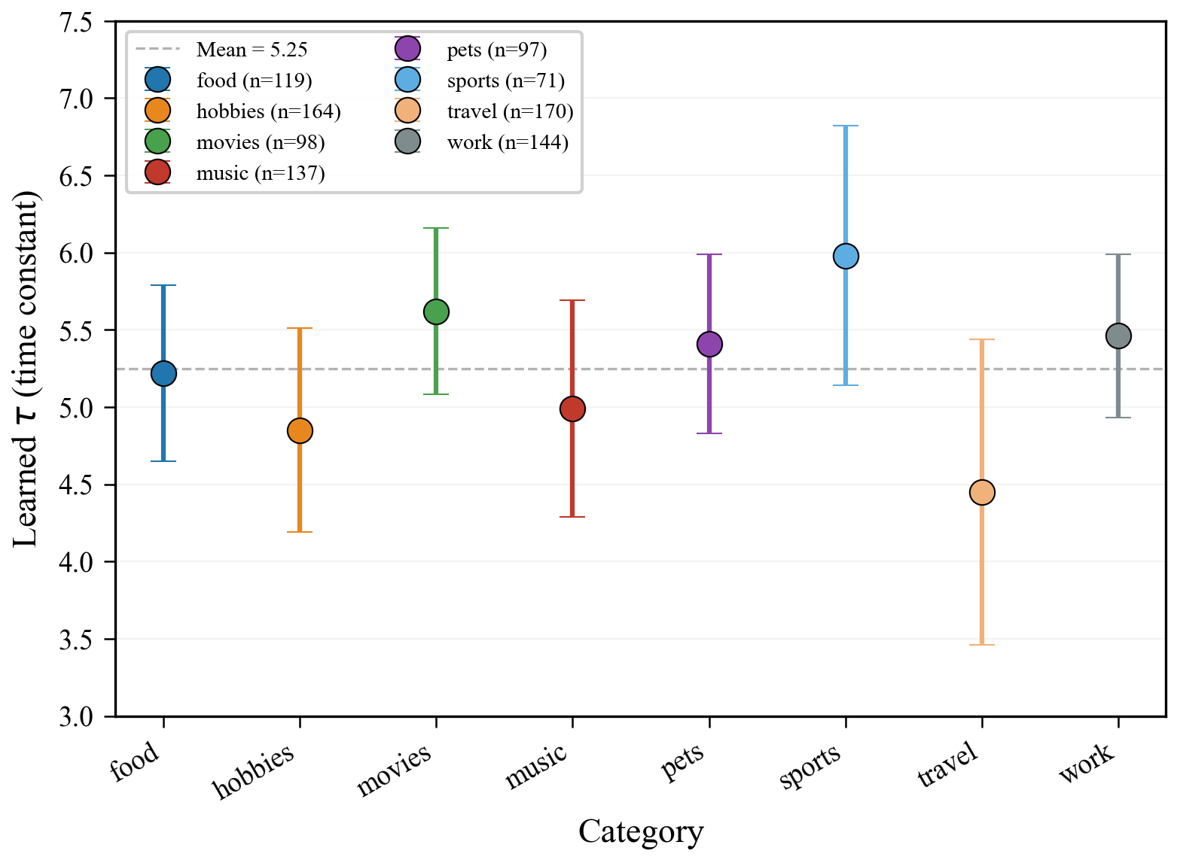
Fig. 2. Learned tau scatter plot by category.
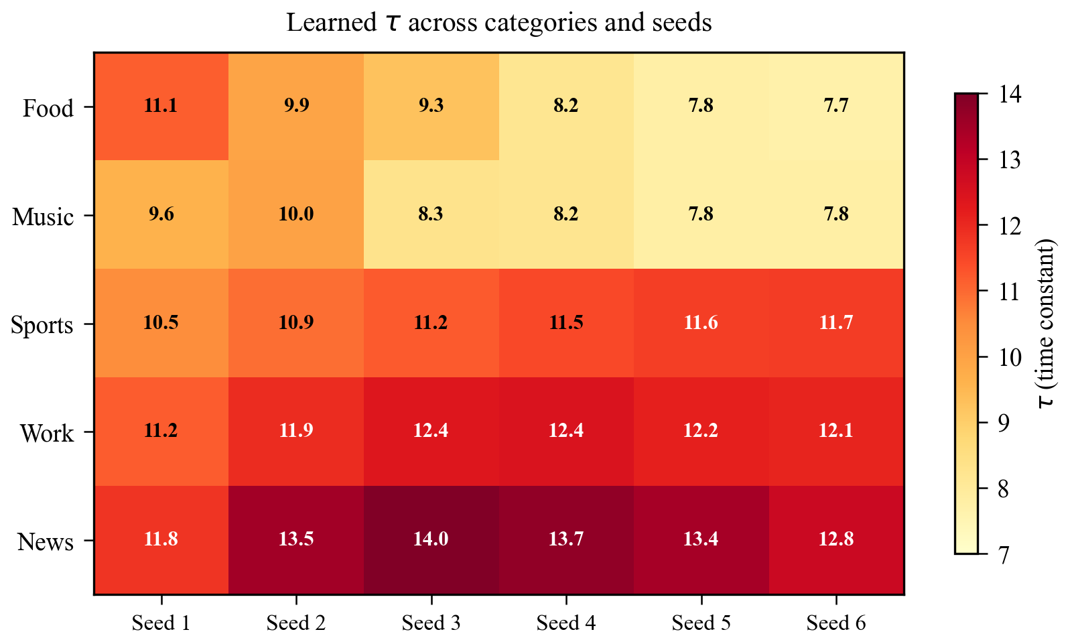
Fig. 3. Tau heatmap across categories and seeds.
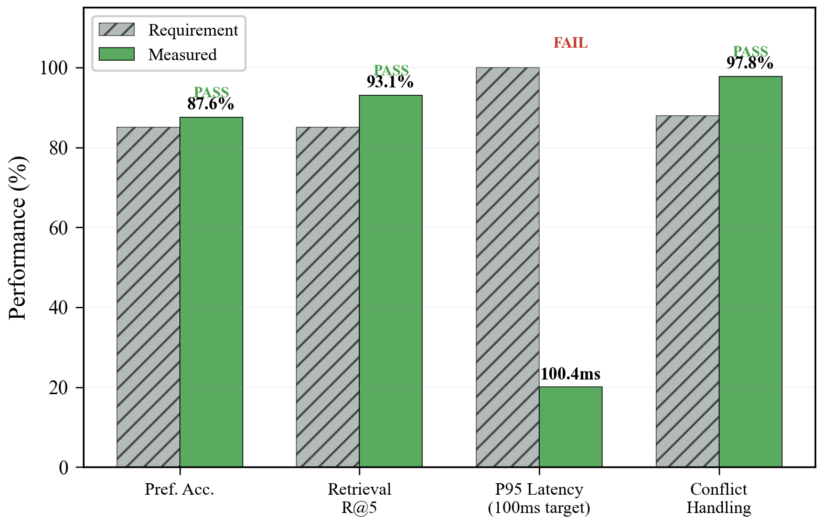
Fig. 4. Kylin V10 deployment performance bars.
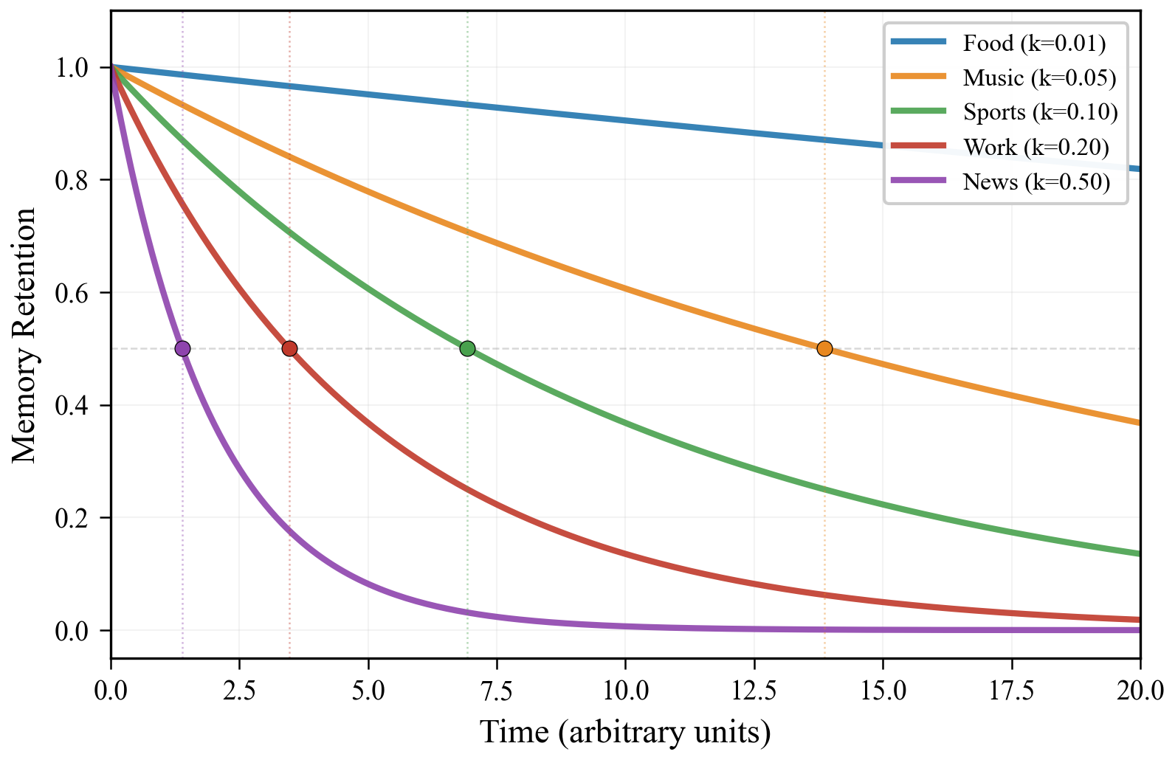
Fig. 5. Memory decay curves for five categories.
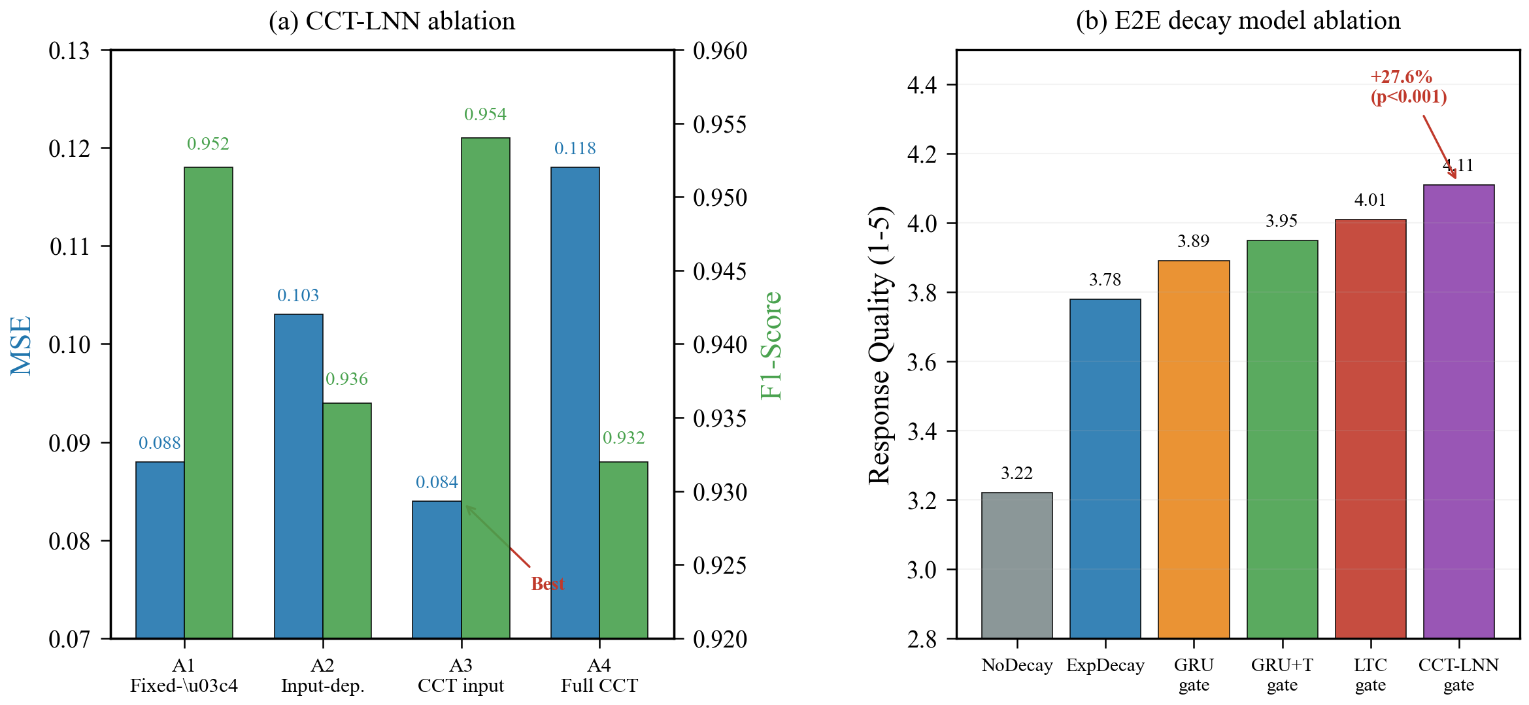
Fig. 6. Ablation study results.

References
[1] Akpinar N, Kafaligonul B, Kurt E. 2025. A novel uncertainty-aware liquid neural network for noise-resilient time series forecasting and classification. Chaos, Solitons and Fractals 189:115643. doi:10.1016/j.chaos.2025.115643.
[2] Anderson JR, Bothell D, Byrne MD, Douglass S, Lebiere C, Qin Y. 2004. An integrated theory of the mind. Psychological Review 111(4):1036-1060. doi:10.1037/0033-295x.111.4.1036.
[3] Beck M, Pöppelbaum R, et al. 2024. xLSTM: Extended long short-term memory. Neural Networks 180:106551. arXiv:2405.04517.
[4] Behrouz A, et al. 2025. Titans: Learning to memorize at test time. Proceedings of the 42nd International Conference on Machine Learning (ICML). arXiv:2501.00663.
[5] Chen RTQ, Rubanova Y, Bettencourt J, Duvenaud D. 2018. Neural ordinary differential equations. Advances in Neural Information Processing Systems 31:6571-6583. doi:10.5555/3295222.3295327 arXiv:1806.07366.
[6] Dao T, Gu A. 2024. Transformers are SSMs: Generalized models and efficient algorithms through structured state space duality. Proceedings of the 41st International Conference on Machine Learning (ICML). arXiv:2405.21060.
[7] Ebbinghaus H. 1885. Uber das Gedachtnis. Leipzig: Duncker and Humblot.
[8] Gu A, Dao T. 2024. Mamba: Linear-time sequence modeling with selective state spaces. Proceedings of the 41st International Conference on Machine Learning (ICML). arXiv:2312.00752.
[9] Hasani R, Lechner M, Amini A, Rus D, Grosu R. 2021. Liquid time-constant networks. Proceedings of the AAAI Conference on Artificial Intelligence 35(9):7657-7666 doi:10.1609/aaai.v35i9.16960.
[10] Hasani R, Lechner M, Wang TH, Chahari M, Rus D. 2022. Closed-form continuous-time neural models. Nature Machine Intelligence 4:992-1003. doi:10.1038/s42256-022-00555-8.
[11] Lewis P, Perez E, Piktus A, Petroni F, Karpukhin V, Goyal N, Kuttler H, Lewis M, Yih W, Rocktaschel T. 2020. Retrieval-augmented generation for knowledge-intensive NLP tasks. Advances in Neural Information Processing Systems 33:9459-9474 arXiv:2005.11401.
[12] Lechner M, Hasani R, Amini A, Rus D, Grosu R. 2020. Neural circuit policies enabling auditable autonomy. Nature Machine Intelligence 2:642-652. doi:10.1038/s42256-020-00237-3 arXiv:1803.08554.
[13] Packer C, Fang V, Patil S, Lin K, Wooders S, Gonzalez JE. 2023. MemGPT: Towards LLMs as operating systems. ICLR 2024 Workshop on Large Language Model (LLM) Agents. arXiv:2310.08560.
[14] Park JS, O'Brien JC, Cai CJ, Morris MR, Liang P, Bernstein MS. 2023. Generative agents: Interactive simulacra of human behavior. Proceedings of the 36th Annual ACM Symposium on User Interface Software and Technology:1-22. doi:10.1145/3586183.3606763.
[15] Shinn N, Cassano F, Gopinath A, Narasimhan K, Yao S. 2023. Reflexion: Language agents with verbal reinforcement learning. Advances in Neural Information Processing Systems 36:8634-8652. doi:10.5555/3666122.3667135.
[16] Sumers TR, Yao S, Narasimhan K, Griffiths TL. 2023. Cognitive architectures for language agents. Transactions on Machine Learning Research. arXiv:2309.02427.
[17] Sun Y, Dong L, Huang S, Ma S, Xia Y, Xue J, Wang J, Wei F. 2024. Retentive network: A successor to Transformer for large language models. Proceedings of the 41st International Conference on Machine Learning (ICML). arXiv:2307.08621.
[18] Chhikara P, Khant D, Aryan S, Singh T, Yadav D. 2025. Mem0: Building production-ready AI agents with scalable long-term memory. Frontiers in Artificial Intelligence and Applications. doi:10.3233/FAIA251160.
[19] Coelho C, Costa MFF, Ferras LL. 2024. Neural fractional differential equations. Applied Mathematical Modelling doi:10.1016/j.apm.2025.116060. arXiv:2403.02737.
[20] Wixted JT. 2004. The psychology and neuroscience of forgetting. Annual Review of Psychology 55:235-269. doi:10.1146/annurev.psych.55.090902.141555.
[21] Liang X, He Y, Xia Y, Wang J, Tao M. 2025. SAGE: Self-evolving agents with reflective and memory-augmented abilities. Neurocomputing 647:130470. doi:10.1016/j.neucom.2025.130470. arXiv:2409.00872.
[22] Zhang S, Dinan E, Urbanek J, Szlam A, Kiela D, Weston J. 2018. Personalizing dialogue agents: I have a dog, do you have pets too. Proceedings of the 56th Annual Meeting of the Association for Computational Linguistics:2204-2213. doi:10.18653/v1/P18-1205.
[23] Zhang Z, Bo X, Ma C. 2024. A survey on the memory mechanism of large language model based agents. Frontiers of Computer Science 19:196345. arXiv:2404.13501.
[24] Zhong W, Guo L, Gao Q, Liu F, Duan Y, Wu J. 2024. MemoryBank: Enhancing large language models with long-term memory. Proceedings of the AAAI Conference on Artificial Intelligence 38:19724-19731. doi:10.1609/aaai.v38i17.29946.
[25] Vaswani A, Shazeer N, Parmar N, Uszkoreit J, Jones L, Gomez AN, Kaiser L, Polosukhin I. 2017. Attention is all you need. Advances in Neural Information Processing Systems 30:5998-6008. arXiv:1706.03762.
[26] Chung J, Gulcehre C, Cho KH, Bengio Y. 2014. Empirical evaluation of gated recurrent neural networks on sequence modeling. NIPS 2014 Workshop on Deep Learning. arXiv:1412.3555.

Declarations

Acknowledgments
This work received no external funding. The authors thank the Kylin V10 deployment team for infrastructure support.

CRediT Authorship Contribution Statement
HanBo Wang: Conceptualization, Methodology, Software, Validation, Formal analysis, Investigation, Data curation, Writing -- original draft. JiaQi Song: Visualization, Writing -- review & editing.

Declaration of Competing Interest
The authors declare that they have no known competing financial interests or personal relationships that could have appeared to influence the work reported in this paper.

Data Availability
Source code, trained model weights, and experimental scripts are publicly available at https://github.com/secret-justice/agent-memory-decay-benchmark (DOI: 10.5281/zenodo.20650214). The PersonaChat dataset is publicly available from Zhang et al. (2018). A Zenodo archive with DOI is planned prior to publication.

